Multimedia Appendix1
Association of sleep duration and depressive symptoms with mortality in cancer survivors

Figure S1 Flowchart of sample inclusion in this study.
Figure S2 Individual associations of sleep duration and depressive symptoms scores with all-causes, cancer, and non-cancer mortality.
Table S1 Association of sleep duration and depressive symptoms scores (without mutually adjusted) with mortality in cancer survivors excluding deaths that occurred during the first 2-year follow-up.
Table S2 Mediation analysis of depressive symptoms on associations of sleep duration with mortality.

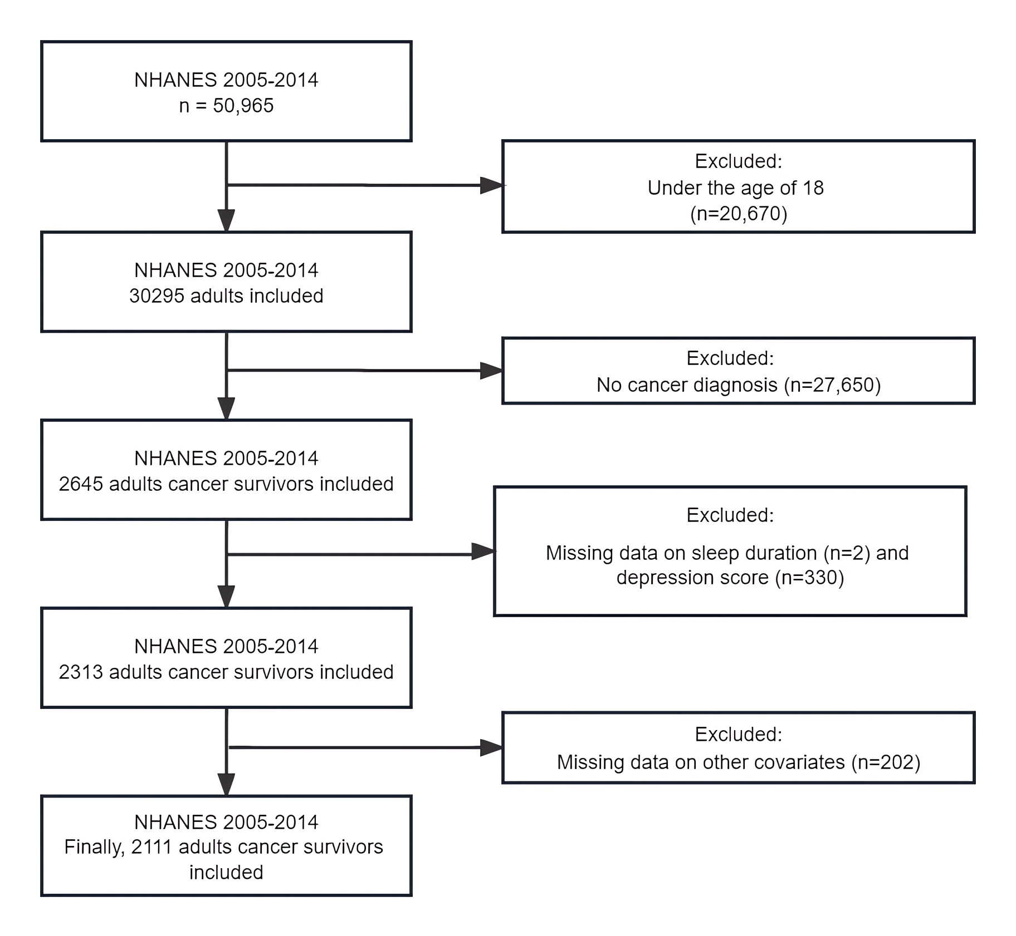
Figure S1 Flowchart of sample inclusion in this study.

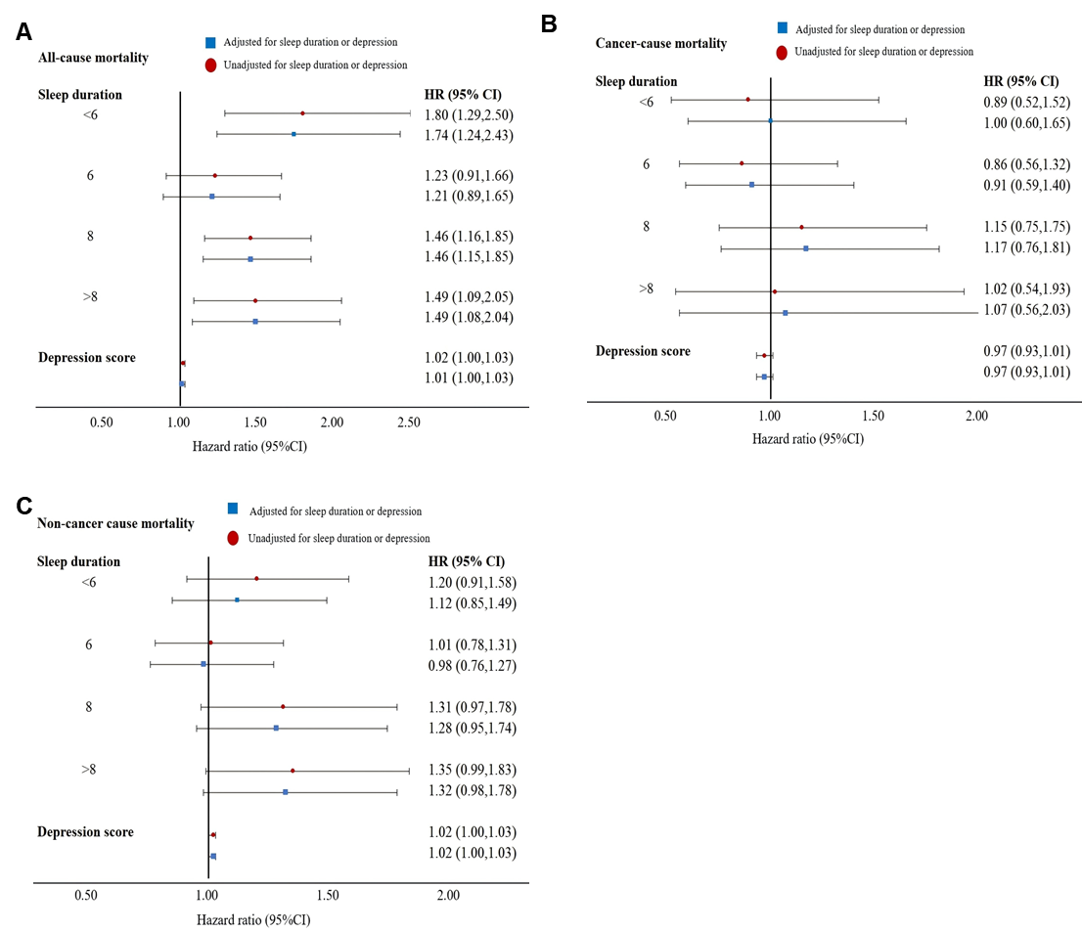
Figure S2 Individual associations of sleep duration and depressive symptoms scores with all-causes, cancer, and non-cancer mortality.
ª Three different kinds of model were used in the analyses: a) only sleep duration was included; b) only depressive symptoms scores were included; and c) both sleep duration and depressive symptoms scores were included.
^{b} Referent sleep duration (7 hours) was used as reference groups.

Table S1 Association of sleep duration and depressive symptoms scores (without mutually adjusted) with mortality in cancer survivors excluding deaths that occurred during the first 2-year follow-up.
Mortality outcome | Death/No. | Model 1ª |  |  | Model 2^{b} |  |  | Model 3^{c}
Mortality outcome | Death/No. | HR | 95%CI | P-value | HR | 95%CI | P-value | HR | 95%CI | P-value
All causes
Depressive symptoms scores | NA | 1.04 | 1.03, 1.06 | <0.001 | 1.02 | 1.00, 1.03 | 0.049 | 1.01 | 1.00, 1.03 | 0.140
Sleep duration | 597/2009
7 | 122/525 | ref. | NA | NA | ref. | NA | NA | ref. | NA | NA
<6 | 86/286 | 2.31 | 1.61, 3.32 | <0.001 | 1.82 | 1.30, 2.55 | <0.001 | 1.70 | 1.21, 2.39 | 0.002
6 | 117/426 | 1.28 | 0.98, 1.68 | 0.071 | 1.14 | 0.84, 1.55 | 0.400 | 1.14 | 0.84, 1.55 | 0.400
8 | 188/569 | 1.28 | 1.02, 1.61 | 0.032 | 1.33 | 1.06, 1.68 | 0.015 | 1.37 | 1.08, 1.75 | 0.011
>8 | 84/203 | 1.37 | 1.04, 1.82 | 0.026 | 1.30 | 0.94, 1.80 | 0.110 | 1.29 | 0.93, 1.79 | 0.130
Cancer cause
Depressive symptoms scores | NA | 0.96 | 0.92, 1.00 | 0.075 | 0.95 | 0.91, 0.99 | 0.020 | 0.95 | 0.91, 0.99 | 0.017
Sleep duration | 187/2009
7 | 47/525 | ref. | NA | NA | ref. | NA | NA | ref. | NA | NA
<6 | 29/286 | 0.78 | 0.43, 1.39 | 0.400 | 0.70 | 0.39, 1.28 | 0.300 | 0.76 | 0.42, 1.39 | 0.400
6 | 38/426 | 0.74 | 0.46, 1.18 | 0.200 | 0.72 | 0.43, 1.20 | 0.200 | 00.76 | 0.46, 1.28 | 0.300
8 | 53/569 | 1.03 | 0.64, 1.66 | >0.900 | 1.02 | 0.63, 1.65 | >0.900 | 1.08 | 0.67, 1.73 | 0.800
>8 | 20/203 | 0.69 | 0.38, 1.25 | 0.200 | 0.70 | 0.38, 1.30 | 0.300 | 00.74 | 0.38, 1.45 | 0.400
Non-cancer cause
Depressive symptoms scores | NA | 1.03 | 1.01, 1.04 | 0.003 | 1.02 | 1.00, 1.04 | 0.025 | 1.02 | 1.00, 1.03 | 0.045
Sleep duration | 410/2009
7 | 75/525 | ref. | NA | NA | ref. | NA | NA | ref. | NA | NA
<6 | 57/286 | 1.31 | 0.96, 1.79 | 0.093 | 1.22 | 0.91, 1.64 | 0.200 | 1.24 | 0.91, 1.67 | 0.200
6 | 79/426 | 1.08 | 0.80, 1.47 | 0.600 | 1.02 | 0.76, 1.37 | >0.900 | 0.97 | 0.74, 1.27 | 0.800
8 | 135/569 | 1.22 | 0.87, 1.72 | 0.200 | 1.26 | 0.88, 1.80 | 0.200 | 1.29 | 0.92, 1.81 | 0.140
>8 | 64/203 | 1.20 | 0.84, 1.71 | 0.300 | 1.22 | 0.86, 1.75 | 0.300 | 1.26 | 0.90, 1.77 | 0.200
ª Adjusted for age (continuous) and sex.
^{b} Model 1 + race, education level, marital status, family poverty income ratio, BMI (category), physical activity, smoking and alcohol consumption.
^{c} Model 2 + comorbidities (including hypertension, diabetes, and CVD) + years since first cancer diagnosis.

Table S2 Mediation Analysis of Depressive symptoms on Associations of Sleep Duration with Mortality.
Depressive symptoms | Sleep Duration  Estimation% (95% CI)
Depressive symptoms | <6 hours | 6 hours | 8 hours | >8 hours
All causes
Total effect | 39.49 (10.63, 70.01) | 23.09 (-0.62, 49.20) | 29.69 (8.12, 52.17) | 44.75 (18.71, 69.95)
Indirect effect | 2.30 (-0.57, 6.97) | 1.60 (-0.48, 4.70) | 0.64 (-0.60, 2.87) | 0.67 (-0.57, 2.89)
Direct effect | 37.19 (8.49, 67.18) | 21.49 (-3.19, 47.81) | 29.05 (7.70, 51.24) | 44.07 (18.10, 69.74)
Proportion mediated | 5.83 (-1.62, 30.51) | 6.94 (-13.60, 53.53) | 2.15 (-2.32, 13.24) | 1.51 (-1.37, 7.31)
Cancer cause
Total effect | 6.85 (-40.65, 55.85) | -4.65 (-46.97, 34.36) | 12.35 (-25.18, 54.25) | 12.86 (-46.72, 67.96)
Indirect effect | 0.86 (-10.89, 11.52) | 0.50 (-6.17, 7.55) | 0.31 (-4.19, 5.08) | 0.48 (-6.40, 7.11)
Direct effect | 5.99 (-42.05, 54.30) | -5.16 (-48.61, 34.26) | 12.04 (-26.54, 53.88) | 12.38 (-45.40, 68.63)
Proportion mediated | 12.56 (-283.85, 262.26) | -10.84 (-264.33, 169.83) | 2.54 (-70.72, 102.01) | 3.71 (-107.90, 178.14)
Non-cancer cause
Total effect | 32.27 (-3.07, 68.49) | 11.35 (-21.10, 44.56) | 28.02 (-1.43, 59.56) | 34.65 (3.15, 73.04)
Indirect effect | 2.31 (-2.85, 9.57) | 1.66 (-2.01, 6.95) | 1.29 (-1.87, 4.65) | 1.07 (-1.56, 4.46)
Direct effect | 29.96 (-6.42, 66.98) | 9.69 (-23.55, 42.27) | 26.73 (-2.78, 58.46) | 33.58 (2.57, 72.90)
Proportion mediated | 7.16 (-30.01, 57.98) | 14.63 (-133.09, 151.66) | 4.61 (-17.05, 28.26) | 3.08 (-8.63, 17.18)
Model adjusted for age and sex, race, education level, marital status, family poverty income ratio, BMI, physical activity, smoking and alcohol consumption, further adjusted for comorbidities (including hypertension, diabetes, and CVD), and years since first cancer diagnosis, with 7 hours of sleep as the reference.

