Supplementary File 1:
According to the bar chart, men are more likely to develop melanoma than women, although the rate varies by age. Before age 60, the risk is higher for women. After age 60, this risk is higher in men. [3]
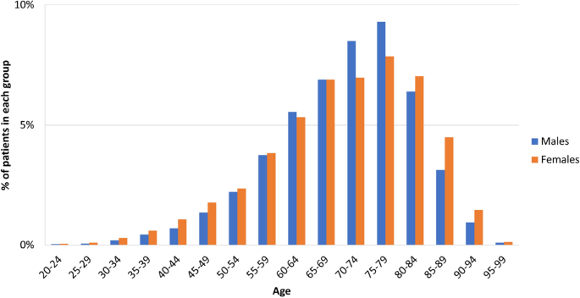
Percentage of melanoma patients by gender at different ages [3]

Supplementary File 2:

The percentage of founded articles retrieved from various databases

Supplementary File 3:
Table 3 lists the names of the journals in which the selected articles were published, the related databases, and the number of articles published in each journal.
Table 3 Journal or conference names and number of studies in databases
Publisher | Journal discipline or name | Number of studies
Frontiers | Frontiers in big data | 1
MDPI | Diagnostics | 1
 | Entropy | 1
 | Sensors | 5
 | Cancers | 1
 | Bioengineering | 1
 | Biomolecules | 1
 | Mathematics | 1
IEEE | Access | 3
 | 2019 International Conference on Sustainable Technologies for Industry 4.0 | 1
 | Tissue and Cell | 1
 | King Saudi | 1
Elsevier | Journal of biomedical informatics | 1
 | Applied Soft Computing | 1
 | Computer Methods and Programs in Biomedicine | 1
PubMed | Asian Pacific Journal of Cancer Prevention | 1
Springer | Neural Processing Letters | 1
Springer | Multimedia tools & applications | 3
Springer | Journal of Digital Imaging | 2
Springer | Journal of big data | 1
Springer | Soft computing | 1
Springer | BMC medical imaging | 1

Supplementary File 4:

the number of melanoma lesions in different datasets

Supplementary File 5:
The bar chart illustrates the number of different datasets in the selected articles. ISIC (International Skin Imaging Collaboration) and HAM10000 are the most widely used datasets that publishes a large number of dermoscopy lesion images for skin cancer diagnosis every year.

The number of datasets retrieved from selected articles

Supplementary File 6:
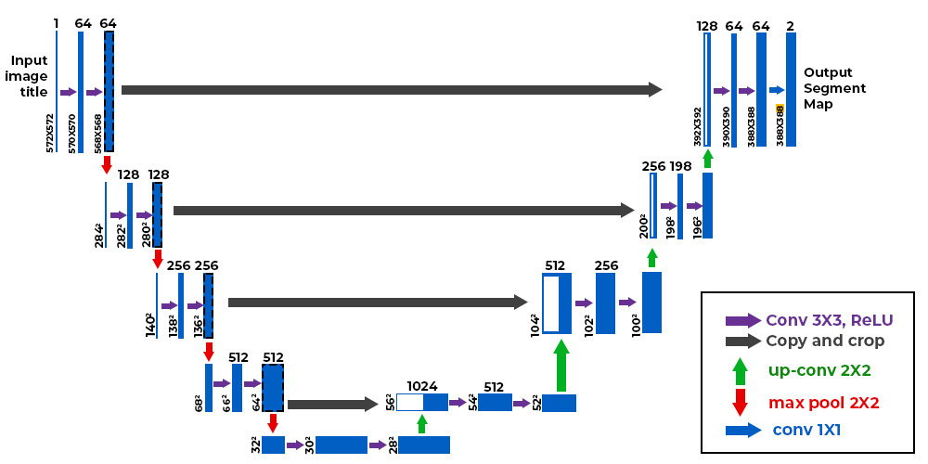
U-Net architecture [39]

Supplementary File 7:
The bar chart illustrates how the U-Net network converts a grayscale input image of size 572×572×1 into a binary segmented output map of size 388×388×2.

Frequency of all the methods used in selected articles

