Data Extraction and Analysis Procedures
1. Data Download
The data required for this study was obtained from the Global Burden of Disease (GBD) Database, accessible through the GBD Results Tool (https://vizhub.healthdata.org/gbd-results/). Specific datasets were selected based on the research scope, including the time frame, geographic regions, and key indicators such as incidence rates, mortality rates, disability-adjusted life years (DALYs) and prevalence rate.

2. Data Selection
Once downloaded, the raw data was filtered and organized to meet the study’s requirements. Variables relevant to stratified analysis (e.g., geographic regions, age groups, and sex) and time-series analysis were prioritized. The cleaned and prepared datasets were then uploaded into Jingding Statistical Software, developed using R software, for further analysis. Care was taken to ensure that all necessary dimensions were included to support a comprehensive and robust analysis.

3. Data Analysis
The cleaned datasets were imported into Jingding Statistical Software, where its intuitive user interface enabled efficient high-dimensional data processing. Using the software’s right-side menu bar, the following analytical modules were applied:
Trend Analysis: Conducted time-series analyses of key indicators, such as incidence and mortality rates, to identify temporal patterns.
Stratified Analysis: Performed comparative analyses across subgroups, including geographic regions, age categories, and sexes, to evaluate disparities or variations.
Significance Testing: Assessed statistical significance between subgroups or across time-series data.

4. Results Generation
The software automatically produced high-resolution visualizations and detailed statistical tables, facilitating the interpretation and presentation of findings. Examples of generated outputs included line charts, bar graphs, and statistical summaries, providing a solid foundation for drawing reliable conclusions.

5. Key Considerations
To ensure the accuracy and reliability of the analysis:
Data Cleaning: The datasets were thoroughly cleaned before analysis, removing outliers and addressing missing values to maintain consistency and accuracy.
Parameter Optimization: The default parameters of the software were adjusted as needed to refine the analysis and enhance precision.

6. Research Significance
This workflow was developed for internal use to standardize the process of downloading, preparing, and analyzing GBD data. By leveraging Jingding Statistical Software, the workflow ensures efficient, reproducible, and scientifically rigorous analysis. This methodology provides robust support for exploring global health trends, informing policy development, and advancing future research.

7. Functionality Demonstration
The following sections showcase the core functionalities of Jingding Statistical Software, including examples of generated visualizations and descriptions of the computational methods and formulas used throughout the analysis process.

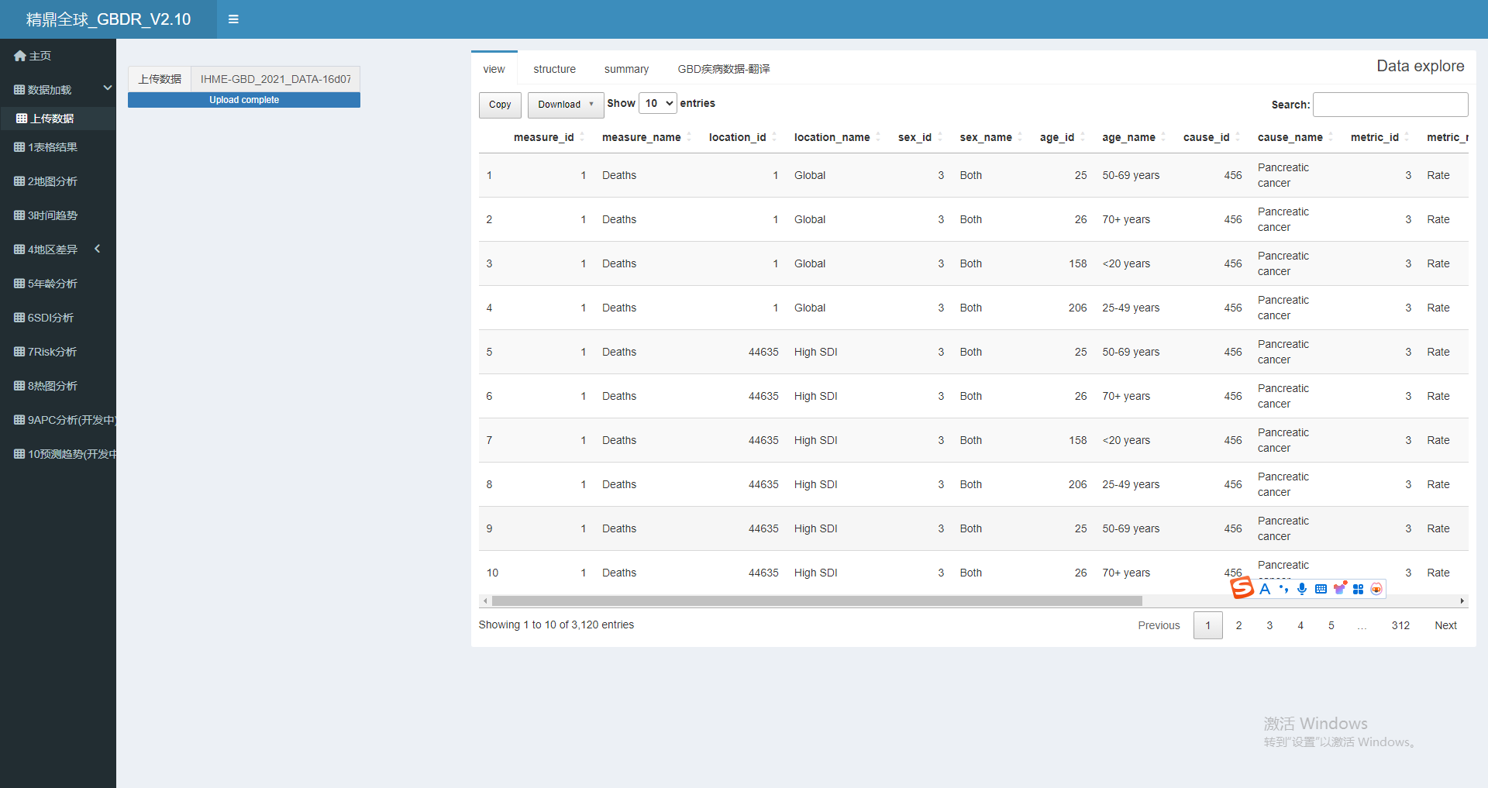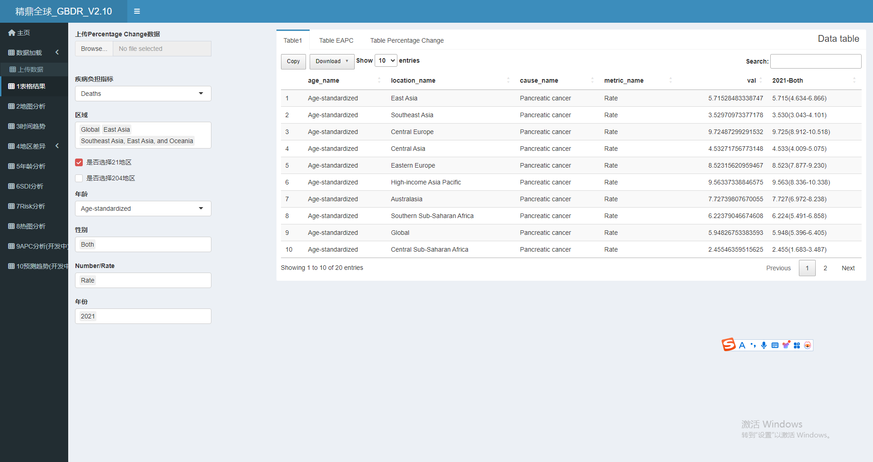
Figure 1 The main interface of the software

This study extracted age-standardized rates (ASRs, per 100,000 population) for all age groups, stratified rates for specific age groups, and corresponding numerical values from the GBD 2021 database. The ASR was calculated as a weighted average of age-specific rates, where the weights were determined based on the age distribution of a standardized population. The calculation formula is as follows:
$$ASR=\frac{\sum_{i=1}^{N}{ }a_{i}w_{i}}{\sum_{i=1}^{N}{ }w_{i}}$$
where $a_{i}$ represents the specific age rate for the 𝑖^{th} age group, $w_{i}$is the weight of the standard population in the same age group, and 𝑁 denotes the total number of age groups. For each indicator, 95% uncertainty intervals (UIs) were defined as the 2.5th and 97.5th percentiles based on 1,000 resampled values, reflecting the range of uncertainty around the estimates.
Subsequently, percentage changes in incidence, prevalence, mortality, and disability-adjusted life years (DALYs) from 1990 to 2021 were calculated using the formula:
$$\text{Percentage change}=\frac{\text{Final value}-\text{Initial value}}{\text{Initial value}}×100\%$$
Statistical significance was assessed based on the overlap of UIs. If UIs overlapped between two data points, the difference was considered not statistically significant (P > 0.05); conversely, non-overlapping UIs indicated a statistically significant difference (P < 0.05).
To evaluate long-term trends in ASRs, a linear regression model was employed:
$$\begin{aligned}\ln\left(\text{ASR}\right)=α+βx+ε\end{aligned}$$
where $\ln\left(\text{ASR}\right)$ is the natural logarithm of ASR, $x$ is the calendar year, and ε is an independent, normally distributed error term. We utilized Joinpoint software (version 5.0.1) to conduct a detailed analysis of long-term trends in the data, providing a clear description of trends within the specified time frame. The estimated annual percentage change (EAPC) was then computed using the formula:
$$\text{EAPC}=100×\left(e^{β}-1\right)$$
EAPC values and their 95% confidence intervals (CIs) were used to describe trends over specific periods. If the upper limit of the EAPC’s 95% CIs was less than zero, it indicated a statistically significant decreasing trend; if the lower limit was greater than zero, it indicated a statistically significant increasing trend. If the CIs included zero, the observed trend was not statistically significant.
All data processing and analyses were performed using R software (version 4.4.0), Joinpoint software (version 5.0.1), and JD_GBDR (V2.10, Jingding Medical Technology Co., Ltd.) utilizing advanced statistical tools to ensure the accuracy and scientific rigor of the results. This standardized methodological framework provides robust support for exploring data trends and their statistical significance.

