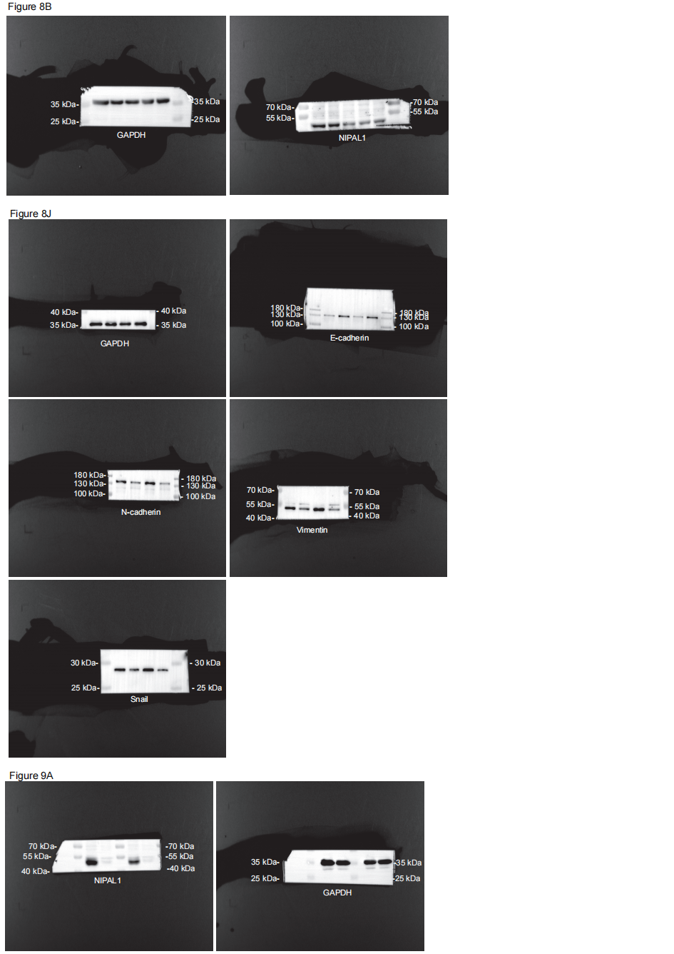
The unprocessed gels and blots with molecular size markings for Figure 8 and Figure 9. Figure 8B：The images of GAPDH exposure for 1s; the images of NIPAL1 exposure for 10s. Figure 8J：The images of GAPDH exposure for 3s; the images of N-cadherin exposure for 30s; the images of E-cadherin exposure for 5 mins；the images of Vimentin exposure for 60s；the images of Snail exposure for 30s. Figure 9A：The images of NIPAL1 exposure for 10s；the images of GAPDH exposure for 3s.
To ensure consistent protein loading across experiments and that both the target protein bands and the loading control bands originated from the same membrane, we performed necessary band excision prior to antibody hybridization.

