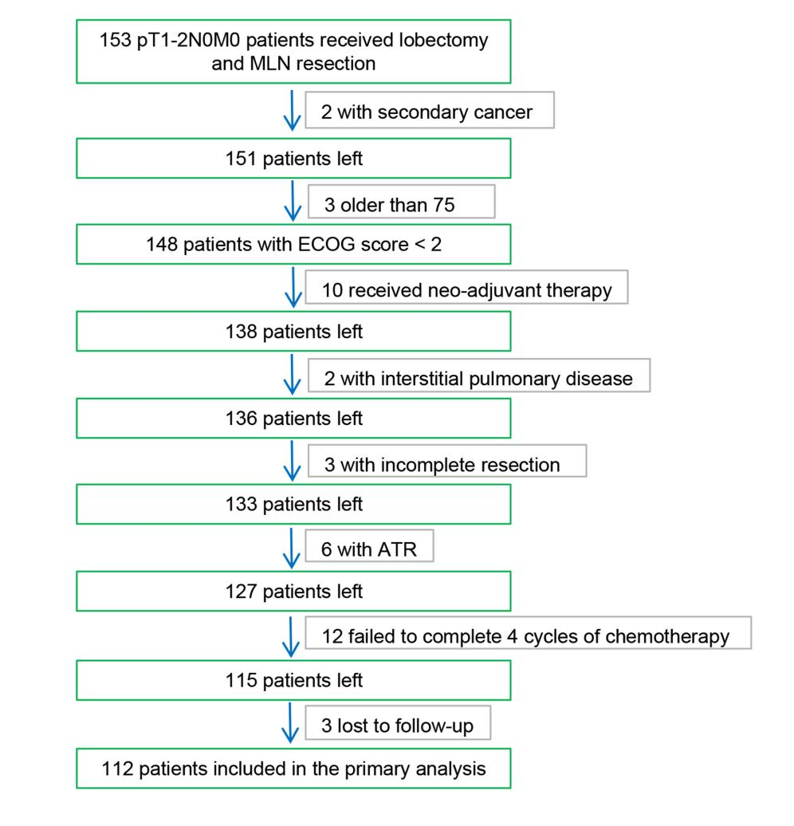
Figure S1. The flowchart of patients screening.

