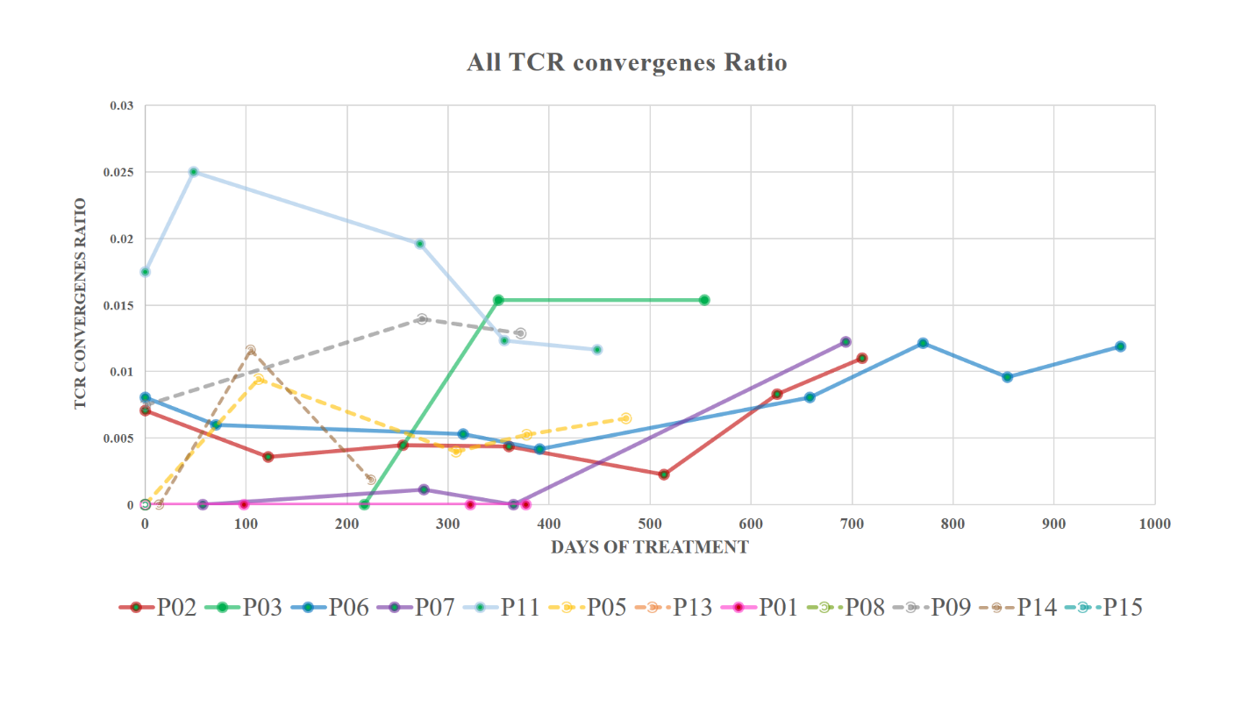

Supplement Figure 1. The T-cell receptor convergence ratio throughout the course of treatment.
The convergence ratio represents how frequently different TCR sequences converge to recognize similar antigens, which may correlate with immune response dynamics.
- non-progressive disease patient No. P2, P3, P5, P6, P7, P11, P13
- progressive disease patient No. P1, P8, P9, P14, P15

