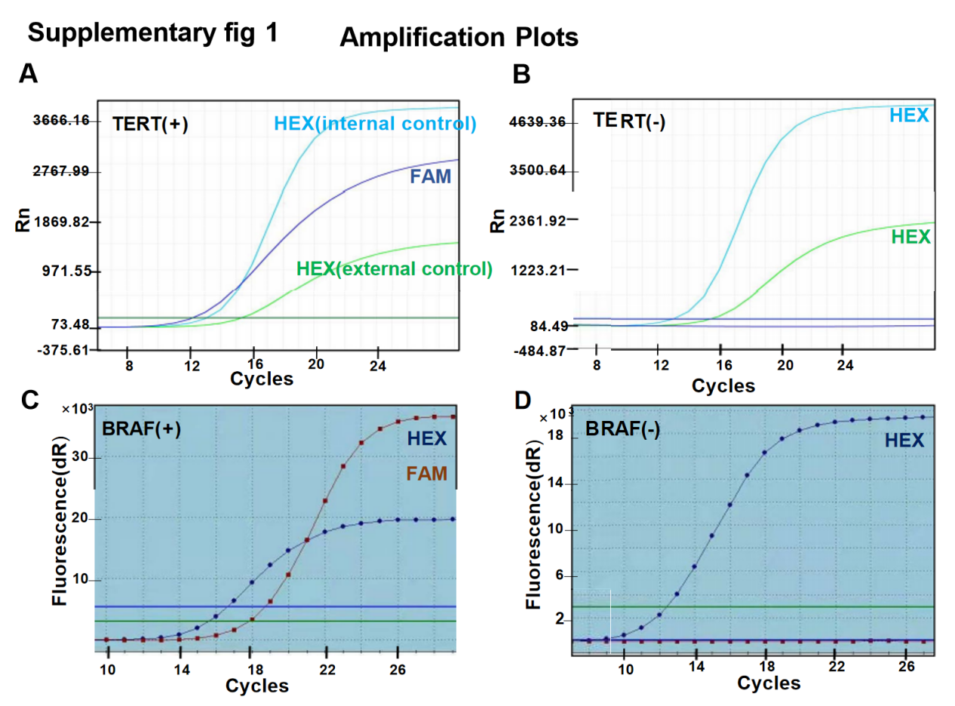
Supplementary Fig1. Representative melting curves of BRAF V600E and TERT promoter mutation.
A-B) DNA from FNA patients were collected, followed by ARMS-PCR assay. Representative melting curves of BRAF V600E and TERT promoter mutation were indicated. Fluorescent signals (FAM and HEX) were collected and internal or external controls were indicated as blue HEX or green HEX, respectively. FAM，TERT promoter mutation. C-D) BRAF V600E of mutated (C) or wildtype (D) was indicated.

