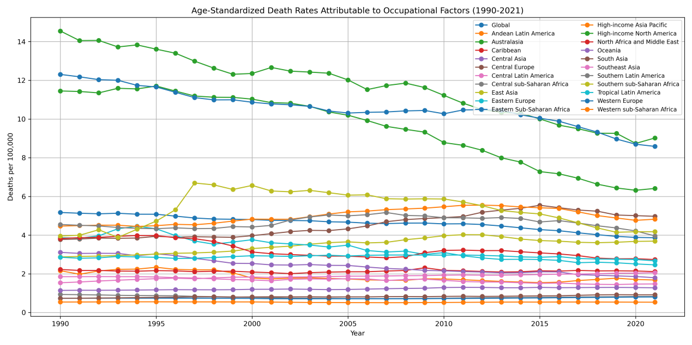
Supplemental Figure 1.Trend of ASDR attributable to occupational factors across 21 GBD regions, 1990–2021

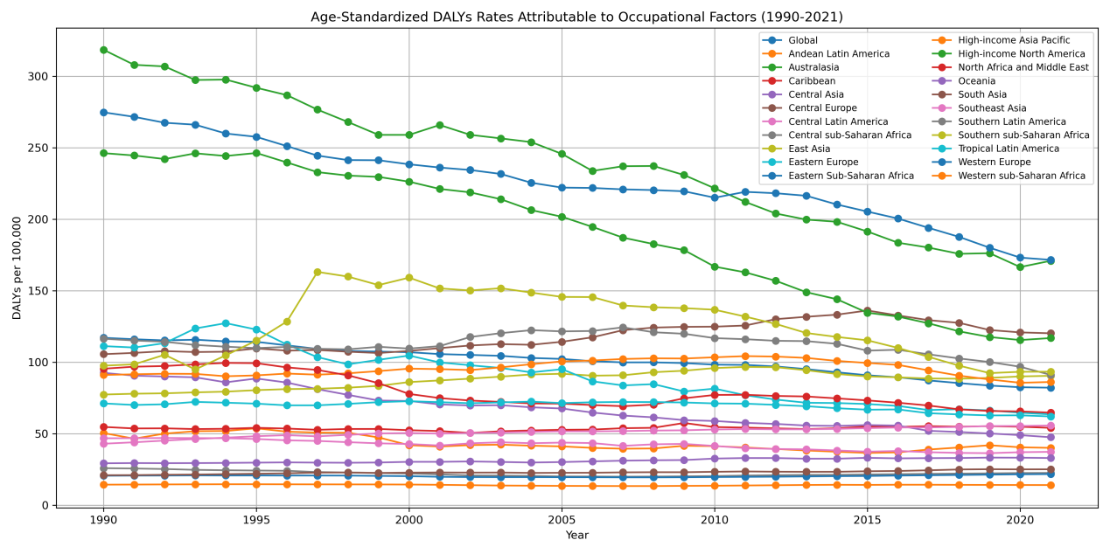
Supplemental Figure 2. Trend of Age-standardized DALY rate attributable to occupational factors across 21 GBD regions, 1990–2021

Supplemental Figure 3. EAPC of ASDR attributable to occupational risks factors in 2021.(A. Occupational risks. B. Occupational exposure to nickel. C. Occupational exposure to asbestos. D. Occupational exposure to polycyclic aromatic hydrocarbons. E. Occupational exposure to sulfuric acid. F.Occupational exposure to diesel engine exhaust. G. Occupational exposure to beryllium. H.Occupational carcinogens. I. Occupational exposure to silica. J. Occupational exposure to cadmium. K. Occupational exposure to arsenic. L. Occupational exposure to formaldehyde. M. Occupational exposure to chromium. N. Occupational exposure to trichloroethylene. O. Occupational exposure to benzene)

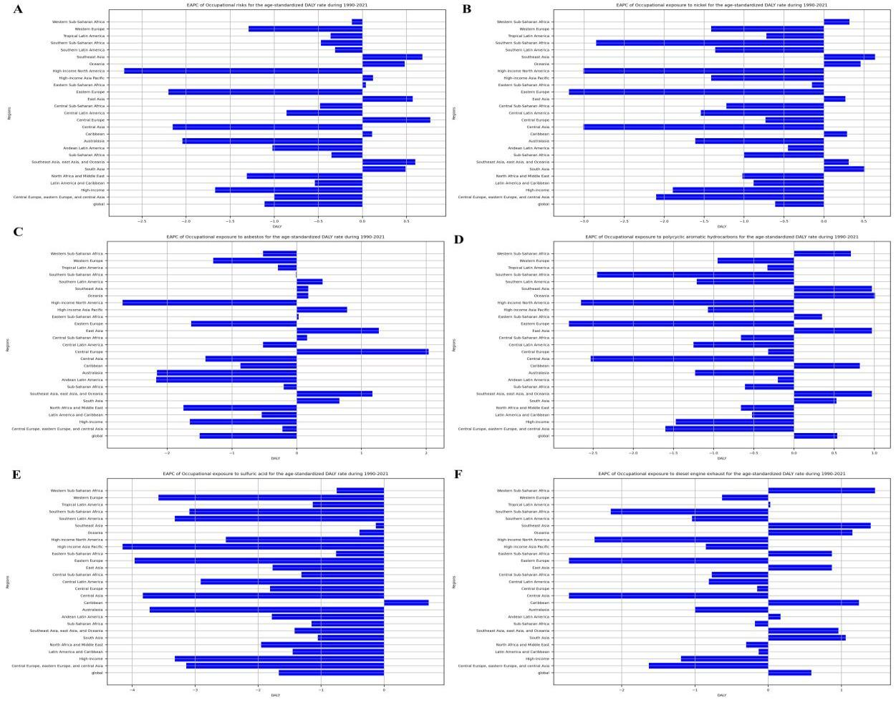
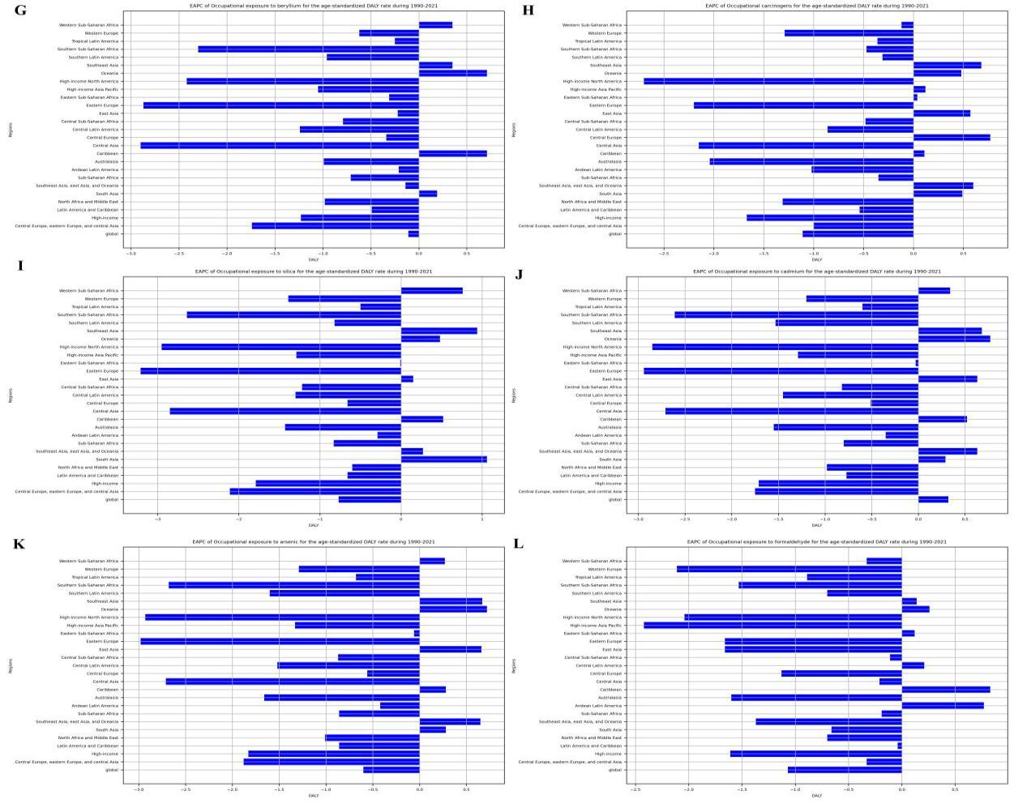
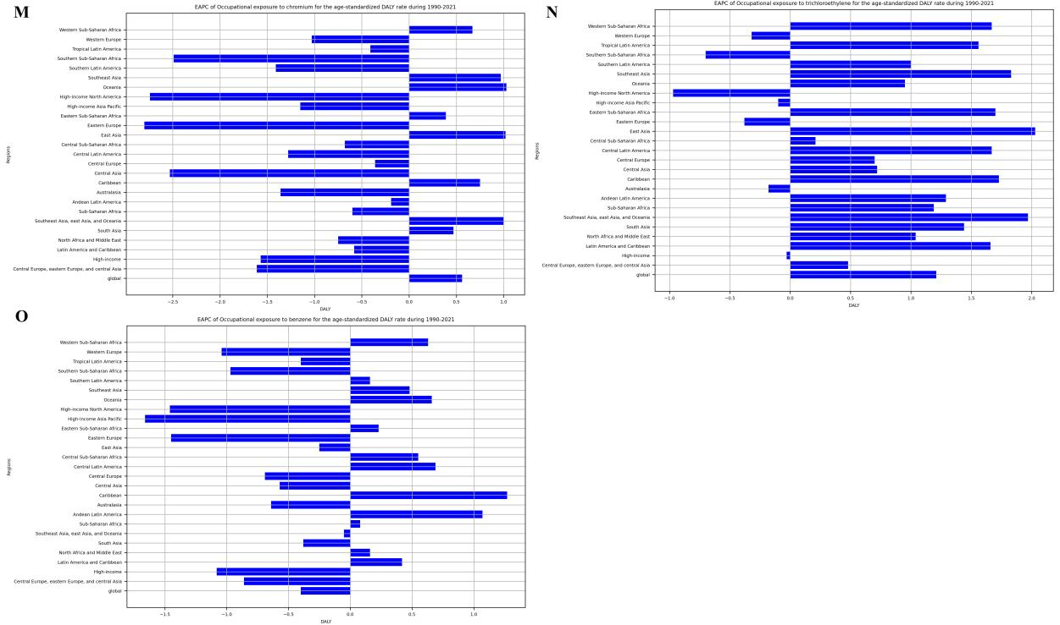
Supplemental Figure 4. EAPC of Age-standardized Rate of DALYs attributable to occupational risks factors in 2021.(A. Occupational risks. B. Occupational exposure to nickel. C. Occupational exposure to asbestos. D. Occupational exposure to polycyclic aromatic hydrocarbons. E. Occupational exposure to sulfuric acid. F.Occupational exposure to diesel engine exhaust. G. Occupational exposure to beryllium. H.Occupational carcinogens. I. Occupational exposure to silica. J. Occupational exposure to cadmium. K. Occupational exposure to arsenic. L. Occupational exposure to formaldehyde. M. Occupational exposure to chromium. N. Occupational exposure to trichloroethylene. O. Occupational exposure to benzene)

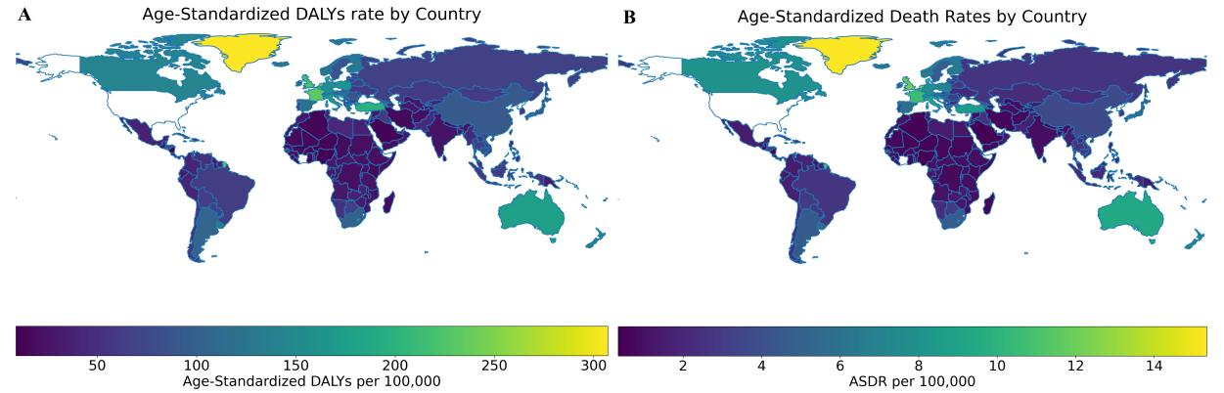
Supplemental Figure 5. Global Maps of Age-standardized Rate of death and DALYs attributable to occupational risks factors in 2021. (A. Death B. DALYs.)

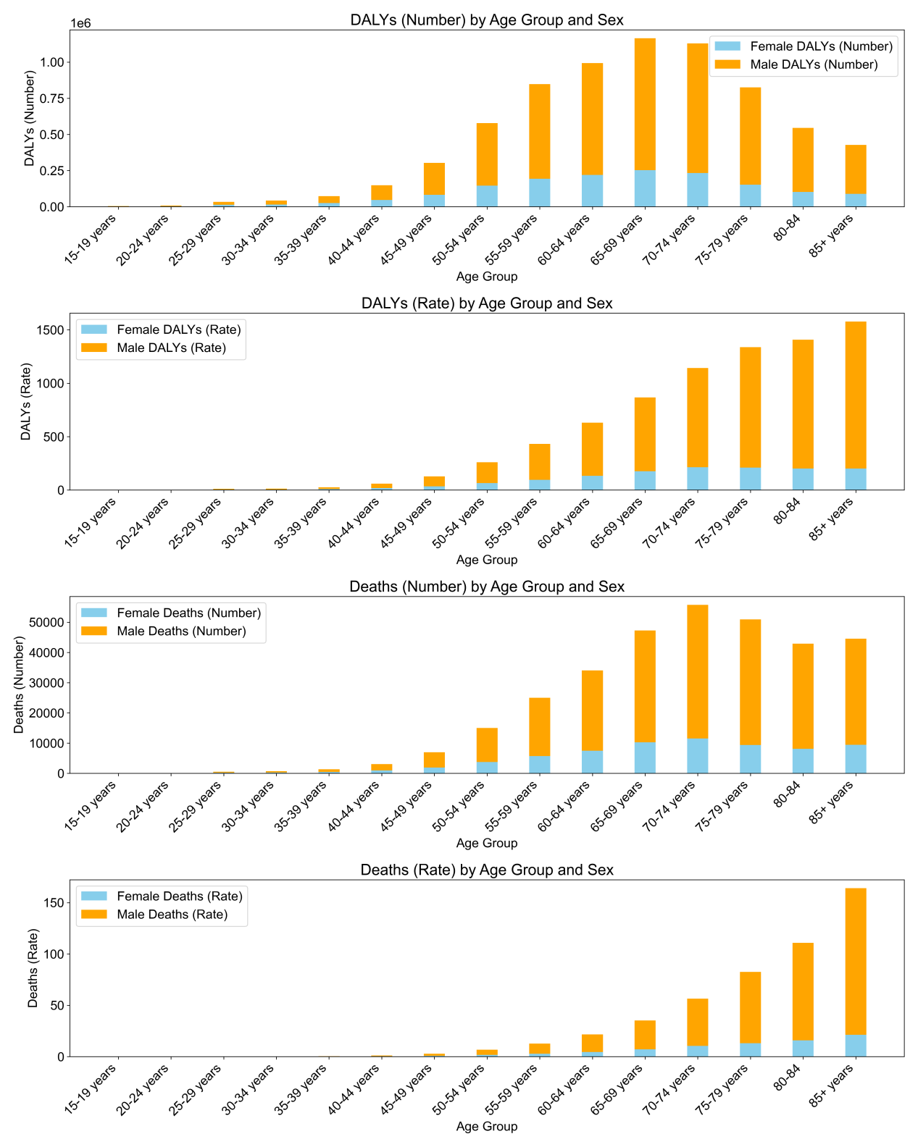
Supplemental Figure 6. Age-specific numbers and rates of deaths and DALYs attributable to occupational risks by age, by sex, in 2021 (A. Death B. DALYs.)

