Supplementary Appendix

Table of Contents

Figure S1: Characteristic of machine learning models in testing cohort…………………………………….2
Table S1: Baseline characteristic of Cohort 2………………………………………………………………..3
Table S2: Importance Scores of Candidate Risk Factors in Training Group ………….…………………….5
Table S3: Importance Scores of Candidate Risk Factors in Testing Group...………….…………………….6
Table S4: Mean and variance of Gaussian distributions……………………………………………………..7
Table S5: Catheter-related thrombosis risk in chemotherapy patients scale…………………………………8
Supplementary file: Core code……………………………………………………………………………….9

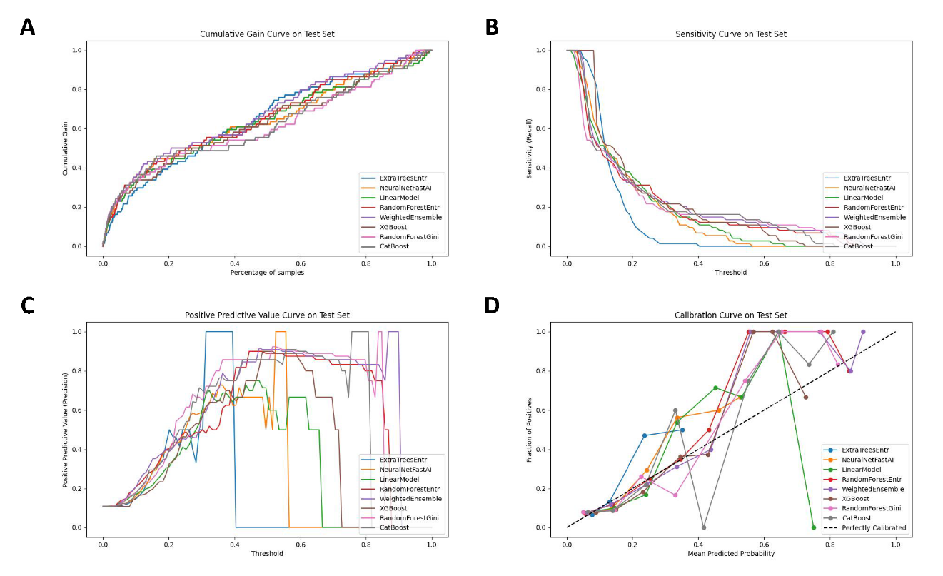Figure S1. Characteristic of machine learning models in testing cohort
RandomForestEntr indicates random forest entropy; RandomForestGini, random forest gini; CatBoost, categorical boosting; ExtraTreesEntr, extra trees entropy; NeuralNetFastAI, neural net fast ai; XGBoost, extreme gradient boosting; LinearModel, linear model; WeightedEnsemble, weighted ensemble learning.
Table S1. Baseline characteristics of Cohort 2
 | Without CRT (n = 1208) | CRT (n = 66) | Shapiro-Wilk test (P value) | p Value
Age (years) | 52.00 (43.00-58.00) | 51.00 (44.00-58.25) | ＜0.001/0.405 | 0.914ª
Height (m) | 1.59 (1.55-1.62) | 1.60 (1.55-1.65) | ＜0.001/0.181 | 0.269ª
Weight (kg) | 61.00 (56.00-67.00) | 62.00 (55.75-72.00) | ＜0.001/0.047 | 0.234ª
Body mass index | 24.22 (21.88-26.72) | 24.14 (22.50-27.66) | ＜0.001/0.041 | 0.417ª
Karnofsky Performance Status | 90.00 (90.00-90.00) | 90.00 (90.00-90.00) | ＜0.001/＜0.001 | 0.745ª
Catheter length (cm) | 16.00 (16.00-17.00) | 27.00 (16.00-40.00) | ＜0.001/＜0.001 | < 0.001ª
Indwelling time (days) | 3.00 (2.00-8.00) | 81.50 (46.75-108.50) | ＜0.001/0.274 | < 0.001ª
Duration of catheter use (days) | 3.00 (2.00-7.00) | 17.50 (11.75-25.00) | ＜0.001/0.185 | < 0.001ª
Leukocyte (10⁹/L) | 5.32 (4.16-6.74) | 5.22 (4.33-6.30) | ＜0.001/< 0.001 | 0.781ª
Platelet (10⁹/L) | 244.00 (197.25-303.00) | 250.00 (190.75-286.25) | ＜0.001/0.005 | 0.480ª
Hemoglobin (g/L) | 116.00 (107.00-124.00) | 120.00 (112.00-129.00) | ＜0.001/0.323 | 0.034ª
Albumin (g/L) | 39.60 (37.80-41.50) | 39.90 (37.88-42.18) | ＜0.001/0.910 | 0.316ª
Prothrombin time (seconds) | 10.70 (10.30-11.30) | 10.95 (10.50-11.40) | ＜0.001/0.907 | 0.078ª
Activated partial thromboplastin time (seconds) | 25.10 (23.80-26.60) | 25.55 (24.00-26.93) | ＜0.001/0.693 | 0.193ª
Total cholesterol (mmol/L) | 4.84 (4.23-5.59) | 4.99 (4.25-5.41) | ＜0.001/0.038 | 0.942ª
D-Dimer (mg/L) | 0.44 (0.26-0.85) | 0.36 (0.25-0.73) | ＜0.001/＜0.001 | 0.285ª
Fibrinogen (g/L) | 3.04 (2.59-3.56) | 2.98 (2.53-3.60) | ＜0.001/0.004 | 0.660ª
Previous catheterization (%) | 781 (64.7) | 12 (18.2) | / | < 0.001^{b}
History of venous thrombosis (%) | 33 (2.7) | 0 (0.0) | / | 0.336^{c}
Catheterization approach |  |  |  | < 0.001^{b}
CVC (%) | 150 (12.4) | 33 (50.0) | /
PICC (%) | 1058 (87.6) | 33 (50.0) | /
Depending on the normality, characteristics for the Without CRT and CRT groups were presented by Median (IQR).
P-value: ªMann-Whitney test; ^{b}Chi-square test; ^{c}Chi-square incorporating Yates’ correction for continuity.
Feature | Importance score | p-value
Platelet count | 0.159047257 | 1.70E-06
APTT | 0.144382004 | 5.98E-08
Age | 0.128975837 | 2.13E-07
TC | 0.120452484 | 1.09E-05
NLR | 0.082505506 | 6.28E-06
ER positive | 0.031890911 | 0.00034256
Catheterization approach | 0.025064779 | 2.98E-06
Ki-67 positive | 0.013531612 | 0.000859075
Stage | 0.010274827 | 9.27E-06
PR positive | 0.009487757 | 0.001045667
Hemoglobin | 0.008430233 | 0.006314273
HER2 positive | 0.007671504 | 0.011778525
BMI | 0.007099825 | 0.000697019
D-dimer | 0.004056812 | 0.042051085
Past catheterization | 0.001677787 | 0.043432753
Leukocyte count | 0.000469651 | 0.00120672
Past thrombosis | 0.000140086 | 0.126118616

Table S2. Importance Scores of Candidate Risk Factors in Training Group
The importance scores of features with positive effect and p-value≤0.05 from the machine learning models are shown. APTT indicates activated partial thromboplastin time; BMI, body mass index; ER positive, estrogen receptor positive; HER2 positive, human epidermal growth factor receptor 2 positive; NLR, neutrophil-to-lymphocyte ratio; PR positive, progesterone receptor positive; TC, total cholesterol.
Features | Importance Score | p_value
Platelet count | 0.050267638 | 0.010805096
TC | 0.038807476 | 0.010800656
APTT | 0.024675325 | 0.021271554
Age | 0.017041067 | 0.035829551
Catheterization approach | 0.015079853 | 0.014213534
BMI | 0.00219814 | 0.336402439
Ki-67 positive | 0.001711127 | 0.266163551

Table S3. Importance Scores of Candidate Risk Factors in Testing Group
The importance scores of features with positive effect and p-value≤0.05 from the machine learning models are shown. APTT indicates activated partial thromboplastin time; BMI, body mass index; TC, total cholesterol.

 | Hemoglobin | APTT | TC
Cohort 1
$$μ_{0}$$ | 118.77 | 26.02 | 4.84
$$μ_{1}$$ | 121.90 | 25.47 | 5.01
$$σ_{0}^{2}$$ | 14.33 | 3.69 | 1.01
$$σ_{1}^{2}$$ | 14.13 | 3.45 | 1.07
Cohort 2
$$μ_{0}$$ | 116.58 | 25.52 | 4.95
$$μ_{1}$$ | 118.70 | 25.51 | 4.87
$$σ_{0}^{2}$$ | 26.78 | 9.09 | 1.14
$$σ_{1}^{2}$$ | 13.02 | 1.83 | 0.98
Table S4. Mean and variance of Gaussian distributions
APTT indicates Activated partial thromboplastin time; TC, total cholesterol.

Variable | Description | Score
Activated partial thromboplastin time | ＜ 31.71s | 1
Activated partial thromboplastin time | ＞ 31.71s | 0
Total cholesterol | ＞ 11.19 mmol/L | 1
Total cholesterol | ＜ 11.19 mmol/L | 0
Hemoglobin | ＞ 134.63 g/L | 1
Hemoglobin | ＜ 134.63 g/L | 0
Catheterization approach | PICC | 1
Catheterization approach | CVC | 0
Total score | Low risk | 0-1
Total score | High risk | 2-4

Table S5. Catheter-related thrombosis risk in chemotherapy patients scale
PICC indicates peripherally inserted central catheter; CVC, central venous catheter.

Supplementary file: Core code
save_suffix = 88
test_ratio = 0.3
label = 'target'
threshold = 0.33 # Define your threshold here
smote = SMOTE(sampling_strategy=1.0, random_state=88)
X_train_res, y_train_res = smote.fit_resample(X_train, y_train)
# split train and test data
train, test = train_test_split(df, test_size=test_ratio, random_state=save_suffix, stratify=df[label])

Model Config with stronger regularization and reduced complexity
save_path = 'agModels-predictClass' # specifies folder to store trained models
default = {
'GBM': [
{'extra_trees': True, 'ag_args': {'name_suffix': 'XT'}, 'num_boost_round': 50, 'learning_rate': 0.05,
'max_depth': 3, 'reg_alpha': 2, 'reg_lambda': 2},
{'num_boost_round': 100, 'learning_rate': 0.03, 'max_depth': 5, 'reg_alpha': 2, 'reg_lambda': 2},
],
'CAT': {
'iterations': 300,
'depth': 4,
'l2_leaf_reg': 5,
},
'XGB': {
'n_estimators': 50,
'learning_rate': 0.05,
'max_depth': 3,
'reg_alpha': 2,
'reg_lambda': 2,
},
'FASTAI': {
'layers': [64, 32],
'ps': [0.5, 0.5],
'weight_decay': 1e-3,
},
'RF': [
{'criterion': 'gini', 'max_depth': 7, 'min_samples_split': 20,
'ag_args': {'name_suffix': 'Gini', 'problem_types': ['binary', 'multiclass']}},
{'criterion': 'entropy', 'max_depth': 7, 'min_samples_split': 20,
'ag_args': {'name_suffix': 'Entr', 'problem_types': ['binary', 'multiclass']}},
],
'XT': [
{'criterion': 'gini', 'max_depth': 7, 'min_samples_split': 20,
'ag_args': {'name_suffix': 'Gini', 'problem_types': ['binary', 'multiclass']}},
{'criterion': 'entropy', 'max_depth': 7, 'min_samples_split': 20,
'ag_args': {'name_suffix': 'Entr', 'problem_types': ['binary', 'multiclass']}},
],
'KNN': [
{'weights': 'uniform', 'ag_args': {'name_suffix': 'Unif'}},
{'weights': 'distance', 'ag_args': {'name_suffix': 'Dist'}},
],
'LR': [
{'C': 1.0, 'penalty': 'l2', 'solver': 'liblinear'},
{'C': 0.1, 'penalty': 'l1', 'solver': 'liblinear'}
]

}

Model training with early stopping and cross-validation
predictor = TabularPredictor(problem_type="binary", label=label, path=save_path,
eval_metric="roc_auc").fit(
train_data=train_data,
tuning_data=None,
hyperparameters=default,
time_limit=720, #
num_bag_folds=5,
num_bag_sets=5,
num_stack_levels=30,
ag_args_fit={'use_bag_holdout': True},
verbosity=2
)

