Supplementary materials

Hotspot mutations (insertion, deletion, Single Nucleotide Variants)
AKT1, AKT2, AKT3, ALK, AR, ARAF, BRAF, CDK4, CDKN2A, CHEK2, CTNNB1, EGFR, ERBB2, ERBB3, ERBB4, ESR1, FGFR1, FGFR2, FGFR3, FGFR4, FLT3, GNA11, GNAQ, GNAS, HRAS, IDH1, IDH2, KIT, KRAS, MAP2K1, MAP2K2, MET, MTOR, NRAS, NTRK1, NTRK2, NTRK3, PDGFRA, PIK3CA, PTEN, RAF1, RET, ROS1, SMO, TP53.
molecular evaluation cut-off: percentage of mutated alleles >5%; coverage of the specific target region >500x
Copy number variations (CNVs)
ALK, AR, CD274, CDKN2A, EGFR, ERBB2, ERBB3, FGFR1, FGFR2, FGFR3, KRAS, MET, PIK3CA, PTEN.
molecular evaluation cut-off: overall specimen cellularity ≥ 50%; number copy variation ≥ 4; median absolute pairwise difference <0.5.
Inter-genetic fusions
ALK, BRAF, ESR1, FGFR1, FGFR2, FGFR3, MET, NRG1, NTRK1, NTRK2, NTRK3, NUTM1, RET, ROS1, RISPO2, RISPO3
Intra-genetic fusions
AR, EGFR, MET
Supplementary table 1. Complete list of the evaluated genomic alteration in the study and molecular evaluation cut-off.
EGFR variant | % | KRAS variant | %
L858R | 40 | KRAS G12C | 41,3
E19del | 35 | KRAS G12V | 15,2
E20ins | 7,5 | KRAS G12D | 15,2
E18delins | 2,5 | Q61H | 8,7
S768I | 2,5 | Q61L | 6,5
E21del | 2,5 | G12A | 6,5
E20dup | 2,5 | G12R | 2,2
L718Y | 2,5 | G13C | 2,2
G719A | 2,5 | G12S | 2,2
l858r + T854A | 2,5
Supplementary table 2. Frequency of the EGFR and KRAS variants in the enrolled population.

Clinical variables | KRAS-mutated, n (%) | Non-KRAS mutated, n (%) | p-value | EGFR mutated, n (%) | Non-EGFR mutated, n (%) | p-value | TP53 mutated, n (%) | Non-TP53 mutated, n (%) | p-value | MET mutated, n (%) | Non-MET mutated, n (%) | p-value
Age, n (%) |  |  | 0.58 |  |  | 0.05 |  |  | 0.17 |  |  | -
>65 years old | 32 (60.4) | 21 (39.6) |  | 21 (39.6) | 32 (60.4) |  | 9 (17) | 44 (83) |  | 10 (18.9) | 43 (81.1)
≤65 years old | 14 (13.6) | 89 (86.4) |  | 19 (18.4) | 84 (81.6) |  | 1 (1) | 102 (99) |  | 0 (0) | 103 (100)
Sex, n (%) |  |  | 0.38 |  |  | 0.04 |  |  | 1 |  |  | 0.34
Male | 23 (33.3) | 46 (66.7) |  | 12 (17.4) | 57 (82.6) |  | 4 (5.8) | 65 (94.2) |  | 6 (8.7) | 63 (91.3)
Female | 23 (26.4) | 64 (73.6) |  | 28 (32.2) | 59 (67.8) |  | 6 (6.9) | 81 (93.1) |  | 4 (4.6) | 83 (95.4)
Smoking history |  |  | 0.001 |  |  | 0.13 |  |  | 0.51 |  |  | 0.09
≥20 packs/year | 27 (45.8) | 32 (54.2) |  | 11 (18.6) | 48 (81.4) |  | 5 (8.5) | 54 (91.5) |  | 1 (1.7) | 58 (98.3)
<20 packs/year | 19 (19.6) | 78 (80.4) |  | 29 (29.9) | 68 (70.1) |  | 5 (5.2) | 92 (94.8) |  | 9 (9.3) | 88 (90.7)
Predominant histological subtype, n(%) |  |  | 0.07 |  |  | 0.02 |  |  | 0.45 |  |  | 0.72
Lepidic | 7 (17.5) | 33 (82.5) |  | 16 (40) | 24 (60) |  | 1 (2.5) | 39 (97.5) |  | 3 (7.5) | 37 (92.5)
Non-lepidic | 39 (33.6) | 77 (66.4) |  | 24 (20.7) | 92 (79.3) |  | 9 (7.8) | 107 (92.2) |  | 7 (6) | 109 (94)
Worst histological subtype, n (%) |  |  | 0.65 |  |  | 0.02 |  |  | 0.4 |  |  | 0.4
Solid/micropapillary | 9 (33.3) | 18 (66.7) |  | 2 (7.4) | 25 (92.6) |  | 3 (11.1) | 24 (88.9) |  | 3 (11.1) | 24 (88.9)
Other | 37 (28.7) | 92 (71.3) |  | 38 (29.5) | 91 (70.5) |  | 7 (5.4) | 122 (94.6) |  | 7 | 122 (94.6)
Pathological TNM stage, n(%) |  |  | 0.7 |  |  | 0.85 |  |  | 0.08 |  |  | 0.73
IA | 30 (28.8) | 74 (71.2) |  | 28 (26.9) | 76 (73.1) |  | 4 (3.8) | 100 (96.2) |  | 6 (5.8) | 98 (94.2)
IB-III | 16 (30.8) | 36 (69.2) |  | 12 (23.1) | 40 (76.9) |  | 6 (11.5) | 46 (88.5) |  | 4 (7.7) | 48 (92.3)
Radiological variables
Tumour diameter, n (%) |  |  | 0.38 |  |  | 0.86 |  |  | 0.75 |  |  | 1
> 20 mm | 21 (25.9) | 60 (74.1) |  | 20 (24.7) | 61 (75.3) |  | 6 (7.4) | 75 (92.6) |  | 5 (6.2) | 76 (93.8)
≤ 20 mm | 25 (33.3) | 50 (66.7) |  | 20 (26.7) | 55 (73.3) |  | 4 (5.3) | 71 (94.7) |  | 5 (6.7) | 70 (93.3)
Solid component diameter, n (%) |  |  | 0.47 |  |  | 0.34 |  |  | 0.1 |  |  | 0.17
> 5 mm | 32 (31.7) | 69 (68.3) |  | 23 (22.8) | 78 (77.2) |  | 9 (8.9) | 92 (91.1) |  | 4 (4) | 97 (96)
≤ 5 mm | 14 (25.5) | 41 (74.5) |  | 17 (30.9) | 38 (69.1) |  | 1 (1.8) | 54 (98.2) |  | 6 (10.9) | 49 (89.1)
Nodule morphology |  |  | 0.58 |  |  | 0.70 |  |  | 0.16 |  |  | 0.07
Pure ground-glass | 13 (26) | 37 (74) |  | 14 (28) | 36 (72) |  | 1 (2) | 49 (98) |  | 6 (12) | 44 (88)
Part-solid nodules | 33 (31.1) | 73 (68.9) |  | 26 (24.5) | 80 (75.5) |  | 9 (8.5) | 97 (91.5) |  | 4 (3.8) | 102 (96.2)
Consolidation-to-tumor ratio, n (%) |  |  | 0.46 |  |  | 0.18 |  |  | 0.10 |  |  | 0.17
> 0.25 | 32 (32) | 68 (68) |  | 22 (22) | 78 (78) |  | 9 (9) | 91 (91) |  | 4 (4) | 96 (96)
≤ 0.25 | 14 (25) | 42 (75) |  | 18 (32.1) | 838(67.9) |  | 1 (1.8) | 55 (98.2) |  | 6 (10.7) | 50 (89.3)
Consolidation-to-tumor ratio, n (%) |  |  | 0.04 |  |  | 0.04 |  |  | 0.19 |  |  | 0.19
> 0.50 | 24 (39.3) | 37 (60.7) |  | 10 (16.4) | 51 (83.6) |  | 6 (9.8) | 55 (90.2) |  | 2 (3.3) | 59 (96.7)
≤ 0.50 | 22 (23.2) | 73 (76.8) |  | 30 (31.6) | 65 (68.4) |  | 4 (4.2) | 91 (95.8) |  | 8 (8.4) | 87 (91.6)
Tumor doubling time*, n (%) |  |  | <0.001 |  |  | 0.39 |  |  | 1 |  |  | 0.47
≥400 days | 13 (17.3) | 62 (82.7) |  | 18 (24) | 57 (76) |  | 5 (6.7) | 70 (93.3) |  | 6 (8) | 69 (92)
<400 days | 26 (50) | 26 (50) |  | 9 (17.3) | 43 82.7) |  | 4 (7.7) | 48 (92.3) |  | 2 (3.8) | 50 (96.2)
Supplementary table 3. Genetic landscape of the most common mutations (frequency > 5%) according to clinical and radiological dichotomized variables. Significance was ascertained by Fisher exact test. P<0.05 are presented in bold.

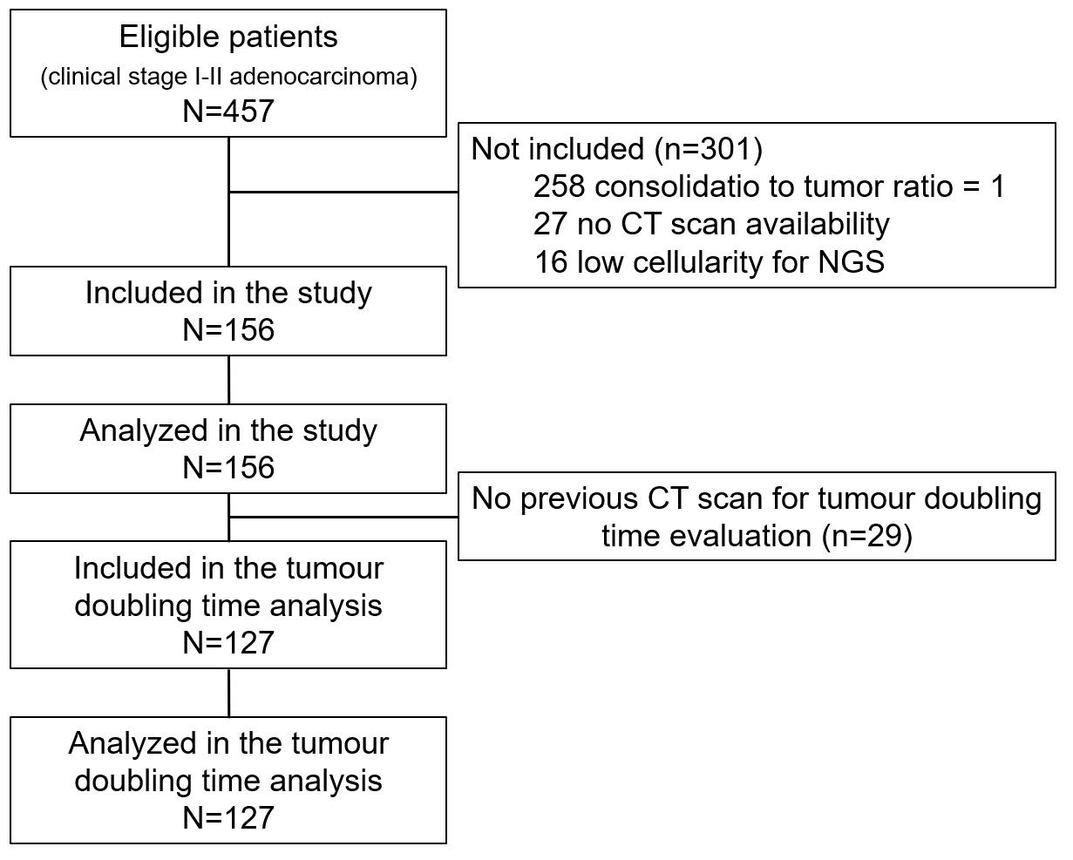
Supplementary figure 1. STROBE flow chart enlightening patients’ selection process.

