Supplementary Figures
Supplementary Figure 1
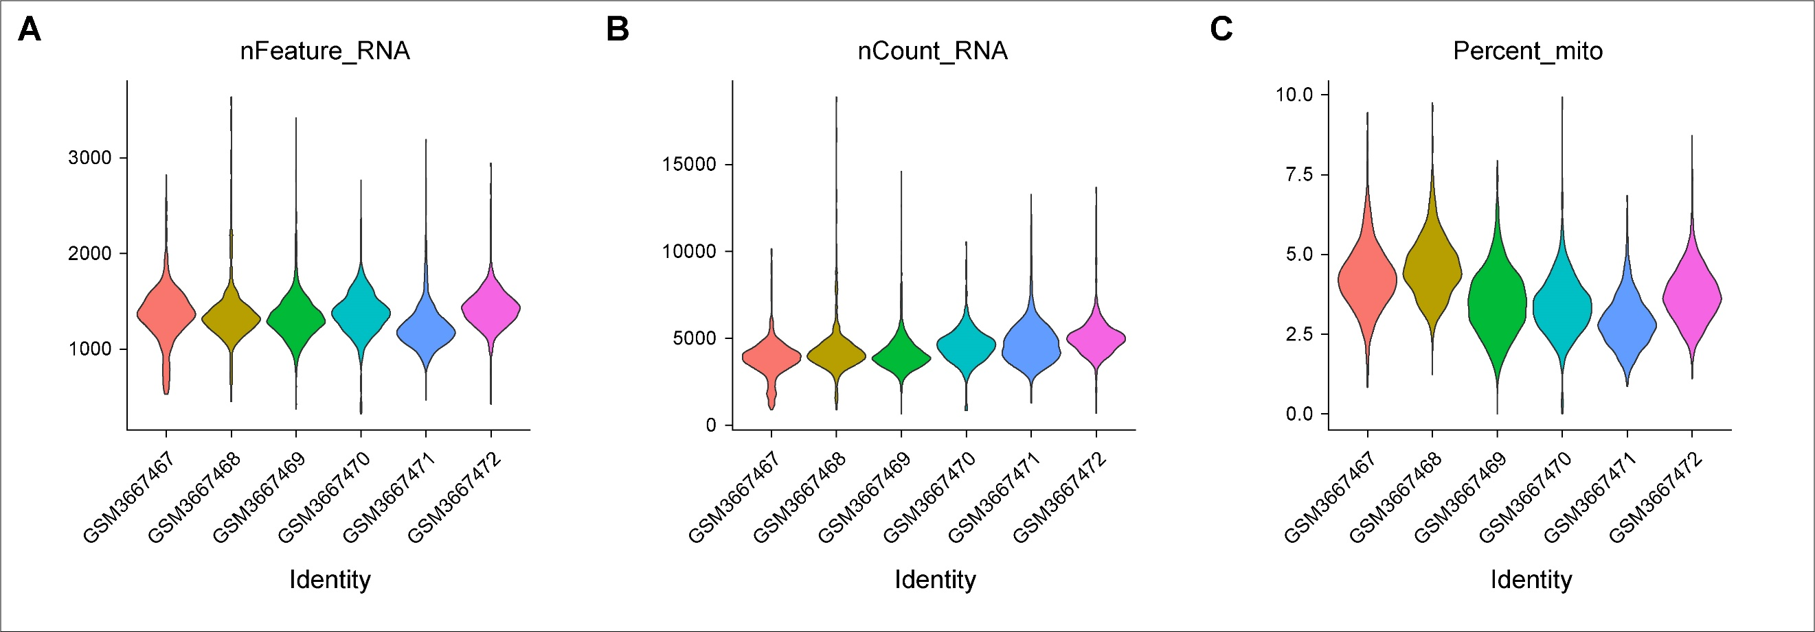
Figure S1 Violin plots show the post-filtering quality parameters for each sample in datasets GSE128223. A The gene numbers detected in each cell in distinct samples. B The unique molecular identifiers (UMIs) of each cell in distinct samples. C Proportion of mitochondrial gene expression per cell in different samples.
Supplementary Figure 2
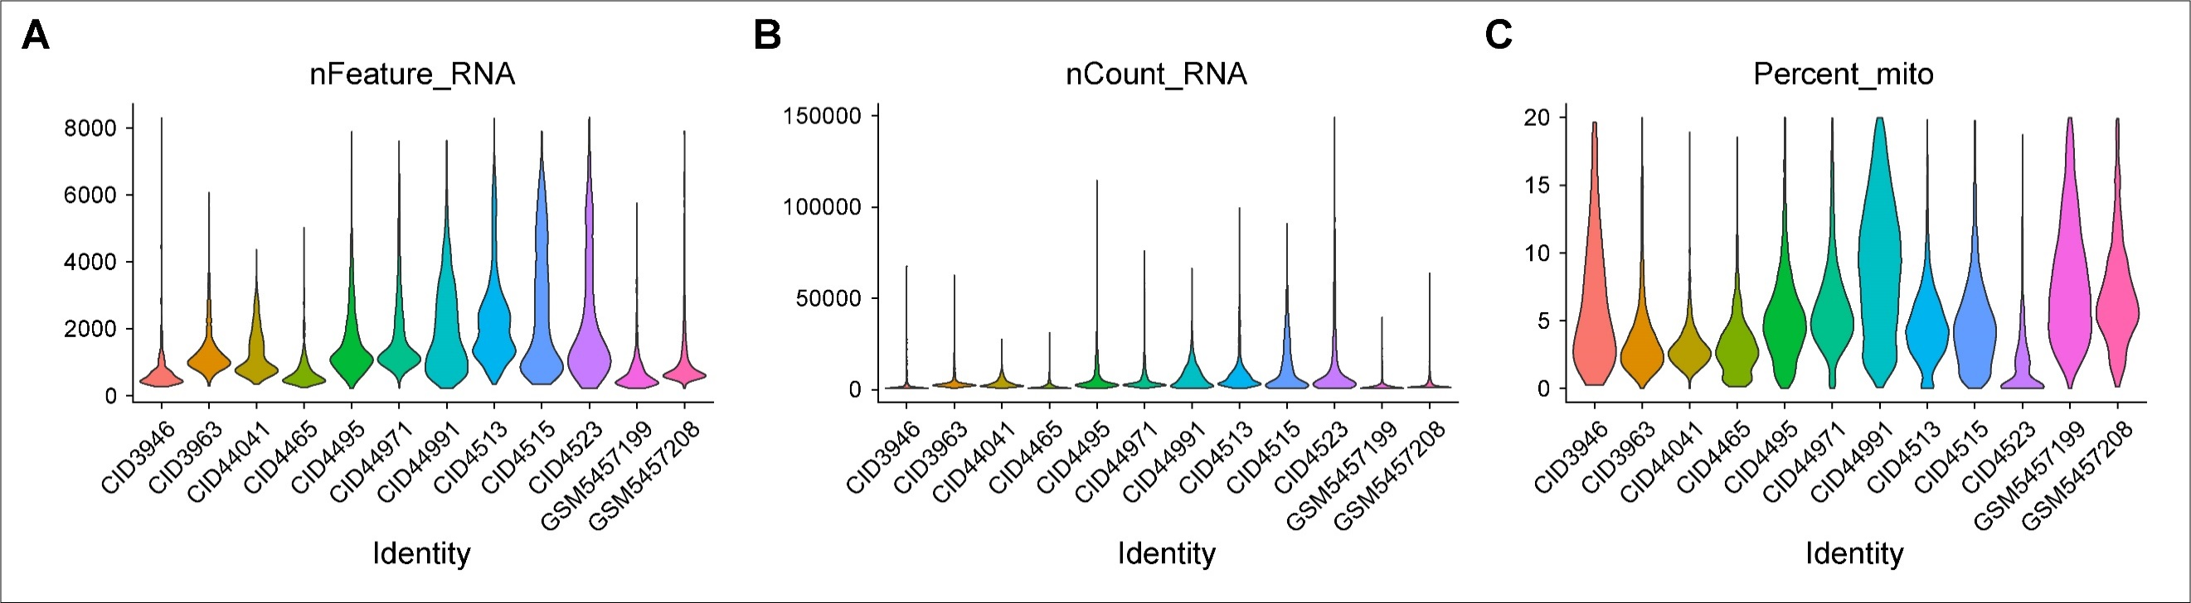
Figure S2 Violin plots show the post-filtering quality parameters for each sample in GSE180286 and GSE176078. A The gene numbers detected in each cell in distinct samples. B The unique molecular identifiers (UMIs) of each cell in distinct samples. C Proportion of mitochondrial gene expression per cell in different samples.

