Supplementary Materials (S1)

S1. Figure 1
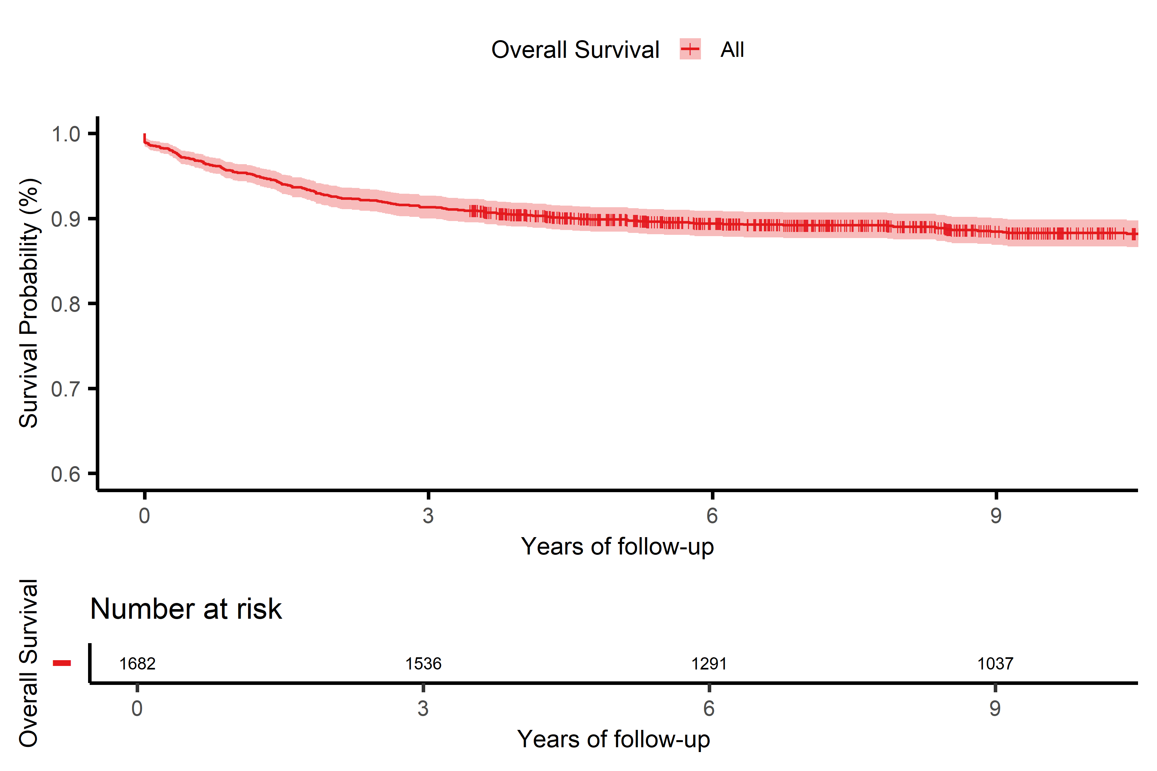
Figure 1. Survival curve for cervical cancer(CC) patients

S1. Table 1. Timetable of death for CC Patients
Time (years) | At Risk (n) | Events (n) | Survival Probability | Std. Error | 95% CI
0 | 1682 | 18 | 0.989 | 0.0025 | 0.984; 0.994
1 | 1604 | 60 | 0.954 | 0.0051 | 0.944; 0.964
2 | 1557 | 47 | 0.926 | 0.0064 | 0.913; 0.938
3 | 1536 | 21 | 0.913 | 0.0069 | 0.900; 0.927
4 | 1467 | 15 | 0.904 | 0.0072 | 0.890; 0.918
5 | 1377 | 9 | 0.899 | 0.0074 | 0.884; 0.913
6 | 1291 | 7 | 0.894 | 0.0076 | 0.879; 0.909
7 | 1202 | 3 | 0.892 | 0.0076 | 0.877; 0.907
8 | 1117 | 2 | 0.890 | 0.0077 | 0.875; 0.905
9 | 1037 | 7 | 0.884 | 0.0079 | 0.869; 0.900
10 | 973 | 2 | 0.883 | 0.0080 | 0.867; 0.899
11 | 907 | 2 | 0.881 | 0.0081 | 0.865; 0.897
12 | 851 | 2 | 0.879 | 0.0082 | 0.863; 0.895
13 | 752 | 2 | 0.877 | 0.0083 | 0.860; 0.893
14 | 691 | 0 | 0.877 | 0.0083 | 0.860; 0.893
15 | 632 | 2 | 0.874 | 0.0085 | 0.858; 0.891
16 | 550 | 0 | 0.874 | 0.0085 | 0.858; 0.891
17 | 442 | 1 | 0.872 | 0.0087 | 0.855; 0.889
18 | 338 | 0 | 0.872 | 0.0087 | 0.855; 0.889
19 | 235 | 0 | 0.872 | 0.0087 | 0.855; 0.889
20 | 119 | 0 | 0.872 | 0.0087 | 0.855; 0.889
21 | 26 | 0 | 0.872 | 0.0087 | 0.855; 0.889

S1. Figure 2
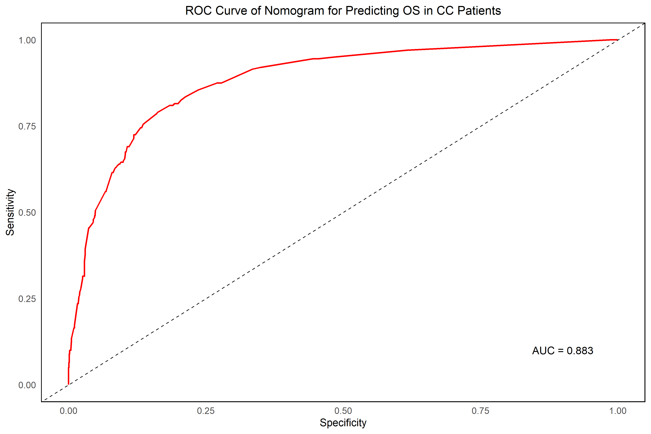
Figure 2. ROC Curve of the Nomogram for Predicting Overall Survival (OS) in CC Patients. The AUC is 0.881, indicating an excellent discriminative ability of the model to predict overall survival in cervical cancer patients.
S1. Table 2. Multicollinearity analysis of the variables in the Cox Model
Variables | GVIF | DF | GVIF^(1/(2*DF))
Age | 1.070593 | 3 | 1.011434
Skin color (Race) | 1.066783 | 2 | 1.016293
City of residence | 1.056695 | 4 | 1.006917
Histopathology type | 1.191537 | 3 | 1.029638
Stage | 1.207645 | 2 | 1.048298

S1. Figure 3: Correlation heat map between predictor variables
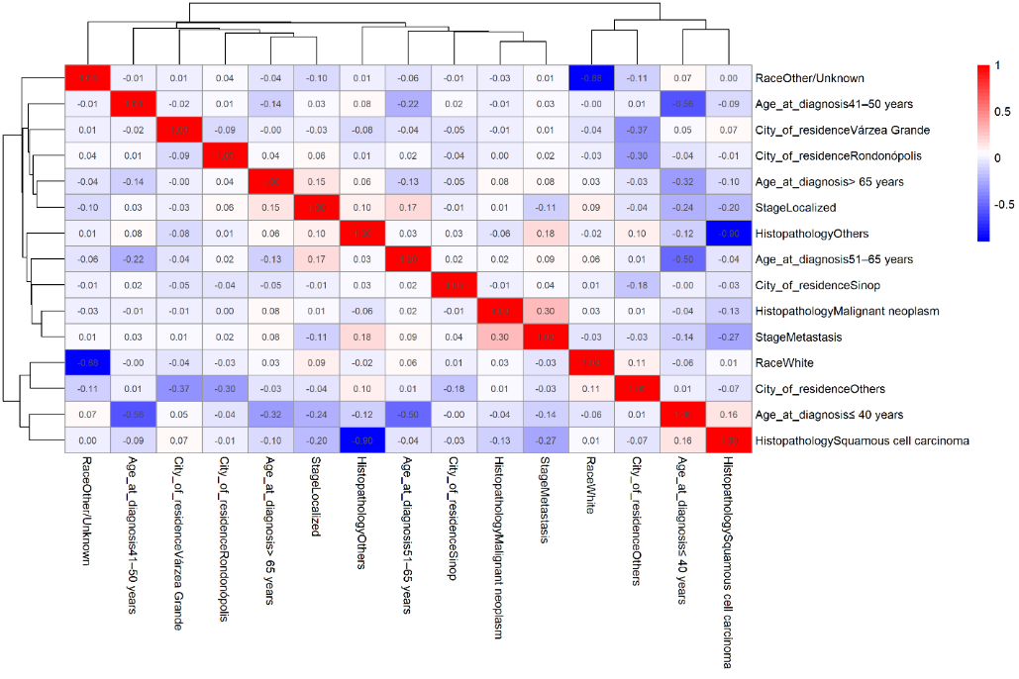
Figure 3: Heatmap of the correlation matrix among predictor variables included in the Cox regression analysis.
S1. Figure 4: Schoenfeld Residuals Analysis
