Supplementary table 1 Basic characteristics at treatment initiation – full data
 | Total | DRd | E-IRd | L-IRd | KRd | p-value¹
 | N = 538 | N = 224 | N = 104 | N = 67 | N = 143 | p-value¹
Sex |  |  |  |  |  | 0.836
Man | 297 (55.2%) | 125 (55.8%) | 60 (57.7%) | 34 (50.7%) | 78 (54.5%)
Woman | 241 (44.8%) | 99 (44.2%) | 44 (42.3%) | 33 (49.3%) | 65 (45.5%)
Age [years] |  |  |  |  |  | <0.001
<65 | 246 (45.7%) | 108 (48.2%) | 39 (37.5%) | 21 (31.3%) | 78 (54.5%)
65–75 | 252 (46.8%) | 99 (44.2%) | 59 (56.7%) | 34 (50.7%) | 60 (42.0%)
>75 | 40 (7.4%) | 17 (7.6%) | 6 (5.8%) | 12 (17.9%) | 5 (3.5%)
Age |  |  |  |  |  | <0.001
N | 538 | 224 | 104 | 67 | 143
Mean (SD) | 64.4 (9.5) | 63.7 (9.9) | 65.1 (9.3) | 68.7 (8.4) | 63.1 (8.8)
Median (5%–95%) | 65.9  (45.3–77.9) | 65.5  (45.0–77.8) | 67.2  (45.9–76.3) | 69.9  (53.1–79.9) | 64.4  (46.6–75.4)
Performance status [ECOG] |  |  |  |  |  | 0.012
PS 0–1 | 463 (86.7%) | 196 (87.9%) | 86 (83.5%) | 51 (76.1%) | 130 (92.2%)
PS 2 | 62 (11.6%) | 25 (11.2%) | 16 (15.5%) | 12 (17.9%) | 9 (6.4%)
PS 3–4 | 9 (1.7%) | 2 (0.9%) | 1 (1.0%) | 4 (6.0%) | 2 (1.4%)
Unknown | 4 | 1 | 1 | 0 | 2
ISS stage |  |  |  |  |  | 0.034
Stage 1 | 208 (47.9%) | 89 (48.4%) | 35 (42.2%) | 18 (37.5%) | 66 (55.5%)
Stage 2 | 122 (28.1%) | 41 (22.3%) | 29 (34.9%) | 18 (37.5%) | 34 (28.6%)
Stage 3 | 104 (24.0%) | 54 (29.3%) | 19 (22.9%) | 12 (25.0%) | 19 (16.0%)
Unknown | 104 | 40 | 21 | 19 | 24
M–protein type |  |  |  |  |  | 0.407
IgG | 309 (57.6%) | 117 (52.2%) | 66 (63.5%) | 38 (57.6%) | 88 (62.0%)
IgA | 126 (23.5%) | 56 (25.0%) | 23 (22.1%) | 19 (28.8%) | 28 (19.7%)
IgD | 3 (0.6%) | 2 (0.9%) | – | – | 1 (0.7%)
IgM | 7 (1.3%) | 5 (2.2%) | 1 (1.0%) | 1 (1.5%) | –
Biclonal | 5 (0.9%) | 1 (0.4%) | 1 (1.0%) | 2 (3.0%) | 1 (0.7%)
Triclonal | 1 (0.2%) | – | – | – | 1 (0.7%)
LC only | 80 (14.9%) | 39 (17.4%) | 13 (12.5%) | 6 (9.1%) | 22 (15.5%)
Nonsecretory | 5 (0.9%) | 4 (1.8%) | – | – | 1 (0.7%)
Unknown | 2 | 0 | 0 | 1 | 1
Light chain type |  |  |  |  |  | 0.046
Kappa | 325 (61.4%) | 139 (63.8%) | 61 (58.7%) | 33 (50.0%) | 92 (65.2%)
Lambda | 197 (37.2%) | 79 (36.2%) | 40 (38.5%) | 31 (47.0%) | 47 (33.3%)
Biclonal | 7 (1.3%) | – | 3 (2.9%) | 2 (3.0%) | 2 (1.4%)
Unknown | 9 | 6 | 0 | 1 | 2
Extraosseous disease |  |  |  |  |  | 0.324
No | 155 (63.5%) | 79 (67.5%) | 26 (65.0%) | 13 (68.4%) | 37 (54.4%)
Yes | 89 (36.5%) | 38 (32.5%) | 14 (35.0%) | 6 (31.6%) | 31 (45.6%)
Unknown | 294 | 107 | 64 | 48 | 75
¹ Pearson’s Chi-squared test; Kruskal-Wallis rank sum test; Fisher’s exact test

Supplementary table 2 Disease status
 | Total | DRd | e-IRd | l-IRd | KRd | p-value¹
 | N = 538 | N = 224 | N = 104 | N = 67 | N = 143 | p-value¹
Disease status |  |  |  |  |  | –
Total | 423 | 176 | 81 | 53 | 113
Relapsed | 321 (75.9%) | 129 (73.3%) | 66 (81.5%) | 30 (56.6%) | 96 (85.0%)
Primary refractory | 44 (10.4%) | 22 (12.5%) | 7 (8.6%) | 6 (11.3%) | 9 (8.0%)
Relapsed and refractory | 44 (10.4%) | 19 (10.8%) | 5 (6.2%) | 13 (24.5%) | 7 (6.2%)
Unknown | 115 | 48 | 23 | 14 | 30
Proteasome inhibitors (PI) - refractory |  |  |  |  |  | 0.088
No | 456 (84.8%) | 188 (83.9%) | 89 (85.6%) | 51 (76.1%) | 128 (89.5%)
Yes | 82 (15.2%) | 36 (16.1%) | 15 (14.4%) | 16 (23.9%) | 15 (10.5%)
Bortezomib - refractory |  |  |  |  |  | 0.359
No | 463 (86.1%) | 191 (85.3%) | 90 (86.5%) | 54 (80.6%) | 128 (89.5%)
Yes | 75 (13.9%) | 33 (14.7%) | 14 (13.5%) | 13 (19.4%) | 15 (10.5%)
Carfilzomib - refractory |  |  |  |  |  | 0.197
No | 530  (98.5%) | 220  (98.2%) | 102  (98.1%) | 65  (97.0%) | 143 (100.0%)
Yes | 8 (1.5%) | 4 (1.8%) | 2 (1.9%) | 2 (3.0%) | –
Ixazomib - refractory |  |  |  |  |  | 0.444
No | 536  (99.6%) | 223  (99.6%) | 104  (100.0%) | 66  (98.5%) | 143 (100.0%)
Yes | 2 (0.4%) | 1 (0.4%) | 0 (0.0%) | 1 (1.5%) | –
Immunomodulatory drugs (IMiD) - refractory |  |  |  |  |  | 0.010
No | 486 (90.3%) | 205 (91.5%) | 97 (93.3%) | 53 (79.1%) | 131 (91.6%)
Yes | 52 (9.7%) | 19 (8.5%) | 7 (6.7%) | 14 (20.9%) | 12 (8.4%)
Lenalidomide - refractory |  |  |  |  |  | 0.010
No | 512 (95.2%) | 216 (96.4%) | 102 (98.1%) | 58 (86.6%) | 136 (95.1%)
Yes | 26 (4.8%) | 8 (3.6%) | 2 (1.9%) | 9 (13.4%) | 7 (4.9%)
Pomalidomide - refractory |  |  |  |  |  | 0.161
No | 529 (98.3%) | 220 (98.2%) | 104 (100.0%) | 64 (95.5%) | 141 (98.6%)
Yes | 9 (1.7%) | 4 (1.8%) | – | 3 (4.5%) | 2 (1.4%)
Thalidomide-– refractory |  |  |  |  |  | 0.351
No | 513 (95.4%) | 215 (96.0%) | 99 (95.2%) | 61 (91.0%) | 138 (96.5%)
Yes | 25 (4.6%) | 9 (4.0%) | 5 (4.8%) | 6 (9.0%) | 5 (3.5%)
PI + IMiD - refractory |  |  |  |  |  | 0.032
No | 437 (81.2%) | 182 (81.2%) | 88 (84.6%) | 46 (68.7%) | 121 (84.6%)
Yes | 101 (18.8%) | 42 (18.8%) | 16 (15.4%) | 21 (31.3%) | 22 (15.4%)

Supplementary table 3 Characteristics of therapy
 | Total | DRd | e-IRd | l-IRd | KRd | p-value¹
 | N = 538 | N = 224 | N = 104 | N = 67 | N = 143 | p-value¹
Line of treatment |  |  |  |  |  | <0.001
2nd line | 356 (66.2%) | 164 (73.2%) | 65 (62.5%) | 26 (38.8%) | 101 (70.6%)
3rd line | 113 (21.0%) | 34 (15.2%) | 27 (26.0%) | 29 (43.3%) | 23 (16.1%)
4th line | 69 (12.8%) | 26 (11.6%) | 12 (11.5%) | 12 (17.9%) | 19 (13.3%)
Number of previous lines [n] |  |  |  |  |  | <0.001
1 | 356 (66.2%) | 164 (73.2%) | 65 (62.5%) | 26 (38.8%) | 101 (70.6%)
2 | 113 (21.0%) | 34 (15.2%) | 27 (26.0%) | 29 (43.3%) | 23 (16.1%)
3 | 69 (12.8%) | 26 (11.6%) | 12 (11.5%) | 12 (17.9%) | 19 (13.3%)
Number of previous lines |  |  |  |  |  | <0.001
N | 538 | 224 | 104 | 67 | 143
Mean (SD) | 1.5 (0.7) | 1.4 (0.7) | 1.5 (0.7) | 1.8 (0.7) | 1.4 (0.7)
Median (5%–95%) | 1.0 (1.0–3.0) | 1.0 (1.0–3.0) | 1.0 (1.0–3.0) | 2.0 (1.0–3.0) | 1.0 (1.0–3.0)
Proteasome inhibitors (PI) |  |  |  |  |  | 0.875
No | 133 (24.7%) | 55 (24.6%) | 26 (25.0%) | 19 (28.4%) | 33 (23.1%)
Yes | 405 (75.3%) | 169 (75.4%) | 78 (75.0%) | 48 (71.6%) | 110 (76.9%)
Bortezomib |  |  |  |  |  | 0.697
No | 138 (25.7%) | 56 (25.0%) | 29 (27.9%) | 20 (29.9%) | 33 (23.1%)
Yes | 400 (74.3%) | 168 (75.0%) | 75 (72.1%) | 47 (70.1%) | 110 (76.9%)
Carfilzomib |  |  |  |  |  | 0.010
No | 522 (97.0%) | 217 (96.9%) | 100 (96.2%) | 62 (92.5%) | 143 (100.0%)
Yes | 16 (3.0%) | 7 (3.1%) | 4 (3.8%) | 5 (7.5%) | 0 (0.0%)
Ixazomib |  |  |  |  |  | 0.544
No | 535 (99.4%) | 223 (99.6%) | 104 (100.0%) | 66 (98.5%) | 142 (99.3%)
Yes | 3 (0.6%) | 1 (0.4%) | 0 (0.0%) | 1 (1.5%) | 1 (0.7%)
Immunomodulatory drugs (IMiD) |  |  |  |  |  | 0.069
No | 279 (51.9%) | 118 (52.7%) | 63 (60.6%) | 27 (40.3%) | 71 (49.7%)
Yes | 259 (48.1%) | 106 (47.3%) | 41 (39.4%) | 40 (59.7%) | 72 (50.3%)
Lenalidomide |  |  |  |  |  | <0.001
No | 481 (89.4%) | 205 (91.5%) | 97 (93.3%) | 48 (71.6%) | 131 (91.6%)
Yes | 57 (10.6%) | 19 (8.5%) | 7 (6.7%) | 19 (28.4%) | 12 (8.4%)
Pomalidomide |  |  |  |  |  | 0.161
No | 529 (98.3%) | 220 (98.2%) | 104 (100.0%) | 64 (95.5%) | 141 (98.6%)
Yes | 9 (1.7%) | 4 (1.8%) | 0 (0.0%) | 3 (4.5%) | 2 (1.4%)
Thalidomide |  |  |  |  |  | 0.708
No | 310 (57.6%) | 128 (57.1%) | 65 (62.5%) | 38 (56.7%) | 79 (55.2%)
Yes | 228 (42.4%) | 96 (42.9%) | 39 (37.5%) | 29 (43.3%) | 64 (44.8%)
PI + IMiD |  |  |  |  |  | 0.114
No | 294 (54.6%) | 124 (55.4%) | 66 (63.5%) | 31 (46.3%) | 73 (51.0%)
Yes | 244 (45.4%) | 100 (44.6%) | 38 (36.5%) | 36 (53.7%) | 70 (49.0%)
Transplantation |  |  |  |  |  | 0.013
No | 263 (48.9%) | 108 (48.2%) | 56 (53.8%) | 42 (62.7%) | 57 (39.9%)
Yes | 275 (51.1%) | 116 (51.8%) | 48 (46.2%) | 25 (37.3%) | 86 (60.1%)
Lenalidomide interruption |  |  |  |  |  | 0.128
No record on interruption | 475 (88.3%) | 191 (85.3%) | 90 (86.5%) | 62 (92.5%) | 132 (92.3%)
Yes | 63 (11.7%) | 33 (14.7%) | 14 (13.5%) | 5 (7.5%) | 11 (7.7%)
Bortezomib interruption |  |  |  |  |  | –
No record on interruption | 538 (100.0%) | 224 (100.0%) | 104  (100.0%) | 67  (100.0%) | 143  (100.0%)
Carfilzomib interruption |  |  |  |  |  | <0.001
No record on interruption | 511  (95.0%) | 224 (100.0%) | 104  (100.0%) | 67  (100.0%) | 116  (81.1%)
Yes | 27 (5.0%) | 0 (0.0%) | 0 (0.0%) | 0 (0.0%) | 27 (18.9%)
Ixazomib interruption |  |  |  |  |  | <0.001
No record on interruption | 512  (95.2%) | 224 (100.0%) | 84  (80.8%) | 61  (91.0%) | 143  (100.0%)
Yes | 26 (4.8%) | 0 (0.0%) | 20 (19.2%) | 6 (9.0%) | 0 (0.0%)
Daratumumab interruption |  |  |  |  |  | <0.001
No record on interruption | 524 (97.4%) | 210 (93.8%) | 104 (100.0%) | 67 (100.0%) | 143 (100.0%)
Yes | 14 (2.6%) | 14 (6.2%) | 0 (0.0%) | 0 (0.0%) | 0 (0.0%)
Whole regimen interruption |  |  |  |  |  | <0.001
No record on interruption | 254 (47.2%) | 114 (50.9%) | 44 (42.3%) | 37 (55.2%) | 59 (41.3%)
1 interruption | 122 (22.7%) | 51 (22.8%) | 27 (26.0%) | 22 (32.8%) | 22 (15.4%)
2 interruptions | 58 (10.8%) | 28 (12.5%) | 9 (8.7%) | 6 (9.0%) | 15 (10.5%)
3 interruptions | 29 (5.4%) | 10 (4.5%) | 5 (4.8%) | 1 (1.5%) | 13 (9.1%)
≥4 interruptions | 75 (13.9%) | 21 (9.4%) | 19 (18.3%) | 1 (1.5%) | 34 (23.8%)
Lenalidomide adjustment |  |  |  |  |  | 0.418
No (including not specified) | 231 (42.9%) | 93 (41.5%) | 42 (40.4%) | 35 (52.2%) | 61 (42.7%)
Yes | 307 (57.1%) | 131 (58.5%) | 62 (59.6%) | 32 (47.8%) | 82 (57.3%)
Carfilzomib adjustment |  |  |  |  |  | <0.001
No (including not specified) | 478  (88.8%) | 224 (100.0%) | 104  (100.0%) | 67  (100.0%) | 83  (58.0%)
Yes | 60 (11.2%) | 0 (0.0%) | 0 (0.0%) | 0 (0.0%) | 60 (42.0%)
Ixazomib adjustment |  |  |  |  |  | <0.001
No (including not specified) | 484  (90.0%) | 224 (100.0%) | 73  (70.2%) | 44  (65.7%) | 143  (100.0%)
Yes | 54 (10.0%) | 0 (0.0%) | 31 (29.8%) | 23 (34.3%) | 0 (0.0%)
Daratumumab adjustment |  |  |  |  |  | <0.001
No (including not specified) | 521 (96.8%) | 207 (92.4%) | 104 (100.0%) | 67 (100.0%) | 143 (100.0%)
Yes | 17 (3.2%) | 17 (7.6%) | 0 (0.0%) | 0 (0.0%) | 0 (0.0%)
Total cumulative dose of lenalidomide [mg] |  |  |  |  |  | <0.001
N | 460 | 175 | 99 | 59 | 127
Mean (SD) | 3 980.4  (3 656.7) | 3 290.4  (2 588.9) | 5 623.4  (5 213.6) | 2 391.8  (1 655.9) | 4 388.5  (3 594.2)
Median (5%–95%) | 2 835.0  (595.0–  11 059.2) | 2 625.0  (472.0–  8 746.5) | 3 675.0 (1 260.0–  17 385.0) | 1 995.0  (588.0–  5 260.5) | 3 475.0  (704.5–  12 133.5)
Unknown | 78 | 49 | 5 | 8 | 16
Total cumulative dose of carfilzomib [mg] |  |  |  |  |  | –
N | 134 | 0 | 0 | 0 | 134
Mean (SD) | 2 440.6  (1 528.1) | – | – | – | 2 440.6  (1 528.1)
Median (5%–95%) | 2 240.5  (523.7–  5 066.2) | – | – | – | 2 240.5  (523.7–  5 066.2)
Unknown | 404 | 224 | 104 | 67 | 9
Total cumulative dose of ixazomib [mg]; |  |  |  |  |  | –
N | 159 | 0 | 99 | 60 | 0
Mean (SD) | 121.5 (117.3) | – | 143.9  (139.0) | 84.6  (50.2) | –
Median (5%–95%) | 87.0  (20.9–412.8) | – | 96.0  (24.0–446.6) | 84.0  (18.0–184.4) | –
Unknown | 379 | 224 | 5 | 7 | 143
Total cumulative dose of daratumumab [mg] |  |  |  |  |  | –
N | 174 | 174 | 0 | 0 | 0
Mean (SD) | 26 174.4  (13 781.2) | 26 174.4  (13 781.2) | – | – | –
Median (5%–95%) | 25 500.0  (7 702.5–  47 537.2) | 25 500.0  (7 702.5–  47 537.2) | – | – | –
Unknown | 364 | 50 | 104 | 67 | 143
¹ Pearson’s Chi-squared test; Fisher’s exact test; Kruskal-Wallis rank sum test

Supplementary table 4 Cytogenetic aberrations.
Cytogenetics² | Total | DRd | E-IRd | L-IRd | KRd | p-value¹
Cytogenetics² | N = 538 | N = 224 | N = 104 | N = 67 | N = 143 | p-value¹
IGH disruption |  |  |  |  |  | 0.990
Negative | 64 (16.6%) | 27 (16.8%) | 13 (16.5%) | 8 (15.1%) | 16 (17.2%)
Positive | 322 (83.4%) | 134 (83.2%) | 66 (83.5%) | 45 (84.9%) | 77 (82.8%)
Unknown | 152 | 63 | 25 | 14 | 50
t(11;14) |  |  |  |  |  | 0.952
Negative | 259 (80.7%) | 114 (82.0%) | 53 (79.1%) | 30 (78.9%) | 62 (80.5%)
Positive | 62 (19.3%) | 25 (18.0%) | 14 (20.9%) | 8 (21.1%) | 15 (19.5%)
Unknown | 217 | 85 | 37 | 29 | 66
t(4;14) |  |  |  |  |  | 0.002
Negative | 295 (85.3%) | 131 (89.1%) | 64 (94.1%) | 35 (72.9%) | 65 (78.3%)
Positive | 51 (14.7%) | 16 (10.9%) | 4 (5.9%) | 13 (27.1%) | 18 (21.7%)
Unknown | 192 | 77 | 36 | 19 | 60
t(6;14)
Negative | 256 (100.0%) | 113 (100.0%) | 52 (100.0%) | 30 (100.0%) | 61 (100.0%) | –
Positive | – | – | – | – | –
Unknown | 282 | 111 | 52 | 37 | 82
t(14;16) |  |  |  |  |  | 0.133
Negative | 309 (97.2%) | 139 (98.6%) | 59 (93.7%) | 40 (95.2%) | 71 (98.6%)
Positive | 9 (2.8%) | 2 (1.4%) | 4 (6.3%) | 2 (4.8%) | 1 (1.4%)
Unknown | 220 | 83 | 41 | 25 | 71
del(13)(q14)/monosomy 13 |  |  |  |  |  | 0.080
Negative | 179 (46.9%) | 77 (47.8%) | 45 (57.0%) | 24 (45.3%) | 33 (37.1%)
Positive | 203 (53.1%) | 84 (52.2%) | 34 (43.0%) | 29 (54.7%) | 56 (62.9%)
Unknown | 156 | 63 | 25 | 14 | 54
gain(1q21) |  |  |  |  |  | 0.170
Negative | 174 (46.4%) | 78 (49.1%) | 38 (50.7%) | 25 (50.0%) | 33 (36.3%)
Positive | 201 (53.6%) | 81 (50.9%) | 37 (49.3%) | 25 (50.0%) | 58 (63.7%)
Unknown | 163 | 65 | 29 | 17 | 52
del(17p13) |  |  |  |  |  | 0.109
Negative | 316 (83.4%) | 143 (88.3%) | 62 (82.7%) | 40 (75.5%) | 71 (79.8%)
Positive | 63 (16.6%) | 19 (11.7%) | 13 (17.3%) | 13 (24.5%) | 18 (20.2%)
Unknown | 159 | 62 | 29 | 14 | 54
Hyperdiploidy |  |  |  |  |  | 0.126
Negative | 147 (53.1%) | 52 (50.0%) | 36 (45.6%) | 20 (62.5%) | 39 (62.9%)
Positive | 130 (46.9%) | 52 (50.0%) | 43 (54.4%) | 12 (37.5%) | 23 (37.1%)
Unknown | 261 | 120 | 25 | 35 | 81
Cytogenetics – risk groups³ |  |  |  |  |  | 0.001
Negative | 215 (65.5%) | 107 (75.4%) | 42 (67.7%) | 23 (46.9%) | 43 (57.3%)
Positive | 113 (34.5%) | 35 (24.6%) | 20 (32.3%) | 26 (53.1%) | 32 (42.7%)
Unknown | 210 | 82 | 42 | 18 | 68
Combination of aberrations⁴ |  |  |  |  |  | 0.298
0 aberrations | 21 (5.3%) | 10 (6.1%) | 4 (4.7%) | 3 (5.5%) | 4 (4.3%)
1 aberration | 66 (16.5%) | 31 (18.8%) | 13 (15.3%) | 6 (10.9%) | 16 (17.0%)
2 aberrations | 96 (24.1%) | 41 (24.8%) | 25 (29.4%) | 15 (27.3%) | 15 (16.0%)
3 aberrations | 104 (26.1%) | 42 (25.5%) | 25 (29.4%) | 13 (23.6%) | 24 (25.5%)
4 aberrations | 92 (23.1%) | 33 (20.0%) | 14 (16.5%) | 18 (32.7%) | 27 (28.7%)
5 aberrations | 17 (4.3%) | 6 (3.6%) | 3 (3.5%) | – | 8 (8.5%)
6 aberrations | 3 (0.8%) | 2 (1.2%) | 1 (1.2%) | – | –
Unknown | 139 | 59 | 19 | 12 | 49
¹ Pearson’s Chi-squared test; Fisher’s exact test
² Cytogenetics aberration evaluated as positive = if the aberration is positive at MM diagnosis or at initiation of any line of therapy, and as negative = if no evaluation was positive and at least one was negative
³ At least 1 aberration t(4;14), t(14;16), del(17p13) positive = high risk; all three aberration negative = standard
risk
⁴ The number of aberrations per patient does not have to be final, as the patient does not have to have evaluated some aberrations

Supplementary table 5 Toxicities
 | Total | DRd | e-IRd | l-IRd | KRd | p-value¹
 | N = 538 | N = 224 | N = 104 | N = 67 | N = 143 | p-value¹
Thrombocytopenia before treatment - grade |  |  |  |  |  | 0.041
0 | 288 (76.4%) | 115 (77.2%) | 55 (69.6%) | 35 (71.4%) | 83 (83.0%)
1 | 80 (21.2%) | 29 (19.5%) | 23 (29.1%) | 11 (22.4%) | 17 (17.0%)
2 | 3 (0.8%) | 1 (0.7%) | 1 (1.3%) | 1 (2.0%) | –
3 | 2 (0.5%) | – | – | 2 (4.1%) | –
4 | 4 (1.1%) | 4 (2.7%) | – | – | –
Unknown | 161 | 75 | 25 | 18 | 43
Neuropathy before treatment - grade |  |  |  |  |  | –
0 | 254 (67.4%) | 102 (68.9%) | 39 (49.4%) | 34 (68.0%) | 79 (79.0%)
1 | 85 (22.5%) | 26 (17.6%) | 28 (35.4%) | 13 (26.0%) | 18 (18.0%)
2 | 34 (9.0%) | 18 (12.2%) | 10 (12.7%) | 3 (6.0%) | 3 (3.0%)
3 | 4 (1.1%) | 2 (1.4%) | 2 (2.5%) | – | –
Unknown | 161 | 76 | 25 | 17 | 43
Neuropathy - grade |  |  |  |  |  | –
0 | 208 (61.2%) | 71 (60.2%) | 35 (45.5%) | 32 (69.6%) | 70 (70.7%)
1 | 85 (25.0%) | 28 (23.7%) | 26 (33.8%) | 10 (21.7%) | 21 (21.2%)
2 | 43 (12.6%) | 18 (15.3%) | 13 (16.9%) | 4 (8.7%) | 8 (8.1%)
3 | 4 (1.2%) | 1 (0.8%) | 3 (3.9%) | – | –
Unknown | 198 | 106 | 27 | 21 | 44
Nausea, vomiting - grade |  |  |  |  |  | –
0 | 242 (72.5%) | 90 (78.3%) | 50 (68.5%) | 33 (71.7%) | 69 (69.0%)
1 | 59 (17.7%) | 18 (15.7%) | 12 (16.4%) | 8 (17.4%) | 21 (21.0%)
2 | 32 (9.6%) | 7 (6.1%) | 11 (15.1%) | 4 (8.7%) | 10 (10.0%)
3 | 1 (0.3%) | – | – | 1 (2.2%) | –
Unknown | 204 | 109 | 31 | 21 | 43
Anorexia - grade |  |  |  |  |  | –
0 | 267 (80.2%) | 94 (81.0%) | 57 (79.2%) | 37 (80.4%) | 79 (79.8%)
1 | 49 (14.7%) | 17 (14.7%) | 13 (18.1%) | 7 (15.2%) | 12 (12.1%)
2 | 15 (4.5%) | 4 (3.4%) | 2 (2.8%) | 1 (2.2%) | 8 (8.1%)
3 | 2 (0.6%) | 1 (0.9%) | – | 1 (2.2%) | –
Unknown | 205 | 108 | 32 | 21 | 44
Diarrhoea -grade |  |  |  |  |  | –
0 | 227 (66.4%) | 80 (63.5%) | 47 (64.4%) | 33 (73.3%) | 67 (68.4%)
1 | 50 (14.6%) | 15 (11.9%) | 13 (17.8%) | 5 (11.1%) | 17 (17.3%)
2 | 56 (16.4%) | 27 (21.4%) | 12 (16.4%) | 5 (11.1%) | 12 (12.2%)
3 | 8 (2.3%) | 4 (3.2%) | 1 (1.4%) | 1 (2.2%) | 2 (2.0%)
4 | 1 (0.3%) | – | – | 1 (2.2%) | –
Unknown | 196 | 98 | 31 | 22 | 45
Constipation - grade |  |  |  |  |  | 0.629
0 | 285 (87.2%) | 97 (85.1%) | 62 (88.6%) | 39 (86.7%) | 87 (88.8%)
1 | 23 (7.0%) | 12 (10.5%) | 4 (5.7%) | 3 (6.7%) | 4 (4.1%)
2 | 17 (5.2%) | 5 (4.4%) | 4 (5.7%) | 2 (4.4%) | 6 (6.1%)
3 | 2 (0.6%) | – | – | 1 (2.2%) | 1 (1.0%)
Unknown | 211 | 110 | 34 | 22 | 45
Fatigue - grade |  |  |  |  |  | –
0 | 140 (39.5%) | 52 (41.3%) | 25 (32.5%) | 20 (41.7%) | 43 (41.7%)
1 | 100 (28.2%) | 38 (30.2%) | 19 (24.7%) | 13 (27.1%) | 30 (29.1%)
2 | 102 (28.8%) | 32 (25.4%) | 28 (36.4%) | 15 (31.2%) | 27 (26.2%)
3 | 12 (3.4%) | 4 (3.2%) | 5 (6.5%) | – | 3 (2.9%)
Unknown | 184 | 98 | 27 | 19 | 40
Thrombosis/Thrombus/Embolism - grade |  |  |  |  |  | 0.027
0 | 298 (92.0%) | 106 (93.8%) | 63 (91.3%) | 44 (97.8%) | 85 (87.6%)
1 | 3 (0.9%) | – | 3 (4.3%) | – | –
2 | 10 (3.1%) | 2 (1.8%) | – | 1 (2.2%) | 7 (7.2%)
3 | 13 (4.0%) | 5 (4.4%) | 3 (4.3%) | – | 5 (5.2%)
Unknown | 214 | 111 | 35 | 22 | 46
Infection - grade |  |  |  |  |  | –
0 | 96 (26.7%) | 34 (25.2%) | 22 (28.9%) | 18 (39.1%) | 22 (21.6%)
1 | 37 (10.3%) | 12 (8.9%) | 10 (13.2%) | 3 (6.5%) | 12 (11.8%)
2 | 164 (45.7%) | 65 (48.1%) | 30 (39.5%) | 15 (32.6%) | 54 (52.9%)
3 | 49 (13.6%) | 17 (12.6%) | 14 (18.4%) | 6 (13.0%) | 12 (11.8%)
4 | 7 (1.9%) | 4 (3.0%) | – | 2 (4.3%) | 1 (1.0%)
5 | 6 (1.7%) | 3 (2.2%) | – | 2 (4.3%) | 1 (1.0%)
Unknown | 179 | 89 | 28 | 21 | 41
Thrombocytopenia - grade |  |  |  |  |  | 0.239
0 | 90 (26.9%) | 36 (31.9%) | 23 (29.9%) | 10 (21.7%) | 21 (21.4%)
1 | 129 (38.6%) | 43 (38.1%) | 25 (32.5%) | 16 (34.8%) | 45 (45.9%)
2 | 54 (16.2%) | 21 (18.6%) | 11 (14.3%) | 7 (15.2%) | 15 (15.3%)
3 | 43 (12.9%) | 8 (7.1%) | 11 (14.3%) | 10 (21.7%) | 14 (14.3%)
4 | 18 (5.4%) | 5 (4.4%) | 7 (9.1%) | 3 (6.5%) | 3 (3.1%)
Unknown | 204 | 111 | 27 | 21 | 45
Neutropenia - grade |  |  |  |  |  | <0.001
0 | 65 (19.2%) | 18 (15.3%) | 16 (21.1%) | 15 (31.9%) | 16 (16.5%)
1 | 81 (24.0%) | 16 (13.6%) | 24 (31.6%) | 14 (29.8%) | 27 (27.8%)
2 | 78 (23.1%) | 24 (20.3%) | 18 (23.7%) | 10 (21.3%) | 26 (26.8%)
3 | 89 (26.3%) | 44 (37.3%) | 14 (18.4%) | 7 (14.9%) | 24 (24.7%)
4 | 25 (7.4%) | 16 (13.6%) | 4 (5.3%) | 1 (2.1%) | 4 (4.1%)
Unknown | 200 | 106 | 28 | 20 | 46
Anemia - grade |  |  |  |  |  | –
0 | 47 (14.0%) | 20 (17.4%) | 8 (10.4%) | 10 (22.2%) | 9 (9.2%)
1 | 144 (43.0%) | 44 (38.3%) | 39 (50.6%) | 16 (35.6%) | 45 (45.9%)
2 | 101 (30.1%) | 35 (30.4%) | 19 (24.7%) | 17 (37.8%) | 30 (30.6%)
3 | 34 (10.1%) | 13 (11.3%) | 8 (10.4%) | 2 (4.4%) | 11 (11.2%)
4 | 9 (2.7%) | 3 (2.6%) | 3 (3.9%) | – | 3 (3.1%)
Unknown | 203 | 109 | 27 | 22 | 45
Rash (exanthema) - grade |  |  |  |  |  | –
0 | 248 (82.9%) | 89 (79.5%) | 38 (80.9%) | 37 (84.1%) | 84 (87.5%)
1 | 21 (7.0%) | 11 (9.8%) | 2 (4.3%) | 3 (6.8%) | 5 (5.2%)
2 | 26 (8.7%) | 11 (9.8%) | 5 (10.6%) | 3 (6.8%) | 7 (7.3%)
3 | 4 (1.3%) | 1 (0.9%) | 2 (4.3%) | 1 (2.3%) | –
Unknown | 239 | 112 | 57 | 23 | 47
IRR (infusion related reaction) - grade |  |  |  |  |  | –
0 | 224 (86.2%) | 82 (72.6%) | 18 (100.0%) | 39 (100.0%) | 85 (94.4%)
1 | 14 (5.4%) | 9 (8.0%) | – | – | 5 (5.6%)
2 | 20 (7.7%) | 20 (17.7%) | – | – | –
3 | 2 (0.8%) | 2 (1.8%) | – | – | –
Unknown | 278 | 111 | 86 | 28 | 53
Dyspnoe - grade |  |  |  |  |  | 0.299
0 | 102 (72.9%) | 52 (74.3%) | 12 (92.3%) | 12 (80.0%) | 26 (61.9%)
1 | 22 (15.7%) | 9 (12.9%) | 1 (7.7%) | 3 (20.0%) | 9 (21.4%)
2 | 16 (11.4%) | 9 (12.9%) | – | – | 7 (16.7%)
Unknown | 398 | 154 | 91 | 52 | 101
Decompensated diabetes mellitus - grade |  |  |  |  |  | 0.339
0 | 129 (94.2%) | 63 (90.0%) | 13 (100.0%) | 14 (93.3%) | 39 (100.0%)
1 | 5 (3.6%) | 5 (7.1%) | – | – | –
2 | 3 (2.2%) | 2 (2.9%) | – | 1 (6.7%) | –
Unknown | 401 | 154 | 91 | 52 | 104
Hepatotoxicity - grade |  |  |  |  |  | 0.810
0 | 130 (92.9%) | 66 (89.2%) | 13 (100.0%) | 15 (100.0%) | 36 (94.7%)
1 | 8 (5.7%) | 6 (8.1%) | – | – | 2 (5.3%)
2 | 2 (1.4%) | 2 (2.7%) | – | – | –
Unknown | 398 | 150 | 91 | 52 | 105
¹ Fisher’s exact test

Supplementary table 6a Treatment withdrawal and length of therapy.
 | Total | DRd | e-IRd | l-IRd | KRd | p-value¹
 | N = 538 | N = 224 | N = 104 | N = 67 | N = 143 | p-value¹
Treatment withdrawal, n (%) |  |  |  |  |  | <0.001
Ongoing | 160 (29.7%) | 109 (48.7%) | 10 (9.6%) | 14 (20.9%) | 27 (18.9%)
Terminated | 378 (70.3%) | 115 (51.3%) | 94 (90.4%) | 53 (79.1%) | 116 (81.1%)
Length of therapy [months] – evaluated for all treatments, n (%) |  |  |  |  |  | 0.002
≤ 3 | 42 (7.8%) | 17 (7.6%) | 4 (3.8%) | 8 (11.9%) | 13 (9.1%)
(3–6] | 76 (14.1%) | 24 (10.7%) | 19 (18.3%) | 9 (13.4%) | 24 (16.8%)
(6–9] | 70 (13.0%) | 21 (9.4%) | 16 (15.4%) | 14 (20.9%) | 19 (13.3%)
(9–12] | 77 (14.3%) | 39 (17.4%) | 14 (13.5%) | 13 (19.4%) | 11 (7.7%)
(12–15] | 60 (11.2%) | 31 (13.8%) | 8 (7.7%) | 8 (11.9%) | 13 (9.1%)
(15–18] | 53 (9.9%) | 28 (12.5%) | 6 (5.8%) | 6 (9.0%) | 13 (9.1%)
(18–21] | 41 (7.6%) | 21 (9.4%) | 5 (4.8%) | 2 (3.0%) | 13 (9.1%)
(21–24] | 30 (5.6%) | 15 (6.7%) | 5 (4.8%) | 4 (6.0%) | 6 (4.2%)
> 24 | 89 (16.5%) | 28 (12.5%) | 27 (26.0%) | 3 (4.5%) | 31 (21.7%)
Length of therapy – evaluated for all treatments |  |  |  |  |  | 0.014
N | 538 | 224 | 104 | 67 | 143
Mean (SD) | 14.6 (10.7) | 13.9 (7.6) | 18.1 (15.7) | 10.6 (7.0) | 15.2 (11.2)
Median (5%-95%) | 12.2  (2.4-35.1) | 13.4  (2.6-26.4) | 11.7  (3.4-51.4) | 9.3  (1.3-23.3) | 12.4  (2.1-36.7)
¹ Pearson’s Chi-squared test; Kruskal-Wallis rank sum test

Supplementary table 6b Treatment withdrawal and length of therapy for terminated treatments.
 | Total | DRd | e-IRd | l-IRd | KRd | p-value¹
 | N = 378 | N = 115 | N = 94 | N = 53 | N = 116 | p-value¹
Reason for tr. withdrawal, n (%) |  |  |  |  |  | –
Treatment response | 36 (9.7%) | 8 (7.0%) | 17 (18.5%) | 1 (1.9%) | 10 (8.8%)
Trt. response + PBSCT (transplantation) | 12 (3.2%) | 3 (2.6%) | 3 (3.3%) | 1 (1.9%) | 5 (4.4%)
Progression | 199 (53.5%) | 64  (55.7%) | 45  (48.9%) | 30  (57.7%) | 60 (53.1%)
Exitus | 47 (12.6%) | 23 (20.0%) | 6 (6.5%) | 11 (21.2%) | 7 (6.2%)
According treatment protocol | 10 (2.7%) | – | 1 (1.1%) | – | 9 (8.0%)
Insufficient response | 12 (3.2%) | 4 (3.5%) | 6 (6.5%) | – | 2 (1.8%)
Toxicity | 25 (6.7%) | 8 (7.0%) | 4 (4.3%) | 6 (11.5%) | 7 (6.2%)
Other | 31  (8.3%) | 5  (4.3%) | 10  (10.9%) | 3  (5.8%) | 13 (11.5%)
Unknown | 6 | 0 | 2 | 1 | 3
Length of therapy [months] – evaluated for terminated treatments, n (%) |  |  |  |  |  | –
≤ 3 | 41  (11.0%) | 17  (14.9%) | 4  (4.3%) | 7  (13.5%) | 13 (11.2%)
(3–6] | 75  (20.1%) | 23  (20.2%) | 19  (20.7%) | 9  (17.3%) | 24 (20.7%)
(6–9] | 66  (17.6%) | 18  (15.8%) | 16  (17.4%) | 13  (25.0%) | 19 (16.4%)
(9–12] | 60 (16.0%) | 25 (21.9%) | 14 (15.2%) | 11 (21.2%) | 10 (8.6%)
(12–15] | 34 (9.1%) | 11 (9.6%) | 6 (6.5%) | 7 (13.5%) | 10 (8.6%)
(15–18] | 29 (7.8%) | 7 (6.1%) | 6 (6.5%) | 5 (9.6%) | 11 (9.5%)
(18–21] | 18 (4.8%) | 6 (5.3%) | 4 (4.3%) | – | 8 (6.9%)
(21–24] | 13 (3.5%) | 3 (2.6%) | 5 (5.4%) | – | 5 (4.3%)
> 24 | 38  (10.2%) | 4  (3.5%) | 18  (19.6%) | – | 16 (13.8%)
Unknown | 4 | 1 | 2 | 1 | 0
Length of therapy – evaluated for terminated treatments |  |  |  |  |  | 0.006
N | 374 | 114 | 92 | 52 | 116
Mean (SD) | 11.9  (10.0) | 9.6  (6.3) | 15.7  (13.7) | 8.4  (4.6) | 12.7 (10.0)
Median (5%-95%) | 9.1  (2.1-34.0) | 8.5  (2.0-21.8) | 9.6  (3.3-46.6) | 8.2  (1.3-15.9) | 9.6  (2.1-34.0)
Unknown | 4 | 1 | 2 | 1 | 0
¹ Kruskal-Wallis rank sum test

Supplementary figure 1 Progression free survival of lenalidomide based triplets in the first relapse of multiple myeloma
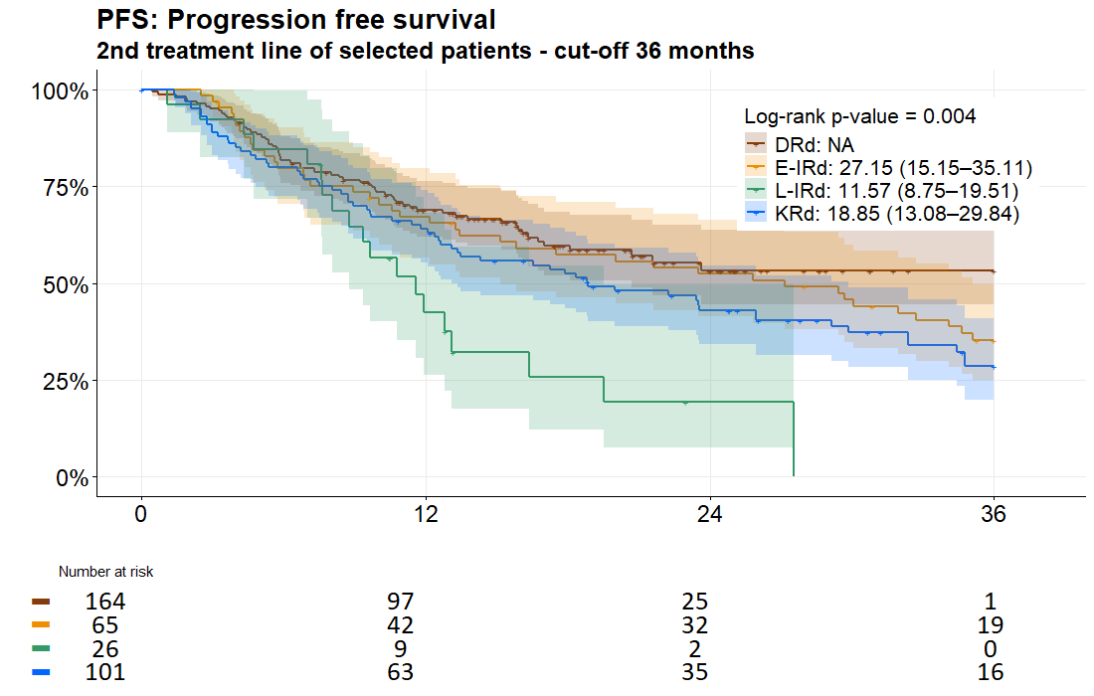

Supplementary figure 2 Overall survival in lenalidomide based triplets

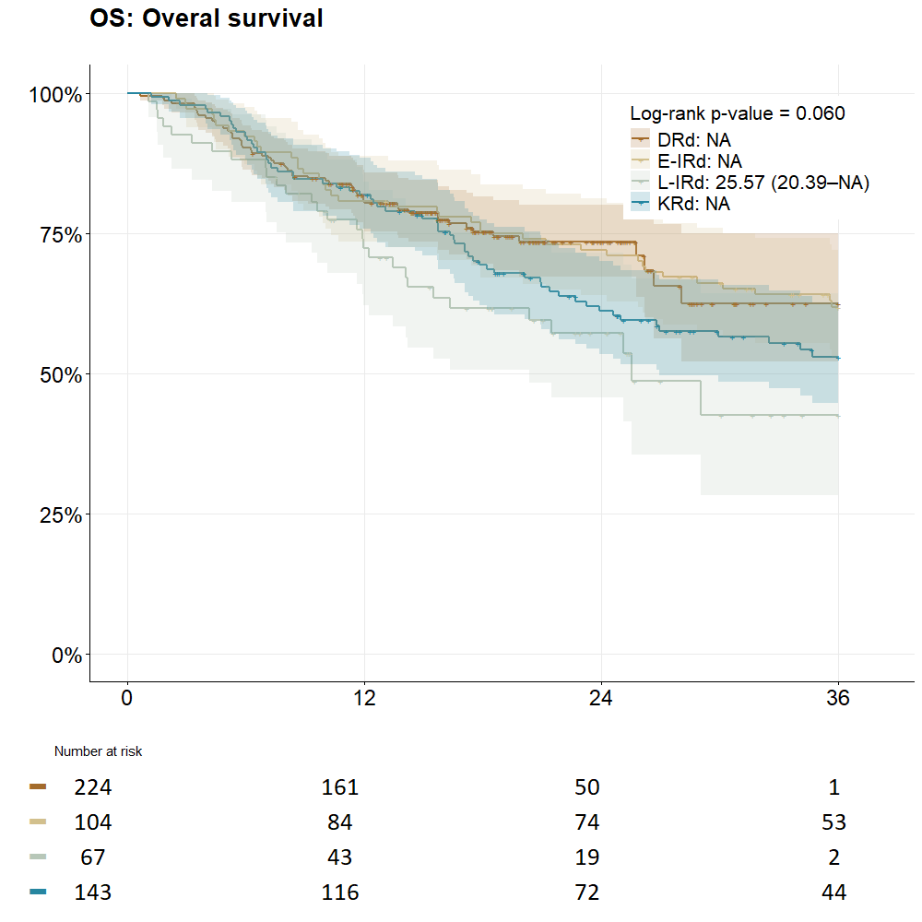
OS | DRd | e-IRd | l-IRd | KRd | p-value of
 |  |  |  |  | log–rank test
n valid | 224 | 104 | 67 | 143 | 0.06
n events (%) | 57 (25.4%) | 39 (37.5%) | 29 (43.3%) | 61 (42.7%) | 0.06
KM median (95% CI) | – | – | 25.6 (20.4–NA) | – | 0.06
Probability at time, % (95% CI):⠀ |  | ⠀ | ⠀ | ⠀ | 0.06
12 months | 80.9 (75.9–86.3) | 80.8 (73.5–88.7) | 72.3 (62.2–84.1) | 81.8 (75.7–88.4) | 0.06
24 months | 73.4 (67.3–80.1) | 72.0 (63.9–81.2) | 57.1 (45.6–71.5) | 61.2 (53.4–70.0) | 0.06
36 months | 62.5 (52.1–75.0) | 61.7 (52.9–72.0) | 42.6 (28.2–64.3) | 53.0 (44.7–62.7) | 0.06

