Supplementary Materials
Full title: Identification of USP39 as a prognostic and predictive biomarker for determining the response to immunotherapy in pancreatic cancer
Authors: Jiahui Yuan ¹, Beibei Xu², Yongcheng Su³, Pingping Zhang⁴, Xianbin Zhang¹, Peng Gong ¹
Author Affiliations:
1. Department of General Surgery, Institute of Precision Diagnosis and Treatment of Digestive System Tumors and Guangdong Provincial Key Laboratory of Chinese Medicine Ingredients and Gut Microbiomics, Carson International Cancer Center, Shenzhen University General Hospital, Shenzhen University, Shenzhen 518055, Guangdong, China
2. CAS Key Laboratory of Quantitative Engineering Biology, Shenzhen Institute of Synthetic Biology, Shenzhen Institute of Advanced Technology, Chinese Academy of Sciences, Shenzhen 518055, China.
3. Xiamen Key Laboratory for Tumor Metastasis, Cancer Research School of Medicine, Xiamen University, Xiamen 361102, China.
4. Department of Gastroenterology, Changhai Hospital, Naval Medical University, Shanghai, 200433, China.
Correspondence:
Prof. Peng Gong
Department of General Surgery, Institute of Precision Diagnosis and Treatment of Digestive System Tumors and Guangdong Provincial Key Laboratory of Chinese Medicine Ingredients and Gut Microbiomics, Carson International Cancer Center, Shenzhen University General Hospital, Shenzhen University, Shenzhen 518055, Guangdong, China. doctorgongpeng@szu.edu.cn.

This file includes:
- Supplementary Figures: S1-4
- Supplementary Tables: S1-3

Supplementary Figures and Figure Legends
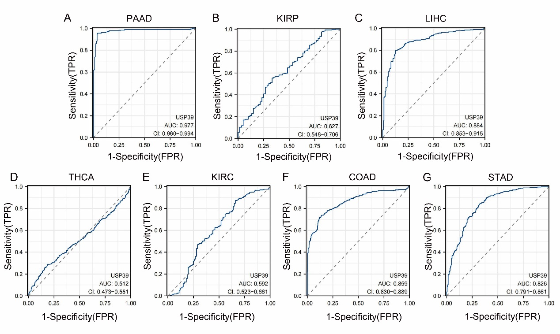
Supplementary Fig.1 Diagnostic value of USP39 expression. Receiver operating characteristic (ROC) curve for the diagnosis of PAAD (A), KIRP (B), LIHC (C), THCA (D), KIRC (E), COAD (F), and STAD (G). AUC = area under the ROC curve.

Supplementary Fig.2 USP39 is closely related to the TME across various tumor tissues. (A and B) MCP-counter and EPIC algorithm were used in our study to confirm the relationship between USP39 expression and immune infiltration levels. (red: positive correlation; blue: negative correlation) (*P < 0.05, **P < 0.01, ***P < 0.001, ****P < 0.0001).

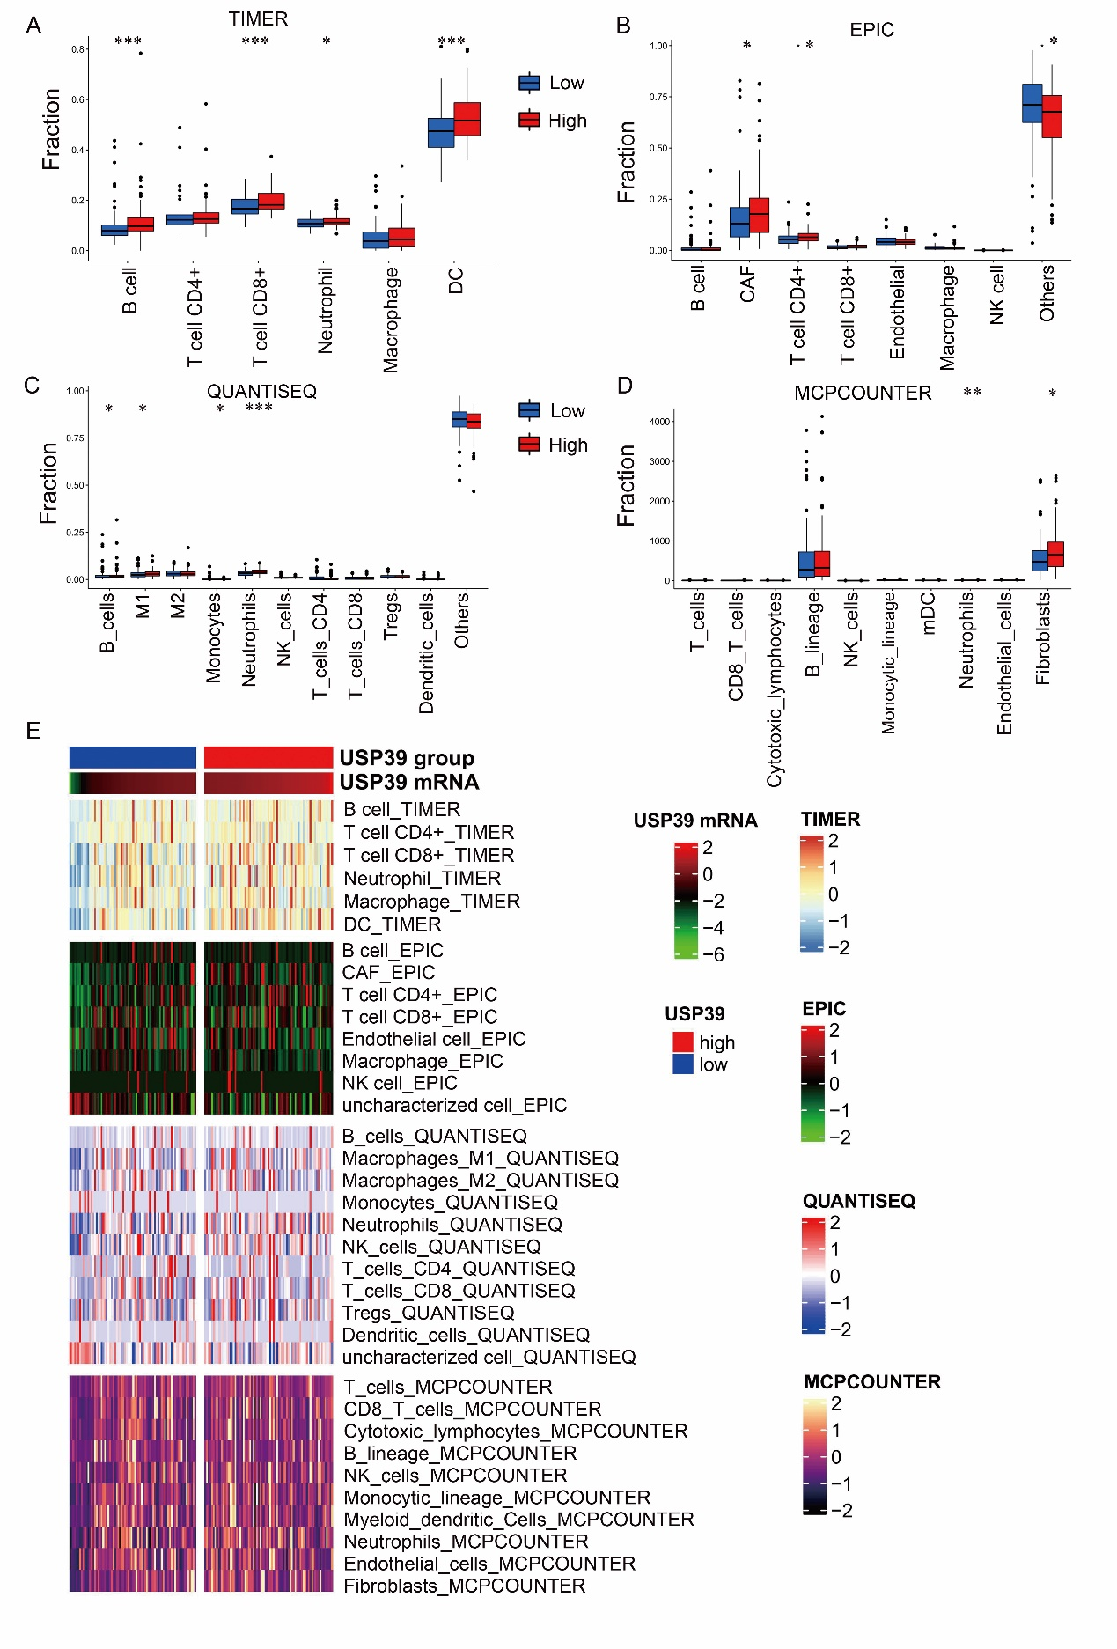
Supplementary Fig. 3 Differences in the infiltration level of immune cells between high and low USP39 expression patient groups in PAAD through four independent immune algorithms. (A-D) A bar graph showing differences in the infiltration level of immune cells between high- and low-USP39 patient groups in PAAD through four independent immune algorithms, including TIMER (A), EPIC (B), QUANTISEQ (C), and MCP-counter (D). (E) A heatmap showing the differences in the infiltration level of immune cells between high- and low-USP39 patient groups in PAAD through four independent immune algorithms, including TIMER, EPIC, QUANTISEQ, and MCP-counter. (*P < 0.05, **P < 0.01, ***P < 0.001).
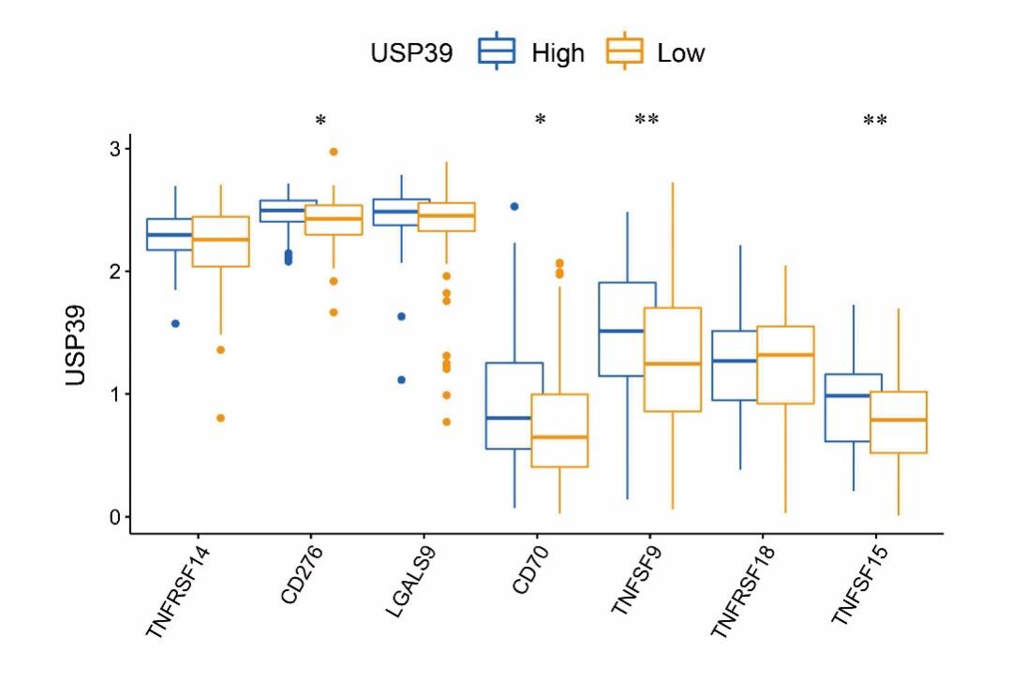
Supplementary Fig. 4 Differential expression analysis of immune-checkpoint genes between high and low USP39 expression patient groups in PAAD. (*P < 0.05, **P < 0.01, ***P < 0.001).

ACC | Adrenocortical carcinoma
BLCA | Bladder Urothelial Carcinoma
BRCA | Breast invasive carcinoma
CESC | Cervical squamous cell carcinoma and endocervical adenocarcinoma
CHOL | Cholangiocarcinoma
COAD | Colon adenocarcinoma
COADREAD | Colon adenocarcinoma/Rectum adenocarcinoma Esophageal carcinoma
ESCA | Esophageal carcinoma
GBM | Glioblastoma multiforme
GBMLGG | Glioma
HNSC | Head and Neck squamous cell carcinoma
KICH | Kidney Chromophobe
KIPAN | Pan-kidney cohort (KICH+KIRC+KIRP)
KIRC | Kidney renal clear cell carcinoma
KIRP | Kidney renal papillary cell carcinoma
LAML | Acute Myeloid Leukemia
LGG | Brain Lower Grade Glioma
LIHC | Liver hepatocellular carcinoma
LUAD | Lung adenocarcinoma
LUSC | Lung squamous cell carcinoma
OV | Ovarian serous cystadenocarcinoma
PAAD | Pancreatic adenocarcinoma
PCPG | Pheochromocytoma and Paraganglioma
PRAD | Prostate adenocarcinoma
READ | Rectum adenocarcinoma
SARC | Sarcoma
STAD | Stomach adenocarcinoma
SKCM | Skin Cutaneous Melanoma
STES | Stomach and Esophageal carcinoma
TGCT | Testicular Germ Cell Tumors
THCA | Thyroid carcinoma
UCEC | Uterine Corpus Endometrial Carcinoma
Supplementary Table S1 The cancer type abbreviations are as above

Supplementary Table S2 The results of Cox-regression analysis for USP39 on different cancer types
Tumor | Event | HR | Lower CI | Upper CI | P value
ACC | OS | 2.63 | 1.49 | 4.66 | 9.02E-04
ACC | DSS | 2.57 | 1.42 | 4.64 | 1.83E-03
ACC | DFI | 5.58 | 2.04 | 15.27 | 8.04E-04
ACC | PFI | 2.71 | 4.88 | 4.88 | 9.06E-04
BLCA | OS | 1.12 | 0.78 | 1.61 | 5.31E-01
BLCA | DSS | 1.22 | 0.79 | 1.89 | 3.65E-01
BLCA | DFI | 0.94 | 0.37 | 2.39 | 8.98E-01
BLCA | PFI | 1.30 | 1.86 | 1.86 | 1.52E-01
BRCA | OS | 1.29 | 0.88 | 1.89 | 1.89E-01
BRCA | DSS | 1.57 | 0.95 | 2.60 | 7.92E-02
BRCA | DFI | 1.19 | 0.70 | 2.01 | 5.22E-01
BRCA | PFI | 1.11 | 1.66 | 1.66 | 6.14E-01
CESC | OS | 0.44 | 0.22 | 0.89 | 2.12E-02
CESC | DSS | 0.53 | 0.24 | 1.17 | 1.15E-01
CESC | DFI | 1.45 | 0.59 | 3.60 | 4.20E-01
CESC | PFI | 0.64 | 1.24 | 1.24 | 1.88E-01
CHOL | OS | 1.49 | 0.36 | 6.09 | 5.80E-01
CHOL | DSS | 1.02 | 0.21 | 4.91 | 9.84E-01
CHOL | DFI | 3.18 | 0.47 | 21.26 | 2.33E-01
CHOL | PFI | 0.94 | 3.52 | 3.52 | 9.27E-01
COAD | OS | 1.04 | 0.56 | 1.91 | 9.10E-01
COAD | DSS | 0.97 | 0.45 | 2.10 | 9.46E-01
COAD | DFI | 1.38 | 0.41 | 4.65 | 6.02E-01
COAD | PFI | 1.17 | 2.04 | 2.04 | 5.89E-01
DLBC | OS | 0.65 | 0.05 | 8.63 | 7.41E-01
DLBC | DSS | 0.11 | 0.00 | 5.17 | 2.60E-01
DLBC | DFI | 29.50 | 0.15 | 5953.12 | 2.11E-01
DLBC | PFI | 2.76 | 25.09 | 25.09 | 3.68E-01
ESCA | OS | 0.97 | 0.59 | 1.59 | 9.07E-01
ESCA | DSS | 1.09 | 0.61 | 1.93 | 7.69E-01
ESCA | DFI | 0.91 | 0.34 | 2.43 | 8.51E-01
ESCA | PFI | 1.30 | 2.06 | 2.06 | 2.63E-01
GBM | OS | 0.61 | 0.34 | 1.10 | 1.03E-01
GBM | DSS | 0.63 | 0.34 | 1.17 | 1.46E-01
GBM | DFI | NA | NA | NA | NA
GBM | PFI | 0.73 | 1.37 | 1.37 | 3.26E-01
HNSC | OS | 1.08 | 0.80 | 1.45 | 6.24E-01
HNSC | DSS | 0.97 | 0.66 | 1.42 | 8.68E-01
HNSC | DFI | 0.43 | 0.17 | 1.12 | 8.45E-02
HNSC | PFI | 1.09 | 1.50 | 1.50 | 5.77E-01
KICH | OS | 1.64 | 0.16 | 16.40 | 6.72E-01
KICH | DSS | 2.87 | 0.23 | 35.74 | 4.12E-01
KICH | DFI | 2.28 | 0.03 | 193.05 | 7.16E-01
KICH | PFI | 1.37 | 10.63 | 10.63 | 7.63E-01
KIRC | OS | 2.77 | 1.88 | 4.08 | 2.90E-07
KIRC | DSS | 3.80 | 2.40 | 6.02 | 1.26E-08
KIRC | DFI | 0.50 | 0.08 | 3.28 | 4.69E-01
KIRC | PFI | 2.86 | 4.26 | 4.26 | 2.87E-07
KIRP | OS | 9.66 | 3.39 | 27.54 | 2.23E-05
KIRP | DSS | 23.35 | 7.11 | 76.70 | 2.09E-07
KIRP | DFI | 8.89 | 2.15 | 36.71 | 2.54E-03
KIRP | PFI | 5.63 | 14.71 | 14.71 | 4.24E-04
LGG | OS | 2.14 | 1.11 | 4.11 | 2.27E-02
LGG | DSS | 2.31 | 1.13 | 4.72 | 2.12E-02
LGG | DFI | 1.49 | 0.36 | 6.09 | 5.78E-01
LGG | PFI | 1.65 | 2.80 | 2.80 | 6.54E-02
LIHC | OS | 2.14 | 1.37 | 3.35 | 8.91E-04
LIHC | DSS | 2.82 | 1.57 | 5.06 | 5.26E-04
LIHC | DFI | 1.18 | 0.76 | 1.81 | 4.60E-01
LIHC | PFI | 1.41 | 2.06 | 2.06 | 7.94E-02
LUAD | OS | 1.00 | 0.72 | 1.40 | 9.89E-01
LUAD | DSS | 1.28 | 0.85 | 1.91 | 2.39E-01
LUAD | DFI | 1.28 | 0.83 | 1.98 | 2.58E-01
LUAD | PFI | 1.20 | 1.63 | 1.63 | 2.25E-01
LUSC | OS | 0.77 | 0.59 | 1.00 | 5.15E-02
LUSC | DSS | 0.68 | 0.45 | 1.03 | 7.04E-02
LUSC | DFI | 1.32 | 0.82 | 2.14 | 2.59E-01
LUSC | PFI | 0.79 | 1.09 | 1.09 | 1.47E-01
MESO | OS | 3.33 | 1.46 | 7.61 | 4.36E-03
MESO | DSS | 2.73 | 1.00 | 7.48 | 5.09E-02
MESO | DFI | 1.55 | 0.12 | 19.72 | 7.37E-01
MESO | PFI | 1.90 | 4.59 | 4.59 | 1.56E-01
OV | OS | 1.12 | 0.78 | 1.60 | 5.48E-01
OV | DSS | 1.10 | 0.74 | 1.62 | 6.40E-01
OV | DFI | 1.20 | 0.72 | 1.97 | 4.84E-01
OV | PFI | 1.04 | 1.47 | 1.47 | 8.22E-01
PAAD | OS | 2.76 | 1.32 | 5.73 | 6.70E-03
PAAD | DSS | 2.64 | 1.16 | 6.01 | 2.07E-02
PAAD | DFI | 2.61 | 0.49 | 13.78 | 2.59E-01
PAAD | PFI | 2.92 | 5.97 | 5.97 | 3.44E-03
PCPG | OS | 46.40 | 3.60 | 598.67 | 3.27E-03
PCPG | DSS | 36.60 | 1.89 | 708.39 | 1.73E-02
PCPG | DFI | 0.16 | 0.01 | 4.12 | 2.71E-01
PCPG | PFI | 6.16 | 28.03 | 28.03 | 1.87E-02
PRAD | OS | 2.83 | 0.27 | 29.28 | 3.82E-01
PRAD | DSS | 8.33 | 0.55 | 125.38 | 1.25E-01
PRAD | DFI | 1.46 | 0.36 | 5.91 | 6.00E-01
PRAD | PFI | 1.90 | 4.10 | 4.10 | 1.01E-01
READ | OS | 1.03 | 0.23 | 4.58 | 9.72E-01
READ | DSS | 1.41 | 0.19 | 10.18 | 7.36E-01
READ | DFI | 0.71 | 0.03 | 15.26 | 8.25E-01
READ | PFI | 0.84 | 2.86 | 2.86 | 7.82E-01
SARC | OS | 0.87 | 0.53 | 1.43 | 5.80E-01
SARC | DSS | 0.91 | 0.53 | 1.57 | 7.37E-01
SARC | DFI | 1.09 | 0.58 | 2.05 | 7.98E-01
SARC | PFI | 0.86 | 1.33 | 1.33 | 4.96E-01
SKCM | OS | 0.98 | 0.68 | 1.43 | 9.34E-01
SKCM | DSS | 1.02 | 0.69 | 1.52 | 9.17E-01
SKCM | DFI | NA | NA | NA | NA
SKCM | PFI | 1.07 | 1.43 | 1.43 | 6.74E-01
STAD | OS | 0.77 | 0.51 | 1.17 | 2.27E-01
STAD | DSS | 0.85 | 0.50 | 1.43 | 5.33E-01
STAD | DFI | 1.03 | 0.47 | 2.27 | 9.45E-01
STAD | PFI | 0.86 | 1.34 | 1.34 | 5.12E-01
TGCT | OS | 0.69 | 0.05 | 9.01 | 7.78E-01
TGCT | DSS | 0.53 | 0.03 | 8.33 | 6.51E-01
TGCT | DFI | 0.78 | 0.34 | 1.81 | 5.61E-01
TGCT | PFI | 0.72 | 1.56 | 1.56 | 4.09E-01
THCA | OS | 0.43 | 0.07 | 2.69 | 3.64E-01
THCA | DSS | 0.35 | 0.02 | 5.62 | 4.59E-01
THCA | DFI | 1.77 | 0.29 | 10.66 | 5.32E-01
THCA | PFI | 2.04 | 7.49 | 7.49 | 2.84E-01
THYM | OS | 0.19 | 0.04 | 0.94 | 4.22E-02
THYM | DSS | 0.35 | 0.03 | 4.55 | 4.19E-01
THYM | DFI | NA | NA | NA | NA
THYM | PFI | 0.77 | 2.27 | 2.27 | 6.37E-01
UCEC | OS | 2.70 | 1.56 | 4.68 | 3.87E-04
UCEC | DSS | 3.37 | 1.76 | 6.47 | 2.54E-04
UCEC | DFI | 2.67 | 1.31 | 5.43 | 6.66E-03
UCEC | PFI | 2.46 | 3.92 | 3.92 | 1.54E-04
UCS | OS | 1.19 | 0.55 | 2.57 | 6.55E-01
UCS | DSS | 1.12 | 0.50 | 2.49 | 7.84E-01
UCS | DFI | 1.44 | 0.36 | 5.69 | 6.02E-01
UCS | PFI | 1.32 | 2.87 | 2.87 | 4.83E-01
UVM | OS | 1.24 | 0.23 | 6.59 | 8.02E-01
UVM | DSS | 1.47 | 0.27 | 8.10 | 6.60E-01
UVM | DFI | NA | NA | NA | NA
UVM | PFI | 3.71 | 17.51 | 17.51 | 9.74E-02

Supplementary Table S3 The results of Cox-regression analysis for USP39 on different cancer types
Tomor | Events | HR | Lower CI | Upper CI | P value
ACC | OS | 4.90 | 1.83 | 13.15 | 2.20E-06
ACC | DSS | 0.21 | 1.77 | 13.58 | 6.83E-06
ACC | DFI | 0.25 | 1.20 | 20.00 | 1.11E-02
ACC | PFI | 0.32 | 2.17 | 11.04 | 1.57E-04
BLCA | OS | 1.16 | 0.82 | 1.64 | 3.95E-01
BLCA | DSS | 0.77 | 0.79 | 1.70 | 2.01E-01
BLCA | DFI | 1.83 | 0.55 | 2.42 | 1.51E-01
BLCA | PFI | 0.66 | 0.84 | 1.59 | 2.00E-02
BRCA | OS | 1.86 | 1.25 | 2.77 | 1.13E-02
BRCA | DSS | 0.63 | 1.22 | 2.85 | 3.36E-02
BRCA | DFI | 0.59 | 1.16 | 2.99 | 1.55E-02
BRCA | PFI | 0.75 | 1.31 | 2.65 | 9.55E-02
CESC | OS | 0.54 | 0.32 | 0.91 | 8.97E-03
CESC | DSS | 1.90 | 0.29 | 1.00 | 1.84E-02
CESC | DFI | 0.49 | 0.21 | 1.40 | 7.55E-02
CESC | PFI | 1.62 | 0.32 | 0.91 | 4.65E-02
CHOL | OS | 2.64 | 0.90 | 7.69 | 1.74E-01
CHOL | DSS | 0.43 | 0.85 | 8.18 | 2.43E-01
CHOL | DFI | 0.00 | 0.59 | 11.73 | 9.03E-02
CHOL | PFI | 0.57 | 0.94 | 7.40 | 3.62E-01
COAD | OS | 0.64 | 0.41 | 1.00 | 3.05E-02
COAD | DSS | 1.61 | 0.36 | 1.13 | 6.65E-02
COAD | DFI | 1.71 | 0.28 | 1.45 | 2.12E-01
COAD | PFI | 0.74 | 0.42 | 0.97 | 1.35E-01
DLBC | OS | 0.00 | 0.00 | 0.00 | 1.35E-01
DLBC | DSS | 8.30 | 0.00 | 0.00 | 2.72E-02
DLBC | DFI | 0.19 | 0.00 | 0.00 | 3.78E-02
DLBC | PFI | 0.43 | 0.00 | 0.00 | 1.08E-01
ESCA | OS | 1.31 | 0.80 | 2.13 | 3.03E-01
ESCA | DSS | 0.62 | 0.70 | 2.45 | 1.83E-01
ESCA | DFI | 0.57 | 0.57 | 2.99 | 2.12E-01
ESCA | PFI | 0.62 | 0.86 | 1.99 | 2.74E-02
GBM | OS | 0.67 | 0.44 | 1.00 | 2.86E-02
GBM | DSS | 1.48 | 0.43 | 1.02 | 4.61E-02
GBM | DFI | NA | NA | NA | NA
GBM | PFI | 1.59 | 0.44 | 1.00 | 1.07E-02
HNSC | OS | 1.32 | 0.96 | 1.82 | 1.09E-01
HNSC | DSS | 1.29 | 0.93 | 1.89 | 1.71E-01
HNSC | DFI | 3.62 | 0.63 | 2.79 | 5.07E-03
HNSC | PFI | 0.77 | 0.94 | 1.85 | 1.66E-01
KICH | OS | 3.61 | 0.88 | 14.82 | 1.94E-01
KICH | DSS | 0.21 | 0.81 | 16.08 | 1.14E-01
KICH | DFI | 0.15 | 0.24 | 53.97 | 6.67E-02
KICH | PFI | 0.31 | 1.09 | 11.99 | 1.17E-01
KIRC | OS | 2.30 | 1.70 | 3.10 | 3.84E-08
KIRC | DSS | 0.34 | 1.57 | 3.37 | 2.07E-08
KIRC | DFI | 1.58 | 0.84 | 6.33 | 3.79E-01
KIRC | PFI | 0.44 | 1.67 | 3.17 | 8.35E-08
KIRP | OS | 3.51 | 1.50 | 8.23 | 1.69E-05
KIRP | DSS | 0.15 | 1.53 | 8.04 | 1.83E-07
KIRP | DFI | 0.34 | 1.50 | 8.21 | 2.20E-03
KIRP | PFI | 0.36 | 1.71 | 7.20 | 1.54E-04
LGG | OS | 1.73 | 1.14 | 2.64 | 3.03E-03
LGG | DSS | 0.55 | 1.10 | 2.71 | 2.32E-03
LGG | DFI | 1.74 | 0.72 | 4.14 | 2.64E-01
LGG | PFI | 0.80 | 1.24 | 2.42 | 1.53E-01
LIHC | OS | 1.86 | 1.20 | 2.90 | 8.91E-04
LIHC | DSS | 0.46 | 1.03 | 3.37 | 9.29E-04
LIHC | DFI | 0.73 | 1.34 | 2.59 | 5.43E-02
LIHC | PFI | 0.69 | 1.39 | 2.50 | 1.05E-02
LUAD | OS | 1.53 | 1.12 | 2.11 | 1.65E-02
LUAD | DSS | 0.36 | 1.02 | 2.30 | 1.39E-04
LUAD | DFI | 0.66 | 1.00 | 2.35 | 7.19E-02
LUAD | PFI | 0.74 | 1.17 | 2.02 | 3.11E-02
LUSC | OS | 0.58 | 0.40 | 0.85 | 7.51E-04
LUSC | DSS | 1.67 | 0.38 | 0.89 | 2.34E-02
LUSC | DFI | 0.39 | 0.33 | 1.02 | 9.64E-03
LUSC | PFI | 1.66 | 0.42 | 0.81 | 3.39E-03
MESO | OS | 2.14 | 1.34 | 3.41 | 2.65E-03
MESO | DSS | 0.45 | 1.17 | 3.91 | 1.78E-02
MESO | DFI | 0.67 | 0.48 | 9.43 | 5.49E-01
MESO | PFI | 0.60 | 1.28 | 3.56 | 4.70E-02
OV | OS | 1.35 | 1.01 | 1.80 | 4.04E-02
OV | DSS | 0.76 | 0.99 | 1.85 | 8.00E-02
OV | DFI | 0.69 | 0.89 | 2.05 | 6.42E-02
OV | PFI | 0.78 | 1.03 | 1.77 | 6.45E-02
PAAD | OS | 2.51 | 1.57 | 4.01 | 2.56E-03
PAAD | DSS | 0.33 | 1.47 | 4.29 | 3.57E-03
PAAD | DFI | 0.44 | 1.07 | 5.87 | 4.38E-02
PAAD | PFI | 0.57 | 1.62 | 3.89 | 2.92E-02
PCPG | OS | 12.22 | 2.89 | 51.57 | 2.61E-03
PCPG | DSS | 0.13 | 1.69 | 88.37 | 5.10E-03
PCPG | DFI | Inf | 1.60 | 93.32 | 1.26E-01
PCPG | PFI | 0.28 | 4.45 | 33.52 | 1.05E-03
PRAD | OS | 2.92 | 0.59 | 14.39 | 7.22E-02
PRAD | DSS | 0.14 | 0.30 | 28.86 | 1.13E-02
PRAD | DFI | 0.48 | 1.41 | 6.07 | 3.53E-02
PRAD | PFI | 0.51 | 1.75 | 4.88 | 1.87E-03
READ | OS | 1.77 | 0.66 | 4.80 | 3.44E-01
READ | DSS | 0.33 | 0.45 | 7.03 | 2.65E-01
READ | DFI | 2.09 | 0.32 | 9.82 | 3.44E-01
READ | PFI | 0.65 | 0.83 | 3.81 | 2.24E-01
SARC | OS | 0.68 | 0.41 | 1.11 | 8.18E-02
SARC | DSS | 1.68 | 0.39 | 1.19 | 3.56E-02
SARC | DFI | 1.29 | 0.38 | 1.22 | 3.56E-01
SARC | PFI | 1.46 | 0.44 | 1.03 | 4.57E-02
SKCM | OS | 1.22 | 0.88 | 1.69 | 2.51E-01
SKCM | DSS | 0.78 | 0.87 | 1.71 | 1.82E-01
SKCM | DFI | NA | NA | NA | NA
SKCM | PFI | 0.83 | 0.94 | 1.58 | 1.67E-01
STAD | OS | 0.70 | 0.51 | 0.96 | 2.22E-02
STAD | DSS | 1.48 | 0.46 | 1.04 | 5.60E-02
STAD | DFI | 0.46 | 0.36 | 1.33 | 4.88E-02
STAD | PFI | 1.42 | 0.50 | 0.98 | 4.48E-02
TGCT | OS | 0.00 | 0.00 | 0.00 | 1.23E-01
TGCT | DSS | Inf | 0.00 | 0.00 | 9.17E-02
TGCT | DFI | 2.23 | 0.00 | 0.00 | 1.20E-01
TGCT | PFI | 1.73 | 0.00 | 0.00 | 9.21E-02
THCA | OS | 0.43 | 0.13 | 1.45 | 9.55E-02
THCA | DSS | 2.61 | 0.09 | 2.08 | 1.92E-01
THCA | DFI | 0.26 | 0.18 | 1.05 | 4.78E-02
THCA | PFI | 0.50 | 0.23 | 0.82 | 8.01E-02
THYM | OS | 0.11 | 0.03 | 0.48 | 6.24E-04
THYM | DSS | Inf | 0.02 | 0.82 | 8.23E-02
THYM | DFI | NA | NA | NA | NA
THYM | PFI | 4.02 | 0.04 | 0.29 | 4.08E-02
UCEC | OS | 2.90 | 1.78 | 4.74 | 1.48E-07
UCEC | DSS | 0.29 | 1.60 | 5.27 | 3.42E-07
UCEC | DFI | 0.45 | 1.55 | 5.43 | 3.24E-03
UCEC | PFI | 0.47 | 1.92 | 4.39 | 2.71E-05
UCS | OS | 1.48 | 0.74 | 2.94 | 2.34E-01
UCS | DSS | 0.70 | 0.71 | 3.07 | 3.12E-01
UCS | DFI | 0.56 | 0.41 | 5.39 | 3.28E-01
UCS | PFI | 0.69 | 0.76 | 2.86 | 2.44E-01
UVM | OS | 0.61 | 0.25 | 1.46 | 3.09E-01
UVM | DSS | 1.56 | 0.24 | 1.51 | 3.79E-01
UVM | DFI | NA | NA | NA | NA
UVM | PFI | 0.59 | 0.28 | 1.32 | 1.27E-01

Supplementary Table S4 Correlations between USP39 and the enrichment scores of immunotherapy-predicted pathways

gene | path | r | p | sign | absR | rSeg | pSeg
USP39 | IFN-Gamma_signature | 0.107469 | 0.154509 | pos | 0.107469 | 0.25 | ns
USP39 | APM_signal | 0.431804 | 1.96E-09 | pos | 0.431804 | 0.5 | <0.001
USP39 | Base_excision_repair | 0.193309 | 0.009939 | pos | 0.193309 | 0.25 | <0.01
USP39 | Cell_cycle | 0.452842 | 2.48E-10 | pos | 0.452842 | 0.5 | <0.001
USP39 | DNA_replication | 0.308836 | 2.88E-05 | pos | 0.308836 | 0.5 | <0.001
USP39 | Fanconi_anemia_pathway | 0.388988 | 8.76E-08 | pos | 0.388988 | 0.5 | <0.001
USP39 | Homologous_recombination | 0.249233 | 0.000822 | pos | 0.249233 | 0.25 | <0.001
USP39 | MicroRNAs_in_cancer | 0.407184 | 1.86E-08 | pos | 0.407184 | 0.5 | <0.001
USP39 | Mismatch_repair | 0.232354 | 0.001858 | pos | 0.232354 | 0.25 | <0.01
USP39 | Nucleotide_excision_repair | 0.211041 | 0.004808 | pos | 0.211041 | 0.25 | <0.01
USP39 | Oocyte_meiosis | 0.474568 | 2.51E-11 | pos | 0.474568 | 0.5 | <0.001
USP39 | p53_signaling_pathway | 0.477274 | 1.86E-11 | pos | 0.477274 | 0.5 | <0.001
USP39 | Progesterone-mediated_oocyte_maturation | 0.47382 | 2.72E-11 | pos | 0.47382 | 0.5 | <0.001
USP39 | Proteasome | 0.44337 | 6.40E-10 | pos | 0.44337 | 0.5 | <0.001
USP39 | Pyrimidine_metabolism | 0.388575 | 9.06E-08 | pos | 0.388575 | 0.5 | <0.001
USP39 | Spliceosome | 0.300005 | 4.97E-05 | pos | 0.300005 | 0.5 | <0.001
USP39 | Viral_carcinogenesis | 0.485729 | 7.24E-12 | pos | 0.485729 | 0.5 | <0.001
USP39 | USP39 | 1 | 0 | pos | 1 | 1 | Not Applicable

Supplementary Table S5 Correlations between USP39 and the steps of the cancer immunity cycle

gene | path | r | p | sign | absR | rSeg | pSeg
USP39 | STEP1 Release of cancer cell antigens | 0.198814 | 0.007982 | pos | 0.198814 | 0.25 | <0.01
USP39 | STEP2 Cancer antigen presentation | 0.176093 | 0.019052 | pos | 0.176093 | 0.25 | <0.05
USP39 | STEP3 Priming and activation | 0.205518 | 0.006065 | pos | 0.205518 | 0.25 | <0.01
USP39 | STEP4 Treg cell recruiting | 0.139004 | 0.06501 | pos | 0.139004 | 0.25 | ns
USP39 | STEP4 Th22 cell recruiting | 0.317765 | 1.63E-05 | pos | 0.317765 | 0.5 | <0.001
USP39 | STEP4 Th2 cell recruiting | 0.120206 | 0.111004 | pos | 0.120206 | 0.25 | ns
USP39 | STEP4 Th17 cell recruiting | 0.099422 | 0.187966 | pos | 0.099422 | 0.25 | ns
USP39 | STEP4 Th1 cell recruiting | 0.139482 | 0.064083 | pos | 0.139482 | 0.25 | ns
USP39 | STEP4 T cell recruiting | 0.055154 | 0.465921 | pos | 0.055154 | 0.25 | ns
USP39 | STEP4 NK cell recruiting | 0.063666 | 0.399855 | pos | 0.063666 | 0.25 | ns
USP39 | STEP4 Neutrophil recruiting | 0.106451 | 0.158475 | pos | 0.106451 | 0.25 | ns
USP39 | STEP4 Monocyte recruiting | -0.12236 | 0.104694 | neg | 0.122364 | 0.25 | ns
USP39 | STEP4 MDSC recruiting | 0.190488 | 0.011097 | pos | 0.190488 | 0.25 | <0.05
USP39 | STEP4 Macrophage recruiting | -0.09988 | 0.185953 | neg | 0.099875 | 0.25 | ns
USP39 | STEP4 Eosinophil recruiting | -0.05845 | 0.439653 | neg | 0.05845 | 0.25 | ns
USP39 | STEP4 Dendritic cell recruiting | -0.01057 | 0.888924 | neg | 0.010573 | 0.25 | ns
USP39 | STEP4 CD8 T cell recruiting | 0.180079 | 0.016464 | pos | 0.180079 | 0.25 | <0.05
USP39 | STEP4 CD4 T cell recruiting | 0.051945 | 0.492305 | pos | 0.051945 | 0.25 | ns
USP39 | STEP4 Basophil recruiting | 0.009519 | 0.899934 | pos | 0.009519 | 0.25 | ns
USP39 | STEP4 B cell recruiting | 0.15499 | 0.039411 | pos | 0.15499 | 0.25 | <0.05
USP39 | STEP5 Infiltration of immune cells into tumors | 0.160372 | 0.032981 | pos | 0.160372 | 0.25 | <0.05
USP39 | STEP6 Recognition of cancer cells by T cells | 0.209859 | 0.005055 | pos | 0.209859 | 0.25 | <0.01
USP39 | STEP7 Killing of cancer cells | -0.00745 | 0.921623 | neg | 0.007448 | 0.25 | ns
USP39 | USP39 | 1 | 0 | pos | 1 | 1 | Not Applicable

