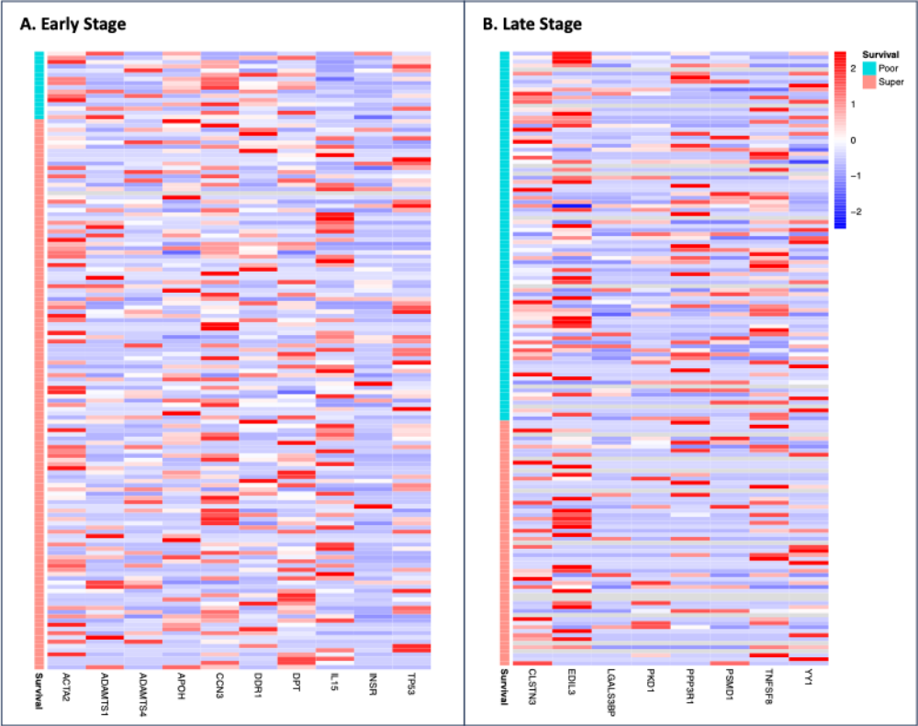
Figure S1. Heatmap for differentially expressed proteins (DEPs) in early- and late-stage colon cancer comparing super and poor survivors.

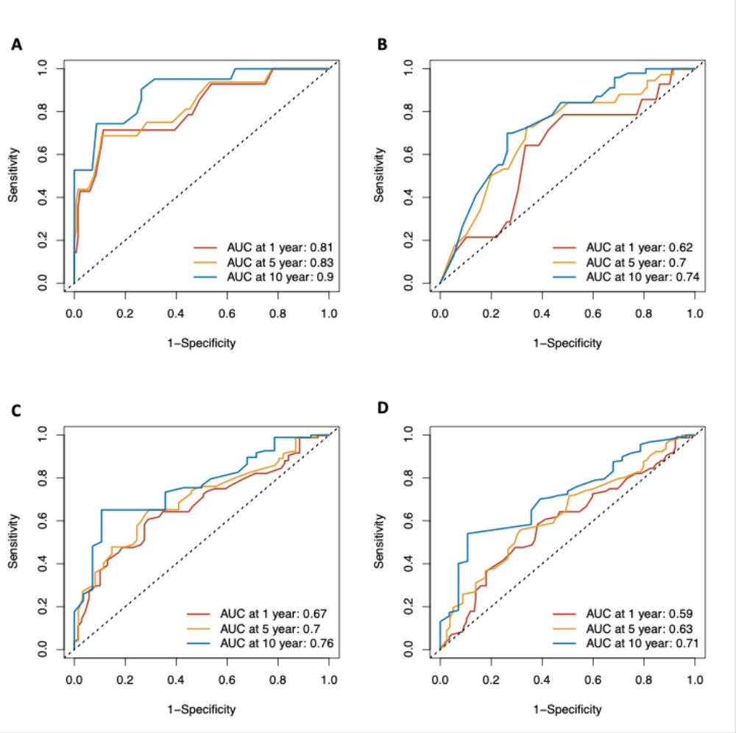
Figure S2. Predictive model performance based on age at diagnosis and sex in the early and late-stage colon cancer. This figure demonstrates the performance of the models only using age at diagnosis and sex as predictors. The upper panel (A and B) for models in the early stage; The lower panel (C and D) for models in the late stage. The left panel (A and C) for models in super and poor survivors; The right panel (B and D) for models in all patients.

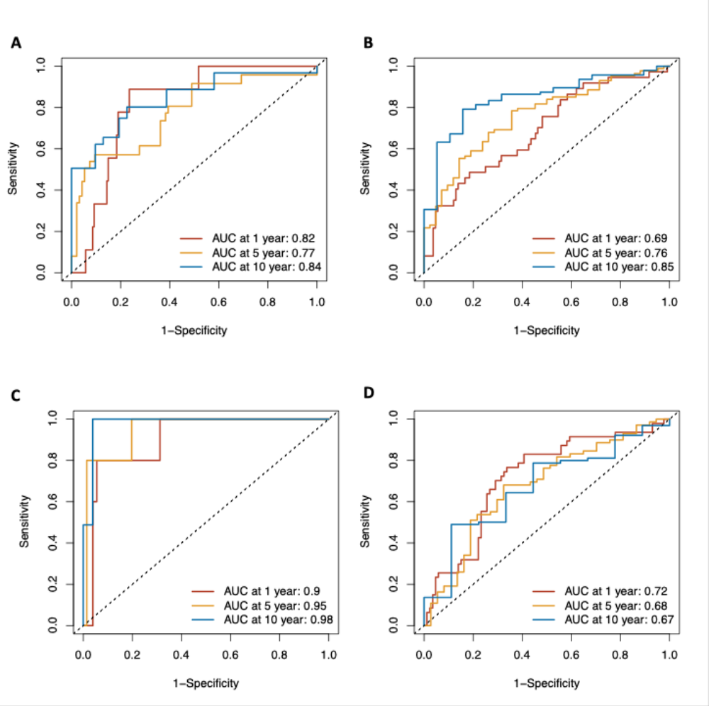
Figure S3. Predictive model performance by sex in the early and late-stage colon cancer. This figure presents a subgroup analysis of model performance stratified by sex. The upper panels (A and B) show the models for male patients, while the lower panels (C and D) display the models for female patients. The left panels (A and C) represent early-stage cases, while the right panels (B and D) represent late-stage cases.

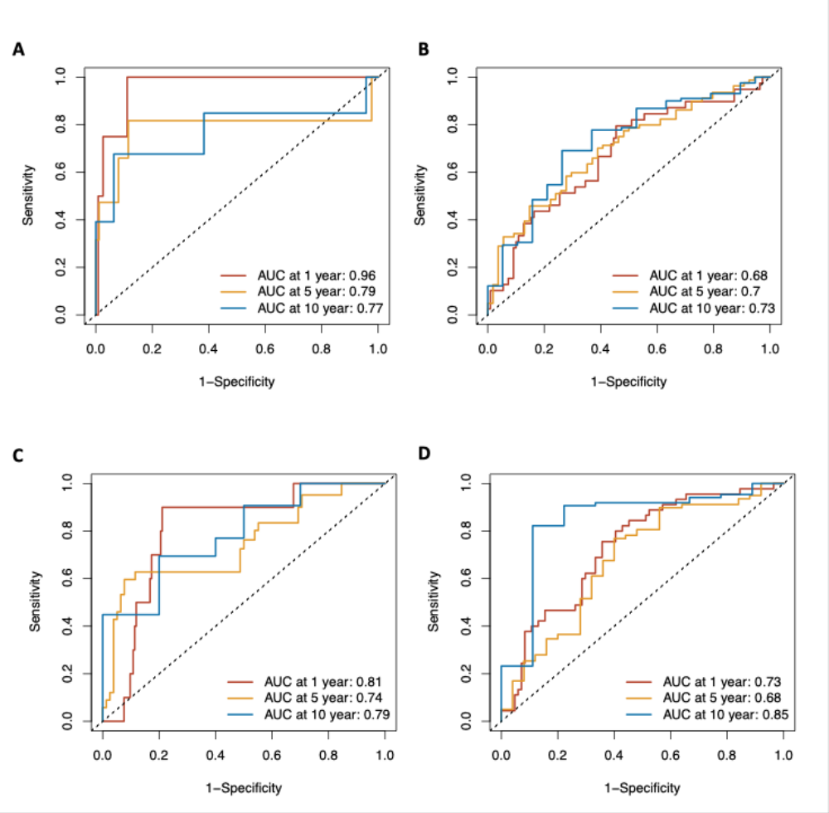
Figure S4. Predictive model performance by age at diagnosis in the early and late-stage colon cancer. This figure illustrates the subgroup analysis of model performance stratified by age, using 70 years as the cutoff. The upper panels (A and B) represent models applied to patients under 70 years of age, while the lower panels (C and D) correspond to patients aged 70 years and older. Additionally, the left panels (A and C) represent models in the early-stage cases; The right panel (B and D) for models in the late-stage cases.

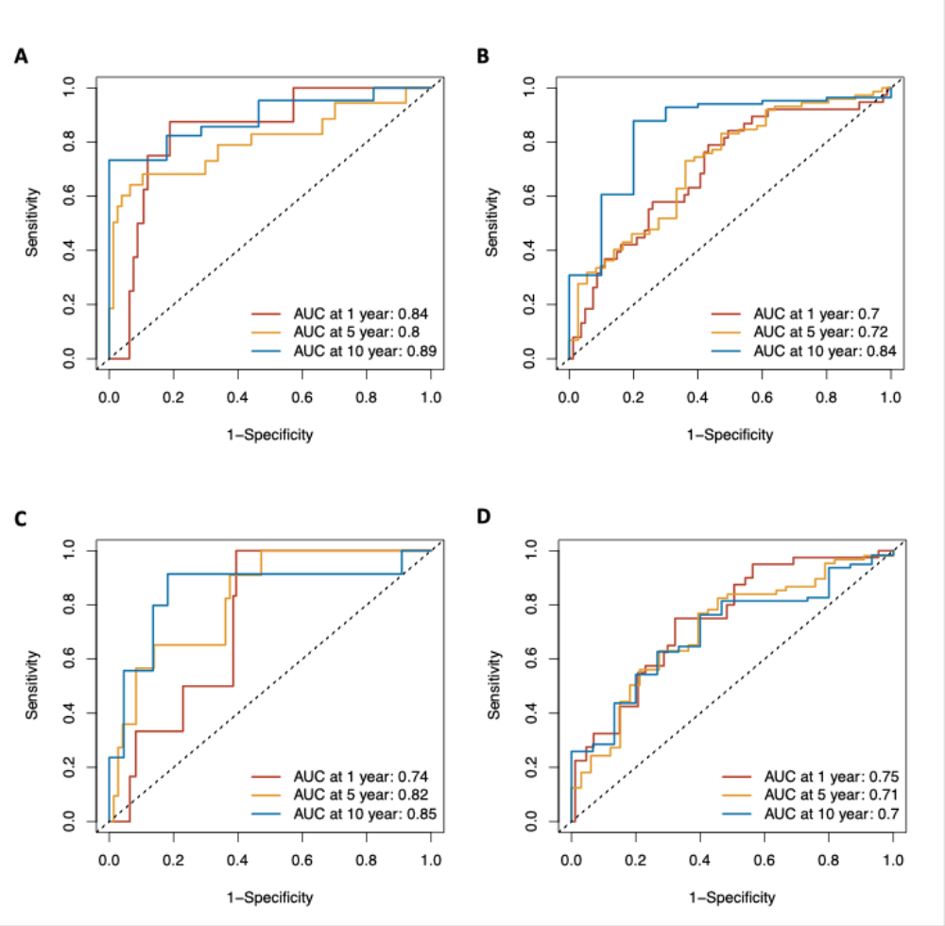
Figure S5. Predictive model performance by tumor location in the early and late-stage colon cancer. This figure presents a subgroup analysis of the predictive model's performance stratified by tumor location. The upper panels (A and B) display results for models applied to patients with left-sided tumors, while the lower panels (C and D) show results for patients with right-sided tumors. Additionally, the left panels (A and C) focus on early-stage cases, and the right panels (B and D) highlight late-stage cases.
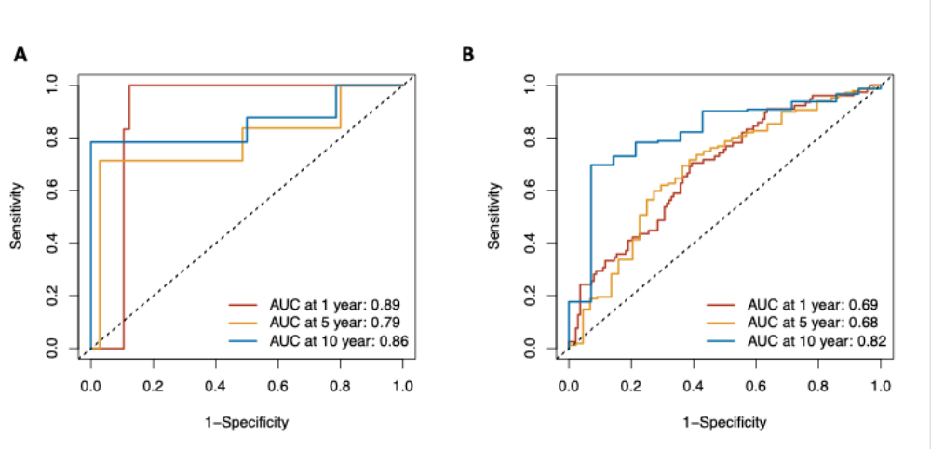
Figure S6. Predictive model performance by tumor stage in the early and late-stage colon cancer. This figure illustrates the sensitivity analysis of model performance by stage III and IV. A refers to stage III cases (characterized by lymph node metastasis only), B refers to stage IV cases (characterized by distant organ metastasis).

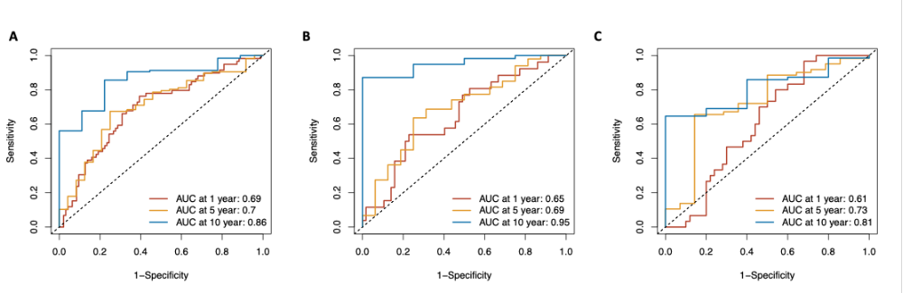
Figure S7. Predictive model performance based on plasma proteins in different sites of late-stage colon cancer. This figure demonstrates the performance of the models used in the metastasis based on 11 proteins among metastasis on A (liver and intrahepatic bile duct), B (lung), C (retroperitoneum and peritoneum), respectively

