Supplemental Materials
Copper's New Role in Cancer: How Cuproptosis-Related Genes Could Revolutionize Glioma Treatment
Yu Wang^{1#}, Sen Qiao^{3#}, Ping Wang^{1#}, Mi Li², Xiaozhen Ma², Hongmei Wang²*, Junhong Dong¹*
¹ School of Basic Medical Sciences, Shandong Second Medical University, Weifang, 261053, China
² School of Basic Medicine, Shaanxi University of Chinese Medicine, No.1, Middle Century Avenue, Chenyangzhai, Xianyang, Shaanxi, 712046, China
³ Assisted Reproduction Center, Northwest Women's and Children's Hospital, No.73 Houzaimen, North Street, Xincheng District, Xi'an, 710003, China
* Corresponding authors
Professor Hongmei Wang: E-mail: wanghongmei@sntcm.edu.cn Tel.: +86-15165041791; Shaanxi University of Chinese Medicine, No.1, Middle Century Avenue, Chenyangzhai, Xianyang, Shaanxi, 712046, China; ORCID: 0000-0002-6975-9467
Professor Junhong Dong: E-mail: djh196@163.com Tel.: +86-18365607858; School of Basic Medical Sciences, Shandong Second Medical University, NO. 7166 Baotong West Street, Weifang, 261053, China
# Yu Wang, Sen Qiao, and Ping Wang contributed equally to this work..
Running title: Cuproptosis-related biomarkers in glioma

Figures and figure legends

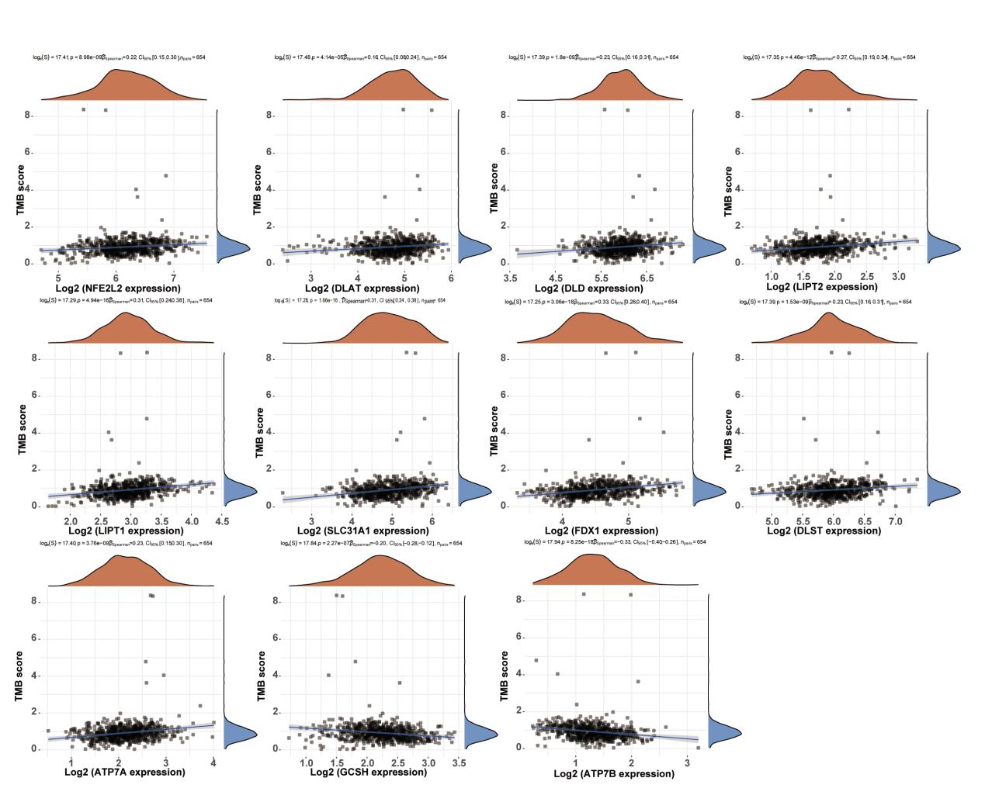
Figure S1. Correlation analysis between CRG expression and TMB/MSI using Spearman’s method. The abscissa represents the gene expression distribution and the ordinate represents the TMB/MSI score distribution. The density curve on the right represents the TMB/MSI score distribution trend, in which the upper-density curve represents the gene expression distribution trend. The values on the top represent the p-value, correlation coefficient, and correlation calculation method.

Functional analysis of cuproptosis-related genes in glioma
Patients with glioma in the TCGA database were clustered using the consistency clustering method, with the K value determined using the combination of the consensus cumulative distribution function and delta area plot. The clustering stability was optimal when K = 2, as evidenced by Figures S2A and S2B. Furthermore, Figure S2C, which depicts a consistency matrix heatmap, indicates that the clustering analysis result was favorable when K = 2. The expression levels of CRGs allowed for classifying these genes into two groups, which were visually represented via the heatmap (Fig. S2D). These findings provide a theoretical basis for further mechanism research and glioma subtype classification.
To investigate the biological role of CRGs in glioma, differential gene expression was analyzed for DLAT, DLD, LIPT2, LIPT1, SLC31A1, FDX1, DLST, ATP7A, NFE2L2, ATP7B, and GCSH. In glioma, 2183 genes were upregulated and 316 genes were downregulated (FC > 2, P < 0.05). A volcano plot revealed that the upregulated genes were COL4A1, TOP2A, LYZ, COL3A1, MYBL2, CD163, CHI3L1, TIMP1, POSTN, and LTF (Fig. S3A). Of note, a majority of these genes serve as immune cell indicators. For instance, LYZ and CD163 are frequently employed as markers of detecting macrophages in peripheral tissues, whereas MYBL2, TIMP1, and POSTN are commonly utilized as markers for monocytes. In addition, COL3A1 can be used as a marker for NKT cells and CHI3L1 for granulosa cells.
A systematic cluster analysis was next performed (Fig. S3B). The upregulated and downregulated genes were examined through KEGG and GO analyses. The KEGG analysis of upregulated genes revealed that the biological functions of CRGs encompassed numerous pathogenic infections, inflammatory reactions, extracellular matrix (ECM)–receptor interactions, cell cycle processes, and phagocytosis. Among these categories, the enrichment rate of CRGs in ECM–receptor interaction, cell cycle, and phagocytosis was statistically significant. Of note, the highest enrichment rate was observed within the context of phagocytosis (Fig. S3C). The GO analysis of upregulated genes revealed that CRGs were significantly associated with mitotic nuclear division, chromosome segregation, organelle fission, nuclear division, extracellular structure organization, and ECM organization, all of which were statistically significant. Among the latter four categories, the CRGs exhibited the highest enrichment rate (Fig. S3D). The aforementioned signaling pathways are frequently observed in tumors and significantly associated with tumor cell proliferation, tumor microenvironment (TME), and inflammatory responses. These findings imply that CRGs may play a role in glioma initiation and progression by influencing tumor cell proliferation, TME, and inflammatory responses. The KEGG analysis of downregulated genes revealed that CRGs exhibited the highest enrichment rate in the neuroactive ligand–receptor interaction pathway, with statistical significance. Additionally, these genes were highly significant in nicotine addiction (Fig. S3E). Furthermore, the GO analysis of downregulated genes indicated that CRGs were significantly enriched in vesicular-mediated transport in synapses (Fig. S3F).

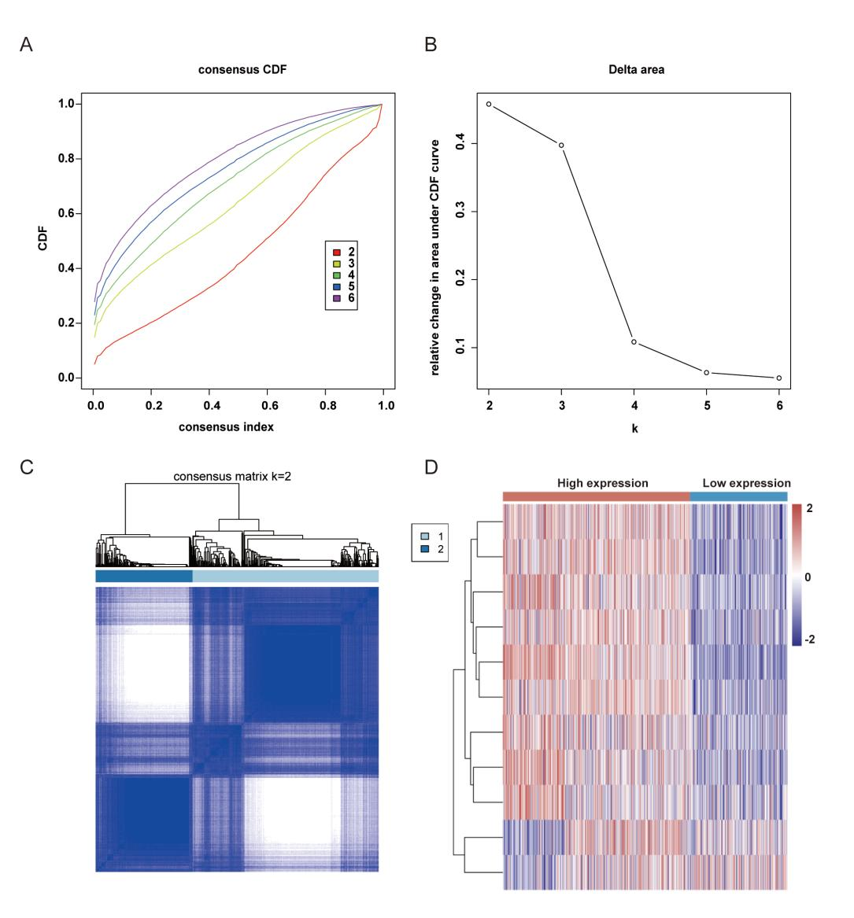
Figure S2. Differential expression of 11 CRGs classified into two groups of gliomas. (A-B) Consensus clustering cumulative distribution function (CDF) and relative change in the area under the CDF curve (CDF delta area). The relative change in area under the CDF curve when cluster number varied from k − 1 to k. The abscissa represents the category number k and the ordinate represents the relative change in the area. (C) Heatmap of the consistency of clustering results (k = 2). Rows and columns represent samples and the different colors represent different types. (D) Expression heatmap of 11 CRGs in different subgroups. Red represents high expression and blue represents low expression.
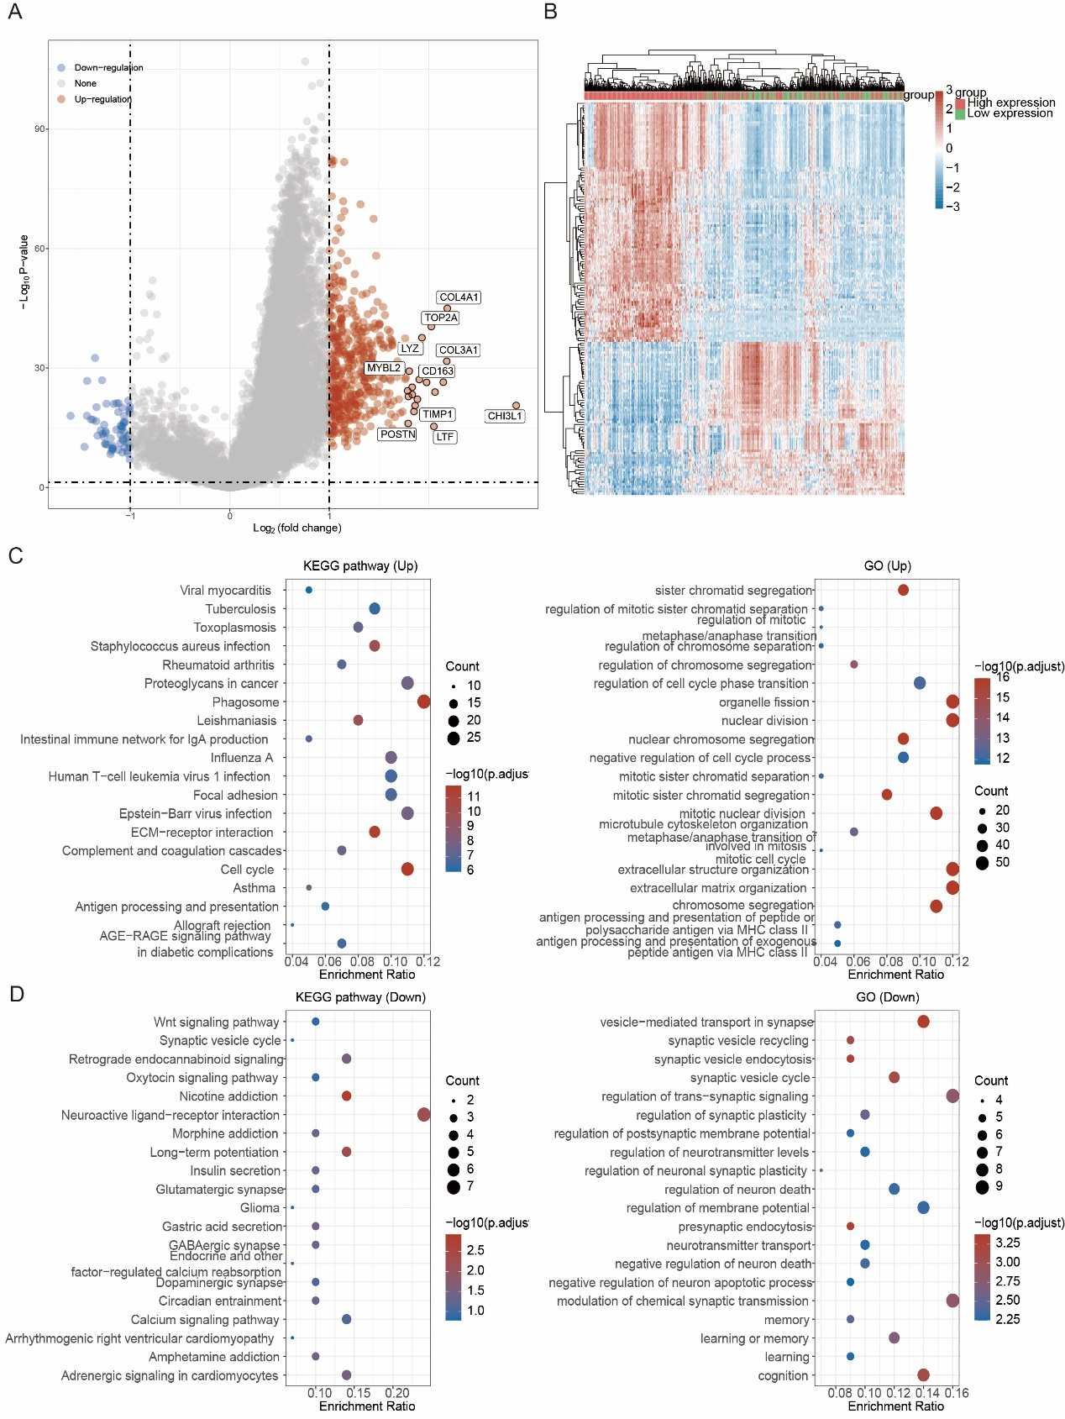
Figure S3. Functional analysis of 11 CRGs in glioma. (A) Differential gene expression of the 11 CRGs in glioma. The top 10 genes are marked. Each dot represents one gene, red indicates upregulated genes, blue indicates downregulated genes, and gray indicates non-differentially expressed genes. (B) The top 50 differential genes are shown in the glioma heatmap. (C) KEGG pathways influenced by 11 CRGs in PAAD (upregulated) and GO terms upregulated by 11 CRGs in PAAD. The abscissa represents the enrichment ratio and the ordinate indicates the pathway names. The redder the color, the greater the significance. (D) Eleven CRG-influenced downregulated functions in glioma analyzed via KEGG and 11 CRG-influenced downregulated functions in glioma analyzed using GO terms.
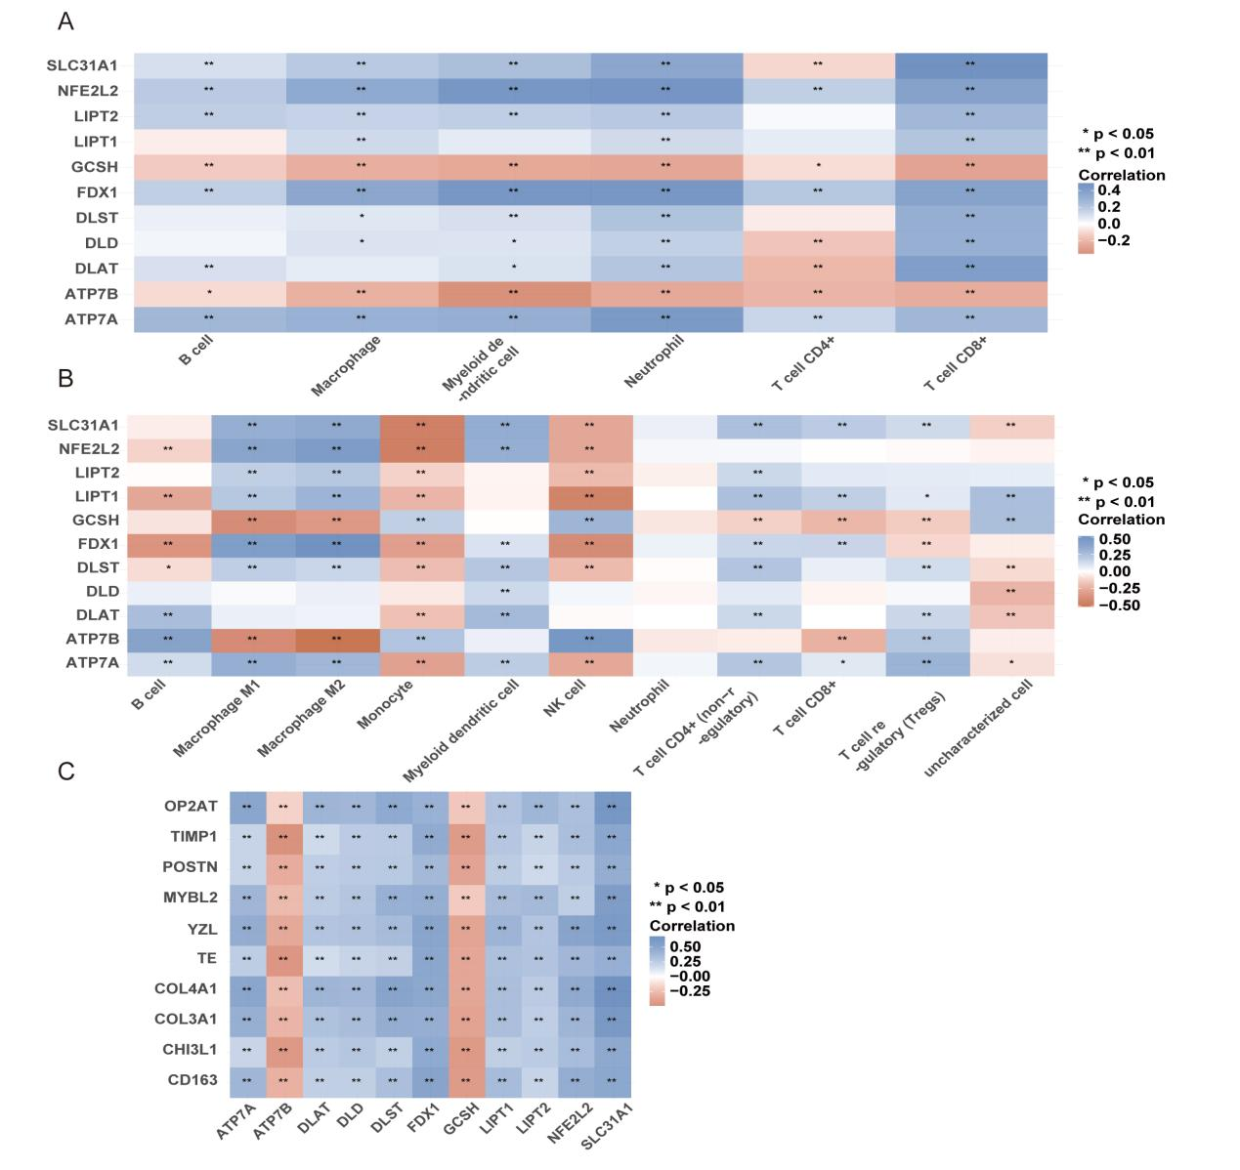
Figure S4. Role of cuproptosis-related genes in regulation of immune microenvironment in glioma. (A-B) Correlations among multiple CRGs. A heatmap of the correlation among multiple genes or models and immune score. The abscissa and ordinate represent genes and the different colors represent different correlation coefficients (blue represents positive correlation, whereas red represents negative correlation); the darker the color, the stronger the relation. Asterisks (*) indicate significance levels: ** for P < 0.01 and * for P < 0.05. (C) Correlation analysis of 11 CRGs with the top 10 genes in glioma.

Effect of clinical drugs on cuproptosis-associated genes in glioma
Owing to its rapid growth and propensity for recurrence, high-grade glioma necessitates active and effective individualized chemotherapy, which holds a great significance. Additional therapeutic approaches include molecular targeted therapy and biological immunotherapy, with several currently in clinical trials. Of note, the treatment guidelines for high-level glioma advocate the use of specific chemotherapy drugs such as TMZ, methyl benzyl hydrazine, lomustine, vincristine, carmustine, irinotecan, etoposide, cisplatin, carboplatin, and cyclophosphamide, among others. The guideline-recommended treatment options for recurrent glioma include TMZ, methyl benzyl hydrazine, carboplatin, cisplatin, lomustine, carmustine, bevacizumab, irinotecan, etoposide, and cyclophosphamide, with TMZ and methyl benzyl hydrazine being the primary choices for low-grade glioma. TMZ has gained significant attention in the chemotherapy of central nervous system tumors, particularly malignant gliomas. Indeed, it has been considered a substantial advancement in glioma chemotherapy. Following oral administration, it is swiftly absorbed, with a near-complete bioavailability of 100%. Under physiological pH, TMZ undergoes rapid conversion into methyltriazenimidazole amide, which facilitates the cytotoxic effect of DNA alkylation on tumor cells. TMZ is being explored with regard to various administration routes. The conventional method of administering TMZ is oral, but there are ongoing efforts to develop alternative routes of administration. Using TMZ as a reference, experiments were performed to examine the regulatory impact of TMZ on the 11 CRGs. The findings revealed that TMZ significantly downregulated the expression of DLAT, DLD, LIPT2, LIPT1, SLC31A1, FDX1, DLST, ATP7A, and NFE2L2 while upregulating the expression of ATP7B and GCSH (Fig. S5).

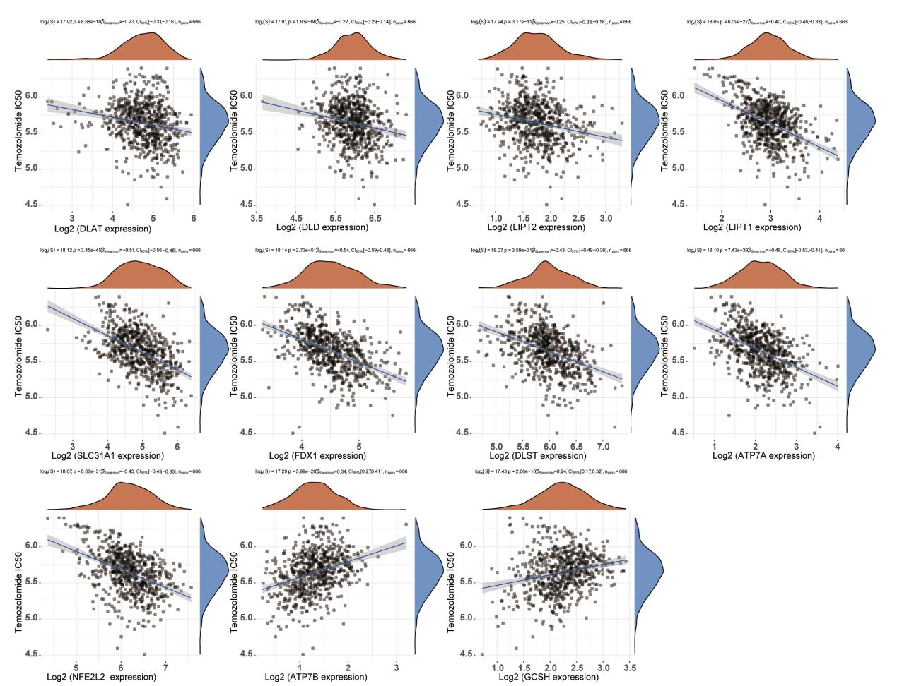
Figure S5. Correlation analysis of 11 CRGs with temozolomide in glioma.

