Supplementary Information for

Abnormal phosphorylation of LRH1 at Ser510 predicts poor prognosis
and promotes cell viability in lung squamous cell carcinoma

Hayato Mine, Kotaro Sugimoto, Makoto Kobayashi, Hironori Takagi, Naoyuki Okabe, Satoshi Muto , Yasuyuki Kobayashi, Yuko Hashimoto, Hiroyuki Suzuki, Hideki Chiba

Kotaro Sugimoto, Hideki Chiba
Email: sugikota@fmu.ac.jp; hidchiba@fmu.ac.jp

This file includes:
Figures S1 to S3
Tables S1 to S2

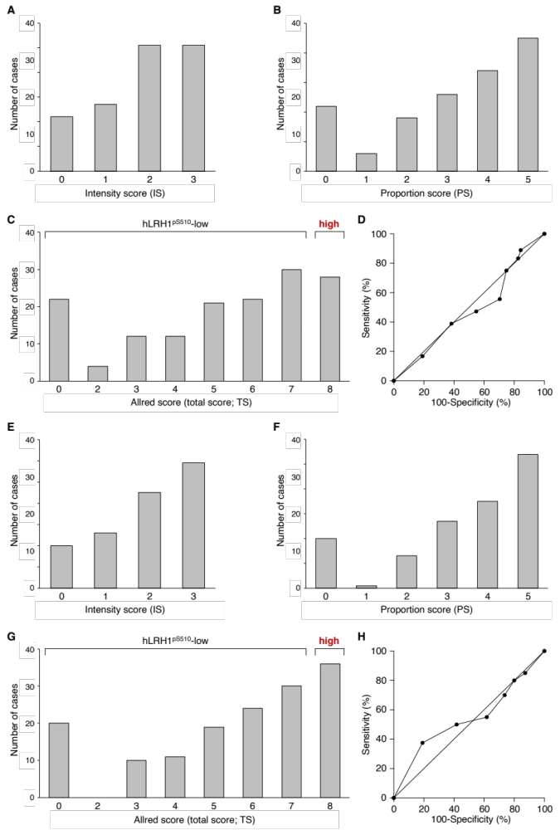

Fig. S1. Semi-quantification of the hLRH1^{pS510} signals in LUAD and LUSC subjects. The intensity score (IS; A, E), the proportion score (PS; B, F), the Allred score (C, G) and the receiver operating characteristic curves (D, H) for LUAD (A-D) and LUSC (E-H) subjects are indicated. PS 5, 4, 3, 2, and 1 correspond to 67% or more, 34-66%, 10-33%, 1-10%, and less than 1% of positive cells, respectively.

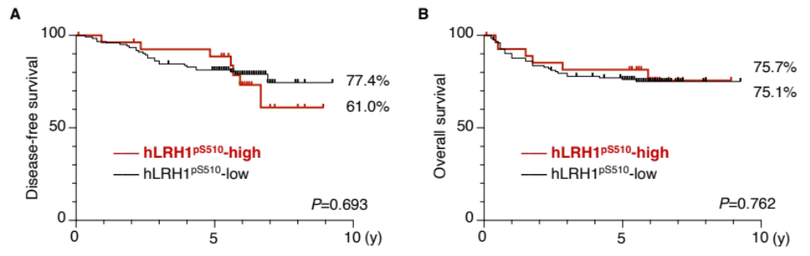
Fig. S2. hLRH1^{pS510}-high is not related to poor outcomes in LUAD patients. The disease-free survival (A) and overall survival (B) for hLRH1^{pS510}-high and hLRH1^{pS510}-low in LUAD subjects are indicated.

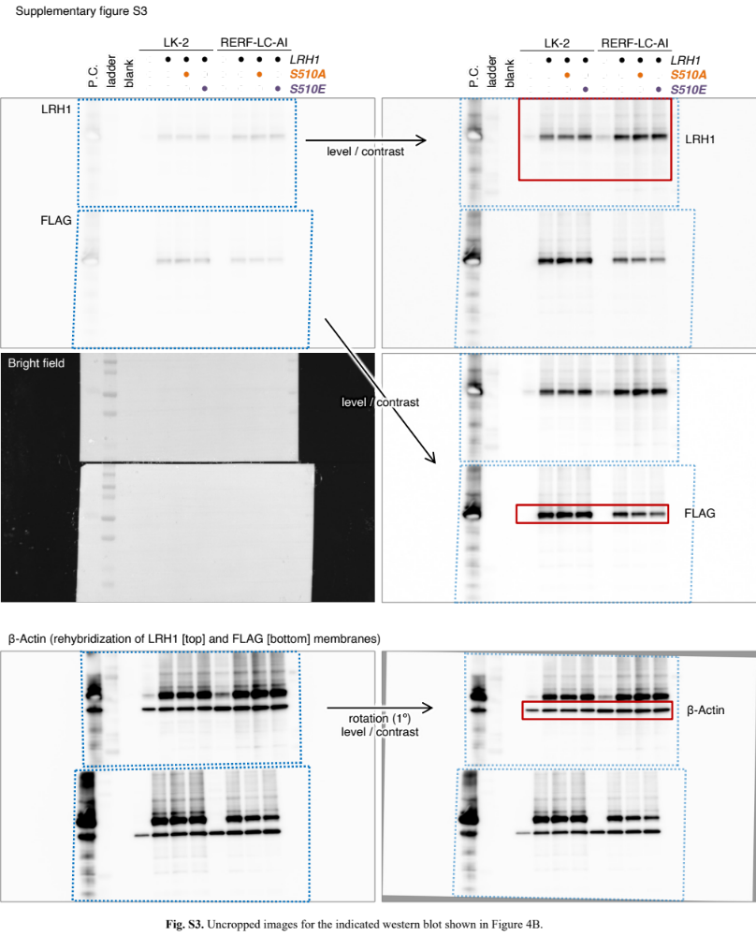
Fig. S3. Uncropped images for the indicated western blot shown in Figure 4B. P.C., positive control (293T transiently transfected with the LRH1 expression vector).

Table. S1. Clinicopathological characteristics of patients with LUAD and LUSC.
Parameter
Age (years), median | 72
Gender, n (%)
Male | 212 | (70.4)
Female | 89 | (29.6)
Smoking, n (%)
(–) | 70 | (23.3)
(+) | 231 | (76.7)
Extent of resection, n (%)
Sublobar resection | 48 | (15.9)
Lobectomy | 253 | (84.1)
Histology, n (%)
Adenocarcinoma | 151 | (50.2)
Squamous cell carcinoma | 150 | (49.8)
Tumor size, n (%)
≦3 cm | 193 | (64.1)
＞3 cm | 108 | (35.9)
pT, n (%)
T1mi | 6 | (2.0)
T1 | 148 | (49.2)
T2 | 108 | (35.9)
T3 | 24 | (8.0)
T4 | 15 | (5.0)
Pathorogical grade, n (%)
G1 | 112 | (37.2)
G2 | 141 | (46.8)
G3 | 48 | (15.9)
Vascular invasion, n (%)
(–) | 169 | (56.1)
(+) | 132 | (43.9)
Lymphatic invasion, n (%)
(–) | 221 | (73.4)
(+) | 80 | (26.6)
Pleural invasion, n (%)
(–) | 215 | (71.4)
(+) | 86 | (28.6)
Lymph node metastasis, n (%)
N0 | 245 | (81.4)
N1 | 27 | (9.0)
N2 | 29 | (9.6)
Pathological stage, n (%)
I | 205 | (68.1)
II | 49 | (16.3)
III | 47 | (15.6)
Postoperative adjuvant therapy, n (%)
(–) | 229 | (76.1)
(+) | 72 | (23.9)
EGFR gene mutations, n (%)
Negative | 165 | (54.8)
Exon 21 point mutation | 34 | (11.3)
Exon 19 deletion | 27 | (9.0)
others | 7 | (2.3)
Unknown | 68 | (22.6)
PD-L1 expression, n (%)
Negative | 28 | (9.3)
1-49% positive | 28 | (9.3)
≧50% positive | 23 | (7.6)
Unknown | 222 | (73.8)
Recurrence, n (%)
(–) | 225 | (74.8)
(+) | 76 | (25.2)
Recurrence pattern, n (%)
Local | 45 | (15.0)
Distance | 31 | (10.3)
No recurrence | 225 | (74.8)
Molecularly-target therapy, n (%)
(–) | 294 | (97.7)
(+) | 7 | (2.3)

Table. S2. Relationship between the hLRH1pS510 signal and clinicopathological factors in patients with LUAD (n=151).
Parameter | Total |  | hLRH1^{pS510}-low |  | hLRH1^{pS510}-high |  | P-value
Parameter |  |  | (n=123) |  | (n=28) |  | P-value
Age |  |  |  |  |  |  | 0.385
< 75 | 97 | (64.2) | 81 | (65.9) | 16 | (57.1)
≧75 | 54 | (35.8) | 42 | (34.1) | 12 | (42.9)
Gender |  |  |  |  |  |  | 0.302
Male | 78 | (51.7) | 66 | (53.7) | 12 | (42.9)
Female | 73 | (48.3) | 57 | (46.3) | 16 | (57.1)
Smoking |  |  |  |  |  |  | 0.870
(–) | 68 | (45.0) | 55 | (44.7) | 13 | (46.4)
(+) | 83 | (55.0) | 68 | (55.3) | 15 | (53.6)
Extent of resection |  |  |  |  |  |  | 0.116
Sublobar resection | 32 | (21.2) | 23 | (18.7) | 9 | (32.1)
Lobectomy | 119 | (78.8) | 100 | (81.3) | 19 | (67.9)
Tumor size |  |  |  |  |  |  | 0.017
≦3 cm | 113 | (74.8) | 97 | (78.9) | 16 | (57.1)
＞3 cm | 38 | (25.2) | 26 | (21.1) | 12 | (42.9)
pT |  |  |  |  |  |  | 0.893
T1mi/T1 | 88 | (58.3) | 72 | (58.5) | 16 | (57.1)
T2/T3/T4 | 63 | (41.7) | 51 | (41.5) | 12 | (42.9)
Pathorogical grade |  |  |  |  |  |  | 0.205
G1 | 81 | (53.6) | 69 | (56.1) | 12 | (42.9)
G2/G3 | 70 | (46.4) | 54 | (43.9) | 16 | (57.1)
Vascular invasion |  |  |  |  |  |  | 0.030
(–) | 111 | (73.5) | 95 | (77.2) | 16 | (57.1)
(+) | 40 | (26.5) | 28 | (22.8) | 12 | (42.9)
Lymphatic invasion |  |  |  |  |  |  | 0.102
(–) | 115 | (76.2) | 97 | (78.9) | 18 | (64.3)
(+) | 36 | (23.8) | 26 | (21.1) | 10 | (35.7)
Pleural invasion |  |  |  |  |  |  | 0.852
(–) | 110 | (72.8) | 90 | (73.2) | 20 | (71.4)
(+) | 41 | (27.2) | 33 | (26.8) | 8 | (28.6)
Lymph node metastasis |  |  |  |  |  |  | 0.130
N0 | 123 | (81.5) | 103 | (83.7) | 20 | (71.4)
N1/N2 | 28 | (18.5) | 20 | (16.3) | 8 | (28.6)
Pathological stage |  |  |  |  |  |  | 0.213
I | 116 | (76.8) | 97 | (78.9) | 19 | (67.9)
II/III | 35 | (23.2) | 26 | (21.1) | 9 | (32.1)
Postoperative adjuvant therapy |  |  |  |  |  |  | 0.193
(–) | 109 | (72.2) | 86 | (69.9) | 23 | (82.1)
(+) | 42 | (27.8) | 37 | (30.1) | 5 | (17.9)
EGFR gene mutations |  |  |  |  |  |  | 0.541
(–) | 71 | (53.4) | 58 | (54.7) | 13 | (48.1)
(+) | 62 | (46.6) | 48 | (45.3) | 14 | (51.9)
PD-L1 expression |  |  |  |  |  |  | 0.648
(–) | 20 | (51.3) | 15 | (53.6) | 5 | (45.5)
(+) | 19 | (48.7) | 13 | (46.4) | 6 | (54.5)
Recurrence |  |  |  |  |  |  | 0.740
(–) | 115 | (76.2) | 93 | (75.6) | 22 | (78.6)
(+) | 36 | (23.8) | 30 | (24.4) | 6 | (21.4)
Distant metastasis |  |  |  |  |  |  | 0.605
(–) | 15 | (42.9) | 13 | (44.8) | 2 | (33.3)
(+) | 20 | (57.1) | 16 | (55.2) | 4 | (66.7)
Molecularly-target therapy |  |  |  |  |  |  | 0.196
(–) | 144 | (95.4) | 116 | (94.3) | 28 | (100.0)
(+) | 7 | (4.6) | 7 | (5.7) | 0 | 0.0
Values are expressed as n (%).

