Supplementary Figures
- Supplementary Figure 1
- Supplementary Figure 2
- Supplementary Figure 3

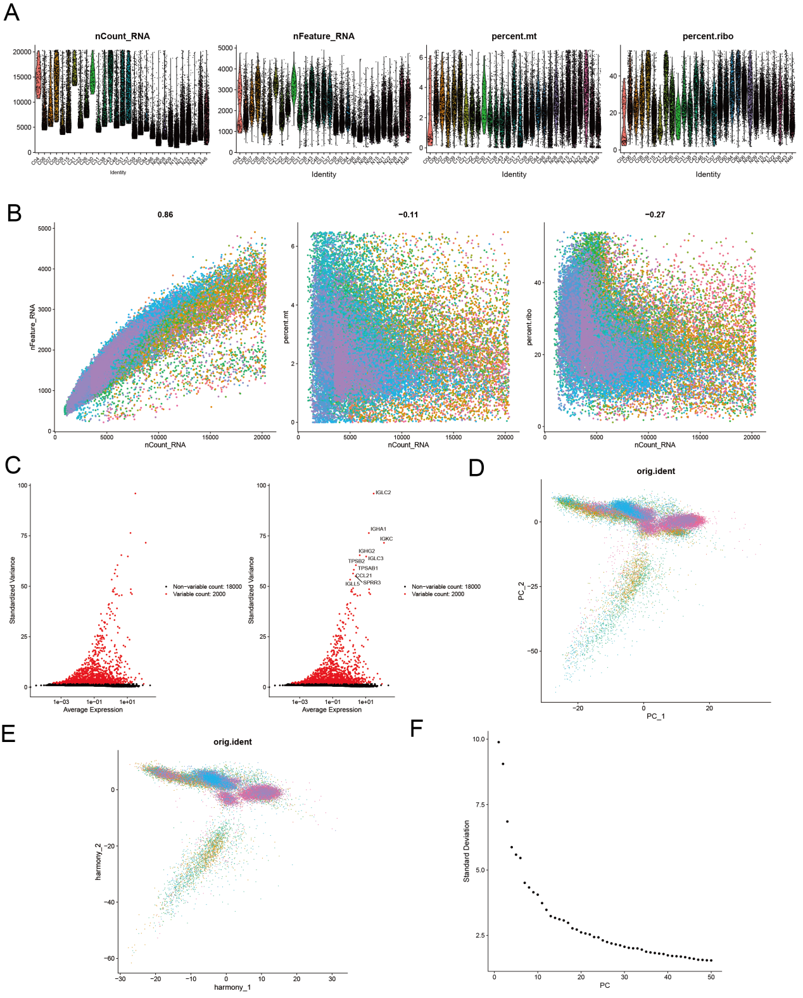
Figure S1. Identification of tumor-associated neutrophil marker genes. This study first imports the expression profile using the Seurat package, where we filter cells based on the total UMI count, the number of expressed genes, and the percentage of mitochondrial reads for each cell. Outliers are defined as those with a deviation of three median absolute deviations (MAD) from the median. Cells with low expression are excluded based on violin plots and scatter plots, and DoubletFinder is used to filter out doublet cells. After filtering, 32,223 cells remain, with the filtered violin plots and scatter plots shown (A-C). (D-F) The data are then sequentially processed with normalization, harmonization, PCA, and Harmony analysis.

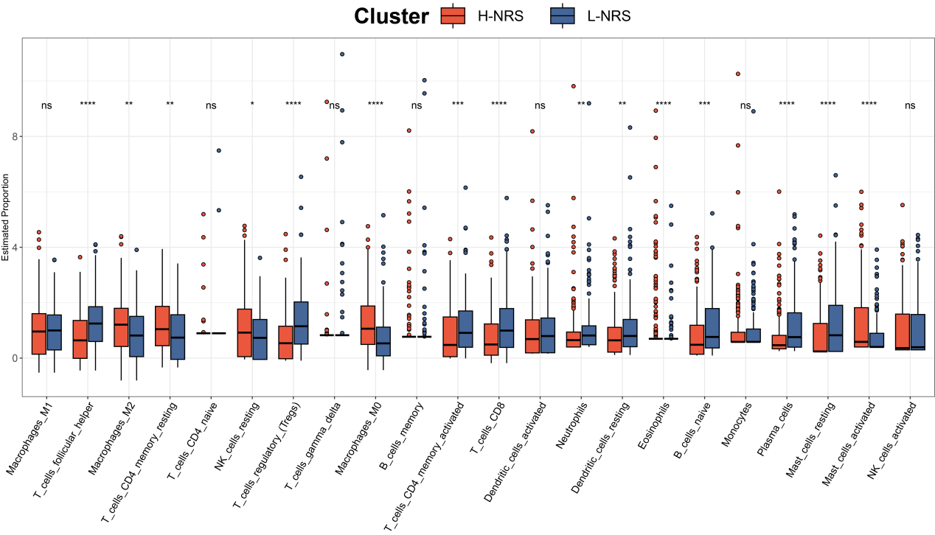
Figure S2. Immune infiltration characteristics of the NRS. Abundance of each TME-infiltrating cell type was quantified by the cibersort algorithm.
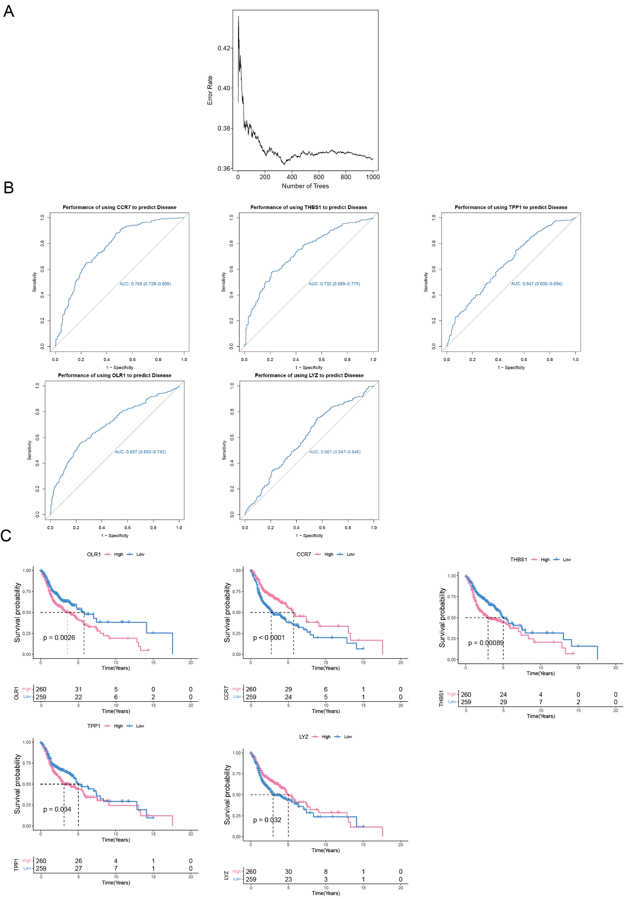
Figure S3. 5 key regulatory genes identified from NRS characteristics. A. ROC curve of five key regulatory genes prognostic features in TCGA dataset. B. Kaplan-Meier curves of overall survival with log-rank test for five key regulatory genes in TCGA dataset.

