Supplementary materials
Supplement figure 1 Study flow chart
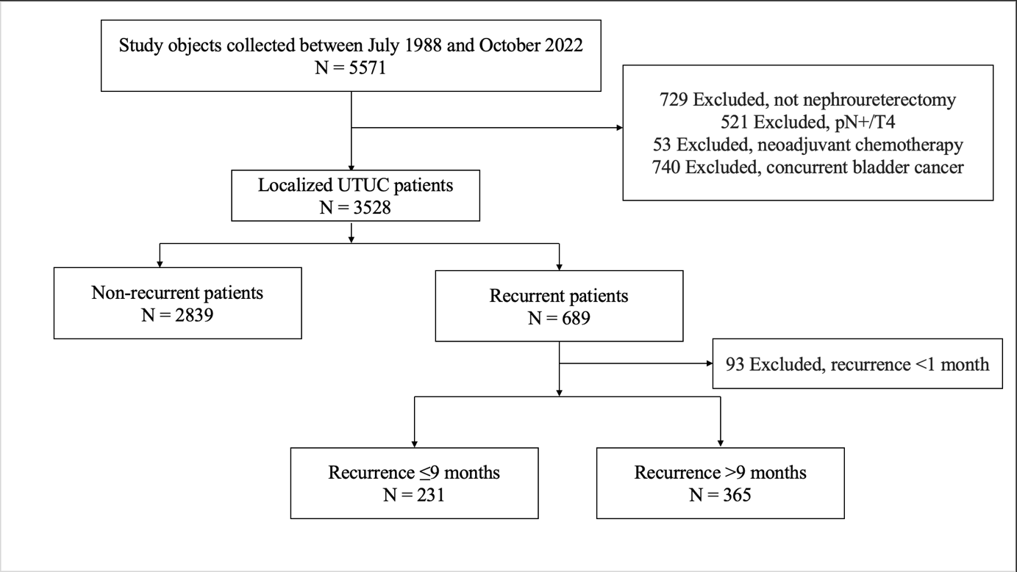

Supplement figure 2 Different cutoff threshold of early recurrence and their corresponding p-value

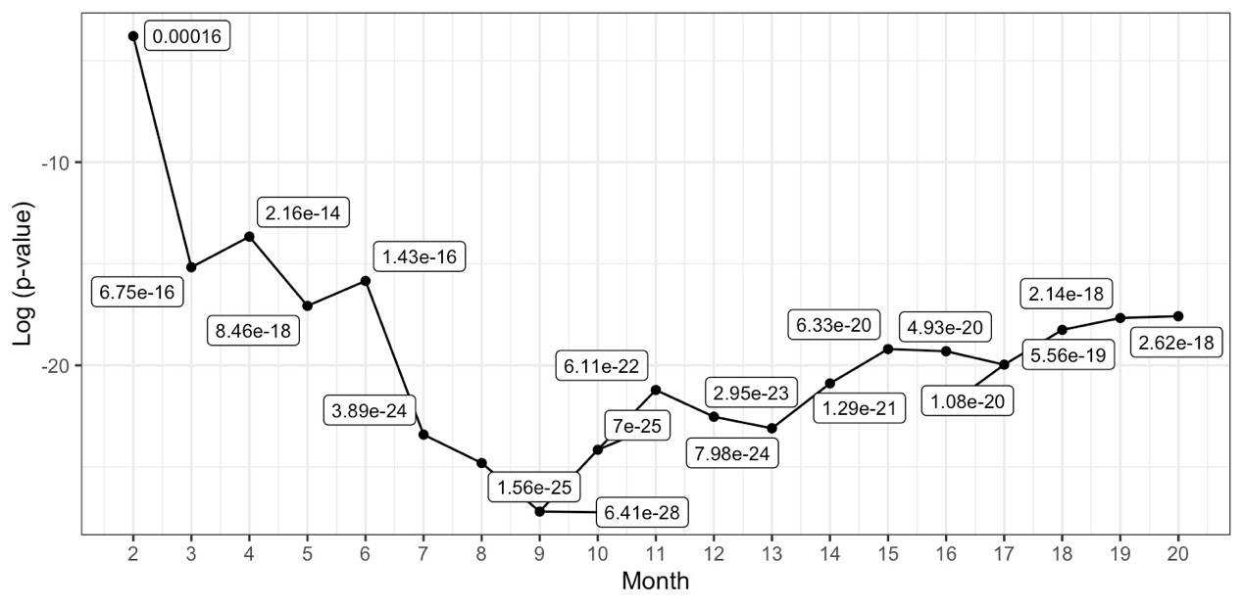

Supplement figure 3 ROC curve of the prediction model for early recurrence

(A) Development cohort

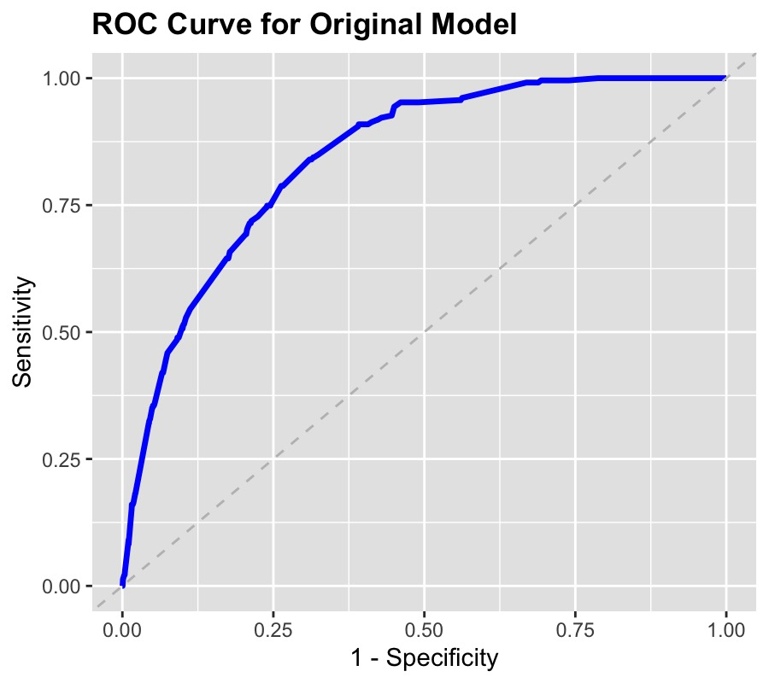

(B) Validation cohort

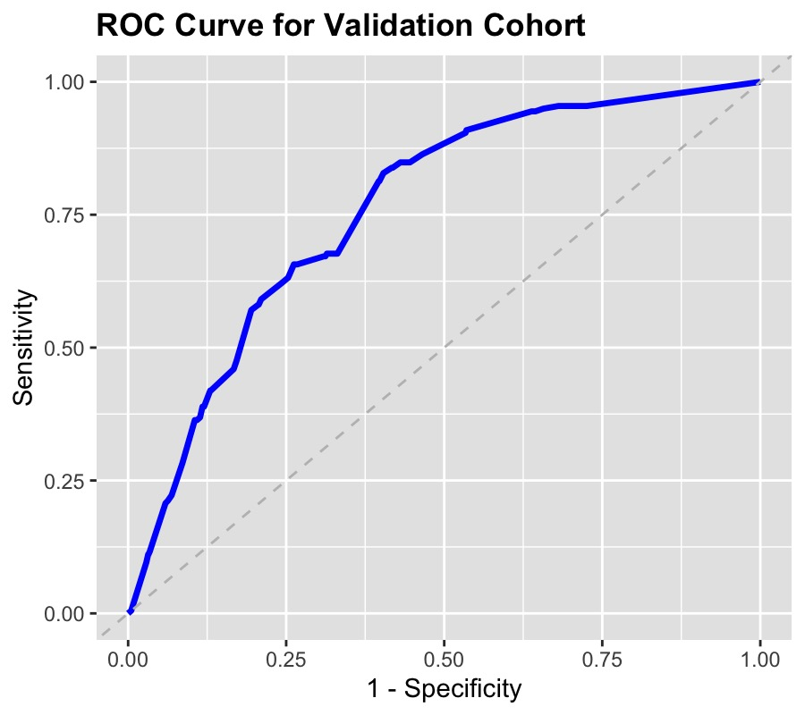

Supplement Figure 4 Survival between groups stratified according to numbers of risk factors for early recurrence
- Overall survival

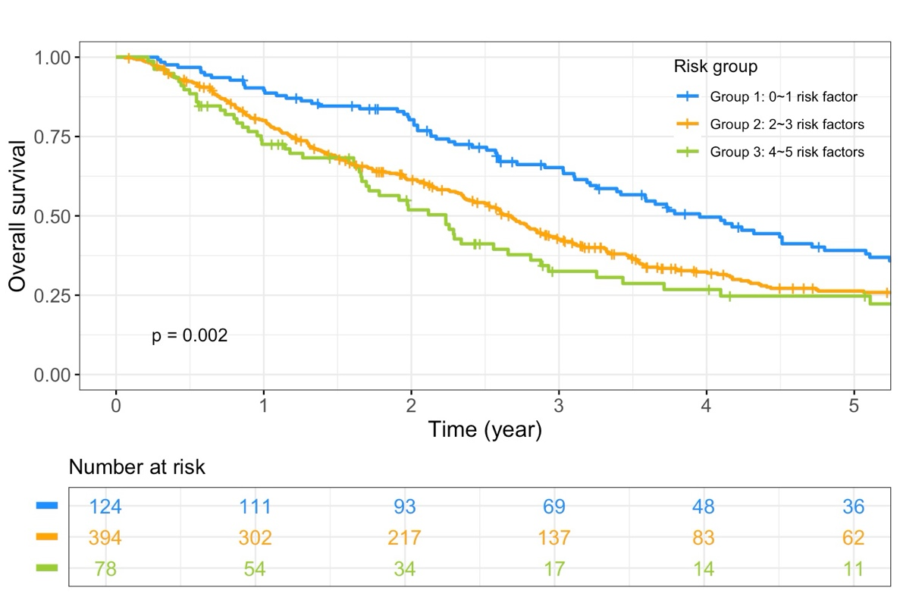
- Cancer-specific survival

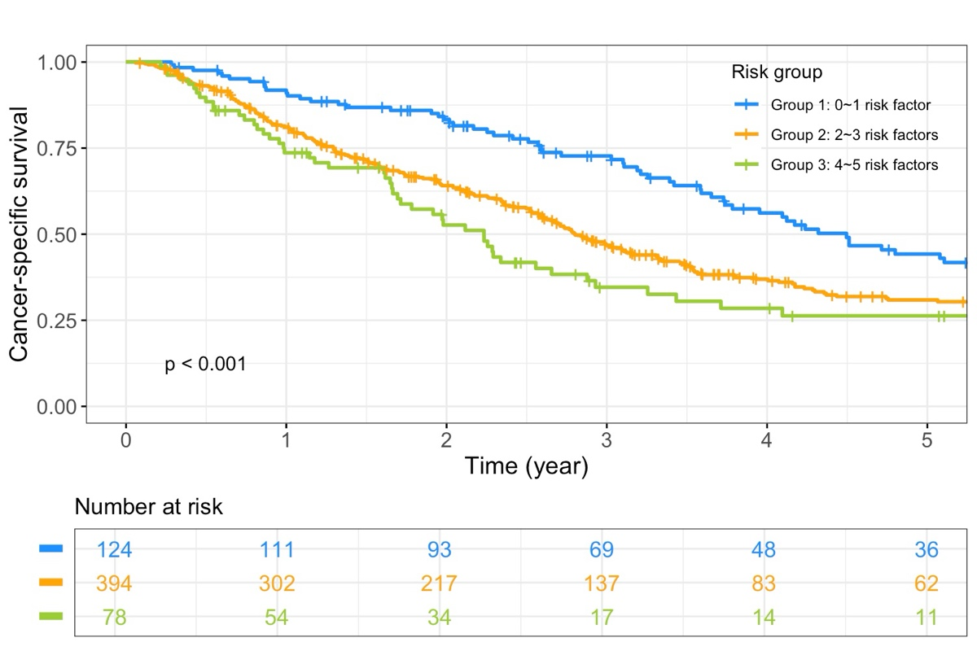

Supplement Table 1 Univariate and multivariate Cox regression analyses of OS and CSS in all UTUC patients
Variables | OS |  |  |  | CSS
Variables | Univariate |  | Multivariate |  | Univariate |  | Multivariate
Variables | HR  (95% CI) | p-value | HR  (95% CI) | p-value | HR  (95% CI) | p-value | HR  (95% CI) | p-value

Recurrence time
Late | Reference |  | Reference |  | Reference |  | Reference
Early | 8.66  (7.33–10.23) | <0.001 | 5.88  (4.90–7.06) | <0.001 | 28.25  (22.88–34.88) | <0.001 | 13.32  (10.50–16.91) | <0.001

Age
<70 | Reference |  | Reference |  | Reference |  | Reference
≥70 | 2.14  (1.90–2.40) | <0.001 | 1.98  (1.76–2.23) | <0.001 | 1.57  (1.29–1.90) | <0.001 | 1.46  (1.19–1.78) | <0.001

Sex
Male | Reference |  | Reference |  | Reference
Female | 0.86  (0.77–0.96) | 0.009 | 0.83  (0.74–0.93) | 0.001 | 0.87  (0.72–1.06) | 0.172

ECOG
0-1 | Reference |  | Reference |  | Reference |  | Reference
2-4 | 2.50  (2.04–3.07) | <0.001 | 1.82  (1.47–2.24) | <0.001 | 1.85  (1.27–2.69) | 0.001 | 1.46  (0.99–2.15) | 0.058

DM
No | Reference |  | Reference |  | Reference |  | Reference
Yes | 1.43  (1.26–1.62) | <0.001 | 1.16  (1.02–1.32) | 0.025 | 1.28  (1.03–1.60) | 0.026 | 0.95  (0.76–1.19) | 0.649

ESRD/Renal insufficiency
No | Reference |  | Reference |  | Reference
Yes | 1.59  (1.41–1.80) | <0.001 | 1.51  (1.34–1.71) | <0.001 | 1.02  (0.84–1.24) | 0.847

Smoking
No | Reference |  |  |  | Reference
Yes | 1.12  (0.96–1.31) | 0.134 |  |  | 1.22  (0.95–1.56) | 0.122

Tumor side
Unilateral | Reference |  |  |  | Reference
Bilateral | 1.35  (0.72–2.52) | 0.345 |  |  | 0.37  (0.05–2.64) | 0.322

Preoperative hydronephrosis
No | Reference |  | Reference |  | Reference
Yes | 1.26  (1.13–1.41) | <0.001 | 1.03  (0.92–1.16) | 0.578 | 1.63  (1.34–1.99) | <0.001 | 1.25  (1.02–1.53) | 0.031

Tumor location
Ureter | Reference |  |  |  | Reference
Renal pelvis | 0.91  (0.82–1.02) | 0.121 |  |  | 0.94  (0.77–1.14) | 0.53

Tumor grade
Low grade | Reference |  | Reference |  | Reference |  | Reference
High grade/G2 | 1.53  (1.28–1.82) | <0.001 | 1.20  (1–1.44) | 0.046 | 3.98  (2.51–6.30) | <0.001 | 1.76  (1.09–2.84) | 0.02

Multifocality
No | Reference |  | Reference |  | Reference |  | Reference
Yes | 1.53  (1.37–1.71) | <0.001 | 1.18  (1.06–1.33) | 0.004 | 3.46  (2.79–4.28) | <0.001 | 2.08  (1.67–2.60) | <0.001

Lympho-vascular invasion
No | Reference |  | Reference |  | Reference |  | Reference
Yes | 1.98  (1.72–2.28) | <0.001 | 1.15  (0.98–1.34) | 0.081 | 3.39  (2.76–4.16) | <0.001 | 1.02  (0.81–1.29) | 0.878

Tumor necrosis
No | Reference |  | Reference |  | Reference |  | Reference
Yes | 1.51  (1.29–1.76) | <0.001 | 1.14  (0.97–1.33) | 0.109 | 2.01  (1.59–2.55) | <0.001 | 1.14  (0.89–1.45) | 0.305

Pathologic T stage
pTis/pTa/pT1 | Reference |  | Reference |  | Reference |  | Reference
pT2 | 1.39  (1.20–1.61) | <0.001 | 1.19  (1.02–1.39) | 0.023 | 2.55  (1.85–3.51) | <0.001 | 1.71  (1.23–2.39) | 0.001
pT3 | 2.12  (1.87–2.40) | <0.001 | 1.57  (1.36–1.81) | <0.001 | 7.07  (5.47–9.14) | <0.001 | 3.77  (2.81–5.05) | <0.001

Lymph node dissection
No | Reference |  |  |  | Reference
Yes | 0.92  (0.78–1.07) | 0.277 |  |  | 1.08  (0.84–1.38) | 0.547

Adjuvant chemotherapy
No | Reference |  |  |  | Reference
Yes | 0.86  (0.72–1.03) | 0.11 |  |  | 1.64  (1.28–2.10) | <0.001 | 0.93  (0.72–1.22) | 0.604

Supplement Table 2 Clinical and pathologic characteristics of development and validation cohort
Variables | Development cohort (N=3435) |  |  |  | Validation cohort (N=2246) |  |  |  |  | p-value
Variables | N |  | % |  | N |  |  | % |  | p-value

Early recurrence
No |  | 3204 |  | 93.3 |  | 2048 | 91.2 |  | 0.003
Yes |  | 231 |  | 6.7 |  | 198 | 8.8

Age
<70 | 1793 |  | 52.2 |  | 1139 |  |  | 50.7 |  | 0.273
≥70 | 1642 |  | 47.8 |  | 1107 |  |  | 49.3 |  | 0.273

Sex
Male | 1435 |  | 41.8 |  | 1515 |  |  | 67.5 |  | <0.001
Female | 2000 |  | 58.2 |  | 731 |  |  | 32.5 |  | <0.001

ECOG
0 | 2187 |  | 63.7 |  | 1764 |  |  | 78.5 |  | <0.001
1 | 1067 |  | 31.1 |  | 367 |  |  | 16.3 |  | <0.001
2 | 152 |  | 4.4 |  | 90 |  |  | 4.0 |  | <0.001
3 | 22 |  | 0.6 |  | 8 |  |  | 0.4 |  | <0.001
4 | 7 |  | 0.2 |  | 17 |  |  | 0.8 |  | <0.001

DM
No | 2655 |  | 77.3 |  | 1920 |  |  | 85.5 |  | <0.001
Yes | 780 |  | 22.7 |  | 326 |  |  | 14.5 |  | <0.001

Smoking
No | 2899 |  | 84.4 |  | 1928 |  |  | 85.8 |  | 0.136
Yes | 536 |  | 15.6 |  | 318 |  |  | 14.2 |  | 0.136

Tumor location
Ureter only | 1323 |  | 38.5 |  | 831 |  |  | 37.0 |  | 0.249
Renal pelvis involvement | 2112 |  | 61.5 |  | 1415 |  |  | 63.0 |  | 0.249

Grade
Low grade | 482 |  | 14.0 |  | 371 |  |  | 16.5 |  | 0.01
High grade/G2 | 2953 |  | 86.0 |  | 1875 |  |  | 83.5 |  | 0.01

Multifocality
No | 1889 |  | 55.0 |  | 1435 |  |  | 63.9 |  | <0.001
Yes | 1546 |  | 45.0 |  | 811 |  |  | 36.1 |  | <0.001

Lympho-vascular invasion
No | 2900 |  | 84.4 |  | 1773 |  |  | 78.9 |  | <0.001
Yes | 535 |  | 15.6 |  | 473 |  |  | 21.1 |  | <0.001

Tumor necrosis
No | 2986 |  | 87.0 |  | 1765 |  |  | 78.6 |  | <0.001
Yes | 449 |  | 13.0 |  | 481 |  |  | 21.4 |  | <0.001

Pathologic T stage
pTis/pTa/pT1 | 1619 |  | 47.1 |  | 1086 |  |  | 48.4 |  | 0.593
pT2 | 690 |  | 20.1 |  | 451 |  |  | 20.1 |  | 0.593
pT3 | 1126 |  | 32.8 |  | 709 |  |  | 31.6 |  | 0.593

Lymph node dissection
No | 2747 |  | 80.0 |  | 1543 |  |  | 68.7 |  | <0.001
Yes | 688 |  | 20.0 |  | 703 |  |  | 31.3 |  | <0.001

Adjuvant chemotherapy
No | 3002 |  | 87.4 |  | 2043 |  |  | 91.0 |  | <0.001
Yes | 433 |  | 12.6 |  | 203 |  |  | 9.0 |  | <0.001

