Supplementary Table S1 Categories and case numbers of adverse events in the blood and lymphatic system in CAR-T reports
PT | Total | Tisagenlecleucel | Axicabtagene ciloleucel | Brexucabtagene autoleucel | Lisocabtagene maraleucel | Idecabtagene vicleucel | Ciltacabtagene autoleucel
Neutropenia | 375 | 97 | 224 | 20 | 8 | 14 | 12
Cytopenia | 263 | 129 | 97 | 12 | 2 | 16 | 7
Pancytopenia | 261 | 60 | 154 | 26 | 2 | 15 | 4
Anaemia | 248 | 72 | 130 | 5 | 9 | 25 | 7
Febrile neutropenia | 243 | 89 | 116 | 17 | 3 | 11 | 7
Thrombocytopenia | 227 | 81 | 110 | 10 | 4 | 12 | 10
Bone marrow failure | 92 | 36 | 46 | 6 | 1 | 3 | 0
B-cell aplasia | 87 | 63 | 21 | 2 | 1 | 0 | 0
Coagulopathy | 87 | 61 | 22 | 2 | 1 | 1 | 0
Disseminated intravascular coagulation | 70 | 32 | 25 | 5 | 1 | 6 | 1
Hypofibrinogenaemia | 40 | 13 | 14 | 10 | 1 | 1 | 1
Leukopenia | 39 | 17 | 13 | 0 | 3 | 3 | 3
Lymphadenopathy | 37 | 26 | 11 | 0 | 0 | 0 | 0
Myelosuppression | 33 | 7 | 19 | 2 | 0 | 5 | 0
Agranulocytosis | 25 | 6 | 18 | 1 | 0 | 0 | 0
Lymphopenia | 25 | 8 | 10 | 1 | 3 | 2 | 1
Febrile bone marrow aplasia | 25 | 3 | 9 | 1 | 0 | 12 | 0
Haematotoxicity | 20 | 2 | 4 | 0 | 2 | 11 | 1
Leukocytosis | 11 | 9 | 2 | 0 | 0 | 0 | 0
Splenomegaly | 11 | 8 | 2 | 1 | 0 | 0 | 0
Bone marrow disorder | 11 | 9 | 2 | 0 | 0 | 0 | 0
Lymphocytosis | 9 | 7 | 0 | 0 | 0 | 0 | 2
Eosinophilia | 7 | 4 | 3 | 0 | 0 | 0 | 0
Thrombotic microangiopathy | 7 | 2 | 3 | 0 | 1 | 1 | 0
Haemolytic anaemia | 5 | 2 | 1 | 1 | 0 | 1 | 0
Haemolysis | 5 | 3 | 1 | 0 | 0 | 1 | 0
Hypoglobulinaemia | 4 | 0 | 3 | 1 | 0 | 0 | 0
Abdominal lymphadenopathy | 4 | 4 | 0 | 0 | 0 | 0 | 0
Aplastic anaemia | 4 | 2 | 2 | 0 | 0 | 0 | 0
Coombs negative haemolytic anaemia | 4 | 1 | 2 | 1 | 0 | 0 | 0
Hyperleukocytosis | 4 | 4 | 0 | 0 | 0 | 0 | 0
Erythropenia | 3 | 2 | 0 | 0 | 1 | 0 | 0
Platelet disorder | 3 | 2 | 1 | 0 | 0 | 0 | 0
Bone marrow infiltration | 3 | 3 | 0 | 0 | 0 | 0 | 0
Immune thrombocytopenia | 3 | 2 | 1 | 0 | 0 | 0 | 0
Splenic haemorrhage | 2 | 2 | 0 | 0 | 0 | 0 | 0
Hyperfibrinolysis | 2 | 2 | 0 | 0 | 0 | 0 | 0
Blood disorder | 2 | 1 | 0 | 0 | 0 | 0 | 1
Splenic infarction | 2 | 2 | 0 | 0 | 0 | 0 | 0
Pseudolymphoma | 2 | 0 | 0 | 1 | 1 | 0 | 0
Neutrophilia | 2 | 2 | 0 | 0 | 0 | 0 | 0
Normocytic anaemia | 2 | 2 | 0 | 0 | 0 | 0 | 0
Splenic lesion | 2 | 1 | 1 | 0 | 0 | 0 | 0
Autoimmune haemolytic anaemia | 2 | 1 | 1 | 0 | 0 | 0 | 0
White blood cell disorder | 2 | 1 | 1 | 0 | 0 | 0 | 0
Thrombotic thrombocytopenic purpura | 2 | 0 | 2 | 0 | 0 | 0 | 0
Thrombocytosis | 1 | 1 | 0 | 0 | 0 | 0 | 0
Reticuloendothelial system stimulated | 1 | 1 | 0 | 0 | 0 | 0 | 0
Methaemoglobinaemia | 1 | 0 | 1 | 0 | 0 | 0 | 0
Monocytosis | 1 | 1 | 0 | 0 | 0 | 0 | 0
Spleen disorder | 1 | 0 | 1 | 0 | 0 | 0 | 0
Bone marrow necrosis | 1 | 1 | 0 | 0 | 0 | 0 | 0
Basophilia | 1 | 1 | 0 | 0 | 0 | 0 | 0
Bicytopenia | 1 | 0 | 1 | 0 | 0 | 0 | 0
Granulocytopenia | 1 | 0 | 1 | 0 | 0 | 0 | 0
Iron deficiency anaemia | 1 | 0 | 1 | 0 | 0 | 0 | 0
Retroperitoneal lymphadenopathy | 1 | 0 | 1 | 0 | 0 | 0 | 0
Normochromic anaemia | 1 | 1 | 0 | 0 | 0 | 0 | 0
Lymphoblastosis | 1 | 1 | 0 | 0 | 0 | 0 | 0
Normochromic normocytic anaemia | 1 | 1 | 0 | 0 | 0 | 0 | 0
Hyperglobulinaemia | 1 | 0 | 0 | 0 | 0 | 1 | 0
Heparin-induced thrombocytopenia | 1 | 1 | 0 | 0 | 0 | 0 | 0
B-lymphocyte abnormalities | 1 | 1 | 0 | 0 | 0 | 0 | 0
Aplasia pure red cell | 1 | 0 | 0 | 1 | 0 | 0 | 0
Hypercoagulation | 1 | 1 | 0 | 0 | 0 | 0 | 0
Lymphocytic infiltration | 1 | 0 | 1 | 0 | 0 | 0 | 0
Extramedullary haemopoiesis | 1 | 1 | 0 | 0 | 0 | 0 | 0
Erythropoiesis abnormal | 1 | 0 | 1 | 0 | 0 | 0 | 0
Lymphatic disorder | 1 | 1 | 0 | 0 | 0 | 0 | 0

Supplementary Table S2 Signal detection of blood and lymphatic system adverse events related to different CAR-T products
PT | Tisagenlecleucel |  |  | Axicabtagene ciloleucel |  |  | Brexucabtagene autoleucel |  |  |  | Lisocabtagene maraleucel |  |  |  | Idecabtagene vicleucel |  |  |  | Ciltacabtagene autoleucel
PT | a | ROR025 | IC025 | a | ROR025 | IC025 | a | ROR025 | IC025 | a |  | ROR025 | IC025 | a |  | ROR025 | IC025 | a |  | ROR025 | IC025
B-cell aplasia | 63 | 1054.56 | 4.74 | 21 | 154.59 | 3.50
Cytopenia | 129 | 30.41 | 4.54 | 97 | 17.27 | 3.81 | 12 | 7.66 | 1.97 |  |  |  |  | 16 |  | 15.16 | 2.65 | 7 |  | 7.18 | 1.42
Hypofibrinogenaemia | 13 | 22.16 | 2.58 | 14 | 18.81 | 2.60 | 10 | 100.18 | 2.46
Coagulopathy | 61 | 14.71 | 3.49 | 22 | 3.51 | 1.56
Disseminated intravascular coagulation | 32 | 9.30 | 2.75 | 25 | 5.48 | 2.10 | 5 | 4.54 | 0.86 |  |  |  |  | 6 |  | 8.73 | 1.32
Lymphocytosis | 7 | 7.04 | 1.41
Bone marrow disorder | 9 | 6.87 | 1.65
Bone marrow infiltration | 3 | 6.78 | 0.35
Abdominal lymphadenopathy | 4 | 5.64 | 0.68
Bone marrow failure | 36 | 5.22 | 2.15 | 46 | 5.54 | 2.27 | 6 | 7.72 | 1.28 |  |  |  |  | 3 |  | 4.17 | 0.25
Febrile neutropenia | 89 | 4.43 | 2.06 | 116 | 4.64 | 2.14 | 17 | 2.90 | 1.27 | 3 |  | 0.86 | -0.54 | 11 |  | 2.37 | 0.91 | 7 |  | 1.95 | 0.54
Hyperleukocytosis | 4 | 4.19 | 0.58
Pancytopenia | 60 | 3.87 | 1.85 | 154 | 8.66 | 3.01 | 26 | 7.34 | 2.42 |  |  |  |  | 15 |  | 5.46 | 1.86 | 4 |  | 1.35 | -0.05
Thrombocytopenia | 81 | 2.54 | 1.30 | 110 | 2.80 | 1.44 | 10 | 1.02 | -0.06 | 4 |  | 0.93 | -0.36 | 12 |  | 1.87 | 0.68 | 10 |  | 2.23 | 0.81
Lymphadenopathy | 26 | 2.22 | 1.03 | 11 | 0.60 | -0.73
Neutropenia | 97 | 2.15 | 1.07 | 224 | 4.18 | 2.02 | 20 | 1.50 | 0.50 | 8 |  | 1.48 | 0.31 | 14 |  | 1.33 | 0.31 | 12 |  | 1.55 | 0.46
Splenomegaly | 8 | 1.45 | 0.29
Anaemia | 72 | 1.37 | 0.43 | 130 | 2.07 | 1.02 | 5 | 0.25 | -1.82 | 9 |  | 1.87 | 0.59 | 25 |  | 2.98 | 1.38 | 7 |  | 0.87 | -0.29
Leukocytosis | 9 | 1.25 | 0.16
Lymphopenia | 8 | 1.04 | -0.06 | 10 | 1.10 | 0.02 |  |  |  | 3 |  | 3.86 | 0.23
Leukopenia | 17 | 0.91 | -0.17 | 13 | 0.51 | -0.95 |  |  |  | 3 |  | 1.43 | -0.19 | 3 |  | 0.63 | -0.79 | 3 |  | 0.94 | -0.46
Febrile bone marrow aplasia | 3 | 0.86 | -0.54 | 9 | 3.25 | 1.12 |  |  |  |  |  |  |  | 12 |  | 55.32 | 2.70
Agranulocytosis | 6 | 0.63 | -0.69 | 18 | 2.07 | 0.89
Haemolysis | 3 | 0.60 | -0.83
Myelosuppression | 7 | 0.43 | -1.15 | 19 | 1.20 | 0.20 |  |  |  |  |  |  |  | 5 |  | 1.02 | -0.20
Eosinophilia | 4 | 0.35 | -1.36 | 3 | 0.18 | -2.14
Hypoglobulinaemia |  |  |  | 3 | 35.65 | 0.41
Haematotoxicity |  |  |  | 4 | 0.51 | -0.95 |  |  |  |  |  |  |  | 11 |  | 16.99 | 2.30
Thrombotic microangiopathy |  |  |  | 3 | 0.30 | -1.50

Supplementary Table S3 Association of blood and lymphatic system adverse events with different CAR-T products
 | a | b | c | d | ROR(95%CI) | IC025
Tisagenlecleucel | 893 | 14129 | 404527 | 27474242 | 4.29(4.01-4.59) | 1.93
Axicabtagene ciloleucel | 1079 | 18080 | 389829 | 26926428 | 4.12(3.88-4.38) | 1.89
Brexucabtagene autoleucel | 126 | 3034 | 187197 | 16079480 | 3.57(2.98-4.26) | 1.51
Lisocabtagene maraleucel | 44 | 920 | 152502 | 13617268 | 4.27(3.16-5.78) | 1.51
Idecabtagene vicleucel | 141 | 2048 | 164475 | 13260403 | 5.55(4.68-6.58) | 2.10
Ciltacabtagene autoleucel | 57 | 1386 | 102413 | 9118967 | 3.66(2.81-4.77) | 1.38

Supplementary Table S4 Proportion of death outcome in different PTs within blood and lymphatic system
PT | Tisagenlecleucel |  | Axicabtagene ciloleucel |  | Brexucabtagene autoleucel |  | Lisocabtagene maraleucel |  | Idecabtagene vicleucel |  | Ciltacabtagene autoleucel
PT | Death | Rate | Death | Rate | Death | Rate | Death | Rate | Death | Rate | Death | Rate
B-cell aplasia | 7 | 11.1% | 1 | 4.8%
Cytopenia | 24 | 18.6% | 21 | 21.6% | 6 | 50.0%
Hypofibrinogenaemia | 4 | 30.8% |  |  | 6 | 60.0%
Coagulopathy | 11 | 18.0% | 7 | 31.8%
Disseminated intravascular coagulation | 9 | 28.1% | 11 | 44.0% | 1 | 20.0% |  |  | 1 | 16.7%
Lymphocytosis | 4 | 57.1%
Bone marrow disorder | 2 | 22.2%
Bone marrow infiltration | 1 | 33.3%
Abdominal lymphadenopathy | 1 | 25.0%
Bone marrow failure | 9 | 25.0% | 6 | 13.0% | 1 | 16.7%
Febrile neutropenia | 8 | 9.0% | 19 | 16.4% | 1 | 5.9% |  |  |  |  | 1 | 14.3%
Hyperleukocytosis
Pancytopenia | 19 | 31.7% | 29 | 18.8% | 4 | 15.4% |  |  | 3 | 20.0%
Thrombocytopenia | 21 | 25.9% | 14 | 12.7% |  |  |  |  | 2 | 16.7%
Lymphadenopathy | 4 | 15.4%
Neutropenia | 19 | 19.6% | 20 | 8.9% | 4 | 20.0% | 1 | 12.5% | 1 | 7.1% | 1 | 8.3%
Splenomegaly | 2 | 25.0%
Anaemia | 21 | 29.2% | 3 | 2.3% |  |  | 2 | 22.2%
Leukocytosis | 2 | 22.2%
Lymphopenia |  |  | 5 | 50.0%
Febrile bone marrow aplasia |  |  | 4 | 44.4%
Agranulocytosis |  |  | 3 | 16.7%
Myelosuppression |  |  | 2 | 10.5%

Supplementary Table S5 Design differences between different CAR-T products
Trade Name | Generic Name | Indications | Target | Costimulatory Domain | Approval time
Kymriah | Tisagenlecleucel | ALL, DLBCL, FL | CD19 | 4-1BB | August 2017
Yescarta | Axicabtagene Ciloleucel | LBCL, FL | CD19 | CD28 | October 2017
Tecartus | Brexucabtagene Autoleucel | MCL, B-ALL | CD19 | CD28 | July 2020
Breyanzi | Lisocabtagene Maraleucel | LBCL, FL, MCL | CD19 | 4-1BB | February 2021
Abecma | Idecabtagene Vicleucel | MM | BCMA | 4-1BB | March 2021
Carvykti | Ciltacabtagene Autoleucel | MM | BCMA | 4-1BB | February 2022
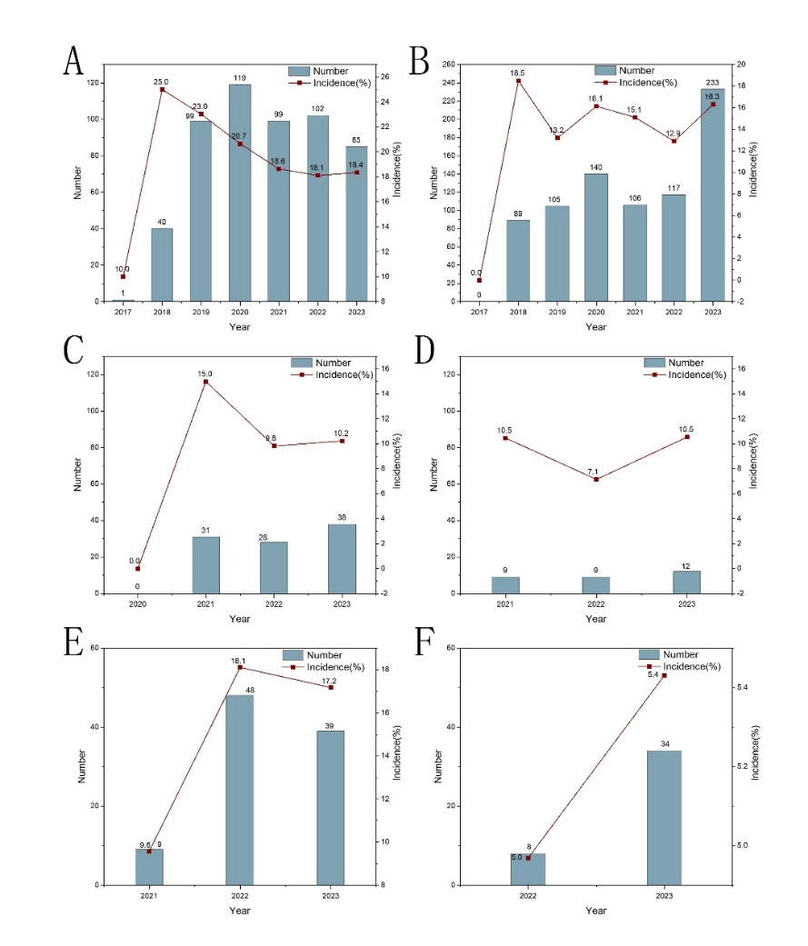
Supplementary Figure S1 Incidence rates of hematological and lymphatic system adverse events in CAR-T reports of different years. A) Incidence rate of hematological and lymphatic system AEs in tisa-cel. B) Incidence rate of hematological and lymphatic system AEs in axi-cel. C) Incidence rate of hematological and lymphatic system AEs in brexu-cel. D) Incidence rate of hematological and lymphatic system AEs in liso-cel. E) Incidence rate of hematological and lymphatic system AEs in ide-cel. F) Incidence rate of hematological and lymphatic system AEs in cilta-cel.
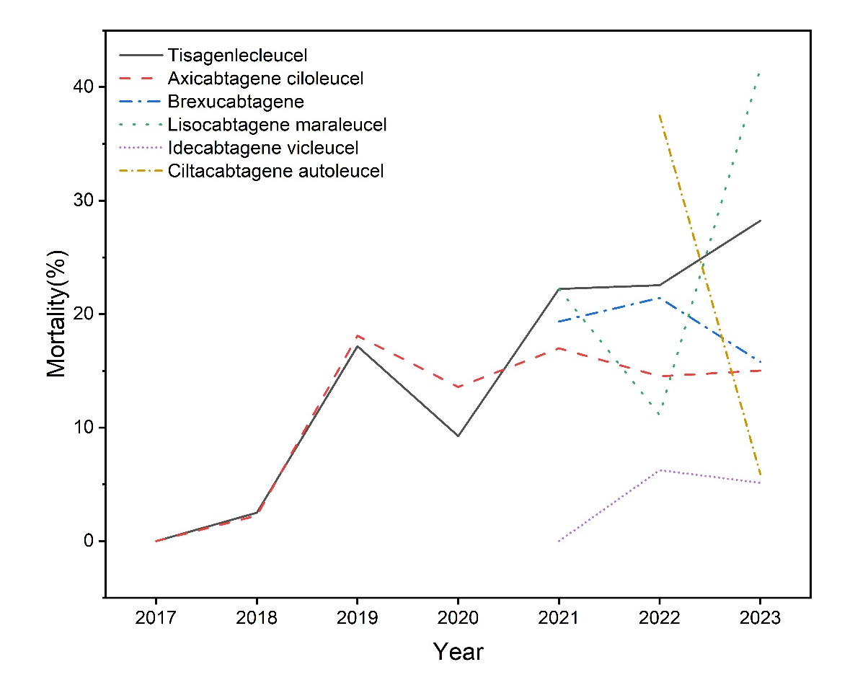
Supplementary Figure S2 Mortality rates of hematological and lymphatic system adverse events (AEs) in CAR-T reports of different years.

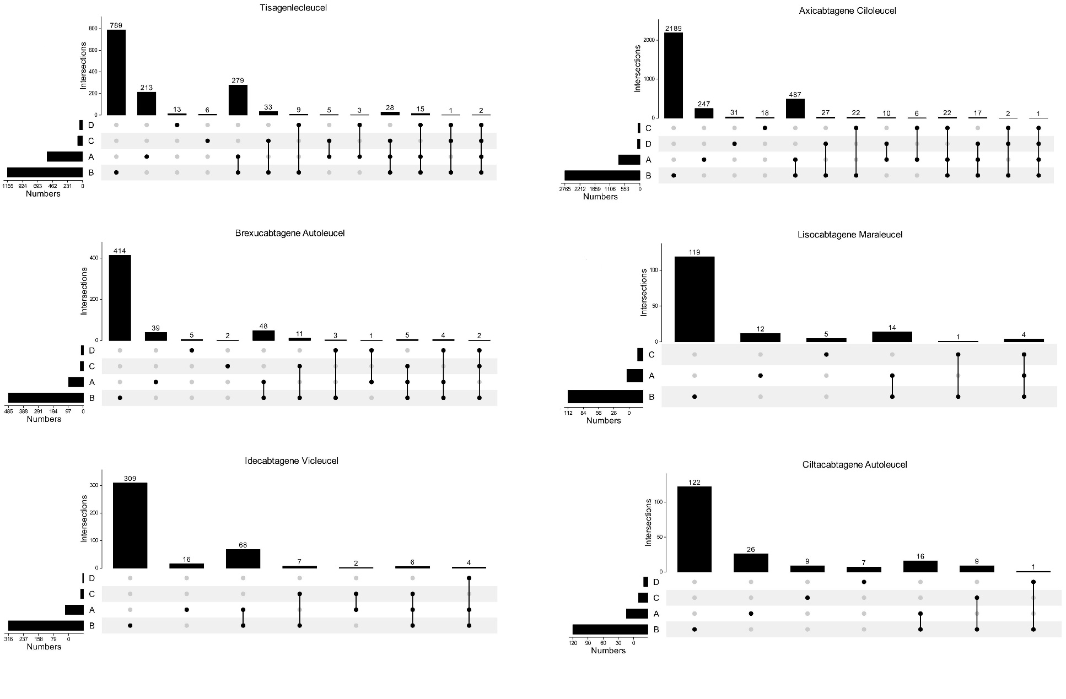
Supplementary Figure S3 Overlapping toxicities of hematological and lymphatic system adverse events and other adverse reactions in CAR-T report. A) Hematological and lymphatic system adverse reactions. B) Cytokine release syndrome. C) Hemophagocytic lymphohistiocytosis. D) Infection.

