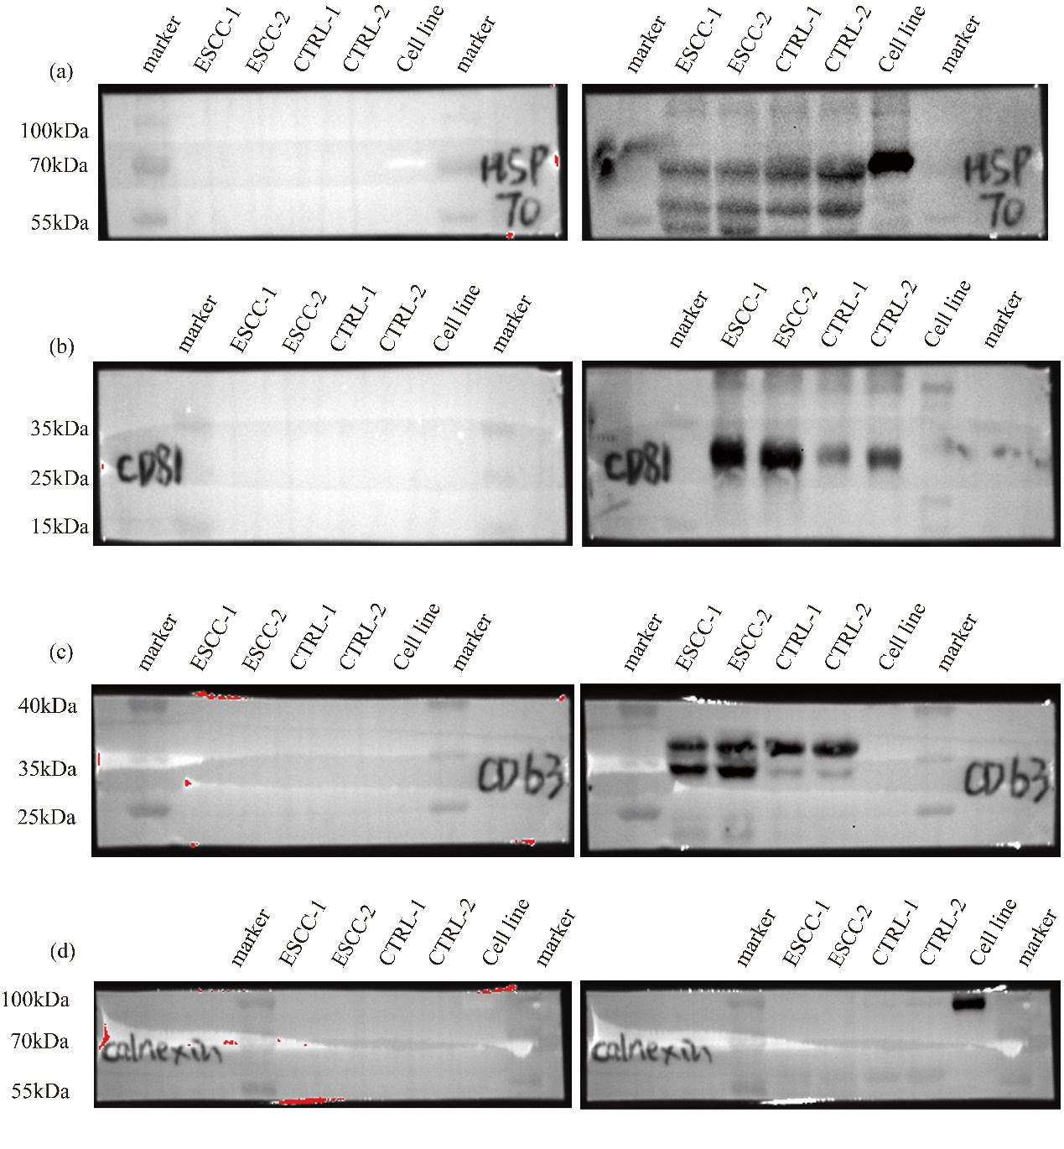
Fig. WB 1: Immunoblotting showed the EVP membrane markers (HSP70, CD63, and CD81) and the intracellular protein Calnexin in EVPs isolated from the saliva of two ESCC patients (ESCC-1 and ESCC-2) and two control subjects (CTRL-1 and CTRL-2) and Cell line. The membrane on the left was imaged under unexposed conditions. The membrane on the right was imaged under exposed conditions. The protein loading for each well was determined to be 50 µg using the BCA assay. a. HSP70. b. CD81. c. CD63. d. Calnexin.
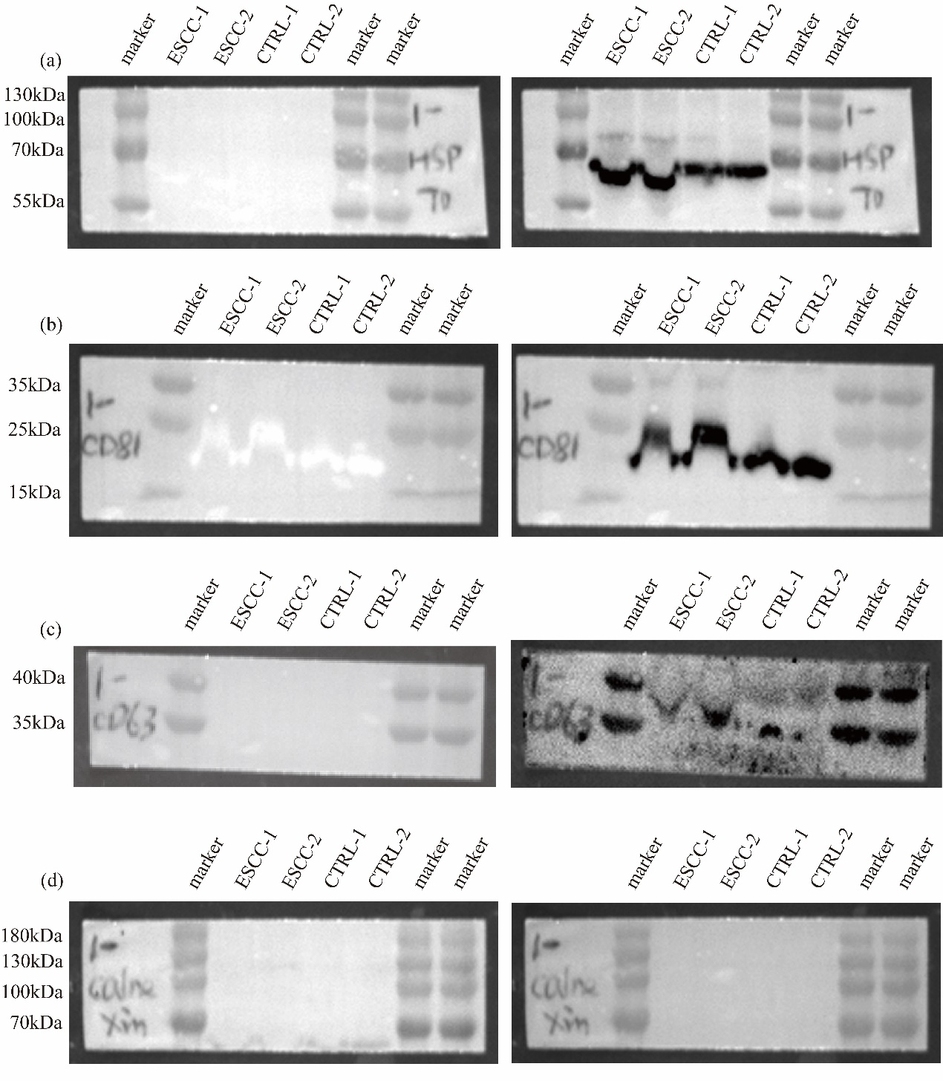
Fig. WB 2: Immunoblotting showed the EVP membrane markers (HSP70, CD63, and CD81) and the intracellular protein Calnexin in EVPs isolated from the saliva of two ESCC patients (ESCC-1 and ESCC-2) and two control subjects (CTRL-1 and CTRL-2). The membrane on the left was imaged under unexposed conditions. The membrane on the right was imaged under exposed conditions. The protein loading for each well was determined to be 50 µg using the BCA assay. a. HSP70. b. CD81. c. CD63. d. Calnexin.

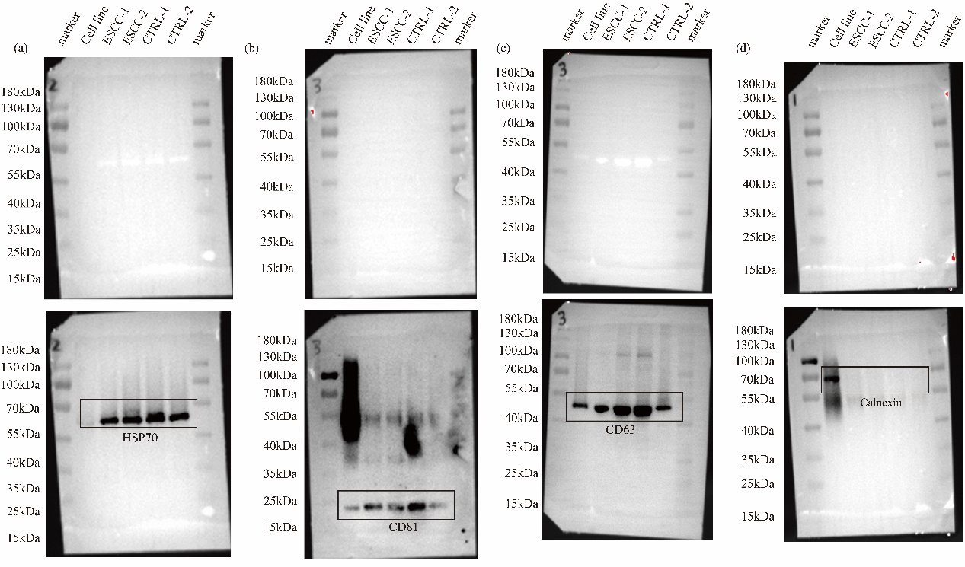
Fig. WB 3: Immunoblotting showed the EVP membrane markers (HSP70, CD63, and CD81) and the intracellular protein Calnexin in EVPs isolated from the saliva of cell line, two ESCC patients (ESCC-1 and ESCC-2) and two control subjects (CTRL-1 and CTRL-2). The upper membrane was imaged under unexposed conditions. The lower membrane was imaged under exposed conditions.The protein loading for each well was determined to be 50 µg using the BCA assay. a. HSP70. b. CD81. c. CD63. d. Calnexin.

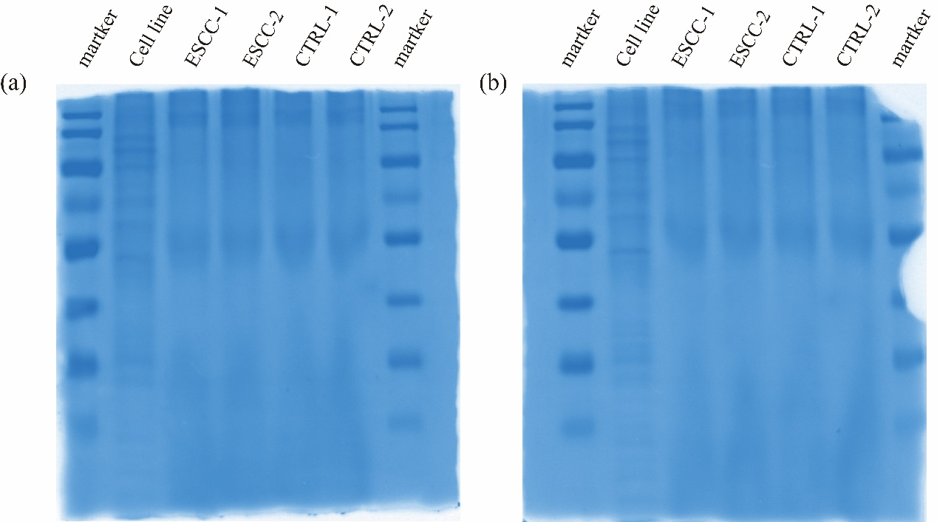
Fig. WB 4: Coomassie Blue staining to check protein loading amount in each lane (cell line, ESCC-1, ESCC-2, CTRL-1 and CTRL-2) during Western Blot experiments. (a) and (b)

