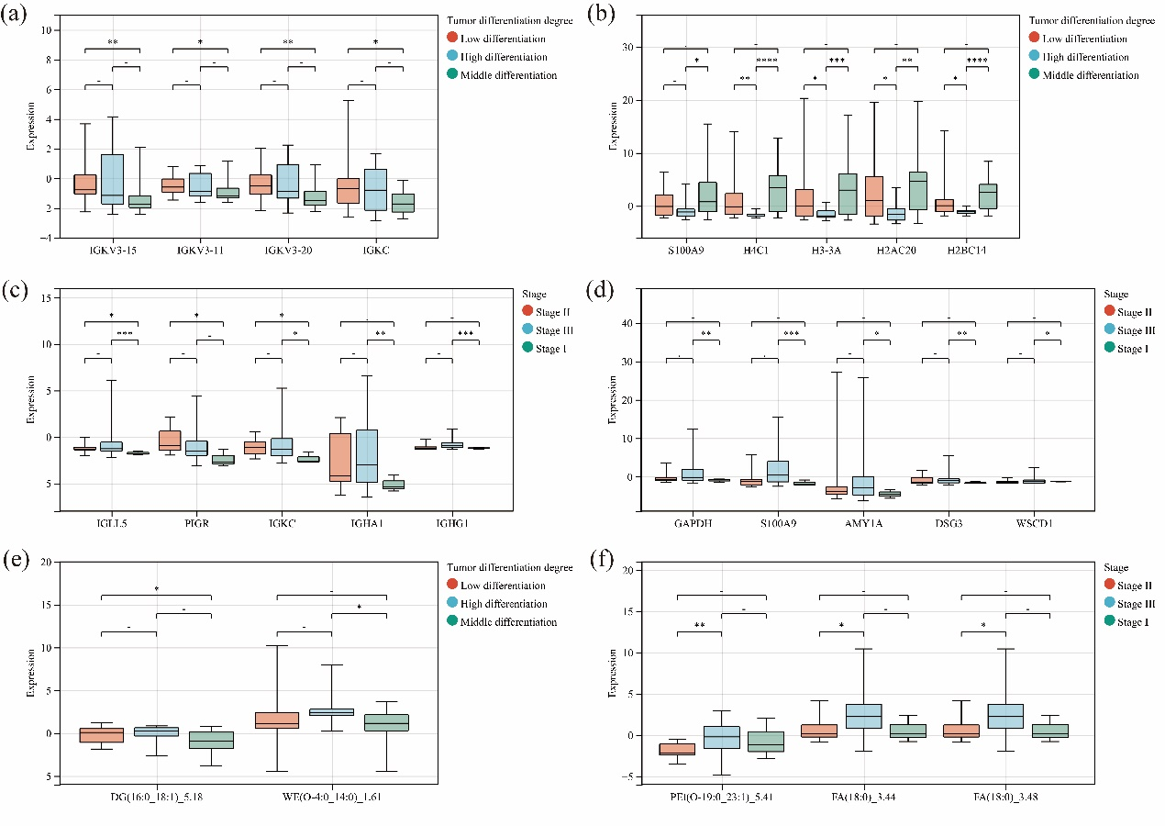
Fig. S1 Correlation analysis of differentially expressed proteins and lipids with clinicopathological data. (a) and (b) Correlation analysis of differentially expressed proteins with tumor differentiation. (c) and (d) Correlation analysis of differentially expressed proteins with tumor stage. (e) Correlation analysis of differential lipids with tumor differentiation. (f) Correlation analysis of differential lipids with tumor stage.

