Supplementary material

Supplementary Table 1 Mapping of original WHO 2016 diagnoses to updated WHO 2021 categories

2016 Diagnosis | Molecular Profile | 2021 Diagnosis | Included/Excluded | Count
Astrocytoma Grade II-III | IDHmut + CDKN2A/B^{del} | Astrocytoma, IDHmut, CNS WHO grade4 | Included | 41
Astrocytoma Grade II-III | IDHwt + (TERTp^{MUT}/EGFR^{AMP}/chromosome+7/-10) | Astrocytoma, IDHwt, CNS WHO grade4 | Included | 83
Glioblastoma | IDHwt | Glioblastoma, IDHwt | Included | 196
Glioblastoma | IDHmut | Astrocytoma, IDHmut, CNS WHO grade4 | Excluded | 45
Astrocytoma Grade II-III | IDHmut, no CDKN2A/B^{del} | Astrocytoma, IDHmut, CNS WHO grade2-3 | Excluded | 121
IDH-mut: Isocitrate dehydrogenase-mutant; CDKN2A/B^{del}: cyclin-dependent kinase inhibitor A/B deletion; IDH-wt: Isocitrate dehydrogenase wild-type; TERTp^{MUT}: telomerase reverse transcriptase promoter mutation; EGFR^{AMP}: epidermal growth factor receptor EGFR amplification; CNS: Central Nervous System; WHO: World Health Organization.
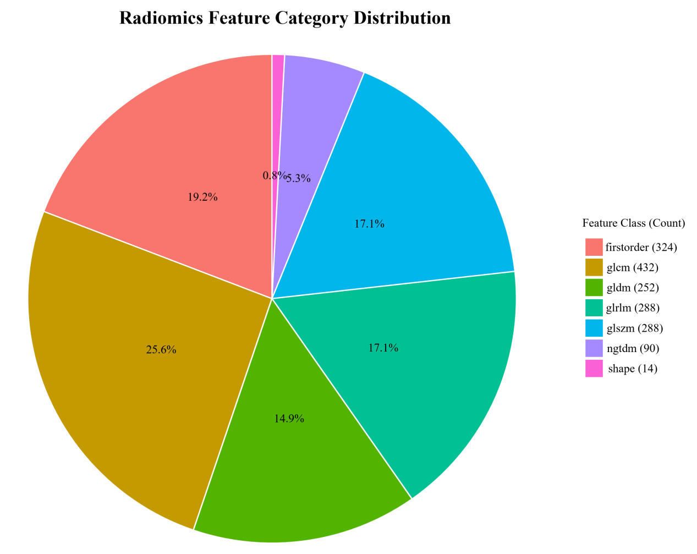
Supplementary Figure 1. Radiomics feature category distribution.GLCM: Gray-Level Co-Occurrence Matrix; GLDM: Gray Level Dependence Matrix; GLRLM: Gray-Level Run-Length Matrix; GLSZM: Gray-Level Size Zone Matrix; NGTDM: Neighborhood Gray Tone Difference Matrix.

