Figure S1. Flowchart of patient selection and grouping based on whether diagnosed with cervical cancer following surgery.

Table S1. Patient characteristics
Characteristics | Cervical cancer group  (n=229) | Non-cancer group  (n=461) | P
Age, Mean±SD | 49.1±11.2 | 40.1±10.9 | <0.001
Gravidity, Mean±SD | 3.4±1.9 | 2.7±2.1 | <0.001
Parity, Mean±SD | 1.5±0.9 | 1.1±0.8 | <0.001
Menstrual status, n (%) |  |  | <0.001
Premenopausal | 127 (55.5%) | 361 (78.3%)
Postmenopausal | 102 (44.5%) | 88 (19.1%)
Abnormal vaginal bleeding, n (%) |  |  | <0.001
Yes | 79 (34.5%) | 57 (12.4%)
No | 150 (65.5%) | 404 (87.6%)
Cytology, n (%) |  |  | <0.001
NILM | 15 (6.6%) | 84 (18.2%)
ASC-US | 33 (14.4%) | 135 (29.3%)
LSIL | 18 (7.9%) | 107 (23.2%)
ASC-H | 55 (24.0%) | 52 (11.3%)
AGC | 2 (0.9%) | 2 (0.4%)
HSIL | 93 (40.6%) | 61 (13.2%)
Not checked | 13 (5.7%) | 20 (4.3%)
HPV infection, n (%) |  |  | 0.024
No infection | 4 (1.8%) | 10 (2.2%)
One type | 172 (75.1%) | 299 (64.9%)
Multi type | 53 (23.1%) | 152 (33.0%)
HPV type, n (%) |  |  | <0.001
HPV16/18 | 149 (65.1%) | 207 (44.9%)
Other high-risk type | 76 (33.2%) | 241 (52.3%)
Low-risk type | 0 (0.00%) | 3 (0.7%)
Negative | 4 (1.8%) | 10 (2.2%)
TZ, n (%) |  |  | 0.016
TZ1 | 53 (23.1%) | 152 (33.0%)
TZ2 | 62 (27.1%) | 111 (24.1%)
TZ3 | 114 (49.8%) | 198 (43.0%)
ECC, n (%) |  |  | 0.002
Yes | 62 (27.1%) | 78 (16.9%)
No | 167 (72.9%) | 383 (83.1%)
Biopsy, n (%) |  |  | <0.001
CIN2 | 8 (3.5%) | 245 (53.2%)
CIN3 | 215 (93.9%) | 205 (44.5%)
Glandular neoplasia /AIS | 6 (2.6%) | 11 (2.5%)
Endocervical glandular involvement, n (%) |  |  | 0.025
Yes | 130 (56.8%) | 220 (47.7%)
No | 99 (43.2%) | 241 (52.2%)
Number of Biopsies, Mean±SD | 4.4±1.2 | 4.1±1.3 | 0.016
History of cervical lesions |  |  | 0.512
Yes | 12 (5.2%) | 30 (6.5%)
No | 217 (94.8%) | 431 (93.5%)
FIGO stage*, n (%)
IA1 | 155 (67.7%) | NA
IA2 | 16 (7.0%） | NA
IB1 | 46 (20.1%) | NA
IB2 | 5 (2.2%) | NA
IB3 | 1 (0.4%) | NA
IIA1 | 3 (1.3%) | NA
IIIC1 | 2 (0.8%) | NA
IVB | 1 (0.4%) | NA
Tumor Embolism, n (%)
Yes | 32 (14.0%) | NA
No | 197 (86.0%) | NA
Pathological type, n (%)
SCC | 213 (93.0%) | NA
AC | 16 (7.0%) | NA
Diagnostic surgery for cancer, n (%)
LEEP | 20 (8.7%) | NA
CKC | 148 (64.6%) | NA
Hysterectomy | 61 (26.6%) | NA
Abbreviations: NILM, negative for intraepithelial lesion malignancy; ASC-US, atypical squamous cells of unknown signiﬁcance; LSIL, low-grade squamous intraepithelial lesion; ASC-H, atypical squamous cells, cannot exclude high-grade lesion; AGC, atypical glandular cells; HSIL, high-grade squamous intraepithelial lesion; HPV, human papillomavirus; TZ, transformation zone; ECC, endocervical curettage; CIN, cervical intraepithelial neoplasia; AIS, adenocarcinoma in situ; SCC: squamous cell carcinoma, AC: adenocarcinoma, LEEP: loop electrosurgical excision procedure, CKC: cold-knife conization.
*FIGO stage 2018[11]

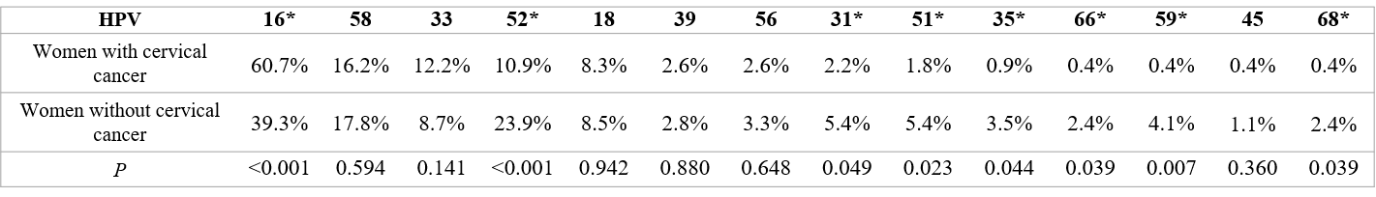
Figure S2. Comparison of the proportion of individuals infected with different types of hrHPV
Abbreviations: hrHPV, high-risk human papillomavirus.
*There is a significant difference in HPV infection proportion between women with cervical cancer and women without cervical cancer.

