Regulatory and Clinical Outcomes of Priority-Reviewed Innovative Cancer Drugs in China (2015-2024): An Observational Study

Supplementary appendix

Table of Contents
Supplementary Figure S1. Flow chart of the included cancer drugs in the analysis. 3
Supplementary Figure S2. The annual number of innovative drugs and indications approved for market by NMPA 4
Supplementary Figure S3. Meta-analyses of efficacy outcomes for cancer indications approved by the NMPA through priority and non-priority reviews (2015–2024) 5
Supplementary Figure S3. Meta-analyses of safety outcomes for cancer indications approved by the NMPA through priority and non-priority reviews (2015–2024) 6
Supplementary Table S1. Efficacy Outcomes of NMPA-Approved Priority-Reviewed Versus Non-Priority-Reviewed Indications Following the Implementation of the New Policy 8
Supplementary Table S2. Safety Outcomes of NMPA-Approved Priority-Reviewed Versus Non-Priority-Reviewed Indications Following the Implementation of the New Policy 9
Supplementary Table S3. Characteristics of innovative cancer drug indications granted in China (n=69) 10
Reference 18

Supplementary Figure S1. Flow chart of the included cancer drugs in the analysis.

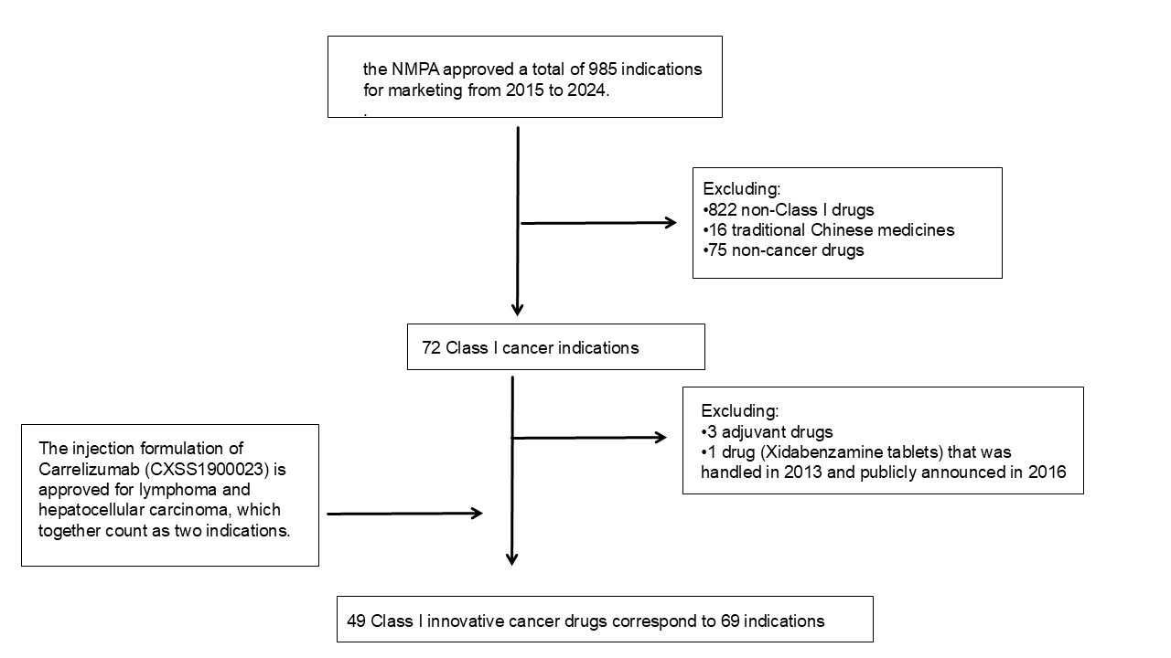
NMPA : National Medical Products Administration;
Data for this study were obtained from the Center for Drug Evaluation (CDE) drug listing database, with data extraction performed as of 31 December 2024.

Supplementary Figure S2. The annual number of innovative drugs and indications approved for market by NMPA

*Drugs are categorized by year of approval; the total number may exceed 49 because the same drug can be approved for different indications in different years and is counted multiple times.

Supplementary Figure S3. Meta-analyses of efficacy outcomes for cancer indications approved by the NMPA through priority and non-priority reviews (2015–2024)
A B
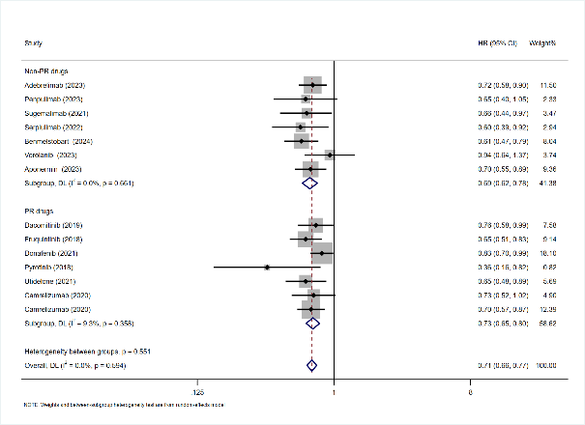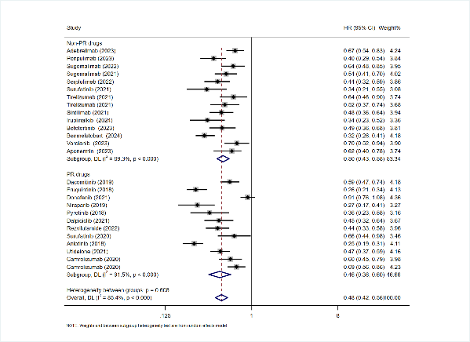
C
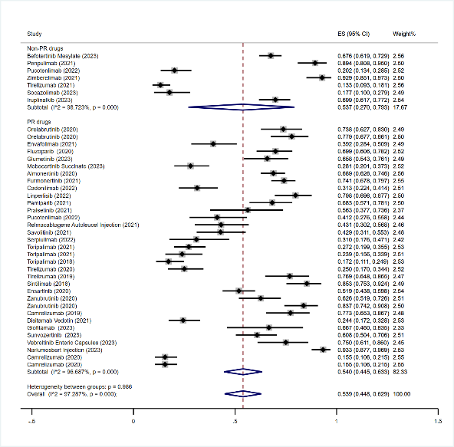
A) Forest plot of hazard ratio for overall survival from the RCTs for cancer indications. B) Forest plot of hazard ratio for progression-free survival from the RCTs for cancer indications. C) Forest Plot of Pooled RR from Single-Arm Trials.

Supplementary Figure S4. Meta-analyses of safety outcomes for cancer indications approved by the NMPA through priority and non-priority reviews (2015–2024)
(A) Forest plot of risk ratios for Grade ≥3 adverse events in RCTs; (B) Forest plot of risk ratios for treatment-related serious adverse events in RCTs; (C) Forest plot of pooled rates for Grade ≥3 adverse events in single-arm trials; and (D)Forest plot of pooled rates for treatment-related serious adverse events in single-arm trials.
A
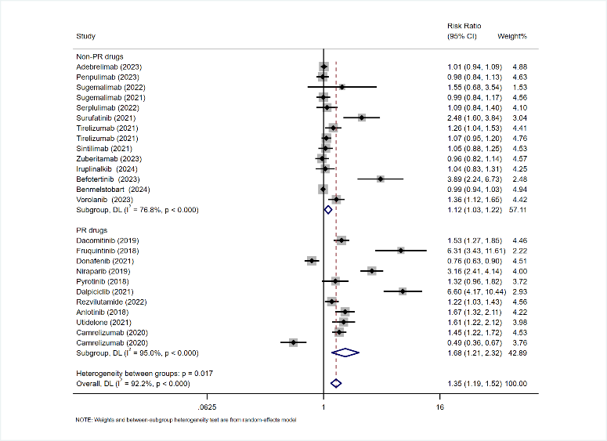
B
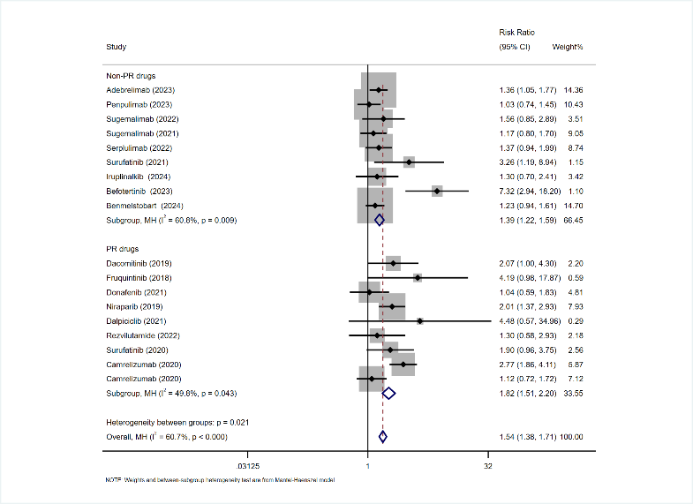
C
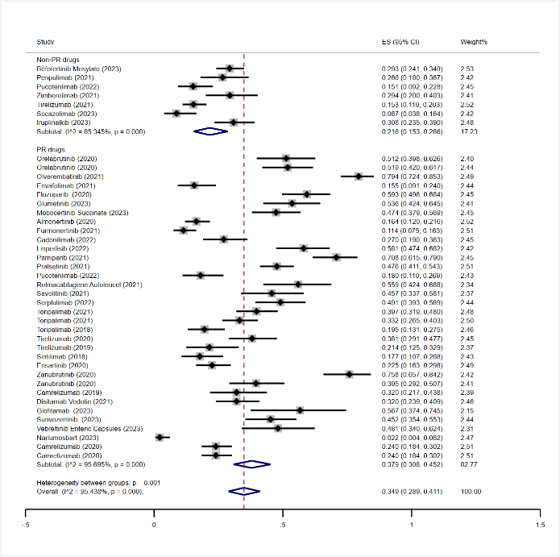
D
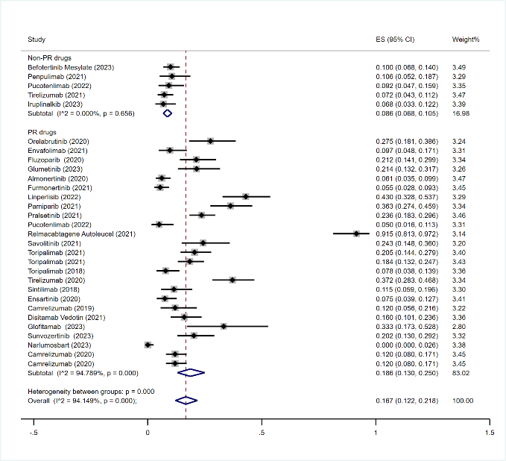
Notes: RCTs: randomized controlled trials. The block and whiskers represent the weighted average and 95% CI. The diamond represents the pooled estimates, respectively; CI, confidence interval.

Supplementary Table S1. Efficacy Outcomes of NMPA-Approved Priority-Reviewed Versus Non-Priority-Reviewed Indications Following the Implementation of the New Policy

 | Priority-reviewed indications | Non-Priority-reviewed indications | p value
single-arm trials
Response rate, %
Median (IQR) | 58.4(31.3,68.3) | 43.9(18.96,68.75) | 0.438
Pooled estimate (95%CI) | 55(40.7,69) | 43.2(17.5,71) | 0.466
randomized controlled trials
Overall survival
months, median (IQR) | / | 20.85(17.3,26.4) | /
Pooled hazard ratio (95%CI) | / | 0.69(0.62,0.78) | /
Clinically meaningful improvement, No. (%)
Progression-free survival
months, median (IQR) | 13.6 | 9(6.9,13.9) | 0.667
Pooled hazard ratio (95%CI) | 0.45(0.36,0.55) | 0.49(0.41,0.59) | 0.516
Clinically meaningful improvement, No. (%) | 1 of 1 | 9 of 11 | 1.000

Supplementary Table S2. Safety Outcomes of NMPA-Approved Priority-Reviewed Versus Non-Priority-Reviewed Indications Following the Implementation of the New Policy

 | Priority-reviewed Indications | Non-Priority-reviewed Indications | p value
randomized controlled trials
Grade ≥3 AEs (%) | 378 of 564(67.02) | 1354 of 2480(54.60) | 0.505
The risk ratio for the pooled Grade≥3 AEs | 2.79(0.53,14.65) | 1.13(1.01,1.26) | 0.286
treatment-related SAE (%) | 22 of 564(3.90) | 496 of 2020(24.55) | 0.008
The risk ratio for the pooled treatment-related SAE | 1.68(0.8,3.53) | 1.39(1.22,1.59) | 0.629
single-arm trials
Grade≥3 AEs (%) | 724 of 1674(43.25) | 156 of 647(24.11) | 0.058
the pooled Grade ≥3 AEs (%) | 42(29.3,55.1) | 20.5(11.3,31.5) | 0.012
treatment-related SAE (%) | 220 of 1124(19.57) | 50 of 555(9.01) | 0.022
the pooled treatment-related SAE (%) | 18.1(9.2,29.1) | 8.9(6.7,11.5) | 0.048

Supplementary Table S3. Characteristics of innovative cancer drug indications granted in China (n=69)
Application Number | Generic Name | Indication | Expedited program |  |  | Approval year | Line of therapy | Cancer type | MAH | Trial phase* | Trial designs | Primary effcacy endpoints‖ | NCT/CTR number | Reference
Application Number | Generic Name | Indication | Priority Review | Conditional Approval | Breakthrough Therapy
CXSS2200006 | Adebrelimab | Lung | No | No | No | 2023 | First line | Solid tumor | domestic | Phase 3 | RCT | OS | NCT03711305 | 1
CXHS1900035 | Orelabrutinib | Lymphoma | Yes | Yes | No | 2020 | Second line and beyond | Hematologic cancer | domestic | Phase 2 | single-arm | RR | NCT03493217 | 2
CXHS2000008 | Orelabrutinib | Lymphoma | Yes | Yes | No | 2020 | Second line and beyond | Hematologic cancer | domestic | Phase 2 | single-arm | RR | NCT03494179 | 3
CXHS2000038 | Olverembatinib | Leukemia | Yes | Yes | No | 2021 | Second line and beyond | Hematologic cancer | domestic | Phase 2 | single-arm | Other | NCT03883087  NCT03883100 | 4
JXHS1800023-24 | Dacomitinib | Lung | Yes | No | No | 2019 | First line | Solid tumor | imported | Phase 3 | RCT | PFS | NCT01774721 | 5
CXSS2000060 | Envafolimab | Solid tumor | Yes | Yes | No | 2021 | Second line and beyond | Solid tumor | domestic | Phase 2 | single-arm | RR | NCT03667170 | 6
CXHS1700008-9 | Fruquintinib | Colorectal cancer | Yes | No | No | 2018 | Second line and beyond | Solid tumor | domestic | Phase 3 | RCT | OS | NCT02314819 | 7
CXHS1900033 | Fluzoparib | Ovarian cancer | Yes | No | No | 2020 | Second line and beyond | Solid tumor | domestic | Phase 1 | single-arm | RR | NCT03509636 | 8
CXHS2200010 | Glumetinib | Lung | Yes | Yes | Yes | 2023 | Second line and beyond | Solid tumor | domestic | Phase 2 | single-arm | RR | NCT04270591 | 9
JXHS2101024 | Mobocertinib Succinate | Lung | Yes | Yes | Yes | 2023 | Second line and beyond | Solid tumor | imported | Phase 2 | single-arm | RR | NCT02716116 | 10
CXHS2000010 | Donafenib | Liver cancer | Yes | No | No | 2021 | First line | Solid tumor | domestic | Phase 3 | RCT | OS | NCT02645981 | 11
CXHS1800043 | Niraparib | Ovarian cancer | Yes | No | No | 2019 | Second line and beyond | Solid tumor | domestic | Phase 3 | RCT | PFS | NCT01847274 | 12
CXHS1900011 | Almonertinib | Lung | Yes | No | No | 2020 | Second line and beyond | Solid tumor | domestic | Phase 2 | single-arm | RR | NCT02981108 | 13
CXHS2100008-09 | Befotertinib Mesylate | Lung | No | No | No | 2023 | Second line and beyond | Solid tumor | domestic | Phase 2 | single-arm | RR | NCT03861156 | 14
CXHS1900039 | Furmonertinib | Lung | Yes | Yes | No | 2021 | Second line and beyond | Solid tumor | domestic | Phase 2 | single-arm | RR | NCT03452592 | 15
CXHS1800016-17 | Flumatinib | Leukemia | Yes | No | No | 2019 | First line | Hematologic cancer | domestic | Phase 3 | RCT | Other | NCT02204644 | 16
CXSS2101032 | Cadonilimab | Cervical cancer | Yes | Yes | Yes | 2022 | Second line and beyond | Solid tumor | domestic | Phase 2 | single-arm | RR | NCT03852251 | 17
CXHS2101013 | Linperlisib | Lymphoma | Yes | Yes | Yes | 2022 | Second line and beyond | Hematologic cancer | domestic | Phase 2 | single-arm | RR | NCT04370405 | 18
CXHS1700013-14 | Pyrotinib | Breast | Yes | No | No | 2018 | Second line and beyond | Solid tumor | domestic | Phase 2 | RCT | RR | NCT02422199 | 19
CXHS2000021 | Pamiparib | Ovarian cancer | Yes | Yes | No | 2021 | Second line and beyond | Solid tumor | domestic | Phase 2 | single-arm | RR | NCT03333915 | 20
CXSS2000022 | Penpulimab | Lymphoma | No | Yes | No | 2021 | Second line and beyond | Hematologic cancer | domestic | Phase 2 | single-arm | RR | NCT03722147 | 21
CXSS2101007 | Penpulimab | Lung | No | No | No | 2023 | First line | Solid tumor | domestic | Phase 3 | RCT | PFS | NCT03866993 | 22
JXHS2000131 | Pralsetinib | Lung | Yes | Yes | No | 2021 | Second line and beyond | Solid tumor | imported | Phase 2 | single-arm | RR | NCT03037385 | 23
CXSS2101041 | Pucotenlimab | Solid tumor | Yes | Yes | No | 2022 | Second line and beyond | Solid tumor | domestic | Phase 2 | single-arm | RR | NCT03704246 | 24
CXSS2101008 | Pucotenlimab | Melanoma | No | Yes | No | 2022 | Second line and beyond | Solid tumor | domestic | Phase 2 | single-arm | RR | NCT04749485 | 25
CXHS2101006-8 | Dalpiciclib | Breast | Yes | No | Yes | 2021 | Second line and beyond | Solid tumor | domestic | Phase 3 | RCT | PFS | NCT03927456 | 26
CXSS2000036 | Relmacabtagene Autoleucel Injection | Lymphoma | Yes | Yes | No | 2021 | Second line and beyond | Hematologic cancer | domestic | Phase 2 | single-arm | RR | NCT04089215 | 27
CXHS2101050 | Rezvilutamide | Prostate cancer | Yes | Yes | Yes | 2022 | First line | Solid tumor | domestic | Phase 3 | RCT | PFS  和 OS | NCT03520478 | 28
CXSS2000005 | Zimberelimab | Lymphoma | No | Yes | No | 2021 | Second line and beyond | Hematologic cancer | domestic | Phase 2 | single-arm | RR | NCT03655483 | 29
CXHS2000012-13 | Savolitinib | Lung | Yes | Yes | No | 2021 | Second line and beyond | Solid tumor | domestic | Phase 2 | single-arm | RR | NCT02897479 | 30
CXSS2101026 | Sugemalimab | Lung | No | No | No | 2022 | Second line and beyond | Solid tumor | domestic | Phase 3 | RCT | PFS | NCT03728556 | 31
CXSS2000056 | Sugemalimab | Lung | No | No | No | 2021 | First line | Solid tumor | domestic | Phase 3 | RCT | PFS | NCT03789604 | 32
CXSS2101030 | Serplulimab | Lung | No | No | No | 2022 | First line | Solid tumor | domestic | Phase 3 | RCT | PFS | NCT04033354 | 33
CXSS2101000 | Serplulimab | Solid tumor | Yes | Yes | No | 2022 | Second line and beyond | Solid tumor | domestic | Phase 2 | single-arm | RR | NCT03941574 | 34
CXHS2000028 | Surufatinib | Neuroendocrine Tumor | No | No | No | 2021 | Second line and beyond | Solid tumor | domestic | Phase 3 | RCT | PFS | NCT02589821 | 35
CXHS1900034 | Surufatinib | Neuroendocrine Tumor | Yes | No | No | 2020 | Second line and beyond | Solid tumor | domestic | Phase 3 | RCT | PFS | NCT02588170 | 36
CXSS2000018、19 | Toripalimab | Urothelial Carcinoma | Yes | Yes | No | 2021 | Second line and beyond | Solid tumor | domestic | Phase 2 | single-arm | RR | NCT03113266 | 37
CXSS2000016-17 | Toripalimab | Nasopharyngeal Carcinoma | Yes | Yes | No | 2021 | Second line and beyond | Solid tumor | domestic | Phase 2 | single-arm | RR | NCT02915432 | 38
CXSS1800006 | Toripalimab | Melanoma | Yes | No | No | 2018 | Second line and beyond | Solid tumor | domestic | Phase 2 | single-arm | RR | NCT03013101 | 39
CXSS2000033 | Tirelizumab | Liver cancer | No | Yes | No | 2021 | Second line and beyond | Solid tumor | domestic | Phase 2 | single-arm | RR | NCT03419897  CTR20171257 | 40
CXSS2000032 | Tirelizumab | Lung | No | No | No | 2021 | First line | Solid tumor | domestic | Phase 3 | RCT | PFS | NCT03663205 | 41
CXSS2000014 | Tirelizumab | Lung | No | No | No | 2021 | First line | Solid tumor | domestic | Phase 3 | RCT | PFS | NCT03594747 | 42
CXSS1900025 | Tirelizumab | Urothelial Carcinoma | Yes | No | No | 2020 | Second line and beyond | Solid tumor | domestic | Phase 2 | single-arm | RR | NCT04004221  CTR20170071 | 43
CXSS1800019 | Tirelizumab | Lymphoma | Yes | No | No | 2019 | Second line and beyond | Hematologic cancer | domestic | Phase 2 | single-arm | RR | NCT03209973 | 44
CXSS2000015 | Sintilimab | Lung | No | No | No | 2021 | First line | Solid tumor | domestic | Phase 3 | RCT | PFS | NCT03607539 | 45
CXSS1800008 | Sintilimab | Lymphoma | Yes | No | No | 2018 | Second line and beyond | Hematologic cancer | domestic | Phase 2 | single-arm | RR | NCT03114683 | 46
CXHS1700002-4 | Anlotinib | Lung | Yes | No | No | 2018 | Second line and beyond | Solid tumor | domestic | Phase 3 | RCT | OS | NCT02388919 | 47
CXHS1800045-46 | Ensartinib | Lung | Yes | No | No | 2020 | Second line and beyond | Solid tumor | domestic | Phase 2 | single-arm | RR | NCT03215693 | 48
CXHS1800005 | Utidelone | Breast | Yes | No | No | 2021 | Second line and beyond | Solid tumor | domestic | Phase 3 | RCT | PFS | NCT02253459 | 49
CXSS2200001 | Zuberitamab | Lymphoma | No | No | No | 2023 | Second line and beyond | Hematologic cancer | domestic | Phase 3 | RCT | RR | CTR20180855 | 50
CXHS1800030 | Zanubrutinib | Lymphoma | Yes | No | No | 2020 | Second line and beyond | Hematologic cancer | domestic | Phase 2 | single-arm | RR | NCT03206918 | 51
CXHS1800024 | Zanubrutinib | Lymphoma | Yes | No | No | 2020 | Second line and beyond | Hematologic cancer | domestic | Phase 2 | single-arm | RR | NCT03206970 | 52
CXSS1800009 | Camrelizumab | Lymphoma | Yes | No | No | 2019 | Second line and beyond | Hematologic cancer | domestic | Phase 2 | single-arm | RR | NCT03155425 | 53
CXSS2000044 | Disitamab Vedotin | Gastric cancer | Yes | Yes | No | 2021 | Second line and beyond | Solid tumor | domestic | Phase 2 | single-arm | RR | NCT03556345 | 54
CXHS2300041-42 | Iruplinalkib | Lung | No | No | No | 2024 | First line | Solid tumor | domestic | Phase 3 | RCT | PFS | NCT04632758，CTR20191231 | 55
JXSS2300014 | Glofitamab | Lymphoma | Yes | Yes | Yes | 2023 | Second line and beyond | Hematologic cancer | imported | Phase 1 | single-arm | Other | NCT04657302，CTR20202232 | 56
CXHS2300015-16 | Befotertinib | Lung | No | No | No | 2023 | First line | Solid tumor | domestic | Phase 3 | RCT | PFS | NCT04206072 | 57
CXSS2300003 | Benmelstobart | Lung | No | No | No | 2024 | First line | Solid tumor | domestic | Phase 3 | RCT | PFS  和 OS | NCT04234607 | 58
CXHS2300006-7 | Sunvozertinib | Lung | Yes | Yes | Yes | 2023 | Second line and beyond | Solid tumor | domestic | Phase 2 | single-arm | RR | NCT05712902 | 59
CXHS2200047-48 | Vebreltinib Enteric Capsules | Lung | Yes | Yes | Yes | 2023 | First line | Solid tumor | domestic | Phase 2 | single-arm | RR | NCT04258033 | 60
CXSS2200061 | Narlumosbart Injection | Giant Cell Tumor of Bone | Yes | Yes | No | 2023 | First line | Solid tumor | domestic | Phase 2 | single-arm | RR | NCT04255576 | 61
CXHS2200003 | Vorolanib | Renal Cell Carcinoma | No | No | No | 2023 | Second line and beyond | Solid tumor | domestic | Phase 3 | RCT | PFS | NCT03095040 | 62
CXSS2101065 | Aponermin | Multiple Myeloma | No | No | No | 2023 | Second line and beyond | Hematologic cancer | domestic | Phase 3 | RCT | PFS | CTR20140751  ChiCTR-IPR-15006024 | 63
CXSS2101042 | Socazolimab | Cervical cancer | No | Yes | No | 2023 | Second line and beyond | Solid tumor | domestic | Phase 1 | single-arm | RR | NCT03676959 | 64
CXHS2101031-32 | Iruplinalkib | Lung | No | No | No | 2023 | Second line and beyond | Solid tumor | domestic | Phase 2 | single-arm | RR | NCT04641754，CTR20190789  NCT04632758，CTR20191231 | 65
CXSS1900034 | Camrelizumab | Lung | Yes | No | No | 2020 | First line | Solid tumor | domestic | Phase 3 | RCT | PFS | NCT03134872 | 66
CXSS1900035 | Camrelizumab | Esophageal Cancer | Yes | No | No | 2020 | Second line and beyond | Solid tumor | domestic | Phase 3 | RCT | OS | NCT03099382 | 67
CXSS1900023 | Camrelizumab | Lymphoma | Yes | No | No | 2020 | Second line and beyond | Hematologic cancer | domestic | Phase 3 | single-arm | RR | NCT02989922 | 68
CXSS1900023 | Camrelizumab | Liver cancer | Yes | No | No | 2020 | Second line and beyond | Solid tumor | domestic | Phase 3 | single-arm | RR | NCT02989922 | 69
* labeled phase 1/2 trials were categorized as phase 2 while labeled phase 2/3 trials were categorized as phase 3. ‖RR includes both hematology and solid cancer. We searched for NMPA approval for these drugs with cut-off date of December 31, 2024. Abbreviations: MAH, market authorization holders; RR= response rate. OS=overall survival. PFS=progression-free survival. Other represents the major molecular response rate. RCT= randomized controlled trial.

Reference
1 Wang J, Zhou C, Yao W, et al. Adebrelimab or placebo plus carboplatin and etoposide as first-line treatment for extensive-stage small-cell lung cancer (CAPSTONE-1): a multicentre, randomised, double-blind, placebo-controlled, phase 3 trial. Lancet Oncol. 2022; 23:739-747.
2 Xu W, Zhou K, Wang T, et al. Orelabrutinib in relapsed or refractory chronic lymphocytic leukemia/small lymphocytic lymphoma patients: Multi-center, single-arm, open-label, phase 2 study. Am J Hematol. 2023; 98:571-79.
3 Deng LJ, Zhou KS, Liu LH, et al. Orelabrutinib for the treatment of relapsed or refractory MCL: a phase 1/2, open-label, multicenter, single-arm study. Blood Adv. 2023; 7:4349-4357.
4 Jiang Q, Li Z, Qin Y, et al. Olverembatinib (HQP1351), a well-tolerated and effective tyrosine kinase inhibitor for patients with T315I-mutated chronic myeloid leukemia: results of an open-label, multicenter phase 1/2 trial. J Hematol Oncol. 2022; 15: 113.
5 Wu YL, Cheng Y, Zhou X, et al. Dacomitinib versus gefitinib as first-line treatment for patients with EGFR-mutation-positive non-small-cell lung cancer (ARCHER 1050): a randomised, open-label, phase 3 trial. Lancet Oncol. 2017; 18:1454-66.
6 Li J, Deng Y, Zhang W, et al. Subcutaneous envafolimab monotherapy in patients with advanced defective mismatch repair/microsatellite instability high solid tumors. J Hematol Oncol. 2021; 14:95.
7 Li J, Qin S, Xu RH, et al. Effect of Fruquintinib vs Placebo on Overall Survival in Patients With Previously Treated Metastatic Colorectal Cancer: The FRESCO Randomized Clinical Trial. JAMA. 2018; 319:2486-96.
8 Li N, Bu H, Liu J, et al. An Open-label, Multicenter, Single-arm, Phase II Study of Fluzoparib in Patients with Germline BRCA1/2 Mutation and Platinum-sensitive Recurrent Ovarian Cancer. Clin Cancer Res. 2021; 27:2452-58.
9 Yu Y, Zhou J, Li X, et al. Gumarontinib in patients with non-small-cell lung cancer harbouring MET exon 14 skipping mutations: a multicentre, single-arm, open-label, phase 1b/2 trial. EClinicalMedicine. 2023; 59:101952.
10 Zhou C, Ramalingam SS, Kim TM, et al. Treatment Outcomes and Safety of Mobocertinib in Platinum-Pretreated Patients With EGFR Exon 20 Insertion-Positive Metastatic Non-Small Cell Lung Cancer: A Phase 1/2 Open-label Nonrandomized Clinical Trial. JAMA Oncol. 2021; 7: e214761.
11 Qin S, Bi F, Gu S, et al. Donafenib Versus Sorafenib in First-Line Treatment of Unresectable or Metastatic Hepatocellular Carcinoma: A Randomized, Open-Label, Parallel-Controlled Phase II-III Trial. J Clin Oncol. 2021; 39:3002-11.
12 Del Campo JM, Matulonis UA, Malander S, et al. Niraparib Maintenance Therapy in Patients With Recurrent Ovarian Cancer After a Partial Response to the Last Platinum-Based Chemotherapy in the ENGOT-OV16/NOVA Trial. J Clin Oncol. 2019; 37:2968-73.
13 Lu S, Wang Q, Zhang G, et al. Efficacy of Aumolertinib (HS-10296) in Patients With Advanced EGFR T790M+ NSCLC: Updated Post-National Medical Products Administration Approval Results From the APOLLO Registrational Trial. J Thorac Oncol. 2022; 17:411-22.
14 Lu S, Zhang Y, Zhang G, et al. Efficacy and Safety of Befotertinib (D-0316) in Patients With EGFR T790M-Mutated NSCLC That Had Progressed After Prior EGFR Tyrosine Kinase Inhibitor Therapy: A Phase 2, Multicenter, Single-Arm, Open-Label Study. J Thorac Oncol. 2022; 17:1192-1204.
15 Shi Y, Hu X, Zhang S, et al. Efficacy, safety, and genetic analysis of furmonertinib (AST2818) in patients with EGFR T790M mutated non-small-cell lung cancer: a phase 2b, multicentre, single-arm, open-label study. Lancet Respir Med. 2021; 9:829-839.
16 Zhang L, Meng L, Liu B, et al. Flumatinib versus Imatinib for Newly Diagnosed Chronic Phase Chronic Myeloid Leukemia: A Phase III, Randomized, Open-label, Multi-center FESTnd Study. Clin Cancer Res. 2021; 27:70-77.
17 Gao X, Xu N, Li Z, et al. Safety and antitumour activity of cadonilimab, an anti-PD-1/CTLA-4 bispecific antibody, for patients with advanced solid tumours (COMPASSION-03): a multicentre, open-label, phase 1b/2 trial. Lancet Oncol. 2023; 24:1134-46.
18 Wang T, Sun X, Qiu L, et al. The Oral PI3Kδ Inhibitor Linperlisib for the Treatment of Relapsed and/or Refractory Follicular Lymphoma: A Phase II, Single-Arm, Open-Label Clinical Trial. Clin Cancer Res. 2023; 29:1440-49.
19 Ma F, Ouyang Q, Li W, et al. Pyrotinib or Lapatinib Combined With Capecitabine in HER2-Positive Metastatic Breast Cancer With Prior Taxanes, Anthracyclines, and/or Trastuzumab: A Randomized, Phase II Study. J Clin Oncol. 2019; 37:2610-19.
20 Wu X, Zhu J, Wang J, et al. Pamiparib Monotherapy for Patients with Germline BRCA1/2-Mutated Ovarian Cancer Previously Treated with at Least Two Lines of Chemotherapy: A Multicenter, Open-Label, Phase II Study. Clin Cancer Res. 2022; 28:653-661.
21 Song Y, Zhou K, Jin C, et al. Penpulimab for Relapsed or Refractory Classical Hodgkin Lymphoma: A Multicenter, Single-Arm, Pivotal Phase I/II Trial (AK105-201). Front Oncol. 2022; 12:925236.
22 Zhong H, Sun S, Chen J, et al. First-line penpulimab combined with paclitaxel and carboplatin for metastatic squamous non-small-cell lung cancer in China (AK105-302): a multicentre, randomised, double-blind, placebo-controlled phase 3 clinical trial. Lancet Respir Med. 2024; 12:355-65.
23 Gainor JF, Curigliano G, Kim DW, et al. Pralsetinib for RET fusion-positive non-small-cell lung cancer (ARROW): a multi-cohort, open-label, phase 1/2 study [published correction appears in Lancet Oncol. 2021 Aug;22(8):e347. doi: 10.1016/S1470-2045(21)00392-2]. Lancet Oncol. 2021; 22:959-69.
24 Zhang B, Song Y, Luo S, et al. Pucotenlimab in patients with advanced mismatch repair-deficient or microsatellite instability-high solid tumors: A multicenter phase 2 study. Cell Rep Med. 2023; 4:101301.
25 Cui C, Chen Y, Luo Z, et al. Safety and efficacy of Pucotenlimab (HX008) - a humanized immunoglobulin G4 monoclonal antibody in patients with locally advanced or metastatic melanoma: a single-arm, multicenter, phase II study. BMC Cancer. 2023; 23:121.
26 Xu B, Zhang Q, Zhang P, et al. Dalpiciclib or placebo plus fulvestrant in hormone receptor-positive and HER2-negative advanced breast cancer: a randomized, phase 3 trial. Nat Med. 2021; 27:1904-09.
27 Ying Z, Yang H, Guo Y, et al. Long-term outcomes of relmacabtagene autoleucel in Chinese patients with relapsed/refractory large B-cell lymphoma: Updated results of the RELIANCE study. Cytotherapy. 2023; 25:521-29.
28 Gu W, Han W, Luo H, et al. Rezvilutamide versus bicalutamide in combination with androgen-deprivation therapy in patients with high-volume, metastatic, hormone-sensitive prostate cancer (CHART): a randomised, open-label, phase 3 trial. Lancet Oncol. 2022; 23:1249-60.
29 Lin N, Zhang M, Bai H, et al. Efficacy and safety of GLS-010 (zimberelimab) in patients with relapsed or refractory classical Hodgkin lymphoma: A multicenter, single-arm, phase II study. Eur J Cancer. 2022; 164:117-26.
30 Lu S, Fang J, Li X, et al. Once-daily savolitinib in Chinese patients with pulmonary sarcomatoid carcinomas and other non-small-cell lung cancers harbouring MET exon 14 skipping alterations: a multicentre, single-arm, open-label, phase 2 study. Lancet Respir Med. 2021; 9:1154-64.
31 Zhou Q, Chen M, Jiang O, et al. Sugemalimab versus placebo after concurrent or sequential chemoradiotherapy in patients with locally advanced, unresectable, stage III non-small-cell lung cancer in China (GEMSTONE-301): interim results of a randomised, double-blind, multicentre, phase 3 trial. Lancet Oncol. 2022; 23:209-19.
32 Zhou C, Wang Z, Sun Y, et al. Sugemalimab versus placebo, in combination with platinum-based chemotherapy, as first-line treatment of metastatic non-small-cell lung cancer (GEMSTONE-302): interim and final analyses of a double-blind, randomised, phase 3 clinical trial. Lancet Oncol. 2022; 23:220-33.
33 Zhou C, Hu Y, Arkania E, et al. A global phase 3 study of serplulimab plus chemotherapy as first-line treatment for advanced squamous non-small-cell lung cancer (ASTRUM-004). Cancer Cell. 2024; 42:198-208.
34 Qin S, Li J, Zhong H, et al. Serplulimab, a novel anti-PD-1 antibody, in patients with microsatellite instability-high solid tumours: an open-label, single-arm, multicentre, phase II trial. Br J Cancer. 2022; 127:2241-48.
35 Xu J, Shen L, Bai C, et al. Surufatinib in advanced pancreatic neuroendocrine tumours (SANET-p): a randomised, double-blind, placebo-controlled, phase 3 study. Lancet Oncol. 2020; 21:1489-99.
36 Xu J, Shen L, Zhou Z, et al. Surufatinib in advanced extrapancreatic neuroendocrine tumours (SANET-ep): a randomised, double-blind, placebo-controlled, phase 3 study. Lancet Oncol. 2020; 21:1500-12.
37 Sheng X, Chen H, Hu B, et al. Safety, Efficacy, and Biomarker Analysis of Toripalimab in Patients with Previously Treated Advanced Urothelial Carcinoma: Results from a Multicenter Phase II Trial POLARIS-03. Clin Cancer Res. 2022; 28:489-97.
38 Wang FH, Wei XL, Feng J, et al. Efficacy, Safety, and Correlative Biomarkers of Toripalimab in Previously Treated Recurrent or Metastatic Nasopharyngeal Carcinoma: A Phase II Clinical Trial (POLARIS-02). J Clin Oncol. 2021; 39:704-12.
39 Tang B, Chi Z, Chen Y, et al. Safety, Efficacy, and Biomarker Analysis of Toripalimab in Previously Treated Advanced Melanoma: Results of the POLARIS-01 Multicenter Phase II Trial. Clin Cancer Res. 2020; 26:4250-59.
40 Ren Z, Ducreux M, Abou-Alfa GK, et al. Tislelizumab in Patients with Previously Treated Advanced Hepatocellular Carcinoma (RATIONALE-208): A Multicenter, Non-Randomized, Open-Label, Phase 2 Trial. Liver Cancer. 2022; 12:72-84.
41 Lu S, Wang J, Yu Y, et al. Tislelizumab Plus Chemotherapy as First-Line Treatment for Locally Advanced or Metastatic Nonsquamous NSCLC (RATIONALE 304): A Randomized Phase 3 Trial. J Thorac Oncol. 2021; 16:1512-22.
42 Wang J, Lu S, Yu X, et al. Tislelizumab Plus Chemotherapy vs Chemotherapy Alone as First-line Treatment for Advanced Squamous Non-Small-Cell Lung Cancer: A Phase 3 Randomized Clinical Trial. JAMA Oncol. 2021; 7:709-17.
43 Ye D, Liu J, Zhou A, et al. Tislelizumab in Asian patients with previously treated locally advanced or metastatic urothelial carcinoma. Cancer Sci. 2021; 112:305-13.
44 Song Y, Gao Q, Zhang H, et al. Treatment of relapsed or refractory classical Hodgkin lymphoma with the anti-PD-1, tislelizumab: results of a phase 2, single-arm, multicenter study. Leukemia. 2020; 34:533-42.
45 Yang Y, Wang Z, Fang J, et al. Efficacy and Safety of Sintilimab Plus Pemetrexed and Platinum as First-Line Treatment for Locally Advanced or Metastatic Nonsquamous NSCLC: a Randomized, Double-Blind, Phase 3 Study (Oncology pRogram by InnovENT anti-PD-1-11). J Thorac Oncol. 2020; 15:1636-46.
46 Shi Y, Su H, Song Y, et al. Safety and activity of sintilimab in patients with relapsed or refractory classical Hodgkin lymphoma (ORIENT-1): a multicentre, single-arm, phase 2 trial. Lancet Haematol. 2019; 6:e12-19.
47 Han B, Li K, Wang Q, et al. Effect of Anlotinib as a Third-Line or Further Treatment on Overall Survival of Patients With Advanced Non-Small Cell Lung Cancer: The ALTER 0303 Phase 3 Randomized Clinical Trial. JAMA Oncol. 2018; 4:1569-75.
48 Yang Y, Zhou J, Zhou J, et al. Efficacy, safety, and biomarker analysis of ensartinib in crizotinib-resistant, ALK-positive non-small-cell lung cancer: a multicentre, phase 2 trial. Lancet Respir Med. 2020; 8:45-53.
49 Zhang P, Sun T, Zhang Q, et al. Utidelone plus capecitabine versus capecitabine alone for heavily pretreated metastatic breast cancer refractory to anthracyclines and taxanes: a multicentre, open-label, superiority, phase 3, randomised controlled trial. Lancet Oncol. 2017; 18:371-83.
50 National Medical Products Administration. Zebetamab Injection Application for Marketing Technical Review Report.2023. https://www.cde.org.cn/main/xxgk/postmarketpage?acceptidCODE=3014b4e29b31eb6c5681d9cce35045f6. (accessed Oct 20, 2023).
51 Xu W, Yang S, Zhou K, et al. Treatment of relapsed/refractory chronic lymphocytic leukemia/small lymphocytic lymphoma with the BTK inhibitor zanubrutinib: phase 2, single-arm, multicenter study. J Hematol Oncol. 2020; 13:48.
52 Song Y, Zhou K, Zou D, et al. Treatment of Patients with Relapsed or Refractory Mantle-Cell Lymphoma with Zanubrutinib, a Selective Inhibitor of Bruton's Tyrosine Kinase. Clin Cancer Res. 2020; 26:4216-24.
53 Song Y, Wu J, Chen X, et al. A Single-Arm, Multicenter, Phase II Study of Camrelizumab in Relapsed or Refractory Classical Hodgkin Lymphoma. Clin Cancer Res. 2019; 25:7363-69.
54 Peng Z, Liu T, Wei J, et al. Efficacy and safety of a novel anti-HER2 therapeutic antibody RC48 in patients with HER2-overexpressing, locally advanced or metastatic gastric or gastroesophageal junction cancer: a single-arm phase II study. Cancer Commun (Lond). 2021; 41:1173-82.
55 Shi Y, Chen J, Yang R, et al. Iruplinalkib (WX-0593) Versus Crizotinib in ALK TKI-Naive Locally Advanced or Metastatic ALK-Positive NSCLC: Interim Analysis of a Randomized, Open-Label, Phase 3 Study (INSPIRE). J Thorac Oncol. 2024;19(6):912-927. doi:10.1016/j.jtho.2024.01.013
56 Song YQ, Zhang HL, Huang HQ, et al. Glofitamab monotherapy induces high complete response rates and manageable safety in Chinese patients with heavily pretreated relapsed or refractory diffuse large B-cell lymphoma. Haematologica. 2024;109(4):1269-1273. Published 2024 Apr 1. doi:10.3324/haematol.2023.283802
57 Lu S, Zhou J, Jian H, et al. Befotertinib (D-0316) versus icotinib as first-line therapy for patients with EGFR-mutated locally advanced or metastatic non-small-cell lung cancer: a multicentre, open-label, randomised phase 3 study. Lancet Respir Med. 2023;11(10):905-915. doi:10.1016/S2213-2600(23)00183-2
58 Cheng Y, Chen J, Zhang W, et al. Benmelstobart, anlotinib and chemotherapy in extensive-stage small-cell lung cancer: a randomized phase 3 trial. Nat Med. 2024;30(10):2967-2976. doi:10.1038/s41591-024-03132-1
59 Wang M, Fan Y, Sun M, et al. Sunvozertinib for patients in China with platinum-pretreated locally advanced or metastatic non-small-cell lung cancer and EGFR exon 20 insertion mutation (WU-KONG6): single-arm, open-label, multicentre, phase 2 trial. Lancet Respir Med. 2024;12(3):217-224. doi:10.1016/S2213-2600(23)00379-X
60 Yang JJ, Zhang Y, Wu L, et al. Vebreltinib for Advanced Non-Small Cell Lung Cancer Harboring c-Met Exon 14 Skipping Mutation: A Multicenter, Single-Arm, Phase II KUNPENG Study. J Clin Oncol. 2024;42(31):3680-3691. doi:10.1200/JCO.23.02363
61 Xu H, Zhou Y, Liang L, et al. Efficacy and safety of JMT103 in patients with unresectable or surgically-challenging giant cell tumor of bone: a multicenter, phase Ib/II study. Nat Commun. 2024;15(1):9541. Published 2024 Nov 5. doi:10.1038/s41467-024-53686-4
62 Sheng X, Ye D, Zhou A, et al. Efficacy and safety of vorolanib plus everolimus in metastatic renal cell carcinoma: A three-arm, randomised, double-blind, multicentre phase III study (CONCEPT). Eur J Cancer. 2023;178:205-215. doi:10.1016/j.ejca.2022.10.025
63 Xia Z, Leng Y, Fang B, et al. Aponermin or placebo in combination with thalidomide and dexamethasone in the treatment of relapsed or refractory multiple myeloma (CPT-MM301): a randomised, double-blinded, placebo-controlled, phase 3 trial. BMC Cancer. 2023;23(1):980. Published 2023 Oct 14. doi:10.1186/s12885-023-11489-8
64 An J, Tang J, Li BX, et al. Efficacy and Safety of the Anti-PD-L1 mAb Socazolimab for Recurrent or Metastatic Cervical Cancer: a Phase I Dose-Escalation and Expansion Study. Clin Cancer Res. 2022;28(23):5098-5106. doi:10.1158/1078-0432.CCR-22-1280
65 Shi Y, Chen J, Zhang H, et al. Efficacy and safety of iruplinalkib (WX-0593) in ALK-positive crizotinib-resistant advanced non-small cell lung cancer patients: a single-arm, multicenter phase II study (INTELLECT). BMC Med. 2023;21(1):72. Published 2023 Feb 24. doi:10.1186/s12916-023-02738-5
66 Zhou C, Chen G, Huang Y, et al. Camrelizumab plus carboplatin and pemetrexed versus chemotherapy alone in chemotherapy-naive patients with advanced non-squamous non-small-cell lung cancer (CameL): a randomised, open-label, multicentre, phase 3 trial. Lancet Respir Med. 2021;9(3):305-314. doi:10.1016/S2213-2600(20)30365-9
67 Huang J, Xu J, Chen Y, et al. Camrelizumab versus investigator's choice of chemotherapy as second-line therapy for advanced or metastatic oesophageal squamous cell carcinoma (ESCORT): a multicentre, randomised, open-label, phase 3 study. Lancet Oncol. 2020;21(6):832-842. doi:10.1016/S1470-2045(20)30110-8
68 Ren Z, Qin S, Meng Z, et al. A Phase 2 Study of Camrelizumab for Advanced Hepatocellular Carcinoma: Two-Year Outcomes and Continued Treatment beyond First RECIST-Defined Progression. Liver Cancer. 2021;10(5):500-509. Published 2021 Jun 30. doi:10.1159/000516470
69 Ren Z, Qin S, Meng Z, et al. A Phase 2 Study of Camrelizumab for Advanced Hepatocellular Carcinoma: Two-Year Outcomes and Continued Treatment beyond First RECIST-Defined Progression. Liver Cancer. 2021;10(5):500-509. Published 2021 Jun 30. doi:10.1159/000516470

