Supplementary Fig. 1 Representative cases of OP pattern. (A) A 68-year-old male with squamous cell carcinoma in the right upper lobe (white arrow). After neoadjuvant chemotherapy and right upper lobe resection, he received pembrolizumab combined with chemotherapy (paclitaxel + carboplatin) for postoperative adjuvant therapy. (B) Baseline axial chest CT image showed the lungs before the initiation of immunotherapy. (C) Eight months later, multiple nodular GGO and consolidation distributed peribronchovascular or peripheral of both lungs were identified on chest CT image. (D) ICI therapy was discontinued, and chest CT image that obtained 5 months later after administering steroid therapy showed marked improvement with residual pneumonitis.

Supplementary Fig. 2 Representative cases of NSIP pattern. A 72-year-old male underwent middle lobe resection, after histopathological confirmation of adenocarcinoma, he received sintilimab combined with cytokine-induced killer (CIK) cells and chemotherapy (pemetrexed + carboplatin). (A) Baseline axial chest CT image showed multiple lung metastases (white arrows). (B) Eighteen months later, chest CT images revealed a reduction in metastases (white arrows) and identified left lower lobe GGO, reticular opacity, and subpleural sparing. (C) ICI therapy was continued, and chest CT image that obtained 3 months later after administering steroid therapy showed pneumonitis improvement.

Supplementary Fig. 3 Representative cases of HP pattern. (A) A 72-year-old male with adenocarcinoma in the right upper lobe (black arrow) and (B) bilateral lung metastases (black arrows), treated with pembrolizumab. (C) Five months later, chest CT images revealed a reduction in metastases and identified poorly defined small centrilobular nodules with mosaic attenuation. (D) ICI therapy was temporarily discontinued, and chest CT image that obtained 5 months later after administering steroid therapy showed improvement with minimal residual pneumonitis.

Supplementary Fig. 4 Representative cases of DAD pattern. (A, B) A 60-year-old male with squamous cell carcinoma in the left upper lung lobe, treated with sintilimab combined with chemotherapy (paclitaxel + carboplatin). (C) One month later, widespread bilateral areas of GGO and consolidation (black arrow) were identified on chest CT image. (D) ICI therapy was discontinued, and chest CT image that obtained 3 months later after administering steroid therapy showed pneumonitis partial improvement (black arrow) and partial worsening (white arrow).

Supplementary Fig. 5 Representative cases of unclassifiable pattern. A 63-year-old male underwent left upper lung lobe squamous cell carcinoma resection in September 2009. In August 2020, a new lung nodule was found, prompting sintilimab therapy. (A) Baseline axial chest CT image showed the lungs before the initiation of immunotherapy. (B) Five months later, bronchitis in the right lower lobe (black arrow) were identified on chest CT image. (C) Chest CT image that obtained 2 months later after continuing ICI without additional therapy showed pneumonitis progression (black arrow). (D) Four months later after the same treatment, chest CT image showed pneumonitis resolution.

Supplementary Fig. 6 Representative cases of unclassifiable patterns. A 70-year-old female with squamous carcinoma in the right lower lobe, received pembrolizumab combined with chemotherapy (paclitaxel). (A) Baseline axial chest CT image showed the lungs before the initiation of immunotherapy. (B) Two months later, multiple GGO in the left lung (white arrow) were identified on chest CT image. (C) ICI therapy was temporarily discontinued, and chest CT image that obtained 3 months later after administering steroid therapy showed pneumonitis resolution.

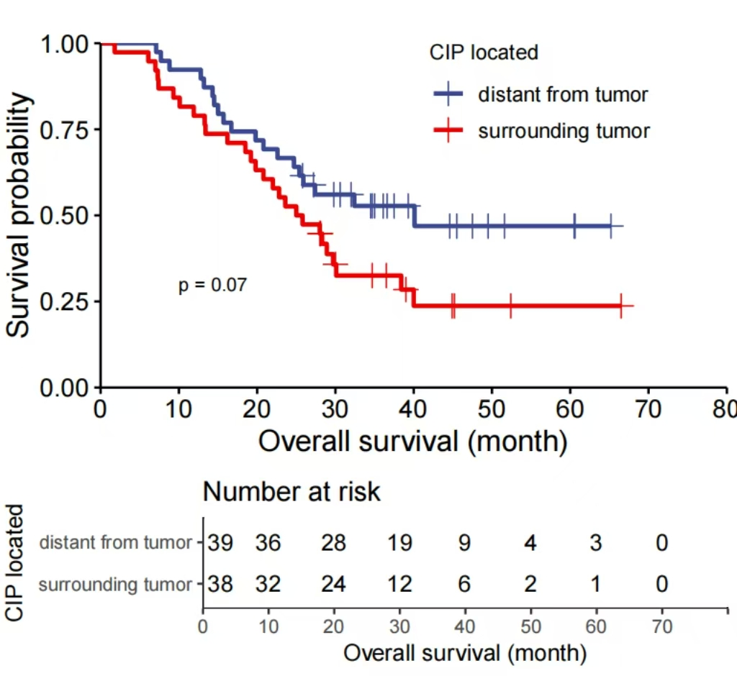
Supplementary Fig. 7 Kaplan-Meier survival curves for 77 patients with primary lung lesions. Overall survival in patients with CIP distant from tumor and surrounding tumor.

Supplementary Fig. 8 A 39-year-old female with left lung adenocarcinoma, received sintilimab combined with anti-angiogenic (IBI305) and chemotherapy (pemetrexed + cisplatin). (A) Baseline axial chest CT image showed the lungs before the initiation of immunotherapy. (B) Three months later, nodular consolidation (white arrow) in both lungs were identified on chest CT image. (C) ICI therapy was continued, and chest CT image that obtained 1 month later after administering steroid therapy showed pneumonitis worsened. (D) ICI therapy was discontinued, and chest CT image that obtained 1 month later showed marked improvement with residual pneumonitis.

