Additional File Table 1. Standardized difference (SD) used to assess the balance of covariates applied in the IPTW method.
Additional File Table 1-1. SDs of ED-SCLC patients with survival analysis based on age (shown in Figures 3A and 3B).
Characteristic | Before adjustment |  |  |  | After adjustment
Characteristic | ICI (-), n=494 | ICI (+), n=96 | SD | ICI (-), n=494 |  | ICI (+), n=96 | SD
Age, years  <70  ≥70, <75  ≥75, <80  ≥80 | 37.9%  26.1%  21.1%  15.0% | 51.0%  29.2%  14.6%  5.2% | 0.268  0.068  -0.170  -0.329 | 41.1%  25.6%  20.2%  13.1% |  | 44.1%  29.4%  19.2%  7.4% | 0.060  0.085  -0.025  -0.191
Sex  Male  Female | 81.8%  18.2% | 83.3%  16.7% | 0.041  -0.041 | 81.9%  18.1% |  | 80.0%  20.0% | -0.050  0.050
BMI, kg/m²  <18.5  18.5–25.0  ≥25.0 | 12.3%  67.8%  19.8% | 15.6%  58.3%  26.0% | 0.095  -0.197  -0.148 | 13.2%  66.1%  20.7% |  | 10.8%  64.7%  24.4% | -0.074  -0.029  0.090
ECOG PS  0 to 1  2 to 4  Unknown | 59.7%  21.3%  19.0% | 69.8%  19.8%  10.4% | 0.212  -0.036  -0.245 | 61.0%  21.7%  17.3% |  | 65.5%  20.5%  14.0% | 0.093  -0.030  -0.091
Pathology  Pure  Combined | 98.8%  1.2% | 99.0%  1.0% | 0.016  -0.016 | 98.9%  1.1% |  | 99.3%  0.7% | 0.041  -0.041
Clinical staging  Stage III  Stage IV | 25.3%  74.7% | 9.4%  90.6% | -0.430  0.430 | 22.4%  77.6% |  | 17.0%  83.0% | -0.136  0.136
Study period  2010 Apr - 2013 Mar  2013 Apr - 2016 Mar  2016 Apr - 2019 Mar  2019 Apr - 2022 Mar | 11.7%  25.7%  36.2%  26.3% | 0.0%  0.0%  0.0%  100.0% | -0.516  -0.832  -1.066  2.366 | 9.7%  21.3%  30.1%  38.8% |  | 0.0%  0.0%  0.0%  100.0% | -0.465  -0.737  -0.927  1.775
Platinum  CBDCA  CDDP | 76.9%  23.1% | 89.6%  10.4% | 0.344  -0.344 | 79.5%  20.5% |  | 89.5%  10.5% | 0.279  -0.279
LDH, U/L  <222  ≥222 | 29.6%  70.4% | 27.1%  72.9% | -0.055  0.055 | 28.5%  71.5% |  | 25.9%  74.1% | -0.058  0.058
Creatinine, mg/dL  <1.0  ≥1.0 | 78.5%  21.5% | 82.3%  17.7% | 0.095  -0.095 | 78.9%  21.1% |  | 81.2%  18.8% | 0.056  -0.056
Sodium, mEq/L  <135  ≥135 | 24.1%  75.9% | 28.1%  71.9% | 0.092  -0.092 | 24.6%  75.4% |  | 23.7%  76.3% | -0.021  0.021
NLR  <5  ≥5 | 66.8%  33.2% | 65.6%  34.4% | -0.025  0.025 | 67.1%  32.9% |  | 63.3%  36.7% | -0.081  0.081
mGPS  0  1  2 | 30.8%  27.1%  42.1% | 25.0%  33.3%  41.7% | -0.129  0.135  -0.009 | 31.2%  27.2%  41.6% |  | 27.8%  25.6%  46.6% | -0.074  -0.037  0.101

Additional File Table 1-2. SDs of ED-SCLC patients with survival analysis for patients under 75 years of age (shown in Figure 3C and Additional Figure 2A).
Characteristic | Before adjustment |  |  |  | After adjustment
Characteristic | ICI (-), n=316 | ICI (+), n=77 | SD | ICI (-), n=316 |  | ICI (+), n=77 | SD
Sex  Male  Female | 83.5%  16.5% | 83.1%  16.9% | 0.011  -0.011 | 83.4%  16.6% |  | 84.2%  15.8% | 0.022  -0.022
BMI, kg/m²  <18.5  18.5–25.0  ≥25.0 | 11.7%  69.0%  19.3% | 15.6%  57.1%  27.3% | 0.113  -0.247  0.189 | 11.7%  67.6%  20.7% |  | 11.7%  65.0%  23.3% | -0.001  -0.055  0.064
ECOG PS  0 to 1  2 to 4  Unknown | 61.4%  20.9%  17.7% | 71.4%  16.9%  11.7% | 0.214  -0.102  -0.171 | 62.0%  21.2%  16.9% |  | 65.4%  18.5%  16.1% | 0.071  -0.066  -0.021
Pathology  Pure  Combined | 98.7%  1.3% | 98.7%  1.3% | 0.003  -0.003 | 99.0%  1.0% |  | 99.3%  0.7% | 0.036  -0.036
Clinical staging  Stage III  Stage IV | 24.4%  75.6% | 10.4%  89.6% | -0.375  0.375 | 22.0%  78.0% |  | 15.9%  84.1% | -0.154  0.154
Study period  Before ICI (-2019 Aug)  After ICI (2019 Sep-) | 79.1%  20.9% | 0.0%  100.0% | -2.752  2.752 | 64.9%  35.1% |  | 0.0%  100.0% | -1.924  1.924
Platinum  CBDCA  CDDP | 64.9%  35.1% | 87.0%  13.0% | 0.536  -0.536 | 68.8%  31.2% |  | 84.7%  15.3% | 0.383  -0.383
LDH, U/L  <222  ≥222 | 30.4%  69.6% | 29.9%  70.1% | -0.011  0.011 | 28.9%  71.1% |  | 26.0%  74.0% | -0.066  0.066
Creatinine, mg/dL  <1.0  ≥1.0 | 79.1%  20.9% | 89.6%  10.4% | 0.292  -0.292 | 81.0%  19.0% |  | 86.5%  13.5% | 0.149  -0.149
Sodium, mEq/L  <135  ≥135 | 25.0%  75.0% | 28.6%  71.4% | 0.081  -0.081 | 25.6%  74.4% |  | 28.7%  71.3% | 0.070  -0.070
NLR  <5  ≥5 | 65.5%  34.5% | 63.6%  36.4% | -0.039  0.039 | 64.2%  35.8% |  | 60.1%  39.9% | -0.085  0.085
mGPS  0  1  2 | 32.0%  25.6%  42.4% | 24.7%  36.4%  39.0% | -0.162  0.234  -0.070 | 32.2%  25.1%  42.7% |  | 27.6%  25.3%  47.2% | -0.101  -0.005  0.089

Additional File Table 1-3. SDs of ED-SCLC patients with survival analysis for patients over 75 years of age (shown in Figure 3D and Additional Figure 2B).
Characteristic | Before adjustment |  |  |  | After adjustment
Characteristic | ICI (-), n=178 | ICI (+), n=19 | SD | ICI (-), n=178 |  | ICI (+), n=19 | SD
Sex  Male  Female | 78.7%  21.3% | 84.2%  15.8% | 0.143  -0.143 | 78.3%  21.7% |  | 81.4%  18.6% | 0.075  -0.075
BMI, kg/m²  <18.5  18.5–25.0  ≥25.0 | 13.5%  65.7%  20.8% | 15.8%  63.2%  21.1% | 0.065  -0.054  0.007 | 12.5%  65.5%  22.0% |  | 9.0%  69.1%  21.9% | -0.111  0.076  -0.002
ECOG PS  0 to 1  2 to 4  Unknown | 56.7%  21.9%  20.8% | 63.2%  31.6%  5.3% | 0.131  0.220  -0.487 | 57.9%  22.1%  20.0% |  | 69.7%  25.4%  4.9% | 0.247  0.077  -0.468
Pathology  Pure  Combined | 98.9%  1.1% | 100.0%  0.0% | 0.151  -0.151 | 99.0%  1.0% |  | 100.0%  0.0% | 0.145  -0.145
Clinical staging  Stage III  Stage IV | 27.0%  73.0% | 5.3%  94.7% | -0.618  0.618 | 25.5%  74.5% |  | 17.0%  83.0% | -0.210  0.210
Study period  Before ICI (-2019 Aug)  After ICI (2019 Sep-) | 75.3%  24.7% | 0.0%  100.0% | -2.468  2.468 | 69.7%  30.3% |  | 0.0%  100.0% | -2.144  2.144
Platinum  CBDCA  CDDP | 98.3%  1.7% | 100.0%  0.0% | 0.185  -0.185 | 98.4%  1.6% |  | 100.0%  0.0% | 0.178  -0.178
LDH, U/L  <222  ≥222 | 28.1%  71.9% | 15.8%  84.2% | -0.301  0.301 | 26.4%  73.6% |  | 11.8%  88.2% | -0.377  0.377
Creatinine, mg/dL  <1.0  ≥1.0 | 77.5%  22.5% | 52.6%  47.4% | -0.541  0.541 | 76.2%  23.8% |  | 57.7%  42.3% | 0.401  -0.401
Sodium, mEq/L  <135  ≥135 | 22.5%  77.5% | 26.3%  73.7% | 0.090  -0.090 | 21.2%  78.8% |  | 17.6%  82.4% | -0.091  0.091
NLR  <5  ≥5 | 69.1%  30.9% | 73.7%  26.3% | 0.102  -0.102 | 69.5%  30.5% |  | 71.0%  29.0% | 0.034  -0.034
mGPS  0  1  2 | 28.7%  29.8%  41.6% | 26.3%  21.1%  52.6% | -0.052  -0.201  0.223 | 28.2%  28.8%  42.9% |  | 32.7%  18.3%  49.0% | 0.098  -0.250  0.121

Additional File Table 1-4. SDs of ED-SCLC patients with survival analysis after ICI approval (shown in Additional Figures 3A and 3B).
Characteristic | Before adjustment |  |  |  | After adjustment
Characteristic | ICI (-), n=110 | ICI (+), n=96 | SD | ICI (-), n=110 |  | ICI (+), n=96 | SD
Age, years  <75  ≥75 | 60.0%  40.0% | 80.2%  19.8% | 0.453  -0.453 | 68.8%  31.2% |  | 74.6%  25.4% | 0.128  -0.128
Sex  Male  Female | 81.8%  18.2% | 83.3%  16.7% | 0.040  -0.040 | 82.9%  17.1% |  | 82.8%  17.2% | -0.003  0.003
BMI, kg/m²  <18.5  18.5–25.0  ≥25.0 | 6.4%  70.0%  23.6% | 15.6%  58.3%  26.0% | 0.299  -0.245  0.056 | 10.8%  65.3%  24.0% |  | 11.0%  64.0%  25.0% | 0.008  -0.027  0.025
ECOG PS  0 to 1  2 to 4  Unknown | 54.5%  16.4%  29.1% | 69.8%  19.8%  10.4% | 0.318  0.089  -0.482 | 59.8%  19.8%  20.4% |  | 63.0%  19.8%  17.1% | 0.065  0.002  -0.083
Pathology  Pure  Combined | 99.1%  0.9% | 99.0%  1.0% | -0.013  0.013 | 99.3%  0.7% |  | 99.3%  0.7% | -0.005  0.005
Clinical staging  Stage III  Stage IV | 34.5%  65.5% | 9.4%  90.6% | -0.638  0.638 | 22.5%  77.5% |  | 17.0%  83.0% | -0.140  0.140
Platinum  CBDCA  CDDP | 88.2%  11.8% | 89.6%  10.4% | 0.045  -0.045 | 90.1%  9.9% |  | 89.8%  10.2% | -0.009  0.009
LDH, U/L  <222  ≥222 | 24.5%  75.5% | 27.1%  72.9% | 0.058  -0.058 | 22.8%  77.2% |  | 24.7%  75.3% | 0.043  -0.043
Creatinine, mg/dL  <1.0  ≥1.0 | 81.8%  18.2% | 82.3%  17.7% | 0.012  -0.012 | 79.6%  20.4% |  | 81.9%  18.1% | 0.057  -0.057
Sodium, mEq/L  <135  ≥135 | 27.3%  72.7% | 28.1%  71.9% | 0.019  -0.019 | 28.1%  71.9% |  | 26.9%  73.1% | -0.027  0.027
NLR  <5  ≥5 | 57.3%  42.7% | 65.6%  34.4% | 0.172  -0.172 | 61.9%  38.1% |  | 62.3%  37.7% | 0.007  -0.007
mGPS  0  1  2 | 29.1%  18.2%  52.7% | 25.0%  33.3%  41.7% | -0.092  0.352  -0.223 | 32.0%  20.0%  48.0% |  | 27.5%  26.0%  46.5% | -0.098  0.141  -0.029

SD: standardized difference, ED: extensive disease, SCLC: Small cell lung cancer, ICI: Immune checkpoint inhibitor, BMI: Body mass index, ECOG: Eastern Cooperative Oncology Group, PS: Performance status, CDDP: Cisplatin, CBDCA: Carboplatin

Additional File Table 2. Patient characteristics based on age < 75 or ≥ 75 years and platinum-based chemotherapy combined with (+) or without (-) immune checkpoint inhibitor (ICI)
n (%) | Overall | < 75 years |  | p | ≥ 75 years |  | p
n (%) | Overall | ICI (-) | ICI (+) | p | ICI (-) | ICI (+) | p
n (%) | n=590 | n=316 | n=77 | p | n=178 | n=19 | p
Age, median [range]  <75 years  ≥75 years | 71 [40–90]  393 (66.6)  197 (33.4) | 68 [40–74]  316 (100.0)  0 (0) | 67 [46–74]  77 (100.0)  0 (0) | – | 79 [75–90]  0 (0)  178 (100) | 78 [75–82]  0 (0)  19 (100) | -
Sex  Male  Female | 484 (82.0)  106 (18.0) | 264 (83.5)  52 (16.5) | 64 (83.q)  13 (16.9) | 1.000 | 140 (78.7)  38 (21.3) | 16 (84.2)  3 (15.8) | 0.787
BMI, kg/m² [range]  <18.5  18.5–25.0  >25.0 | 76 (12.9)  391 (66.3)  123 (20.8) | 37 (11.7)  218 (69.0)  61 (19.3) | 12 (15.6)  44 (57.1)  21 (27.3) | 0.140 | 24 (13.5)  117 (65.7)  37 (20.8) | 3 (15.8)  12 (63.2)  4 (21.1) | 0.959
ECOG PS  0 to 1  2 to 4  Unknown | 362 (61.4)  124 (21.0)  104 (17.6) | 194 (61.4)  66 (20.9)  56 (17.7) | 55 (71.4)  13 (16.9)  9 (11.7) | 0.242 | 101 (56.7)  39 (21.9)  38 (21.3) | 12 (63.2)  6 (31.6)  1 (5.3) | 0.216
Pathology  Pure SCLC  Combined SCLC | 583 (98.8)  7 (1.2) | 312 (98.7)  4 (1.3) | 76 (98.7)  1 (1.3) | 1.000 | 176 (98.9)  2 (1.1) | 19 (100.0)  0 (0.0) | 1.000
Clinical staging  Stage III  Stage IV | 134 (22.7)  456 (77.3) | 77 (24.4)  239 (75.6) | 8 (10.4)  69 (89.6) | 0.012 | 48 (27.0)  130 (73.0) | 1 (5.3)  18 (94.7) | 0.072
Study period  Before (-2019 Aug)  After (2019 Sep-) | 384 (65.1)  206 (34.9) | 250 (79.1)  66 (20.9) | 0 (0.0)  77 (100.0) | <0.001 | 134 (75.3)  44 (24.7) | 0 (0.0)  19 (100.0) | <0.001
Platinum  CDDP  CBDCA | 466 (79.0)  124 (21.0) | 205 (64.9)  111 (35.1) | 67 (87.0)  10 (13.0) | <0.001 | 175 (98.3)  3 (1.7) | 19 (100.0)  0 (0.0) | 1.000
LDH, U/L  <222  ≥222 | 172 (29.2)  418 (70.8) | 96 (30.4)  220 (69.6) | 23 (29.9)  54 (70.1) | 1.000 | 50 (28.1)  128 (71.9) | 3 (15.8)  16 (84.2) | 0.380
Creatinine  <1  ≥1 | 467 (79.2)  123 (20.8) | 250 (79.1)  66 (20.9) | 69 (89.6)  8 (10.4) | 0.051 | 138 (77.5)  40 (22.5) | 10 (52.6)  9 (47.4) | 0.035
Sodium, mEq/L  <135  ≥135 | 146 (24.7)  444 (75.3) | 79 (25.0)  237 (75.0) | 22 (28.6)  55 (71.4) | 0.619 | 40 (22.5)  138 (77.5) | 5 (26.3)  14 (73.7) | 0.927
NLR  <5  ≥5 | 393 (66.6)  197 (33.4) | 206 (65.5)  110 (34.5) | 49 (63.6)  28 (36.4) | 0.861 | 123 (69.1)  55 (30.9) | 14 (73.7)  5 (26.3) | 0.880
mGPS  0  1  2 | 176 (29.8)  166 (28.1)  248 (42.0) | 101 (32.0)  81 (25.6)  134 (42.4) | 19 (24.7)  28 (36.4)  30 (39.0) | 0.148 | 51 (28.7)  53 (29.8)  74 (41.6) | 5 (26.3)  4 (21.1)  10 (52.6) | 0.614

IQR: Interquartile range, ICI: Immune checkpoint inhibitor, BMI: Body mass index, ECOG: Eastern Cooperative Oncology Group, PS: Performance status, SCLC: Small cell lung cancer, CDDP: Cisplatin, CBDCA: Carboplatin

Adittinal File Figure 1. Consort diagram and chemotherapy regimen
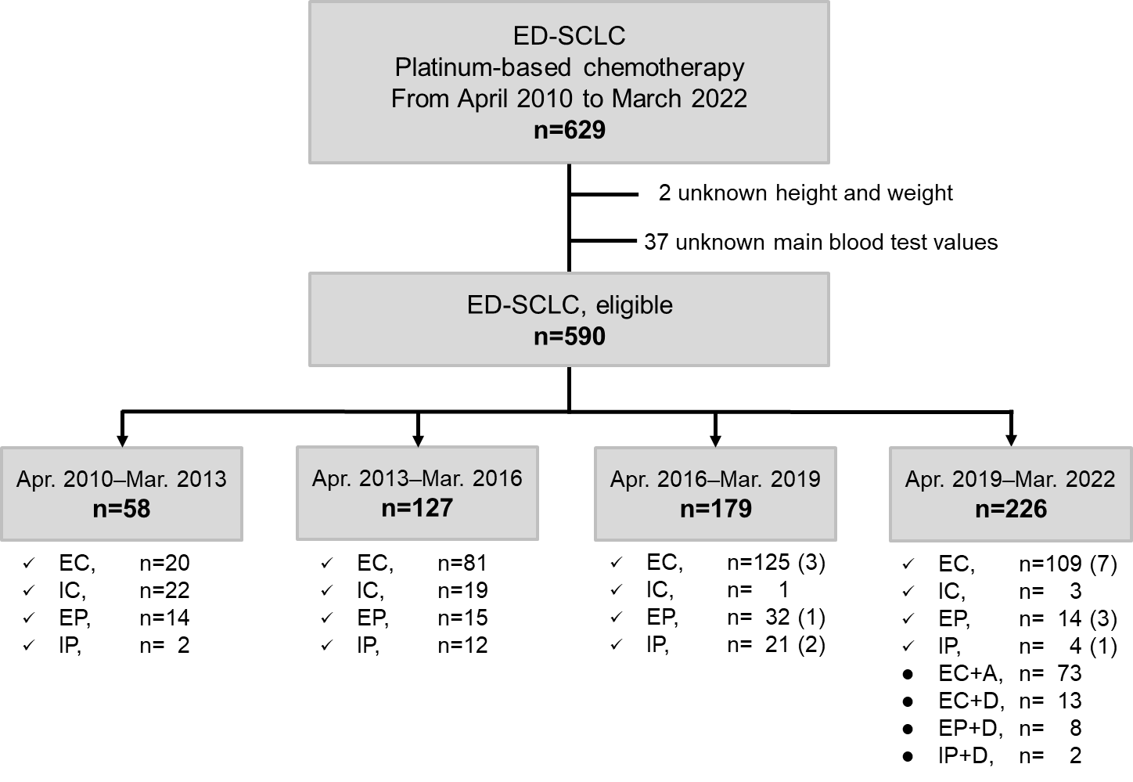
Note: Atezolizumab was approved for use in Japan on August 22, 2019.
( ) = number of patients treated with immune checkpoint inhibitor after first-line chemotherapy
ED: Extensive-disease, SCLC: Small-cell lung cancer, E: Etoposide, I: Irinotecan, C: Carboplatin, P: Cisplatin, A: Atezolizumab, D: Durvalumab

Additional File Figure 2. Overall survival for (A) patients aged < 75 years and (B) patients aged ≥ 75 years using the IPTW method.
A. IPTW analysis for patients aged < 75 years B. IPTW analysis for patients aged ≥ 75 years
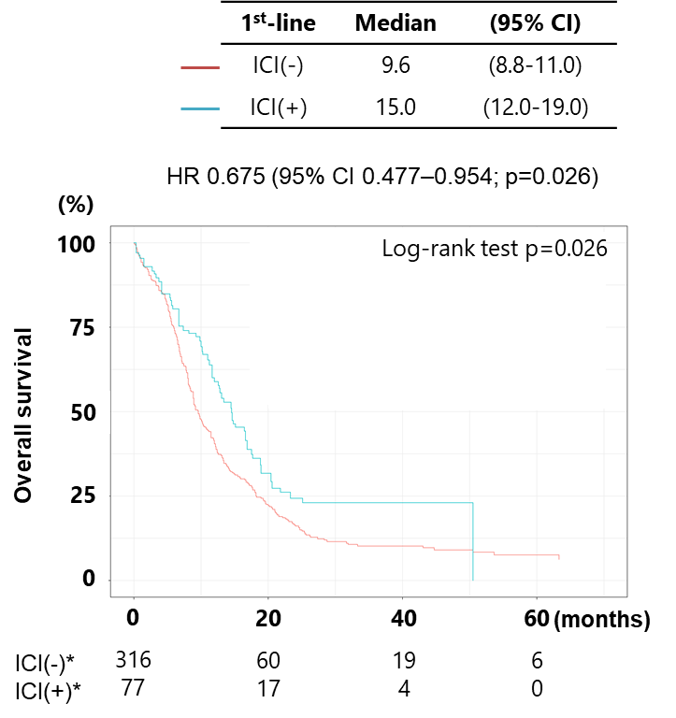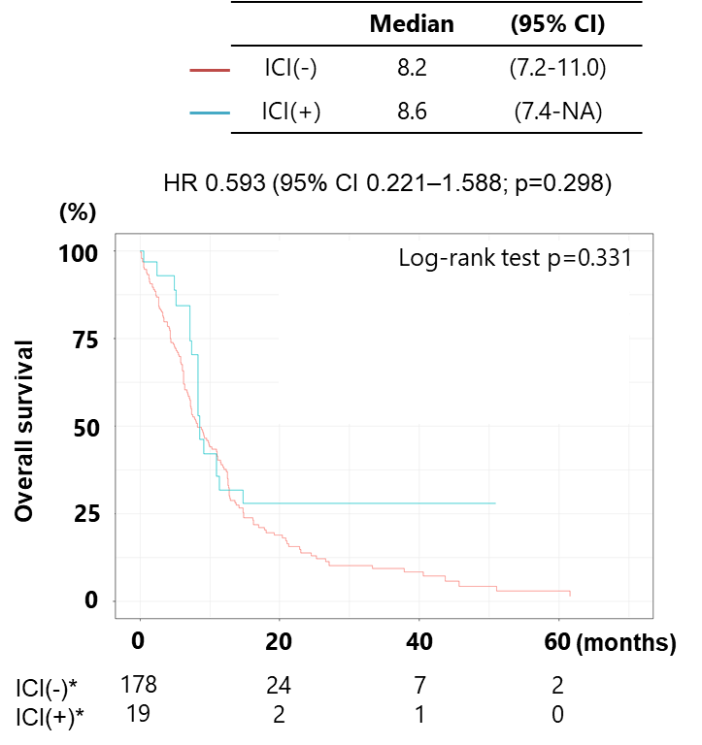
*The numbers of at-risk patients are unweighted counts at each time point.
CI: confidence interval, ICI: immune checkpoint inhibitor

Additional File Figure 3. Overall survival after ICI approval for (A) patients with ED-SCLC and (B) patients using the IPTW method.
A. Overall, n=206 B. IPTW analysis for overall
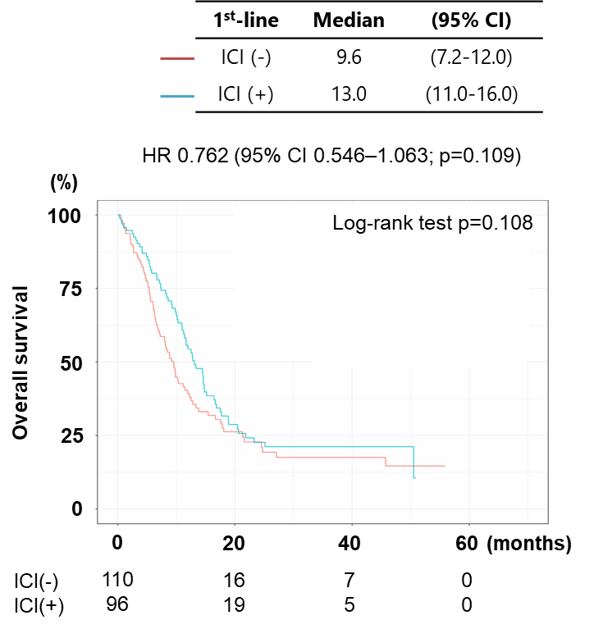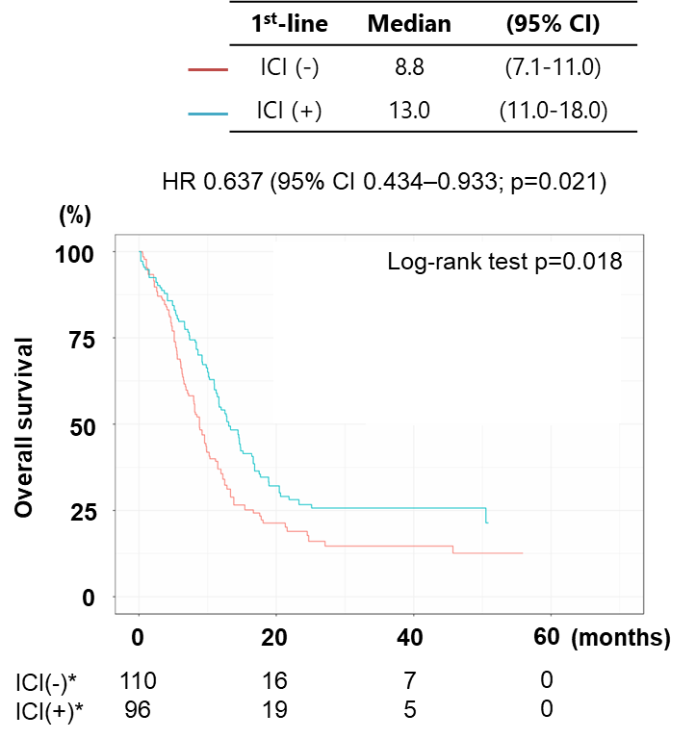
*The numbers of at-risk patients are unweighted counts at each time point.
CI: confidence interval, ICI: immune checkpoint inhibitor
Additional File Figure 4. Progress after initial platinum-based chemotherapy.
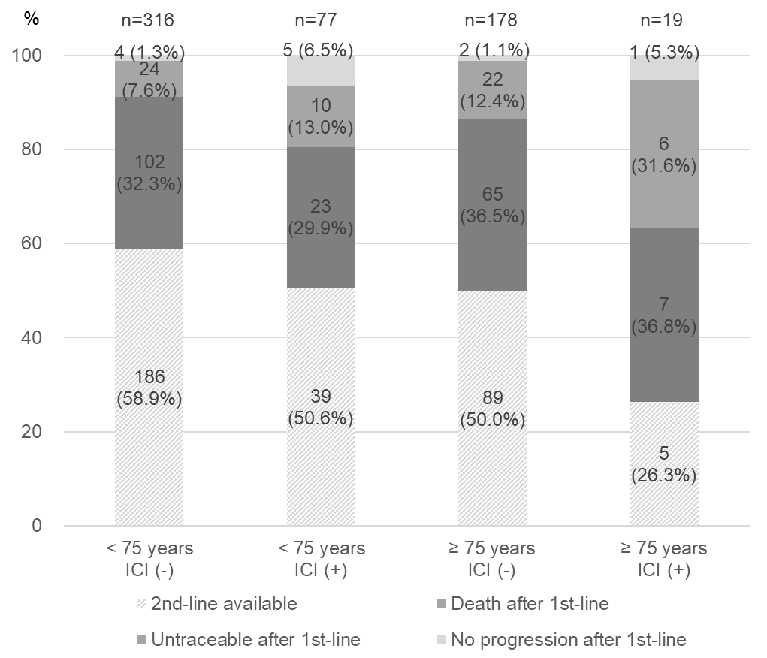
ICI: immune checkpoint inhibitor

