Table S1 T cell subsets in DLBCL patients and healthy controls
T Cell Subset | DLBCL | Healthy Controls (n=6) | P Value
CD4⁺ T Cells | (n=13)
T naïve | 3.01±2.85 | 27.13±15.22 | <0.001
TCM | 33.87±19.55 | 42.30±21.11 | 0.258
TEM | 58.71±19.60 | 21.08±5.79 | <0.001
T effector | 4.42±4.45 | 3.94±5.46 | 0.917
CD8⁺ T Cells | (n=19)
T naïve | 8.79±9.54 | 41.43±3.51 | <0.001
TCM | 14.24±11.69 | 4.20±2.36 | 0.162
TEM | 54.88±24.30 | 24.20±8.66 | 0.047
T effector | 22.10±15.21 | 30.20±13.08 | 0.395
These data refer to the proportions of T naïve, TCM, TEM and T effectors within CD4+ T cells and CD8+ T cells respectively, which were presented as means ± standard deviations. P<0.05 denotes statistical significance. Abbreviations: DLBCL, diffuse large B-cell lymphoma; T naïve, naïve T cell; TCM, T central memory cell; TEM, T effector memory cell; T effector, T effector cell.
Table S2 Expression of immune checkpoints on T cells in DLBCL patients and healthy controls
 | Immune checkpoints | DLBCL (n=60, %) | Healthy Controls (n=12, %) | P Value
CD4⁺ T cells | PD-1 | 27.96±28.25 | 0.98±1.67 | <0.001
CD4⁺ T cells | CTLA-4 | 9.90±11.74 | 7.64±8.56 | 0.530
CD4⁺ T cells | LAG-3 | 6.00±7.79 | 2.11±2.09 | 0.005
CD4⁺ T cells | TIM-3 | 6.66±11.40 | 1.46±2.33 | 0.003
CD8⁺ T cells | PD-1 | 33.38±25.95 | 4.88±4.26 | <0.001
CD8⁺ T cells | CTLA-4 | 8.93±11.69 | 10.54±7.88 | 0.650
CD8⁺ T cells | LAG-3 | 6.81±8.47 | 2.87±1.98 | 0.004
CD8⁺ T cells | TIM-3 | 12.14±20.89 | 3.27±3.52 | 0.014
Data are presented as means ± standard deviations. P<0.05 denotes statistical significance. Abbreviations: DLBCL, diffuse large B-cell lymphoma.
Table S3 Expression of cell senescence markers on peripheral T cells in DLBCL patients and healthy populations
 | Senescence markers | DLBCL (n=60, %) | Healthy Controls (n=12, %) | P Value
CD4⁺T cell | CD28⁺ | 76.21±25.45 | 78.84±16.98 | 0.779
 | CD57⁺ | 22.33±16.47 | 16.52±13.38 | 0.345
 | KLRG1⁺ | 23.65±24.20 | 19.45%±15.21 | 0.658
 | CD57⁺KLRG1⁺ | 8.99±12.40 | 5.82±8.35 | 0.516
 | CD28⁺CD57⁻ | 61.91±23.40 | 69.86±13.24 | 0.353
 | CD28⁻CD57⁺ | 9.33±11.46 | 8.29±8.50 | 0.806
 | CD28⁺KLRG1⁻ | 64.22±27.29 | 67.91±19.36 | 0.731
 | CD28⁻KLRG1⁺ | 8.33±15.95 | 5.68±9.61 | 0.671
CD8⁺T cell | CD28⁺ | 66.32±28.69 | 72.01±21.24 | 0.592
 | CD57⁺ | 35.99±16.71 | 21.07±13.20 | 0.019
 | KLRG1⁺ | 36.61±32.30 | 17.07±14.42 | 0.025
 | CD57⁺KLRG1⁺ | 13.21±16.18 | 3.92±2.84 | 0.002
 | CD28⁺CD57⁻ | 45.27±20.47 | 63.13±23.58 | 0.027
 | CD28⁻CD57⁺ | 15.33±13.30 | 10.59±7.29 | 0.331
 | CD28⁺KLRG1⁻ | 42.12±27.17 | 57.68±18.72 | 0.184
 | CD28⁻KLRG1⁺ | 8.80±17.30 | 1.38±1.05 | 0.010
This table presents the respective proportions of various cell subsets within both CD4+ T cells and CD8+ T cell populations. Data are presented as means ± standard deviations. P<0.05 denotes statistical significance. Abbreviations: DLBCL, diffuse large B-cell lymphoma.
Table S4 Immune effectors on T cells in DLBCL patients and healthy controls
 | Immune effectors  (%) | DLBCL (n=36) | Healthy Controls (n=12) | P Value
CD4⁺ T cells | IFN-γ | 13.17±13.65 | 9.17±8.42 | 0.341
CD4⁺ T cells | TNF-α | 8.41±8.53 | 19.86±23.84 | 0.374
CD8⁺ T cells | IFN-γ | 32.67±20.86 | 23.06±14.75 | 0.145
CD8⁺ T cells | TNF-α | 10.47±14.62 | 3.71±3.78 | 0.121
Data are presented as means ± standard deviations. P<0.05 denotes statistical significance. Abbreviations: DLBCL, diffuse large B-cell lymphoma.
Table S5 T cell subsets in EBV- DLBCL patients and healthy controls
T Cell Subset | EBV- DLBCL | Healthy Controls (n=6) | P Value
CD4⁺ T Cells | (n=10)
T naïve | 3.61±3.00 | 27.13±15.22 | 0.012
TCM | 40.53±16.62 | 42.30±21.11 | 0.854
TEM | 51.70±16.13 | 21.08±5.79 | 0.001
T effector | 4.18±3.34 | 3.94±5.46 | 0.913
CD8⁺ T Cells | (n=16)
T naïve | 10.39±9.58 | 41.43±3.51 | <0.001
TCM | 15.69±12.24 | 4.20±2.36 | 0.132
TEM | 48.66±21.03 | 24.20±8.66 | 0.071
T effector | 25.27±14.32 | 30.20±13.08 | 0.588
These data refer to the proportions of T naïve, TCM, TEM and T effectors within CD4+ T cells and CD8+ T cells respectively, which were presented as means ± standard deviations. P<0.05 denotes statistical significance. Abbreviations: EBV- DLBCL, EBV negative diffuse large B-cell lymphoma; T naïve, naïve T cell; TCM, T central memory cell; TEM, T effector memory cell; T effector, T effector cell.
Table S6 Expression of immune checkpoints on T cells in EBV- DLBCL patients and healthy controls
 | Immune checkpoints | EBV-DLBCL (n=54) | Healthy Controls (n=12) | P Value
CD4⁺ T cells | PD-1 | 26.52±27.36 | 0.98±1.67 | <0.001
CD4⁺ T cells | CTLA-4 | 9.80±12.01 | 7.64±8.56 | 0.559
CD4⁺ T cells | LAG-3 | 6.10±8.22 | 2.11±2.09 | 0.001
CD4⁺ T cells | TIM-3 | 5.27±7.92 | 1.46±2.33 | 0.006
CD8⁺ T cells | PD-1 | 33.03±26.94 | 4.88±4.26 | <0.001
CD8⁺ T cells | CTLA-4 | 8.98±12.11 | 10.54±7.88 | 0.672
CD8⁺ T cells | LAG-3 | 6.89±8.85 | 2.87±1.98 | 0.001
CD8⁺ T cells | TIM-3 | 10.57±20.49 | 3.27±3.52 | 0.212
Data are presented as means ± standard deviations. P<0.05 denotes statistical significance. Abbreviations: EBV- DLBCL, EBV negative diffuse large B-cell lymphoma.
Table S7 Expression of cell senescence markers on peripheral T cells in EBV- DLBCL patients and healthy populations
 | Senescence markers | EBV-DLBCL (n=54) | Healthy Controls (n=12) | P Value
CD4⁺T cell | CD28⁺ | 76.73±25.50 | 78.84±16.98 | 0.786
 | CD57⁺ | 21.24±15.75 | 16.52±13.38 | 0.341
 | KLRG1⁺ | 22.51±24.07 | 19.45%±15.21 | 0.677
 | CD57⁺KLRG1⁺ | 8.99±12.40 | 5.82±8.35 | 0.516
 | CD28⁺CD57⁻ | 62.79±23.58 | 69.86±13.24 | 0.322
 | CD28⁻CD57⁺ | 8.73±10.63 | 8.29±8.50 | 0.893
 | CD28⁺KLRG1⁻ | 65.42±27.43 | 67.91±19.36 | 0.767
 | CD28⁻KLRG1⁺ | 7.75±15.44 | 5.68±9.61 | 0.657
CD8⁺T cell | CD28⁺ | 67.5±27.76 | 72.01±21.24 | 0.599
 | CD57⁺ | 35.91±16.55 | 21.07±13.20 | 0.005
 | KLRG1⁺ | 35.79±32.08 | 17.07±14.42 | 0.058
 | CD57⁺KLRG1⁺ | 11.61±13.84 | 3.92±2.84 | 0.003
 | CD28⁺CD57⁻ | 46.33±20.23 | 63.13±23.58 | 0.015
 | CD28⁻CD57⁺ | 15.0±13.22 | 10.59±7.29 | 0.261
 | CD28⁺KLRG1⁻ | 45.59±26.10 | 57.68±18.72 | 0.145
 | CD28⁻KLRG1⁺ | 7.71±16.86 | 1.38±1.05 | 0.029
This table presents the respective proportions of various cell subsets within both CD4+ T cells and CD8+ T cell populations. Data are presented as means ± standard deviations. P<0.05 denotes statistical significance. Abbreviations: EBV- DLBCL, EBV negative diffuse large B-cell lymphoma.
Table S8 Immune effectors on T cells in EBV- DLBCL patients and healthy controls
 | Immune effectors  (%) | EBV-DLBCL (n=30) | Healthy Controls (n=12) | P Value
CD4⁺ T cells | IFN-γ | 14.01±13.67 | 9.17±8.42 | 0.257
CD4⁺ T cells | TNF-α | 9.80±8.68 | 19.86±23.84 | 0.450
CD8⁺ T cells | IFN-γ | 32.83±19.87 | 23.06±14.75 | 0.049
CD8⁺ T cells | TNF-α | 11.34±15.21 | 3.71±3.78 | 0.011

Table S9T cell subsets in EBV+ and EBV- DLBCL patients
 | T Cell Subset (%) | EBV+DLBCL (n=3) | EBV- DLBCL  (n=10) | P Value
CD4⁺T cell | T naïve | 1.03±0.68 | 3.61±3.10 | 0.179
CD4⁺T cell | TCM | 11.65±7.62 | 40.53±17.20 | 0.017
CD4⁺T cell | TEM | 82.10±6.65 | 51.70±15.47 | 0.010
CD4⁺T cell | T effector | 5.23±6.70 | 4.18±3.33 | 0.847
CD8⁺T cell | T naïve | 0.22±0.32 | 10.40±9.03 | 0.001
CD8⁺T cell | TCM | 6.50±0.65 | 15.69±13.04 | 0.221
CD8⁺T cell | TEM | 88.10±4.41 | 48.66±20.46 | <0.001
CD8⁺T cell | T effector | 5.17±4.77 | 25.27±14.80 | 0.031
These data refer to the proportions of T naïve, TCM, TEM and T effectors within CD4+ T cells and CD8+ T cells respectively, which were presented as means ± standard deviations. P<0.05 denotes statistical significance. Abbreviations: EBV+ DLBCL, EBV positive diffuse large B-cell lymphoma; EBV- DLBCL, EBV negative diffuse large B-cell lymphoma; T naïve, naïve T cell; TCM, T central memory cell; TEM, T effector memory cell; T effector, T effector cell.
Table S10 Immune checkpoints expression in EBV+ and EBV- DLBCL patients
 | Immune checkpoint (%) | EBV⁺ DLBCL  (n=6) | EBV⁻ DLBCL  (n=12) | P value
CD4⁺T cell | PD-1 | 43.69±30.41 | 10.80±14.15 | 0.045
CD4⁺T cell | CTLA-4 | 10.82±9.90 | 10.42±9.18 | 0.933
CD4⁺T cell | LAG-3 | 6.83±4.65 | 6.17±6.50 | 0.832
CD4⁺T cell | TIM-3 | 17.76±24.92 | 5.36±5.77 | 0.280
 | TIM-3⁻CTLA-4⁻ | 70.30±21.71 | 86.70±10.89 | 0.049
CD8⁺T cell | PD-1 | 46.18±21.47 | 20.92±22.43 | 0.036
CD8⁺T cell | CTLA-4 | 8.46±7.60 | 11.46±11.67 | 0.578
CD8⁺T cell | LAG-3 | 6.18±4.58 | 4.25±5.95 | 0.508
CD8⁺T cell | TIM-3 | 23.15±22.67 | 5.41±5.74 | 0.156
 | TIM-3⁻CTLA-4⁻ | 70.80±18.56 | 82.11±16.09 | 0.199
Data were presented as means ± standard deviations. P<0.05 denotes statistical significance. Abbreviations: EBV+ DLBCL, EBV positive diffuse large B-cell lymphoma; EBV- DLBCL, EBV negative diffuse large B-cell lymphoma
Table S11 T cell senescence level in EBV+ and EBV- DLBCL patients
 | Senescence markers  （%） | EBV⁺ DLBCL  (n=6) | EBV⁻ DLBCL  (n=12) | P value
CD4⁺T cell | CD28⁺ | 46.18±41.64 | 82.20%±21.71 | 0.091
CD4⁺T cell | CD57⁺ | 36.80±21.60 | 32.20%±21.33 | 0.715
CD4⁺T cell | KLRG1⁺ | 37.38±24.74 | 20.65%±22.11 | 0.238
CD4⁺T cell | CD57⁺KLRG1⁺ | 27.95±29.55 | 23.18±19.50 | 0.127
CD4⁺T cell | CD28⁺CD57⁻ | 50.20±19.55 | 58.30±18.64 | 0.469
CD4⁺T cell | CD28⁻CD57⁺ | 17.33±20.17 | 7.75±13.32 | 0.289
CD4⁺T cell | CD28⁺KLRG1⁻ | 49.43±23.71 | 69.68±26.43
CD4⁺T cell | CD28⁻KLRG1⁺ | 15.54±22.81 | 8.02±16.40 | 0.499
CD8⁺T cell | CD28⁺ | 50.79±40.79 | 72.52%±23.00 | 0.209
CD8⁺T cell | CD57⁺ | 37.08±21.46 | 44.10%±17.07 | 0.512
CD8⁺T cell | KLRG1⁺ | 23.42±36.30 | 30.53%±34.07 | 0.688
CD8⁺T cell | CD57⁺KLRG1⁺ | 12.97±11.74 | 8.80±12.90 | 0.253
CD8⁺T cell | CD28⁺CD57⁻ | 31.68±21.32 | 47.58±18.36 | 0.170
CD8⁺T cell | CD28⁻CD57⁺ | 18.20±16.16 | 12.01±10.24 | 0.377
CD8⁺T cell | CD28⁺KLRG1⁻ | 10.00±12.26 | 45.03±23.52 | 0.018
CD8⁺T cell | CD28⁻KLRG1⁺ | 18.91±20.69 | 5.85±10.94 | 0.156
CD8⁺T cell | CD28⁺KLRG1⁻CD57⁻ | 12.05±10.75 | 37.46±16.71 | 0.036
This table presents the respective proportions of various cell subsets within both CD4+ T cells and CD8+ T cell populations. Data are presented as means ± standard deviations. P<0.05 denotes statistical significance. Abbreviations: EBV+ DLBCL, EBV positive diffuse large B-cell lymphoma; EBV- DLBCL, EBV negative diffuse large B-cell lymphoma

Table S12 Correlation between T cell immunity indicators and age in healthy populations
 |  | R | R² | P value
CD4⁺ T cells | CTLA4 | -0.027 | 0.001 | 0.931
CD4⁺ T cells | PD1 | -0.486 | 0.237 | 0.109
CD4⁺ T cells | TIM3 | 0.339 | 0.115 | 0.281
CD4⁺ T cells | LAG3 | -0.322 | 0.104 | 0.307
CD4⁺ T cells | CD28 | -0.178 | 0.032 | 0.580
CD4⁺ T cells | CD57 | -0.140 | 0.019 | 0.665
CD4⁺ T cells | KLAG1 | -0.137 | 0.019 | 0.671
CD4⁺ T cells | CD57- CD28+ | -0.612 | 0.374 | 0.035
CD4⁺ T cells | CD57+ CD28- | -0.138 | 0.019 | 0.668
CD4⁺ T cells | CD28- KLRG1+ | -0.200 | 0.040 | 0.533
CD4⁺ T cells | CD28+ KLRG1- | -0.063 | 0.004 | 0.847
CD4⁺ T cells | CD57+ KLRG1+ | 0.155 | 0.0239 | 0.631
CD4⁺ T cells | INF-γ | -0.373 | 0.1388 | 0.233
CD4⁺ T cells | TNF-α | 0.128 | 0.0163 | 0.692
CD8⁺ T cells | CTLA4 | 0.017 | 0.000 | 0.960
CD8⁺ T cells | PD1 | 0.068 | 0.005 | 0.833
CD8⁺ T cells | TIM3 | 0.421 | 0.177 | 0.173
CD8⁺ T cells | LAG3 | -0.219 | 0.048 | 0.494
CD8⁺ T cells | CD28 | -0.220 | 0.04853 | 0.491
CD8⁺ T cells | CD57 | 0.443 | 0.196 | 0.150
CD8⁺ T cells | KLAG1 | 0.372 | 0.138 | 0.234
CD8⁺ T cells | CD57- CD28+ | -0.335 | 0.112 | 0.288
CD8⁺ T cells | CD57+ CD28- | 0.211 | 0.04453 | 0.510
CD8⁺ T cells | CD28- KLRG1+ | 0.712 | 0.507 | 0.009
CD8⁺ T cells | CD28+ KLRG1- | -0.728 | 0.529 | 0.007
CD8⁺ T cells | CD57+ KLRG1+ | 0.597 | 0.356 | 0.041
CD8⁺ T cells | INF-γ | -0.075 | 0.006 | 0.817
CD8⁺ T cells | TNF-α | -0.145 | 0.0210 | 0.653
This table presents the correlation between age and each T cell immunity indicator. Pearson correlation coefficient is performed. P<0.05 denotes statistical significance.
Table S13 Correlation between T cell immunity indicators and age in EBV- DLBCL
 |  | R | R² | P value
CD4⁺ T cells | CTLA4 | -0.099 | 0.010 | 0.481
CD4⁺ T cells | PD1 | 0.201 | 0.0403 | 0.176
CD4⁺ T cells | TIM3 | -0.198 | 0.039 | 0.183
CD4⁺ T cells | LAG3 | 0.230 | 0.053 | 0.115
CD4⁺ T cells | CD28 | -0.120 | 0.014 | 0.397
CD4⁺ T cells | CD57 | 0.175 | 0.031 | 0.220
CD4⁺ T cells | KLRG1 | 0.302 | 0.091 | 0.042
CD4⁺ T cells | CD57- CD28+ | -0.171 | 0.029 | 0.230
CD4⁺ T cells | CD57+ CD28- | 0.206 | 0.042 | 0.147
CD4⁺ T cells | CD28- KLRG1+ | 0.382 | 0.146 | 0.008
CD4⁺ T cells | CD28+ KLRG1- | -0.322 | 0.104 | 0.027
CD4⁺ T cells | CD57+ KLRG1+ | 0.329 | 0.108 | 0.026
CD4⁺ T cells | INF-γ | 0.053 | 0.003 | 0.777
CD4⁺ T cells | TNF-α | 0.026 | 0.001 | 0.890
CD8⁺ T cells | CTLA4 | -0.206 | 0.043 | 0.138
CD8⁺ T cells | PD1 | 0.376 | 0.141 | 0.009
CD8⁺ T cells | TIM3 | -0.413 | 0.170 | 0.141
CD8⁺ T cells | LAG3 | 0.051 | 0.003 | 0.731
CD8⁺ T cells | CD28 | 0.037 | 0.001 | 0.794
CD8⁺ T cells | CD57 | 0.250 | 0.062 | 0.077
CD8⁺ T cells | KLRG1 | 0.377 | 0.142 | 0.026
CD8⁺ T cells | CD57- CD28+ | -0.061 | 0.004 | 0.675
CD8⁺ T cells | CD57+ CD28- | -0.011 | 0.000 | 0.938
CD8⁺ T cells | CD28- KLRG1+ | 0.217 | 0.047 | 0.211
CD8⁺ T cells | CD28+ KLRG1- | -0.334 | 0.111 | 0.050
CD8⁺ T cells | CD57+ KLRG1+ | 0.411 | 0.169 | 0.014
CD8⁺ T cells | INF-γ | 0.047 | 0.002 | 0.802
CD8⁺ T cells | TNF-α | -0.095 | 0.009 | 0.606
This table presents the correlation between age and each T cell immunity indicator. Pearson correlation coefficient is performed. P<0.05 denotes statistical significance. Abbreviations: EBV- DLBCL, EBV negative diffuse large B-cell lymphoma.
Table S14 Correlation between T cell immunity indicators and age in EBV+ DLBCL
 |  | R | R² | P value
CD4⁺ T cells | CTLA4 | 0.811 | 0.658 | 0.051
CD4⁺ T cells | PD1 | 0.209 | 0.044 | 0.691
CD4⁺ T cells | TIM3 | -0.309 | 0.095 | 0.552
CD4⁺ T cells | LAG3 | 0.495 | 0.245 | 0.319
CD4⁺ T cells | CD28 | 0.264 | 0.070 | 0.613
CD4⁺ T cells | CD57 | 0.294 | 0.087 | 0.571
CD4⁺ T cells | KLRG1 | -0.788 | 0.622 | 0.062
CD4⁺ T cells | CD57- CD28+ | -0.229 | 0.053 | 0.662
CD4⁺ T cells | CD57+ CD28- | -0.797 | 0.634 | 0.058
CD4⁺ T cells | CD28- KLRG1+ | -0.284 | 0.080 | 0.586
CD4⁺ T cells | CD28+ KLRG1- | -0.047 | 0.002 | 0.930
CD4⁺ T cells | CD57+ KLRG1+ | 0.129 | 0.017 | 0.807
CD4⁺ T cells | INF-γ | 0.496 | 0.246 | 0.317
CD4⁺ T cells | TNF-α | 0.262 | 0.068 | 0.617
CD8⁺ T cells | CTLA4 | 0.732 | 0.535 | 0.099
CD8⁺ T cells | PD1 | 0.725 | 0.525 | 0.103
CD8⁺ T cells | TIM3 | -0.425 | 0.181 | 0.401
CD8⁺ T cells | LAG3 | 0.462 | 0.214 | 0.356
CD8⁺ T cells | CD28 | -0.149 | 0.022 | 0.778
CD8⁺ T cells | CD57 | -0.308 | 0.095 | 0.552
CD8⁺ T cells | KLRG1 | -0.432 | 0.1862 | 0.393
CD8⁺ T cells | CD57- CD28+ | -0.229 | 0.053 | 0.662
CD8⁺ T cells | CD57+ CD28- | 0.179 | 0.032 | 0.734
CD8⁺ T cells | CD28- KLRG1+ | -0.221 | 0.049 | 0.674
CD8⁺ T cells | CD28+ KLRG1- | 0.081 | 0.007 | 0.879
CD8⁺ T cells | CD57+ KLRG1+ | 0.390 | 0.152 | 0.445
CD8⁺ T cells | INF-γ | 0.062 | 0.004 | 0.907
CD8⁺ T cells | TNF-α | -0.452 | 0.204 | 0.369
This table presents the correlation between age and each T cell immunity indicator. Pearson correlation coefficient is performed. P<0.05 denotes statistical significance. Abbreviations: EBV+ DLBCL, EBV positive diffuse large B-cell lymphoma.

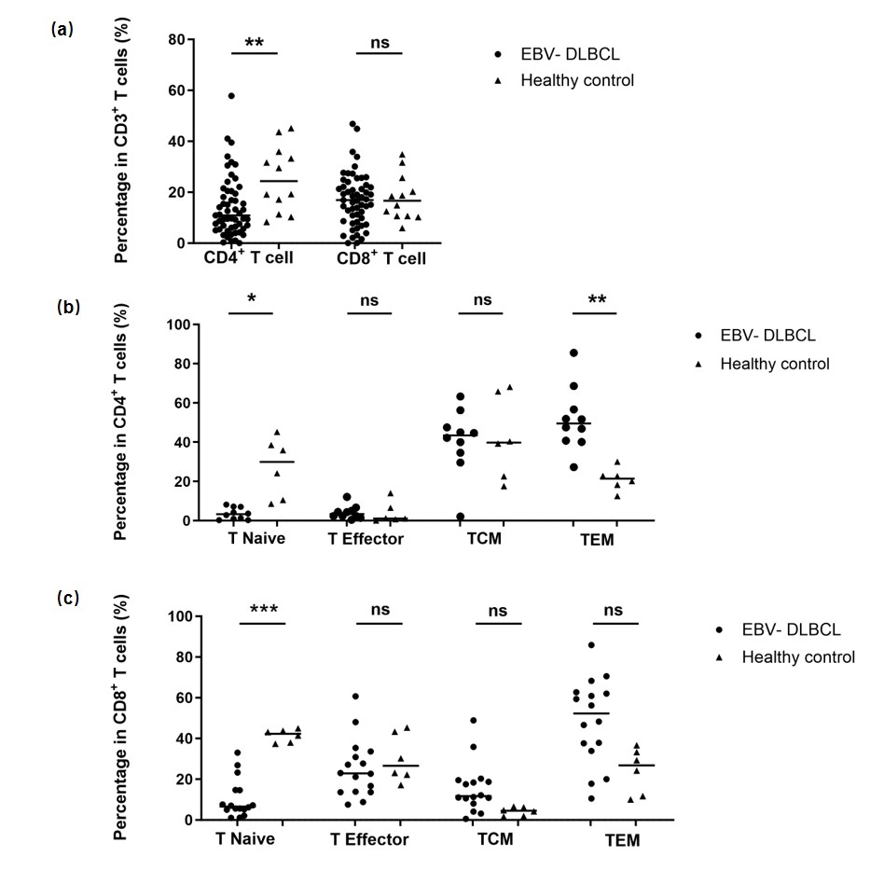
Figure S1 Distribution of peripheral T cell subsets in EBV- DLBCL patients versus healthy populations
(a) Comparison of CD4⁺T and CD8⁺T cell frequencies between the two groups; (b) Comparison of each cell subset proportions inside CD4⁺T cells between the groups; (c) Comparison of each cell subset proportions inside CD8⁺T cells between the groups. ns denotes no statistical significance, *p < 0.05, **p < 0.01, ***p < 0.001. Abbreviations: EBV- DLBCL, EBV negative diffuse large B-cell lymphoma; T naïve, T naïve cell; T effector, T effector cell; TCM, T central memory cell; TEM, T effector memory cell.
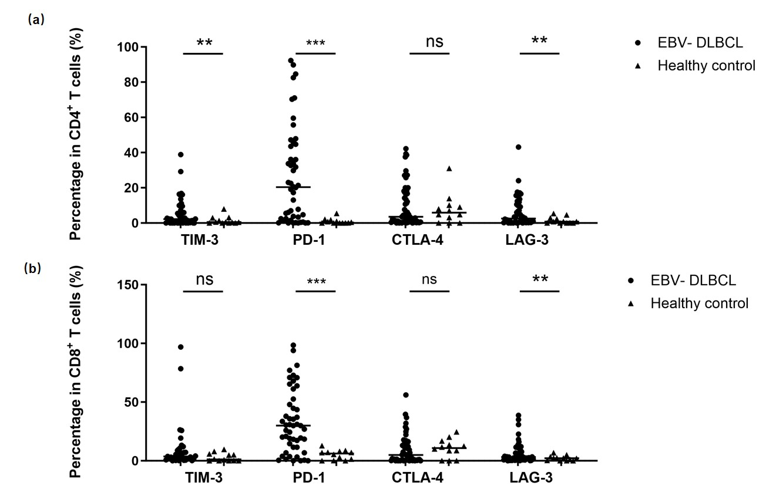
Figure S2 Expression of immune checkpoints on peripheral T cells in EBV- DLBCL patients versus healthy populations
Comparison of immune checkpoint expression on (a) CD4⁺T cells and (b) CD8⁺T cells between the two groups. ns represents no statistical difference, *p < 0.05, **p < 0.01, ***p < 0.001. Abbreviation: EBV- DLBCL, EBV negative diffuse large B-cell lymphoma.
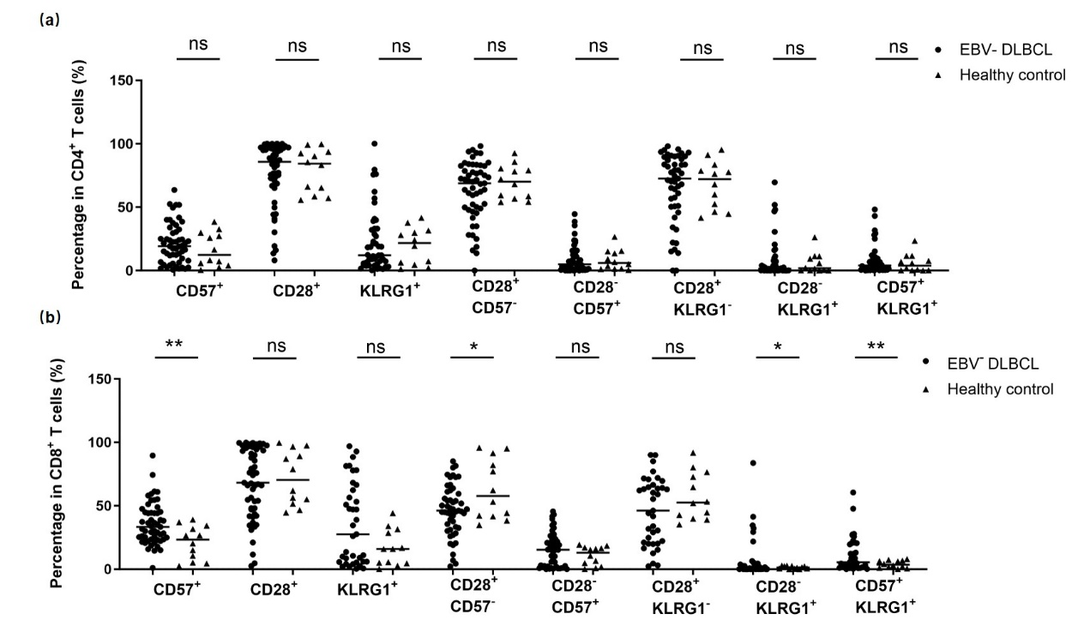
Figure S3 Expression of senescence markers on peripheral T cells in EBV- DLBCL patients versus healthy populations
Comparison of senescence marker positivity on (a) CD4⁺T and (b) CD8⁺T cells between the two groups. ns signifies no statistical significance, *p < 0.05, **p < 0.01. Abbreviation: EBV- DLBCL, EBV negative diffuse large B-cell lymphoma.
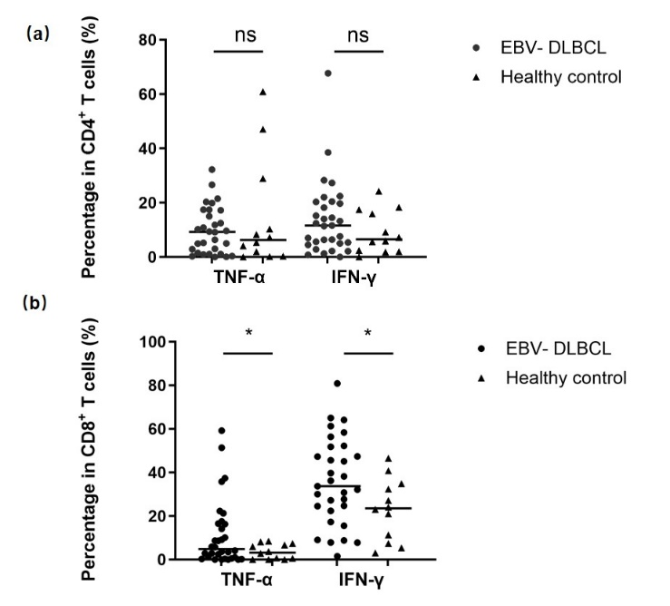
Figure S4 Expression of cytokines on peripheral T cells in EBV- DLBCL patients versus healthy populations
Comparison of TNF-α and IFN-γ expression on (a) CD4⁺T cells and (b) CD8⁺T cells between the two groups. ns denotes no statistically significant difference. *p < 0.05. Abbreviation: DLBCL, diffuse large B-cell lymphoma.
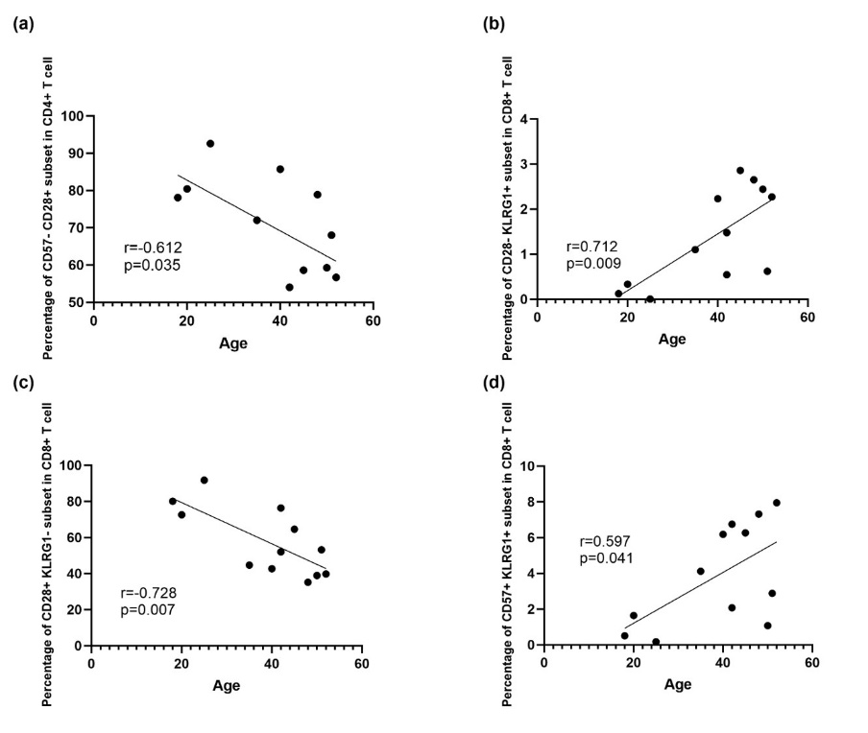
Figure S5 Correlation between T cell immunity indicators and age in healthy populations
(a) Percentage of CD57-CD28+ cell subset in CD4+ T cells is negatively correlated to age (r=-0.612, p=0.035); (b) Percentage of CD28-KLRG+ cell subset in CD4+ T cells is positively correlated to age (r=0.712, p=0.009); (c) Percentage of CD28+KLRG- cell subset in CD4+ T cells is negatively correlated to age (r=-0.728, p=0.007); (d) Percentage of CD57+KLRG1+ cell subset in CD4+ T cells is positively correlated to age (r=0.597, p=0.041).
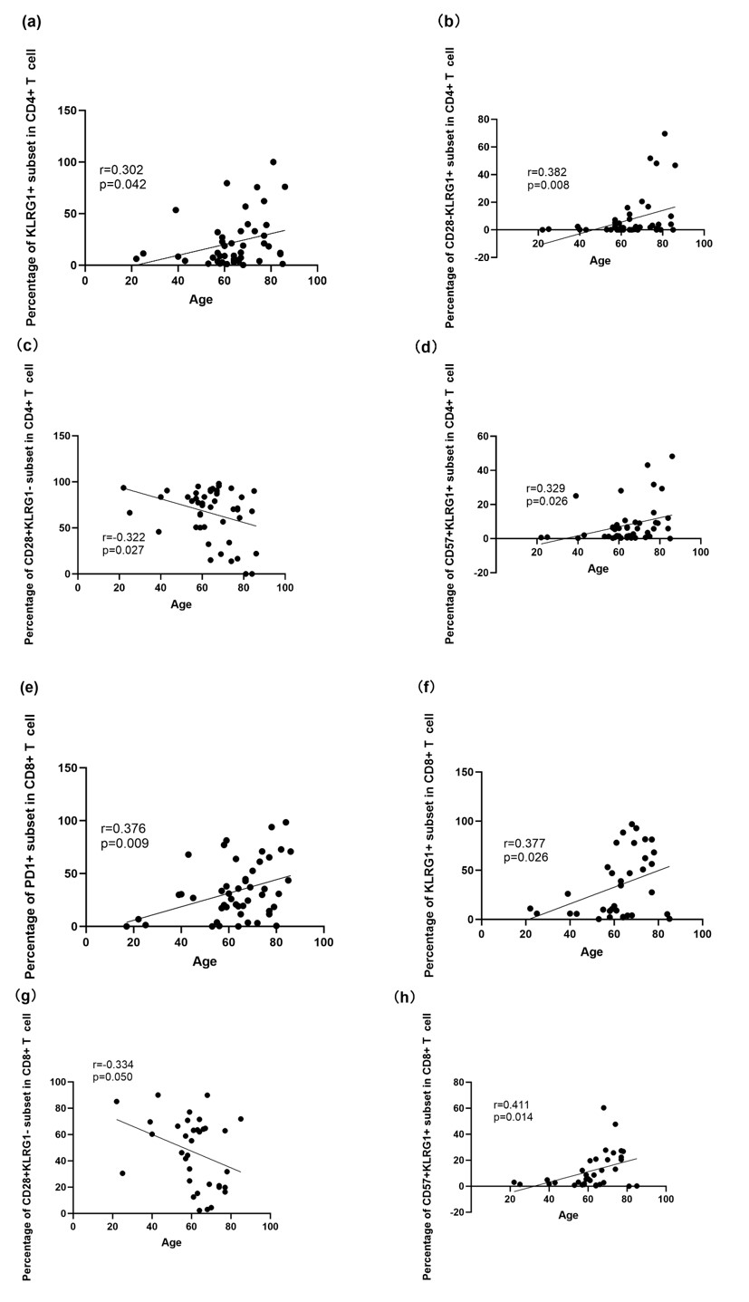
Figure S6 Correlation between T cell immunity indicators and age in EBV- DLBCL patients
(a) Percentage of KLRG1+ cell subset in CD4+ T cells is positively correlated to age (r=0.302, p=0.042); (b) Percentage of CD28-KLRG+ cell subset in CD4+ T cells is positively correlated to age (r=0.382, p=0.008); (c) Percentage of CD28+KLRG- cell subset in CD4+ T cells is negatively correlated to age (r=-0.322, p=0.027); (d) Percentage of CD57+KLRG1+ cell subset in CD4+ T cells is positively correlated to age (r=0.329, p=0.026); (e) Percentage of PD1+ cell subset in CD8+ T cells is positively correlated to age (r=376, p=0.009); (f) Percentage of KLRG+ cell subset in CD8+ T cells is positively correlated to age (r=0.377, p=0.026); (g) Percentage of CD28+KLRG- cell subset in CD8+ T cells is negatively correlated to age (r=-0.334, p=0.050); (d) Percentage of CD57+KLRG1+ cell subset in CD8+ T cells is positively correlated to age (r=0.411, p=0.014).

