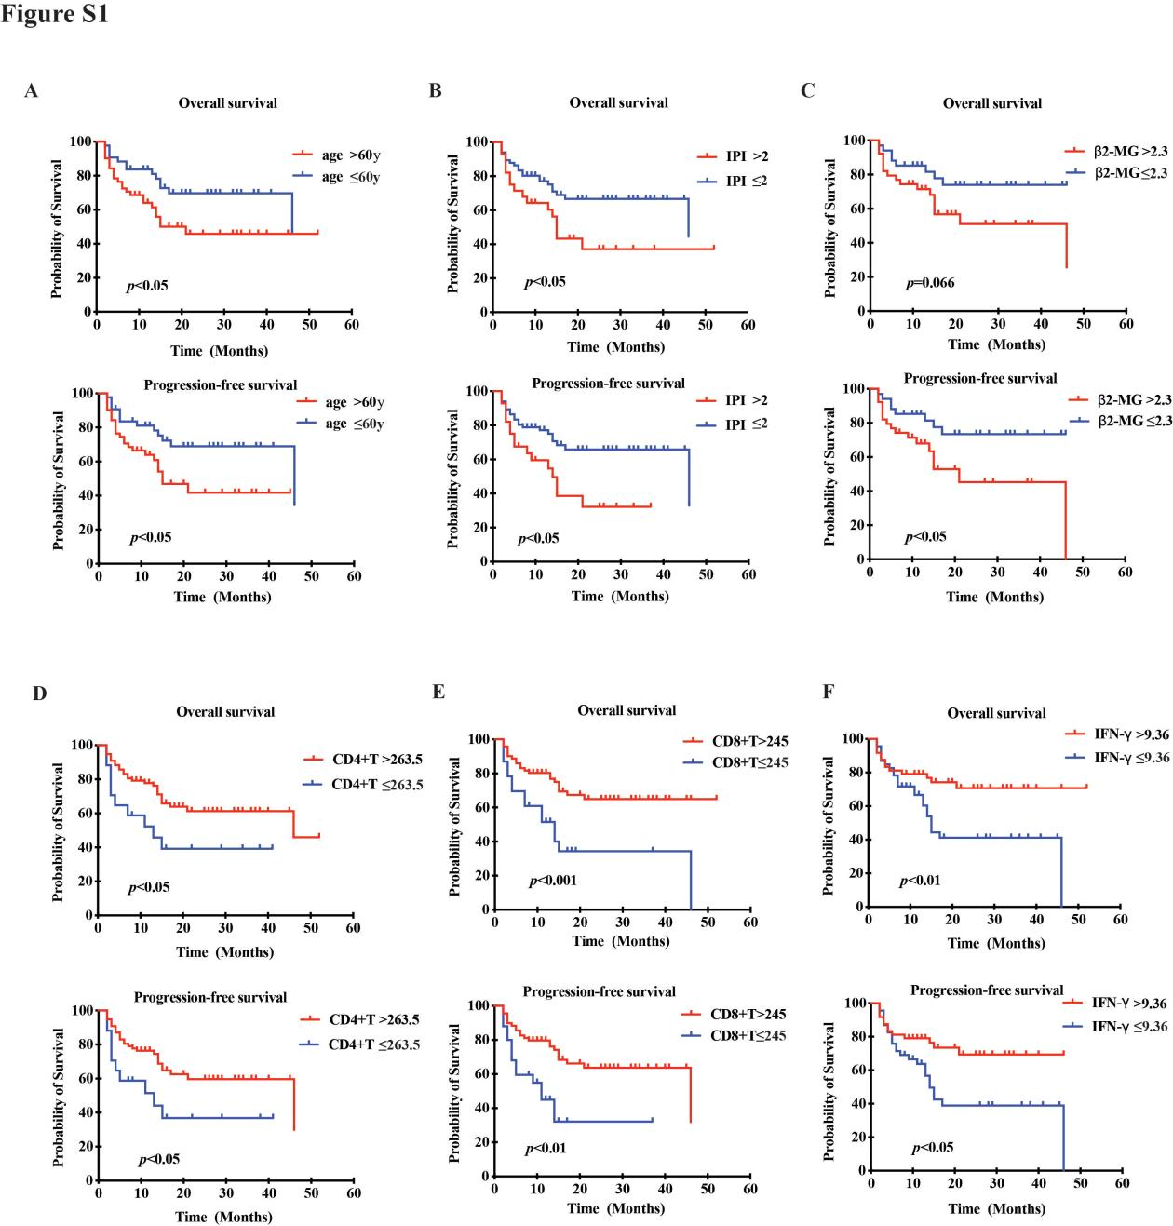
Figure S1. Kaplan‐Meier estimate of overall survival and progress free survival in new diagnosed DLBCL patients according to age (A), IPI (B), β2-MG (C), CD4+ T cell count (D), CD8+ T cell count (E), IFN-γ level (F).

Supplementary Table1. Comparison of clinical characteristics between included and excluded newly diagnosed DLBCL patients in our study

Clinical Characteristics | Included patients(n=94) | Excluded patients without special subtype (n=507) | p value
Age>60, n (%) | 51 (54.2%) | 258 (50.9%) | 0.548
Male, n (%) | 45 (47.8%) | 272 (53.6%) | 0.303
ECOG>2, n (%) | 14 (14.8%) | 96 (18.9%) | 0.352
B symptoms, n (%) | 39 (41.4%) | 166 (32.7%) | 0.100
Ann Arbor stage Ⅲ/Ⅳ, n (%) | 68 (72.3%) | 409 (80.7%) | 0.067
LDH>250U/L, n (%) | 56 (59.6%) | 269 (53.1%) | 0.244
Extra nodal involvement>2, n (%) | 24 (25.5%) | 181 (35.7%) | 0.056
IPI score>3, n (%) | 50 (53.2%) | 307 (60.6%) | 0.098
Bone marrow Involvement, n (%) | 27 (28.7%) | 169 (33.3%) | 0.381
Abbreviations: ECOG, Eastern Cooperative Oncology Group; LDH, Lactate dehydrogenase; IPI, International Prognostic Index.

Supplementary Table2. The general clinical features of DLBCL patients in another independent cohort
Clinical Characteristics | Total patients (47)
Median age(range) | 55 (19-78)
>60 years | 19 (40.4%)
Male | 21 (44.7%)
ECOG>2 | 10 (21.3%)
B symptoms | 23 (48.9%)
Ann Arbor stage
Ⅰ/Ⅱ | 14 (29.8%)
Ⅲ/Ⅳ | 33 (70.2%)
LDH>250U/L | 29 (61.7%)
Extra nodal involvement>2 | 18 (38.3%)
IPI score
0-2 | 21 (44.7%)
3-5 | 26 (55.3%)
Bone marrow involvement | 12 (25.5%)
Abbreviations: ECOG, Eastern Cooperative Oncology Group; LDH, Lactate dehydrogenase; IPI, International Prognostic Index.

