Global, Regional, and National Burden Trends of Lip and Oral Cavity Cancer Among Individuals Aged 60 and Above from 1990 to 2021: A Systematic Analysis Based on the 2021 Global Burden of Disease Data
Context
Supplementary Figure 1. EAPCs of ASR (A. ASIR; B. ASPR; C. ASMR; D.ASDR)
Supplementary Figure 2. Results of Age-Period-Cohort analysis(A. ASIR of age effects; B. ASPR of age effects; C. ASMR of age effects; D.ASDR of age effects; E. ASIR of period effects; F. ASPR of period effects; G. ASMR of period effects; H.ASDR of period effects; I. ASIR of cohort effects; J. ASPR of cohort effects; K. ASMR of cohort effects; L.ASDR of cohort effects)
Supplementary Figure 3. Gender-based Temporal Trends (A. ASIR; B. ASPR; C. ASMR; D.ASDR)
Supplementary Figure 4. Age-based Temporal Trends (A. ASIR; B. ASPR; C. ASMR; D.ASDR)
Supplementary Figure 5. Correlation between ASRs and SDI across 204 countries (A. ASIR; B. ASPR; C. ASMR; D.ASDR)
Supplementary Figure 6. Attributable Risk Factors for ASDR
Supplementary Table 1. ASRs and EAPCs for 204 countries in 1990 and 2021
Supplementary Table 2. Correlation Coefficients and p-values
Supplementary Table 3. Predictive Analysis Results
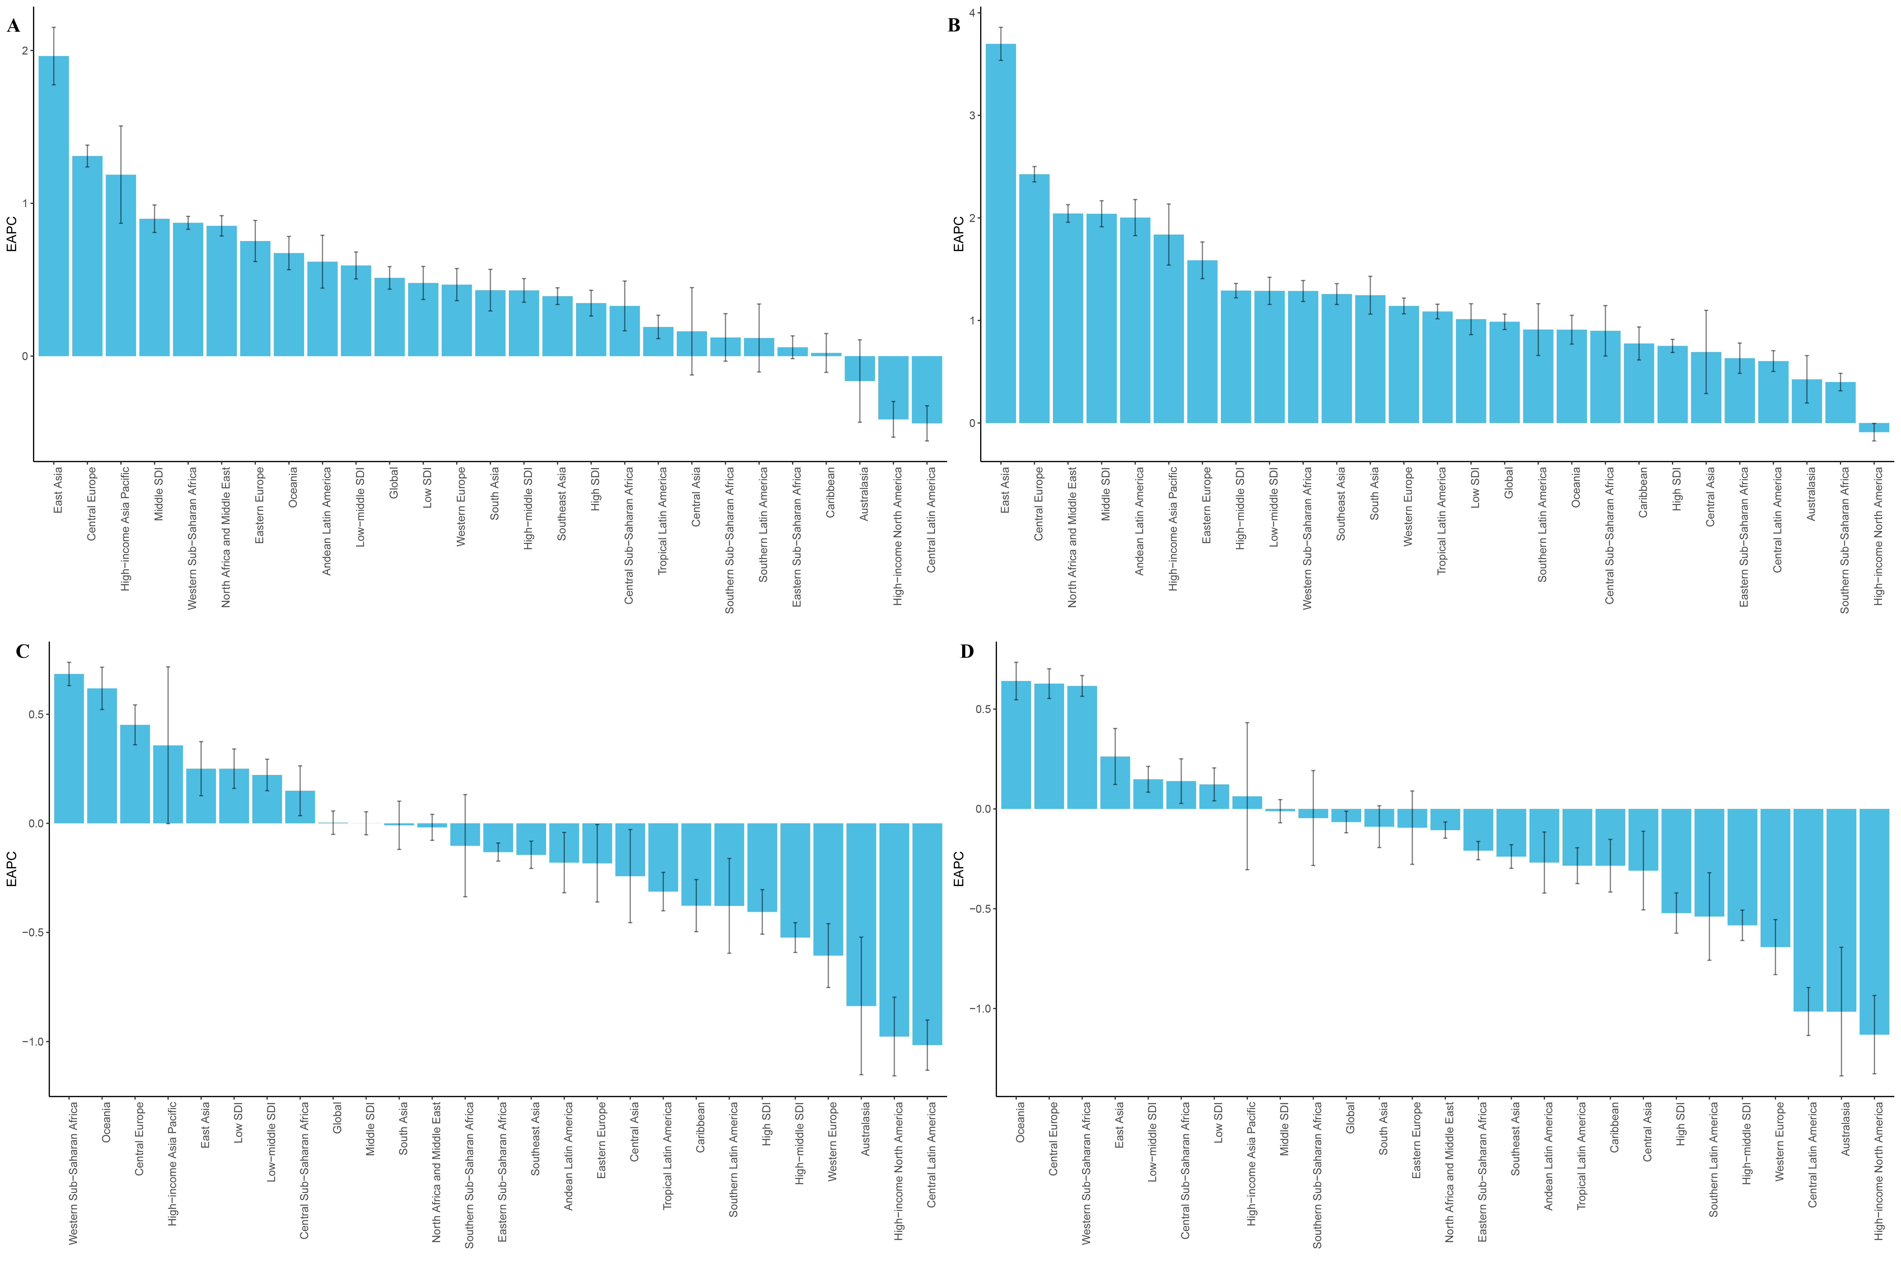
Supplementary Figure 1. EAPCs of ASR (A. ASIR; B. ASPR; C. ASMR; D.ASDR)
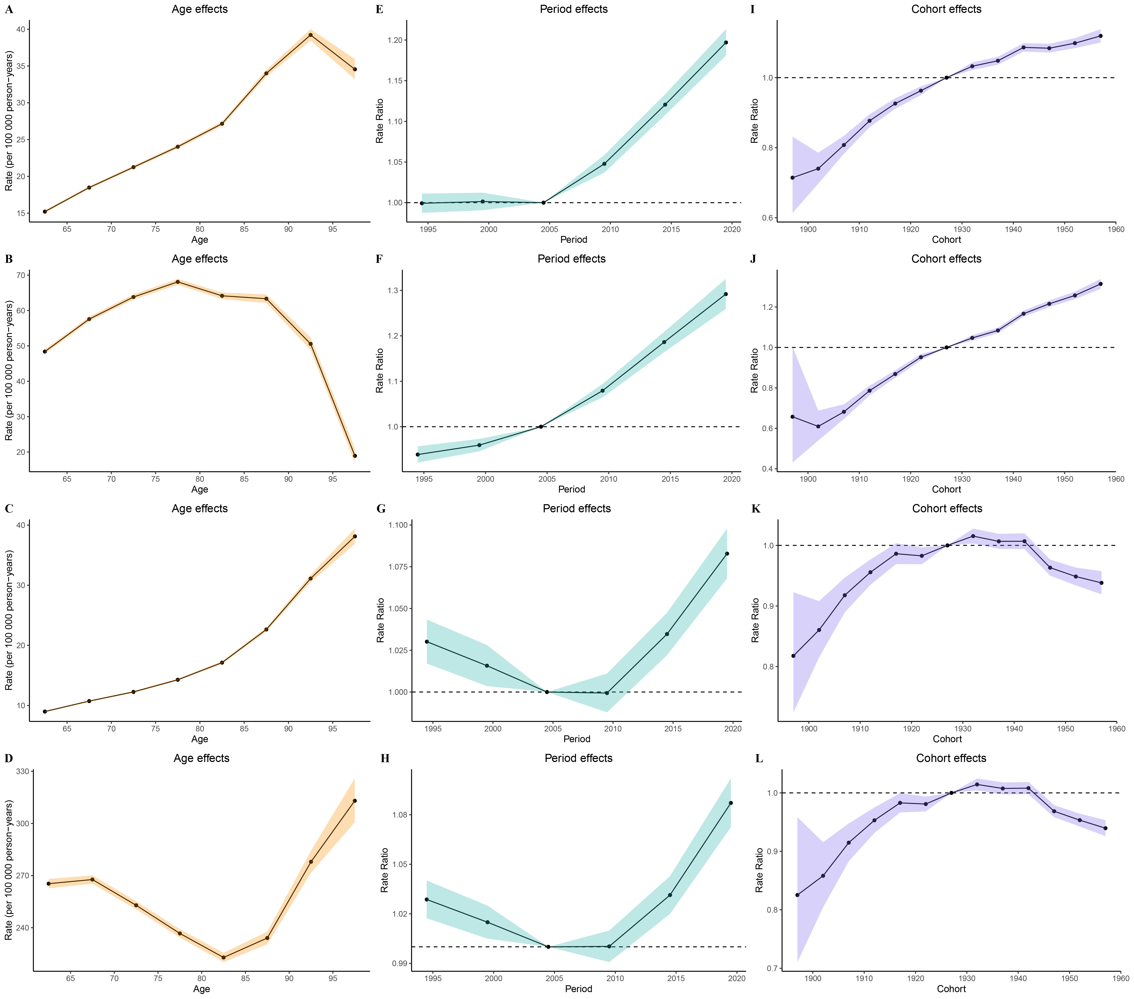
Supplementary Figure 2. Results of Age-Period-Cohort analysis (A. ASIR of age effects; B. ASPR of age effects; C. ASMR of age effects; D.ASDR of age effects; E. ASIR of period effects; F. ASPR of period effects; G. ASMR of period effects; H.ASDR of period effects; I. ASIR of cohort effects; J. ASPR of cohort effects; K. ASMR of cohort effects; L.ASDR of cohort effects)

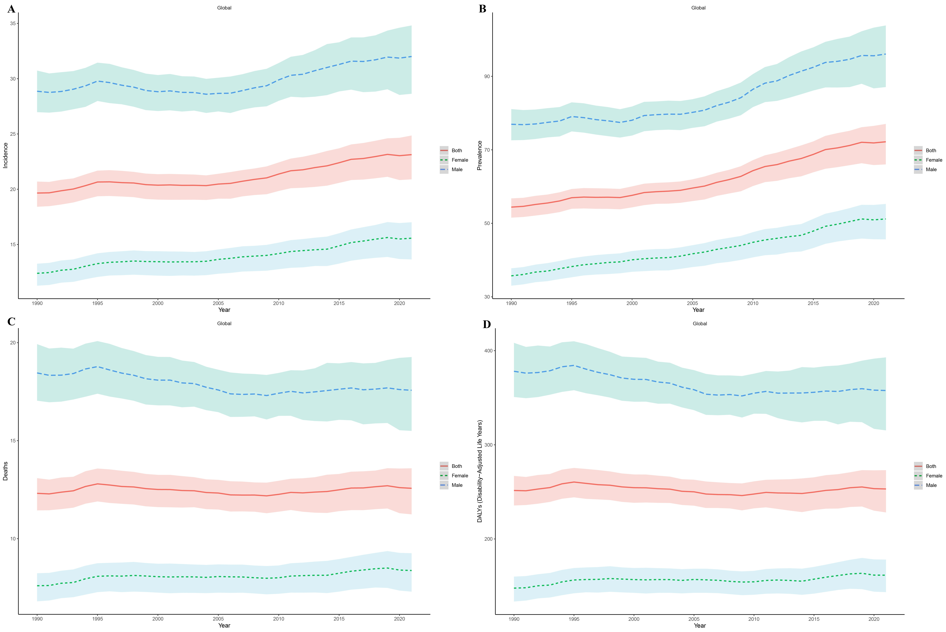
Supplementary Figure 3. Gender-based Temporal Trends (A. ASIR; B. ASPR; C. ASMR; D.ASDR)
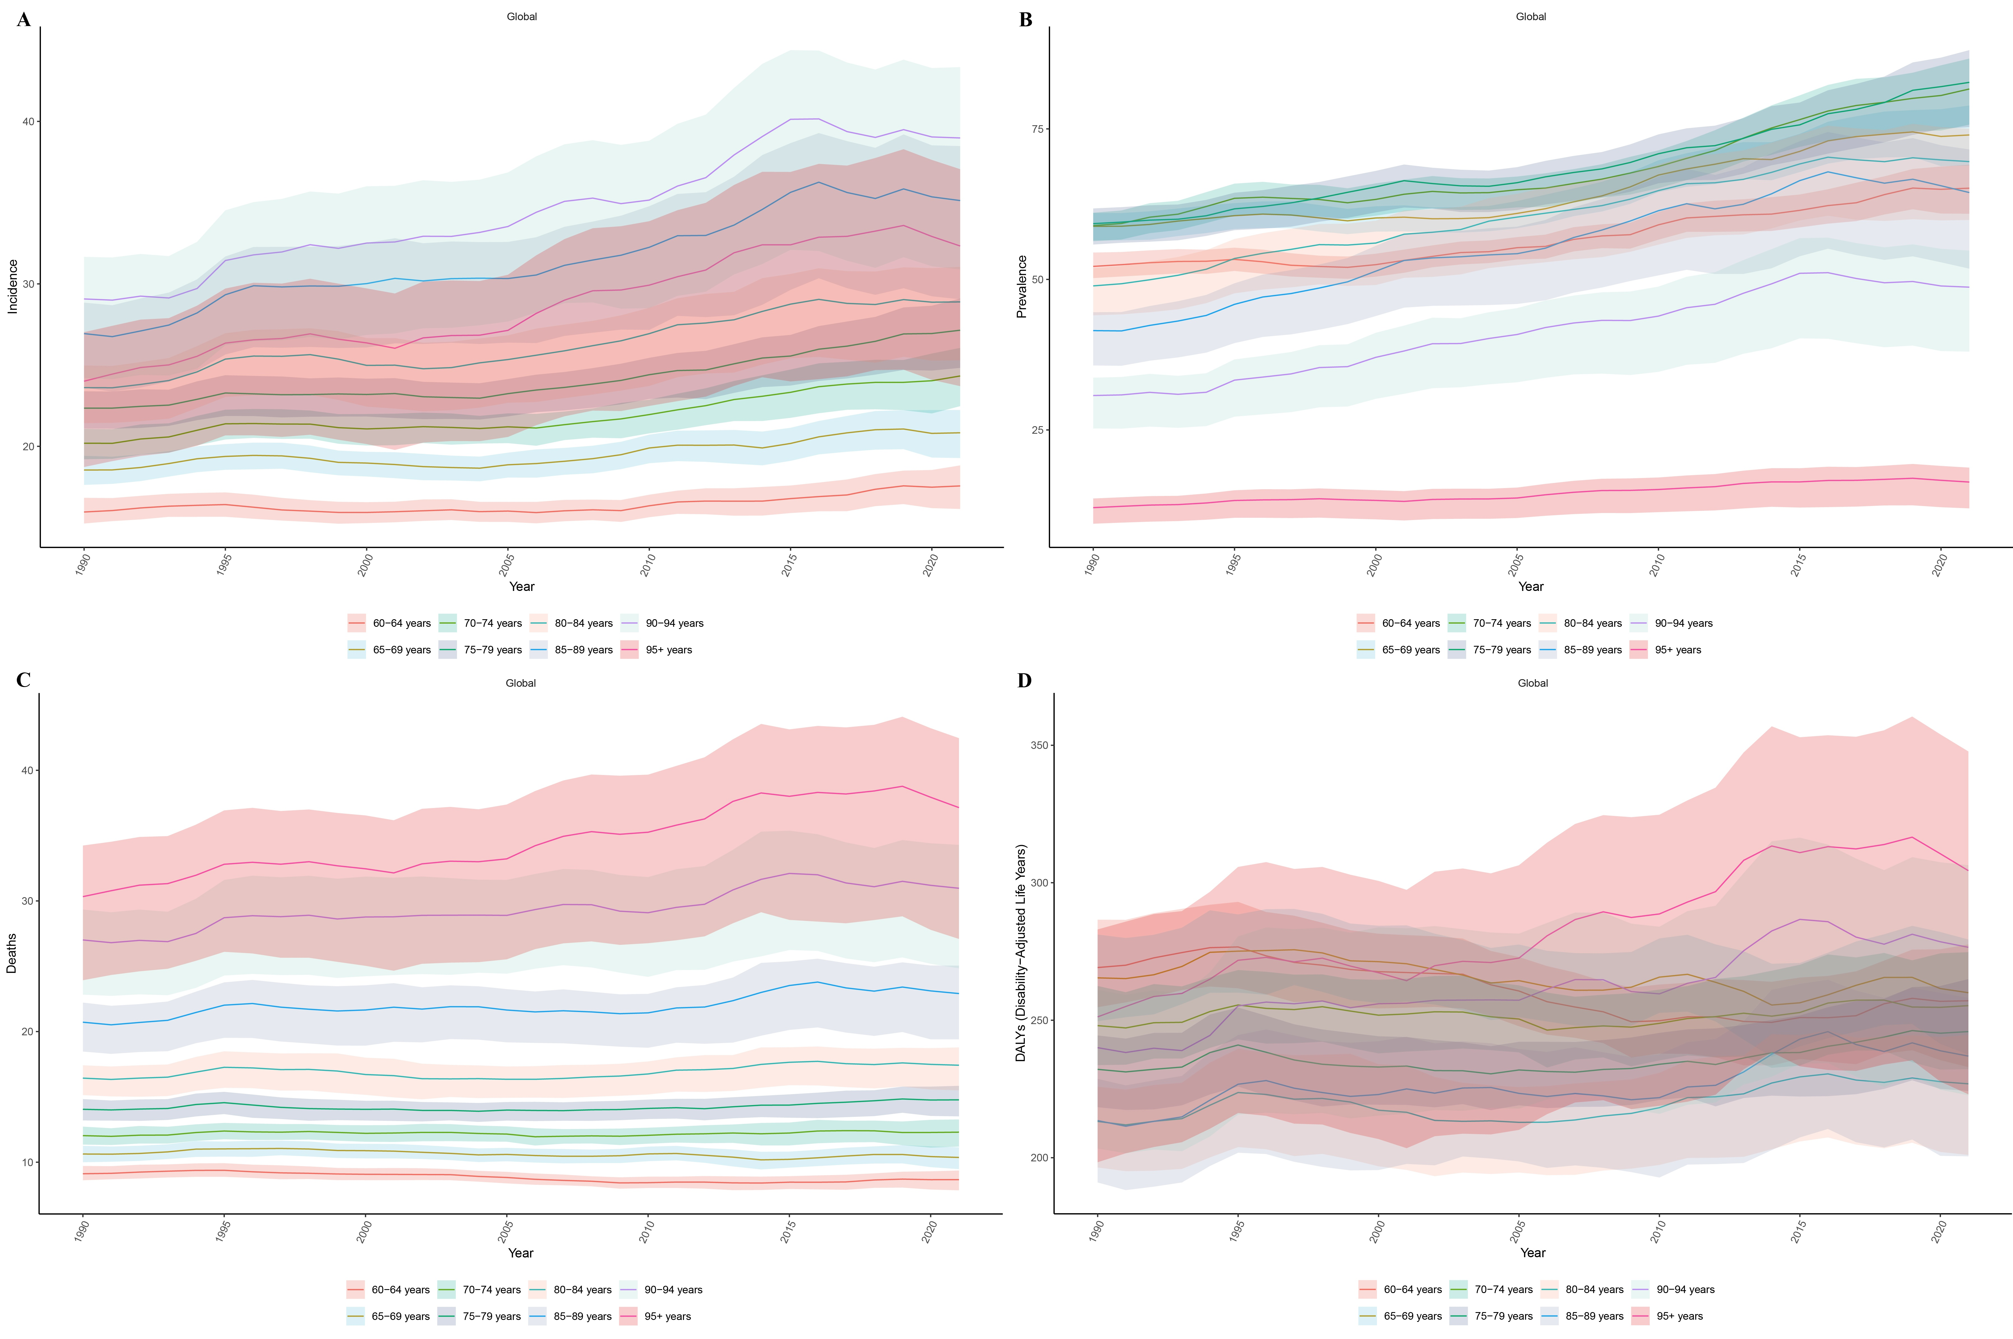
Supplementary Figure 4. Age-based Temporal Trends (A. ASIR; B. ASPR; C. ASMR; D.ASDR)

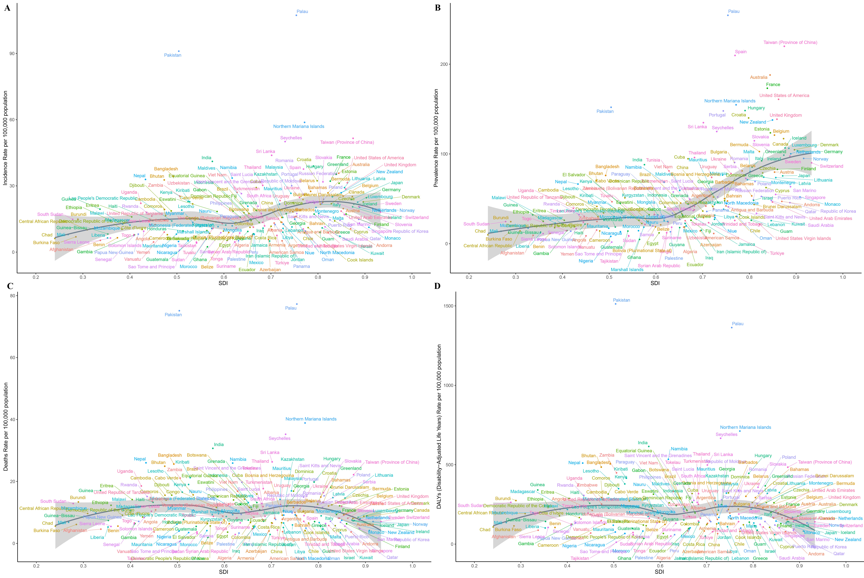
Supplementary Figure 5. Correlation between ASRs and SDI across 204 countries(A. ASIR; B. ASPR; C. ASMR; D.ASDR)

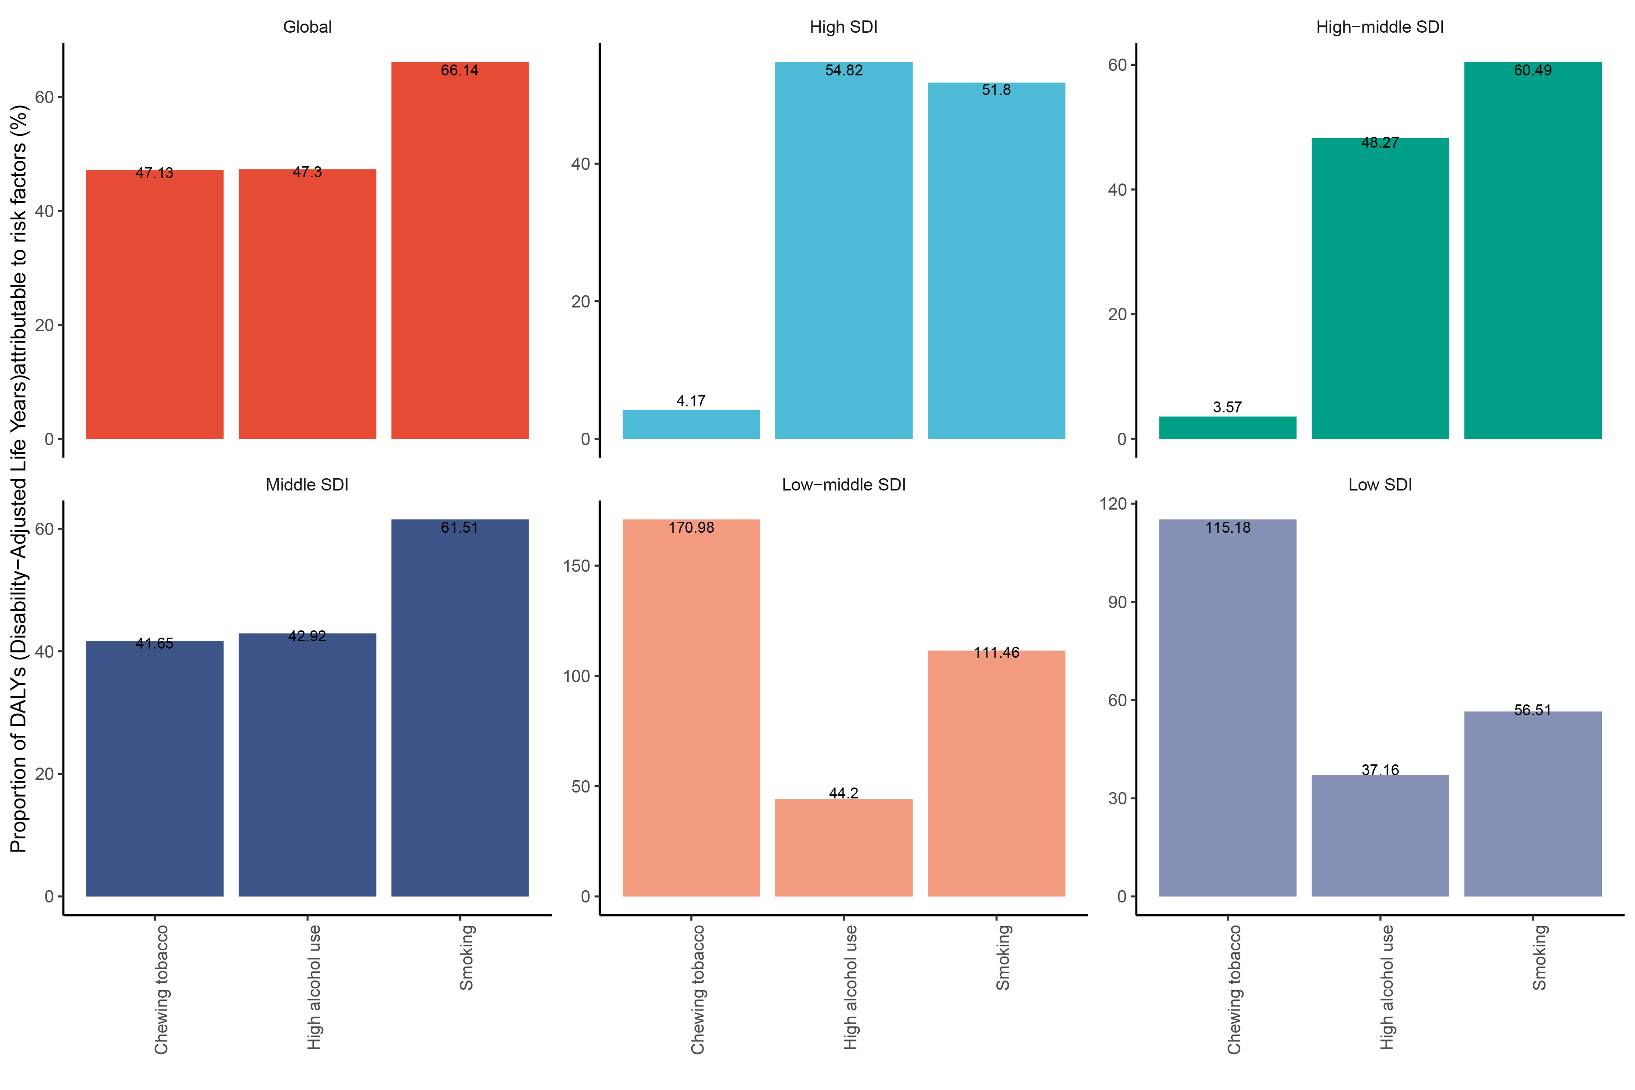
Supplementary Figure 6. Attributable Risk Factors for ASDR
Supplementary Table 1. ASRs and EAPCs for 204 countries in 1990 and 2021
location | ASIR |  |  | ASPR |  |  | ASMR |  |  | ASDR
location | 1990-Both | 2021-Both | EAPCs | 1990-Both | 2021-Both | EAPCs | 1990-Both | 2021-Both | EAPCs | 1990-Both | 2021-Both | EAPC
Afghanistan | 4.81(2.93,7.85) | 5.30(3.30,8.00) | 0.32(0.18,0.46) | 7.24(4.35,12.09) | 9.41(5.69,14.52) | 0.87(0.63,1.11) | 4.50(2.77,7.28) | 4.60(2.91,6.84) | 0.02(-0.30,0.33) | 87.78(53.33,145.22) | 87.51(53.73,132.40) | -0.023491
Albania | 11.30(8.17,15.24) | 13.15(8.67,19.02) | 0.88(0.73,1.02) | 25.08(17.92,34.48) | 41.90(27.20,61.23) | 2.36(2.07,2.65) | 9.00(6.57,12.07) | 8.13(5.43,11.66) | -0.06(-0.76,0.64) | 172.16(125.45,232.12) | 147.46(97.07,213.72) | -0.250571
Algeria | 6.98(4.77,9.98) | 7.16(4.74,10.48) | 0.29(0.14,0.44) | 12.78(8.60,18.50) | 18.48(12.19,27.33) | 1.22(1.10,1.35) | 5.75(3.99,8.20) | 4.75(3.18,6.81) | -0.13(-0.86,0.60) | 101.09(69.38,144.84) | 82.78(54.92,119.57) | -0.506115
American Samoa | 4.07(2.79,5.70) | 5.11(3.56,7.14) | 1.54(0.95,2.13) | 8.72(5.87,12.48) | 11.40(7.82,16.22) | 1.58(0.99,2.17) | 3.06(2.15,4.23) | 3.79(2.71,5.19) | 1.68(0.58,2.78) | 53.33(37.50,73.60) | 66.07(47.10,90.77) | 1.5423649
Andorra | 13.76(7.94,22.20) | 10.56(5.83,17.76) | -0.69(-0.94,-0.45) | 57.73(32.39,94.68) | 47.16(25.80,80.05) | -0.45(-0.68,-0.22) | 5.74(3.46,9.09) | 3.70(2.16,5.94) | -1.04(-4.09,2.11) | 122.29(72.62,196.74) | 78.13(44.82,126.30) | -1.232432
Angola | 9.87(6.40,14.62) | 12.47(8.00,18.56) | 0.71(0.64,0.77) | 14.07(9.21,20.69) | 22.04(14.32,32.67) | 1.45(1.30,1.60) | 9.27(5.98,13.81) | 10.82(6.97,16.16) | 0.50(0.01,0.99) | 185.80(121.35,275.27) | 212.14(137.68,315.08) | 0.3813323
Antigua and Barbuda | 17.09(14.43,19.95) | 15.82(13.11,18.81) | -0.20(-0.55,0.15) | 39.70(32.67,48.07) | 42.16(34.17,51.52) | 0.18(-0.17,0.54) | 11.98(10.36,13.72) | 10.00(8.51,11.67) | -0.45(-1.83,0.95) | 238.96(205.98,274.92) | 195.48(165.72,228.46) | -0.581991
Argentina | 13.62(11.29,16.42) | 13.48(10.89,16.38) | 0.31(0.04,0.59) | 31.71(25.70,39.10) | 38.86(31.10,47.84) | 0.97(0.66,1.27) | 9.22(7.77,10.87) | 7.81(6.49,9.25) | 0.03(-0.86,0.94) | 187.58(157.71,222.39) | 155.92(130.21,184.88) | -0.230809
Armenia | 7.18(6.00,8.55) | 10.14(8.25,12.28) | 1.34(1.08,1.59) | 16.74(13.77,20.21) | 29.02(23.19,35.92) | 2.16(1.84,2.48) | 5.37(4.50,6.35) | 6.53(5.38,7.70) | 0.69(-0.46,1.85) | 110.28(92.48,130.59) | 130.50(107.75,153.56) | 0.707121
Australia | 36.52(29.90,44.48) | 35.74(28.07,44.47) | -0.18(-0.45,0.09) | 160.70(131.94,196.21) | 187.94(147.64,237.23) | 0.42(0.19,0.66) | 10.48(8.91,12.08) | 8.16(6.72,9.67) | -0.83(-1.62,-0.03) | 220.05(186.92,256.34) | 163.85(135.94,195.34) | -1.00971
Austria | 15.14(12.52,18.07) | 19.69(15.81,24.05) | 0.95(0.81,1.09) | 45.99(37.21,55.94) | 79.80(63.58,98.97) | 1.98(1.81,2.15) | 9.30(7.79,10.90) | 9.19(7.54,10.89) | 0.08(-1.01,1.18) | 194.26(162.63,228.93) | 188.18(155.15,223.45) | -0.047867
Azerbaijan | 4.95(3.29,7.27) | 5.70(3.61,8.60) | 0.90(0.70,1.11) | 10.26(6.80,14.98) | 14.34(8.97,21.75) | 1.63(1.36,1.91) | 4.06(2.70,5.99) | 4.02(2.56,6.03) | 0.30(-0.34,0.95) | 82.56(55.34,120.77) | 82.74(52.83,124.78) | 0.3284471
Bahamas | 22.56(19.35,26.24) | 21.69(17.01,27.24) | 0.13(-0.00,0.26) | 50.22(42.37,59.40) | 53.27(41.20,68.47) | 0.57(0.41,0.72) | 16.34(14.26,18.67) | 14.97(11.97,18.65) | -0.16(-1.17,0.86) | 338.44(294.97,387.06) | 292.87(232.41,367.30) | -0.232728
Bahrain | 14.93(10.36,21.02) | 16.17(9.93,24.53) | 0.23(0.06,0.41) | 29.22(20.06,41.71) | 47.60(28.23,73.82) | 1.63(1.46,1.81) | 11.03(7.67,15.26) | 8.98(5.56,13.49) | -0.50(-1.49,0.49) | 204.72(142.22,285.21) | 159.20(94.99,244.70) | -0.954281
Bangladesh | 36.85(22.43,54.93) | 34.33(20.23,53.04) | -0.32(-0.43,-0.21) | 58.20(35.32,87.30) | 76.05(43.44,119.96) | 0.85(0.70,0.99) | 32.88(20.09,49.14) | 25.62(15.42,39.34) | -0.77(-1.51,-0.03) | 684.73(416.77,1033.12) | 504.95(295.11,786.87) | -1.050258
Barbados | 19.49(16.74,22.54) | 18.28(13.82,23.29) | -0.10(-0.25,0.05) | 45.89(38.48,54.78) | 50.24(37.22,65.99) | 0.45(0.32,0.59) | 13.62(11.99,15.34) | 11.63(8.99,14.60) | -0.35(-1.38,0.69) | 261.36(230.02,294.95) | 217.22(166.34,275.76) | -0.4431
Belarus | 26.13(21.32,31.73) | 27.50(20.76,35.73) | -0.02(-0.48,0.45) | 57.16(46.22,69.99) | 81.15(60.99,106.29) | 1.06(0.45,1.68) | 18.10(14.86,21.77) | 13.43(10.36,17.26) | -1.29(-3.03,0.47) | 387.51(316.51,471.22) | 300.93(230.44,389.67) | -1.075205
Belgium | 19.96(16.14,24.43) | 25.37(19.98,31.71) | 0.95(0.73,1.17) | 80.58(63.68,100.25) | 120.99(94.76,151.85) | 1.51(1.29,1.74) | 9.32(7.83,10.90) | 9.29(7.59,11.09) | 0.13(-0.93,1.21) | 192.90(162.42,226.11) | 197.63(162.32,237.32) | 0.2584006
Belize | 8.89(7.65,10.29) | 8.87(7.33,10.62) | 0.11(-0.28,0.49) | 18.83(15.93,22.21) | 21.04(17.11,25.47) | 0.35(0.03,0.67) | 6.81(5.93,7.74) | 6.37(5.31,7.45) | -0.17(-0.64,0.30) | 133.71(116.91,152.41) | 124.25(103.65,145.64) | -0.141891
Benin | 4.81(3.31,6.76) | 6.48(4.16,9.64) | 0.84(0.73,0.96) | 7.61(5.17,10.87) | 11.44(7.12,17.50) | 1.14(1.03,1.25) | 4.31(2.99,6.07) | 5.58(3.61,8.27) | 0.61(0.05,1.17) | 84.98(58.58,119.83) | 104.73(66.39,156.97) | 0.5445834
Bermuda | 38.61(31.43,46.94) | 26.83(20.29,35.70) | -0.76(-0.99,-0.53) | 103.11(81.65,127.25) | 102.65(75.57,137.91) | 0.52(0.31,0.74) | 23.84(19.74,28.54) | 12.08(9.34,15.39) | -2.04(-3.21,-0.86) | 460.99(379.75,554.67) | 228.94(174.62,295.72) | -1.824336
Bhutan | 30.50(18.35,46.21) | 32.70(20.89,48.16) | 0.17(0.03,0.31) | 49.36(29.35,75.33) | 70.20(43.37,105.34) | 1.16(0.98,1.34) | 27.16(16.47,41.29) | 24.92(16.15,36.56) | -0.32(-0.81,0.18) | 559.84(334.29,857.39) | 485.02(304.86,727.21) | -0.542401
Bolivia (Plurinational State of) | 8.68(5.60,13.17) | 9.51(5.87,14.49) | 0.32(0.27,0.37) | 13.21(8.29,20.30) | 18.73(11.29,28.89) | 1.20(1.16,1.24) | 7.93(5.17,11.91) | 7.59(4.75,11.24) | -0.13(-0.16,-0.09) | 151.46(97.34,230.00) | 140.29(86.22,210.00) | -0.258603
Bosnia and Herzegovina | 11.35(9.22,13.90) | 15.71(11.65,20.54) | 1.42(1.28,1.57) | 28.08(22.44,34.57) | 51.92(38.34,68.10) | 2.58(2.32,2.83) | 8.27(6.69,10.10) | 9.11(6.88,11.74) | 0.45(-0.51,1.41) | 170.25(139.07,206.36) | 187.15(141.40,241.61) | 0.523548
Botswana | 17.77(11.75,25.85) | 17.80(11.64,26.04) | -0.07(-0.18,0.04) | 29.55(19.22,43.32) | 33.11(21.72,49.20) | 0.32(0.15,0.48) | 15.26(10.08,22.26) | 14.26(9.41,20.82) | -0.18(-1.10,0.74) | 311.29(203.29,457.20) | 289.21(186.52,429.29) | -0.346033
Brazil | 16.63(15.15,18.01) | 17.43(15.56,19.09) | 0.17(0.09,0.25) | 32.31(29.56,35.03) | 45.28(40.70,49.62) | 1.08(1.00,1.15) | 13.20(12.01,14.24) | 11.59(10.31,12.63) | -0.33(-1.21,0.56) | 258.17(237.25,278.13) | 233.67(211.37,253.76) | -0.306576
Brunei Darussalam | 25.60(18.10,35.98) | 22.60(16.15,30.88) | 0.02(-0.15,0.19) | 41.98(29.76,58.91) | 43.70(30.84,60.00) | 0.46(0.34,0.58) | 17.26(12.31,24.11) | 13.22(9.52,17.74) | -0.22(-0.61,0.16) | 338.73(242.88,472.46) | 242.87(175.05,325.40) | -0.689752
Bulgaria | 14.24(11.67,17.33) | 23.82(18.65,30.06) | 0.99(0.63,1.36) | 43.54(34.89,53.85) | 90.45(69.76,115.36) | 1.57(1.16,1.98) | 7.68(6.44,9.10) | 10.30(8.36,12.40) | 0.44(-0.73,1.63) | 150.94(126.75,178.71) | 220.82(178.79,267.81) | 0.593579
Burkina Faso | 5.24(3.48,7.64) | 6.92(4.56,10.32) | 0.79(0.67,0.92) | 8.38(5.52,12.32) | 12.05(7.77,18.06) | 1.13(1.02,1.23) | 4.71(3.14,6.89) | 6.12(4.05,9.11) | 0.68(0.03,1.32) | 91.50(61.06,134.01) | 114.51(75.77,169.97) | 0.6222589
Burundi | 18.06(12.44,25.38) | 14.90(9.56,21.80) | -0.93(-1.07,-0.78) | 26.58(18.29,37.52) | 24.57(15.52,36.13) | -0.40(-0.52,-0.28) | 16.61(11.46,23.35) | 13.38(8.67,19.70) | -1.18(-1.85,-0.50) | 348.65(239.07,491.37) | 274.19(175.14,406.77) | -1.091873
Cabo Verde | 0.74(0.52,1.03) | 21.83(14.20,32.68) | 9.18(6.52,11.90) | 1.44(0.99,2.01) | 51.13(32.79,76.97) | 9.85(7.23,12.54) | 0.60(0.42,0.83) | 15.67(10.14,23.12) | 8.51(6.97,10.08) | 11.08(7.77,15.48) | 271.84(178.03,400.35) | 8.432698
Cambodia | 14.75(9.79,21.75) | 19.31(12.83,27.72) | 0.91(0.79,1.03) | 24.91(16.41,37.23) | 41.55(27.30,61.15) | 1.73(1.56,1.91) | 13.45(8.97,19.93) | 15.55(10.40,22.18) | 0.52(-0.07,1.11) | 263.26(173.23,394.24) | 293.03(193.58,422.52) | 0.3540185
Cameroon | 5.91(4.17,8.16) | 7.88(5.18,11.61) | 0.79(0.71,0.87) | 9.69(6.79,13.49) | 14.25(9.24,21.19) | 1.02(0.89,1.15) | 5.20(3.70,7.20) | 6.63(4.44,9.68) | 0.58(-0.04,1.22) | 101.88(72.74,140.96) | 125.97(83.70,184.65) | 0.5542531
Canada | 35.85(29.17,43.47) | 25.14(19.95,31.31) | -0.90(-1.06,-0.74) | 147.71(118.69,182.01) | 117.04(92.46,146.28) | -0.42(-0.56,-0.29) | 12.95(11.10,14.92) | 8.03(6.60,9.54) | -1.35(-2.13,-0.57) | 263.85(226.37,307.18) | 154.62(128.47,184.72) | -1.495818
Central African Republic | 10.68(7.12,16.41) | 10.07(6.53,14.98) | -0.26(-0.30,-0.22) | 14.48(9.63,22.06) | 14.30(9.34,20.99) | -0.11(-0.18,-0.05) | 10.24(6.83,15.76) | 9.67(6.29,14.51) | -0.21(-0.57,0.14) | 205.39(137.11,320.29) | 191.75(125.04,286.40) | -0.298687
Chad | 4.08(2.69,5.95) | 6.15(4.07,8.89) | 1.28(1.14,1.42) | 6.26(4.11,9.16) | 9.93(6.54,14.48) | 1.41(1.34,1.49) | 3.73(2.47,5.44) | 5.57(3.71,8.02) | 1.29(0.60,1.99) | 73.24(48.80,105.96) | 108.04(71.82,154.87) | 1.1857922
Chile | 9.52(7.84,11.51) | 8.70(6.99,10.67) | 0.04(-0.12,0.20) | 22.40(18.06,27.59) | 30.31(24.05,37.73) | 1.38(1.16,1.61) | 6.25(5.24,7.37) | 4.19(3.46,4.97) | -0.89(-1.52,-0.25) | 124.57(104.33,147.33) | 80.03(66.61,95.24) | -1.147673
China | 8.30(7.03,9.58) | 13.57(10.68,16.90) | 1.89(1.67,2.11) | 15.21(12.93,17.54) | 41.53(32.66,51.86) | 3.70(3.49,3.91) | 6.66(5.65,7.69) | 6.68(5.27,8.26) | -0.22(-1.26,0.84) | 128.22(108.35,148.56) | 127.27(99.34,158.70) | 0.1244399
Colombia | 13.82(11.73,16.04) | 11.23(8.66,14.02) | -0.96(-1.18,-0.75) | 27.81(23.20,32.82) | 33.26(25.28,42.52) | 0.45(0.24,0.66) | 10.79(9.24,12.41) | 6.75(5.25,8.38) | -1.77(-2.02,-1.51) | 200.54(172.35,230.80) | 124.39(96.97,154.96) | -1.844454
Comoros | 16.69(11.27,24.12) | 16.48(11.05,24.23) | -0.26(-0.33,-0.18) | 27.14(18.12,39.56) | 30.19(20.14,44.43) | 0.10(0.01,0.19) | 14.83(10.17,21.15) | 13.96(9.34,20.51) | -0.41(-0.85,0.04) | 307.82(209.27,441.51) | 280.69(186.82,413.72) | -0.551415
Congo | 12.58(8.38,18.45) | 13.70(9.32,19.50) | 0.17(0.05,0.29) | 18.55(12.24,27.42) | 24.72(16.65,35.39) | 0.84(0.67,1.01) | 11.58(7.73,16.98) | 11.60(7.90,16.41) | -0.13(-0.37,0.11) | 226.41(149.27,336.19) | 224.42(152.26,318.49) | -0.150568
Cook Islands | 8.81(5.89,12.72) | 11.09(7.43,15.82) | 0.93(0.82,1.04) | 19.06(12.52,27.95) | 32.76(21.79,47.24) | 1.93(1.79,2.07) | 6.55(4.45,9.46) | 6.54(4.43,9.15) | 0.78(-0.49,2.08) | 123.71(82.87,180.90) | 121.70(81.26,173.18) | 0.1289825
Costa Rica | 13.82(11.37,16.58) | 11.70(9.25,14.54) | -0.62(-0.78,-0.46) | 35.54(28.95,43.36) | 36.38(28.28,46.15) | -0.06(-0.24,0.11) | 9.03(7.56,10.63) | 6.65(5.33,8.10) | -1.07(-1.71,-0.42) | 171.06(143.43,201.74) | 123.44(99.26,150.74) | -1.180183
Croatia | 31.57(25.74,38.13) | 32.30(25.65,40.06) | 0.30(0.13,0.46) | 102.74(82.13,127.79) | 140.10(110.04,176.07) | 1.33(1.20,1.47) | 17.34(14.53,20.44) | 12.66(10.38,15.23) | -0.84(-2.34,0.69) | 352.84(293.56,419.44) | 261.34(214.49,316.56) | -0.9151
Cuba | 27.23(22.49,32.24) | 29.23(22.75,37.07) | 0.52(0.34,0.71) | 70.09(56.66,84.92) | 94.65(72.52,121.03) | 1.38(1.16,1.59) | 17.51(14.80,20.38) | 15.94(12.70,19.63) | -0.11(-1.02,0.81) | 331.94(280.18,387.50) | 318.55(251.78,396.17) | 0.2201755
Cyprus | 16.23(11.12,23.02) | 14.15(9.57,20.16) | -0.26(-0.41,-0.11) | 46.95(31.98,66.72) | 62.54(42.01,89.44) | 1.21(1.01,1.42) | 10.03(6.93,13.98) | 5.72(4.00,7.97) | -1.91(-2.56,-1.26) | 169.14(116.98,234.80) | 105.83(74.49,148.40) | -1.50739
Czechia | 16.57(14.01,19.48) | 21.93(17.84,26.68) | 1.09(0.97,1.21) | 38.87(32.31,46.37) | 78.81(62.94,97.54) | 2.46(2.32,2.60) | 12.66(10.85,14.61) | 12.45(10.33,14.87) | 0.13(-0.98,1.24) | 256.21(218.54,297.38) | 261.24(216.84,313.82) | 0.2766384
Cote d'Ivoire | 9.08(6.31,12.62) | 10.28(6.67,14.99) | 0.39(0.34,0.44) | 14.57(10.05,20.37) | 18.91(12.10,27.62) | 0.81(0.68,0.94) | 8.05(5.62,11.17) | 8.51(5.64,12.35) | 0.17(0.00,0.34) | 158.87(110.26,220.65) | 167.09(108.68,244.72) | 0.1525709
Democratic People's Republic of Korea | 7.62(4.98,11.28) | 8.46(5.34,12.76) | 0.57(0.44,0.70) | 17.27(11.20,25.49) | 22.54(14.13,33.95) | 1.18(0.95,1.41) | 5.70(3.68,8.39) | 5.65(3.57,8.54) | 0.03(-0.89,0.95) | 114.99(74.04,169.57) | 116.11(73.65,173.95) | 0.2320146
Democratic Republic of the Congo | 9.49(6.27,13.75) | 10.35(6.51,15.14) | 0.26(0.05,0.47) | 14.15(9.46,20.48) | 17.87(11.28,25.97) | 0.76(0.47,1.06) | 8.78(5.77,12.72) | 9.11(5.70,13.54) | 0.17(-0.22,0.57) | 172.27(115.01,247.69) | 178.38(114.43,259.52) | 0.1234786
Denmark | 13.06(11.05,15.16) | 22.74(18.80,26.90) | 1.22(0.62,1.83) | 51.11(42.83,60.21) | 104.66(86.32,125.80) | 1.83(1.19,2.47) | 6.46(5.74,7.19) | 8.79(7.55,9.95) | 0.22(-0.43,0.87) | 133.11(118.80,147.95) | 176.41(153.73,198.47) | 0.2028823
Djibouti | 17.87(11.88,26.50) | 18.64(11.80,27.48) | -0.02(-0.08,0.04) | 29.63(19.54,44.54) | 34.35(21.54,51.26) | 0.28(0.15,0.41) | 15.63(10.50,23.15) | 15.58(9.95,23.04) | -0.24(-0.73,0.25) | 324.13(214.30,487.72) | 315.55(198.16,472.66) | -0.244592
Dominica | 24.85(18.14,33.10) | 22.35(15.17,31.85) | -0.33(-0.44,-0.22) | 49.33(35.91,66.64) | 47.87(32.33,69.04) | -0.12(-0.26,0.01) | 19.42(14.31,25.79) | 16.87(11.54,23.94) | -0.56(-1.37,0.26) | 367.27(271.28,486.71) | 322.43(220.02,458.60) | -0.332725
Dominican Republic | 16.54(11.46,23.15) | 18.53(11.29,28.76) | 0.52(0.37,0.67) | 29.41(20.01,41.52) | 40.77(24.43,63.79) | 1.21(1.06,1.35) | 14.27(9.88,19.86) | 14.03(8.72,21.57) | 0.21(-0.24,0.67) | 255.37(176.27,358.23) | 260.06(159.42,405.43) | 0.2489295
Ecuador | 6.04(5.09,7.18) | 7.89(5.89,10.23) | 1.22(1.03,1.41) | 10.57(8.80,12.63) | 18.66(13.57,24.93) | 2.23(2.05,2.42) | 5.17(4.39,6.06) | 5.56(4.26,7.14) | 0.71(0.53,0.90) | 93.22(79.20,109.83) | 97.87(74.06,127.34) | 0.5283513
Egypt | 2.52(1.88,3.34) | 5.31(3.92,7.13) | 3.15(2.67,3.63) | 4.12(3.06,5.44) | 12.11(8.76,16.25) | 4.10(3.66,4.53) | 2.18(1.63,2.87) | 3.64(2.70,4.82) | 2.72(2.34,3.09) | 39.30(29.29,51.85) | 67.14(49.89,88.70) | 2.4996671
El Salvador | 8.73(6.96,10.81) | 9.76(7.25,12.94) | 0.28(0.18,0.38) | 16.00(12.73,20.01) | 26.07(18.86,35.37) | 1.67(1.58,1.76) | 7.25(5.78,8.87) | 6.39(4.81,8.32) | -0.43(-0.82,-0.03) | 137.94(110.26,168.71) | 119.90(90.01,157.28) | -0.552081
Equatorial Guinea | 10.07(6.47,15.25) | 14.26(8.88,21.60) | 1.24(1.20,1.28) | 14.39(9.23,21.72) | 30.65(18.58,47.66) | 2.80(2.66,2.93) | 9.53(6.15,14.56) | 10.98(6.84,16.41) | 0.49(0.13,0.87) | 190.79(122.80,292.00) | 210.95(129.86,318.13) | 0.3178765
Eritrea | 15.46(10.28,22.69) | 15.95(10.59,22.44) | -0.10(-0.22,0.02) | 22.00(14.56,32.13) | 26.13(17.23,37.29) | 0.27(0.14,0.40) | 14.17(9.53,20.67) | 14.14(9.48,20.00) | -0.15(-0.57,0.26) | 300.29(200.09,442.26) | 287.78(192.29,406.91) | -0.322298
Estonia | 17.85(14.54,21.51) | 31.17(23.85,39.36) | 1.64(1.38,1.90) | 49.93(40.19,61.23) | 123.53(94.03,158.67) | 2.81(2.56,3.05) | 10.29(8.57,12.18) | 12.12(9.56,14.92) | 0.02(-1.27,1.33) | 217.77(180.42,259.20) | 260.57(204.65,322.16) | 0.1598805
Eswatini | 16.90(11.41,24.50) | 18.38(11.24,28.66) | 0.39(0.16,0.61) | 28.09(18.88,40.48) | 32.36(19.64,50.84) | 0.32(0.23,0.40) | 14.42(9.77,20.98) | 15.11(9.33,23.29) | 0.45(-0.28,1.17) | 297.28(200.66,435.69) | 314.44(192.93,488.67) | 0.3015864
Ethiopia | 15.19(10.35,23.24) | 14.32(10.95,18.33) | -0.36(-0.46,-0.26) | 20.03(13.48,31.11) | 24.99(19.05,31.99) | 0.61(0.46,0.75) | 14.58(10.08,22.26) | 12.31(9.48,15.62) | -0.78(-1.71,0.15) | 291.86(198.22,453.26) | 235.90(182.07,298.39) | -0.878892
Fiji | 13.02(8.91,18.64) | 13.40(8.84,19.24) | 0.05(-0.04,0.15) | 24.50(16.40,35.23) | 26.20(16.77,38.75) | 0.10(-0.08,0.28) | 10.69(7.35,15.11) | 10.84(7.32,15.35) | 0.06(-0.12,0.23) | 199.74(136.39,284.20) | 196.01(130.79,281.81) | -0.028283
Finland | 13.53(11.36,15.85) | 17.24(14.09,20.71) | 0.95(0.78,1.13) | 51.38(42.63,61.14) | 82.84(67.57,99.90) | 1.84(1.66,2.01) | 6.97(6.11,7.84) | 6.35(5.35,7.23) | -0.29(-0.61,0.03) | 137.94(122.17,154.51) | 128.61(110.92,145.70) | -0.123236
France | 40.29(32.28,49.80) | 35.24(28.13,43.38) | -0.21(-0.33,-0.09) | 157.68(124.01,197.56) | 173.20(138.19,214.89) | 0.58(0.46,0.71) | 17.33(14.48,20.46) | 9.34(7.59,11.19) | -1.62(-2.94,-0.27) | 377.00(314.08,449.31) | 199.39(163.27,240.45) | -2.022623
Gabon | 14.37(9.34,21.28) | 15.77(10.43,22.96) | 0.17(0.10,0.24) | 22.99(14.89,34.30) | 31.10(20.05,45.57) | 0.75(0.58,0.91) | 12.74(8.32,18.99) | 12.60(8.40,18.26) | -0.19(-0.54,0.17) | 247.78(161.18,370.68) | 241.97(158.80,352.78) | -0.174053
Gambia | 6.00(4.15,8.41) | 7.82(5.09,11.27) | 0.69(0.57,0.81) | 10.16(7.02,14.30) | 14.65(9.47,21.18) | 0.93(0.74,1.12) | 5.19(3.62,7.19) | 6.41(4.18,9.22) | 0.46(-0.13,1.05) | 101.63(70.75,141.82) | 125.16(81.35,179.51) | 0.4861179
Georgia | 10.41(8.51,12.45) | 17.45(14.57,20.68) | 2.13(1.52,2.75) | 25.78(20.93,31.48) | 46.20(37.79,55.71) | 2.39(1.74,3.05) | 7.45(6.13,8.84) | 11.97(10.09,13.94) | 2.17(0.65,3.70) | 159.84(133.46,189.08) | 248.61(210.36,289.10) | 1.9981357
Germany | 18.34(15.17,22.18) | 24.62(19.81,30.00) | 1.15(1.02,1.28) | 63.17(51.62,77.18) | 103.38(82.83,127.33) | 1.85(1.69,2.01) | 9.37(7.95,10.84) | 8.92(7.31,10.45) | -0.01(-1.00,0.99) | 199.24(169.35,231.28) | 187.89(155.50,220.51) | -0.009392
Ghana | 1.98(1.36,2.81) | 2.39(1.53,3.62) | 0.39(0.16,0.61) | 3.41(2.31,4.90) | 4.83(3.06,7.40) | 0.85(0.55,1.16) | 1.71(1.17,2.40) | 1.94(1.24,2.88) | -0.98(-2.68,0.74) | 33.14(22.77,46.57) | 36.16(23.33,53.81) | 0.089455
Global | 19.66(18.42,20.69) | 23.13(20.90,24.86) | 0.51(0.44,0.59) | 54.41(51.55,56.78) | 72.19(66.03,77.03) | 0.99(0.91,1.06) | 12.31(11.44,13.09) | 12.57(11.24,13.59) | 0.01(-0.71,0.73) | 251.49(235.59,266.94) | 253.10(228.19,273.06) | -0.065697
Greece | 14.37(12.12,16.81) | 17.22(14.24,20.39) | 0.55(0.40,0.70) | 58.50(48.58,69.55) | 76.18(62.80,91.12) | 0.81(0.69,0.94) | 6.66(5.88,7.40) | 7.04(6.07,7.91) | 0.21(-0.33,0.76) | 124.18(110.11,138.16) | 138.28(121.35,155.18) | 0.360691
Greenland | 55.65(42.75,71.13) | 32.14(23.39,43.31) | -1.78(-1.95,-1.61) | 123.22(94.25,159.90) | 92.34(66.64,125.10) | -0.75(-0.96,-0.53) | 37.13(29.05,47.30) | 18.13(13.50,24.04) | -2.55(-2.94,-2.17) | 750.48(592.40,948.85) | 366.73(274.78,484.55) | -2.369753
Grenada | 21.28(17.07,26.14) | 18.87(14.76,23.61) | -0.43(-0.85,-0.02) | 42.25(33.40,52.74) | 44.07(33.88,56.16) | -0.08(-0.38,0.22) | 16.69(13.58,20.22) | 13.19(10.46,16.23) | -0.33(-2.05,1.42) | 337.86(272.83,410.88) | 263.38(208.24,324.79) | -0.76006
Guam | 7.72(5.82,9.86) | 8.99(6.63,11.88) | 1.80(1.40,2.19) | 19.53(14.46,25.42) | 26.09(19.07,34.72) | 2.19(1.83,2.55) | 5.21(3.97,6.66) | 5.56(4.18,7.25) | 1.25(0.30,2.21) | 94.33(72.02,121.12) | 115.04(86.88,149.94) | 1.8799809
Guatemala | 9.04(7.97,10.20) | 6.94(5.70,8.34) | -1.36(-1.57,-1.14) | 12.85(11.23,14.67) | 14.10(11.34,17.31) | -0.19(-0.40,0.03) | 8.51(7.55,9.53) | 5.49(4.58,6.47) | -1.82(-2.09,-1.56) | 147.78(131.16,165.50) | 98.79(82.16,117.00) | -1.812026
Guinea | 16.10(11.38,21.97) | 19.46(13.20,27.19) | 0.62(0.59,0.65) | 24.61(17.36,33.96) | 32.11(21.61,45.41) | 0.79(0.73,0.85) | 14.62(10.25,19.96) | 17.11(11.65,23.86) | 0.55(0.50,0.60) | 293.57(206.50,399.96) | 340.77(230.04,475.80) | 0.5096449
Guinea-Bissau | 5.48(3.64,8.06) | 8.19(5.43,11.87) | 1.24(1.12,1.36) | 7.84(5.12,11.61) | 12.93(8.53,18.93) | 1.52(1.41,1.62) | 5.13(3.44,7.49) | 7.41(5.02,10.69) | 0.95(0.22,1.69) | 102.79(68.15,151.16) | 142.76(96.46,206.09) | 0.9935153
Guyana | 10.88(8.88,13.18) | 9.35(6.88,12.22) | -0.10(-0.25,0.06) | 17.73(14.29,21.73) | 17.98(13.10,23.92) | 0.35(0.18,0.52) | 9.38(7.68,11.34) | 7.54(5.61,9.89) | -0.27(-0.86,0.32) | 189.90(154.70,230.75) | 152.39(112.61,202.60) | -0.218351
Haiti | 15.37(9.73,24.57) | 14.34(8.72,22.53) | -0.14(-0.17,-0.10) | 21.45(13.45,35.16) | 21.84(13.29,34.90) | 0.14(0.03,0.26) | 14.70(9.41,23.31) | 13.26(7.97,20.66) | -0.29(-1.07,0.50) | 291.82(183.65,474.17) | 256.85(152.53,405.12) | -0.326979
Honduras | 6.45(4.73,8.76) | 9.59(6.18,14.18) | 1.41(1.29,1.54) | 10.81(7.87,14.67) | 18.65(11.88,27.73) | 1.93(1.83,2.03) | 5.69(4.18,7.73) | 7.70(4.96,11.34) | 1.11(0.95,1.26) | 107.77(79.30,146.39) | 144.62(93.98,212.19) | 1.1062138
Hungary | 28.03(23.41,33.51) | 38.99(31.78,46.92) | 1.08(0.99,1.16) | 72.61(59.49,88.46) | 148.32(119.44,179.59) | 2.31(2.18,2.44) | 19.49(16.45,22.84) | 19.80(16.55,23.19) | 0.30(-1.06,1.69) | 406.12(341.62,477.95) | 445.41(372.94,522.93) | 0.3328147
Iceland | 19.67(16.39,23.24) | 21.78(17.25,26.66) | 0.35(0.21,0.50) | 87.79(72.24,105.56) | 106.67(84.37,131.86) | 0.70(0.54,0.85) | 8.16(7.08,9.22) | 7.38(6.03,8.60) | -0.29(-0.50,-0.08) | 166.52(145.61,187.68) | 140.98(117.62,163.71) | -0.521592
India | 30.72(26.24,35.41) | 41.09(34.94,47.08) | 0.76(0.60,0.92) | 51.82(44.82,59.09) | 88.05(75.54,100.73) | 1.56(1.35,1.76) | 26.46(22.45,30.70) | 30.69(26.00,35.25) | 0.39(-0.14,0.92) | 552.76(473.14,635.54) | 614.94(520.33,706.07) | 0.1639152
Indonesia | 11.32(8.40,14.33) | 14.92(10.79,19.40) | 0.74(0.69,0.79) | 21.10(15.63,26.75) | 32.09(23.17,41.97) | 1.09(0.94,1.24) | 9.63(7.17,12.16) | 11.68(8.47,15.20) | 0.51(0.30,0.73) | 186.34(138.56,235.68) | 215.43(155.44,281.39) | 0.3558195
Iran (Islamic Republic of) | 3.25(2.64,3.99) | 5.02(4.07,6.06) | 1.64(1.42,1.85) | 6.83(5.44,8.57) | 15.03(11.96,18.63) | 2.71(2.40,3.01) | 2.46(2.03,2.96) | 2.88(2.41,3.36) | 0.85(0.69,1.01) | 43.43(36.28,51.99) | 50.20(42.42,58.20) | 0.7690171
Iraq | 6.46(4.28,9.35) | 8.31(5.38,11.82) | 0.68(0.50,0.87) | 13.58(9.03,19.57) | 22.50(14.68,32.63) | 1.58(1.27,1.90) | 4.85(3.21,6.92) | 5.11(3.33,7.21) | -0.03(-0.36,0.29) | 99.55(66.27,141.57) | 99.23(64.57,139.81) | -0.220775
Ireland | 25.75(20.75,31.53) | 20.50(16.04,25.46) | -0.49(-0.74,-0.24) | 98.32(77.85,122.40) | 98.68(77.93,122.79) | 0.33(0.15,0.52) | 12.66(10.56,14.88) | 7.27(5.86,8.64) | -1.59(-2.42,-0.76) | 253.43(210.87,299.03) | 141.83(115.94,168.58) | -1.79286
Israel | 9.84(8.05,11.89) | 10.97(8.60,13.59) | 0.23(-0.02,0.49) | 35.22(28.44,43.09) | 48.29(37.74,60.35) | 0.95(0.67,1.23) | 5.45(4.56,6.34) | 4.64(3.70,5.53) | -0.71(-1.10,-0.32) | 104.37(87.78,121.95) | 87.65(71.06,104.49) | -0.77665
Italy | 23.24(20.08,26.55) | 21.68(18.07,25.27) | -0.19(-0.32,-0.06) | 70.51(59.49,82.19) | 85.27(70.81,101.06) | 0.73(0.63,0.83) | 12.33(11.26,13.20) | 8.90(7.73,9.71) | -0.77(-1.74,0.21) | 249.62(231.47,266.48) | 170.11(151.67,184.39) | -1.19936
Jamaica | 10.99(9.02,13.14) | 10.83(7.94,14.66) | 0.20(-0.10,0.50) | 26.08(21.13,31.57) | 28.65(20.42,39.08) | 0.48(0.18,0.77) | 7.70(6.41,9.10) | 7.14(5.30,9.46) | 0.03(-0.69,0.76) | 151.50(126.15,179.48) | 138.17(101.54,184.93) | -0.087257
Japan | 15.43(13.74,17.05) | 23.79(19.20,28.21) | 1.32(1.01,1.64) | 44.01(38.80,49.73) | 75.57(60.77,91.00) | 1.89(1.61,2.17) | 5.68(5.18,5.98) | 7.52(6.33,8.22) | 0.56(-0.12,1.24) | 108.89(101.25,114.21) | 133.52(117.15,144.12) | 0.3488987
Jordan | 8.40(5.80,11.83) | 9.02(5.96,13.25) | 0.34(0.22,0.47) | 18.40(12.71,25.87) | 27.18(17.69,40.16) | 1.49(1.32,1.67) | 6.11(4.23,8.57) | 5.15(3.42,7.45) | -0.61(-0.96,-0.26) | 118.59(82.47,166.49) | 95.42(62.58,140.00) | -0.774901
Kazakhstan | 16.84(14.32,19.64) | 15.71(12.85,19.09) | -0.37(-0.70,-0.04) | 37.78(31.56,45.09) | 43.72(35.08,54.05) | 0.37(-0.10,0.84) | 12.96(11.16,14.92) | 10.46(8.67,12.41) | -0.93(-2.01,0.17) | 277.12(239.18,319.38) | 212.57(176.21,253.86) | -1.141513
Kenya | 16.81(11.61,21.80) | 22.95(17.82,28.90) | 1.22(1.10,1.34) | 29.04(19.91,37.89) | 44.93(34.52,57.09) | 1.52(1.32,1.72) | 14.29(9.82,18.58) | 19.02(14.73,23.92) | 1.22(0.91,1.53) | 288.87(196.59,377.78) | 378.96(291.79,479.05) | 1.1706685
Kiribati | 20.61(13.15,30.68) | 22.78(13.87,35.07) | 0.37(0.32,0.42) | 28.79(18.24,42.91) | 34.35(20.67,53.22) | 0.59(0.53,0.66) | 19.75(12.55,29.59) | 21.22(12.91,32.95) | 0.28(-2.30,2.93) | 391.22(249.16,585.79) | 414.84(249.60,649.88) | 0.252861
Kuwait | 15.85(12.68,19.62) | 7.20(5.37,9.40) | 0.25(-0.97,1.48) | 48.54(38.62,61.02) | 25.73(19.12,34.17) | 1.06(-0.23,2.36) | 8.70(7.13,10.49) | 3.44(2.62,4.41) | -0.22(-1.04,0.61) | 176.62(145.84,213.45) | 60.07(46.03,77.46) | -0.782408
Kyrgyzstan | 20.34(16.23,25.10) | 12.24(9.29,15.77) | -0.37(-1.14,0.41) | 42.42(33.20,53.08) | 32.11(24.22,41.65) | 0.32(-0.48,1.12) | 16.54(13.34,20.36) | 8.68(6.75,11.11) | -0.71(-1.81,0.39) | 346.56(278.60,429.19) | 178.17(137.58,229.70) | -0.950556
Lao People's Democratic Republic | 13.43(8.71,20.24) | 14.10(9.45,20.24) | 0.14(0.04,0.24) | 20.05(12.88,30.43) | 26.13(17.19,38.02) | 0.89(0.74,1.05) | 12.64(8.24,19.10) | 11.96(8.08,17.06) | -0.21(-0.54,0.12) | 248.75(160.17,380.58) | 225.77(151.49,324.52) | -0.333658
Latvia | 15.17(12.46,18.24) | 25.06(19.71,31.18) | 1.77(1.57,1.98) | 33.23(27.13,40.37) | 74.15(57.59,93.20) | 2.78(2.50,3.05) | 11.39(9.36,13.62) | 14.78(11.68,18.37) | 0.97(-0.57,2.54) | 242.52(198.52,292.26) | 319.63(251.08,399.76) | 0.9809975
Lebanon | 9.97(6.48,15.23) | 11.39(7.62,16.44) | 0.68(0.51,0.84) | 22.99(14.73,35.89) | 38.41(25.08,56.16) | 1.92(1.74,2.09) | 7.01(4.64,10.57) | 5.97(4.08,8.49) | -0.38(-0.98,0.23) | 135.92(88.24,208.93) | 109.63(73.99,158.22) | -0.545385
Lesotho | 13.72(9.27,19.73) | 19.03(11.96,29.43) | 1.41(1.25,1.58) | 22.62(15.10,32.39) | 30.40(18.79,47.49) | 1.10(1.02,1.18) | 11.90(8.07,17.21) | 16.54(10.41,25.42) | 1.49(0.56,2.42) | 245.96(166.57,354.82) | 349.53(216.96,546.11) | 1.5322049
Liberia | 4.57(2.99,6.67) | 6.41(3.94,9.86) | 1.10(1.01,1.19) | 6.93(4.49,10.14) | 11.99(7.25,18.56) | 1.93(1.81,2.04) | 4.16(2.74,6.09) | 5.29(3.28,8.00) | 0.65(-0.06,1.36) | 81.45(53.08,120.12) | 101.61(62.38,153.86) | 0.6809274
Libya | 9.29(5.97,13.58) | 10.75(7.14,15.60) | 0.74(0.58,0.90) | 21.92(14.12,31.82) | 31.81(21.05,46.40) | 1.22(1.05,1.38) | 6.56(4.27,9.60) | 6.59(4.46,9.55) | 0.23(0.12,0.33) | 132.34(86.50,192.65) | 132.43(89.92,191.19) | 0.133559
Lithuania | 17.03(14.02,20.53) | 29.21(22.99,36.86) | 1.50(1.23,1.77) | 34.88(28.56,42.45) | 73.66(57.49,93.42) | 2.19(1.83,2.54) | 10.79(8.99,12.78) | 14.64(11.73,17.96) | 0.80(-0.72,2.33) | 224.30(185.48,266.34) | 325.07(259.63,400.19) | 0.9523607
Luxembourg | 25.54(21.42,30.20) | 22.61(18.41,27.44) | -0.19(-0.32,-0.06) | 98.35(80.65,118.87) | 106.30(85.06,129.53) | 0.54(0.34,0.74) | 12.67(11.14,14.30) | 8.42(7.09,9.74) | -0.98(-2.06,0.11) | 265.97(233.76,301.51) | 168.05(142.69,193.97) | -1.349519
Madagascar | 15.55(10.91,21.69) | 12.22(8.30,17.41) | -0.89(-1.05,-0.73) | 25.08(17.40,34.96) | 21.46(14.43,30.65) | -0.59(-0.80,-0.37) | 13.86(9.83,19.20) | 10.55(7.14,15.00) | -0.95(-1.38,-0.52) | 290.88(205.50,405.74) | 217.60(146.16,310.35) | -1.030221
Malawi | 10.92(7.68,15.08) | 12.71(8.52,18.01) | 0.39(0.32,0.46) | 16.90(11.67,23.41) | 22.90(15.07,33.09) | 1.00(0.90,1.10) | 9.83(6.91,13.58) | 10.76(7.27,15.18) | 0.20(0.14,0.27) | 201.55(141.35,278.49) | 219.13(146.37,311.43) | 0.1653529
Malaysia | 23.95(17.17,32.51) | 26.63(19.03,35.84) | 0.04(-0.11,0.19) | 54.63(39.40,74.25) | 76.51(54.12,104.74) | 0.74(0.53,0.95) | 17.90(12.81,24.27) | 16.95(12.38,22.47) | -0.45(-0.58,-0.32) | 357.27(259.10,478.60) | 320.67(233.23,426.67) | -0.689188
Maldives | 22.37(14.71,32.61) | 20.77(14.37,28.81) | -0.56(-0.72,-0.40) | 40.95(26.70,60.73) | 59.29(40.18,84.54) | 0.97(0.71,1.24) | 19.14(12.66,28.08) | 13.18(9.28,18.06) | -1.65(-1.80,-1.49) | 350.57(229.88,522.40) | 221.13(153.14,306.43) | -1.912804
Mali | 7.22(5.06,10.04) | 7.96(5.25,11.45) | 0.38(0.27,0.50) | 11.08(7.76,15.64) | 13.89(9.06,20.16) | 0.79(0.66,0.92) | 6.51(4.58,8.96) | 6.82(4.55,9.82) | 0.26(0.02,0.50) | 130.74(91.54,181.29) | 135.66(89.31,197.69) | 0.189026
Malta | 17.68(14.23,21.80) | 17.45(13.55,21.87) | -0.36(-0.50,-0.22) | 68.70(54.37,85.67) | 80.51(62.25,101.65) | 0.22(0.06,0.38) | 8.89(7.37,10.57) | 6.73(5.41,8.18) | -1.17(-1.73,-0.61) | 182.16(151.12,217.40) | 132.88(108.12,160.69) | -1.29865
Marshall Islands | 8.13(5.68,11.79) | 10.70(6.95,15.38) | 1.06(0.96,1.16) | 12.95(9.02,18.74) | 18.44(11.82,26.97) | 1.17(1.06,1.29) | 7.24(5.02,10.51) | 9.30(6.17,13.24) | 0.94(0.53,1.35) | 137.14(94.40,202.35) | 173.98(113.29,250.23) | 0.9720998
Mauritania | 5.82(4.02,8.12) | 8.13(5.26,12.02) | 0.82(0.73,0.92) | 9.40(6.42,13.19) | 17.32(11.07,25.99) | 1.75(1.64,1.86) | 5.14(3.58,7.08) | 6.19(4.14,8.98) | 0.44(-0.47,1.37) | 100.96(70.19,138.62) | 118.98(78.93,173.54) | 0.308338
Mauritius | 24.46(21.04,28.00) | 21.73(18.26,25.29) | 0.04(-0.32,0.40) | 58.74(49.29,69.58) | 61.05(50.30,72.29) | 0.46(0.09,0.84) | 17.82(15.52,20.07) | 14.21(12.18,16.24) | -0.32(-1.24,0.60) | 339.59(297.00,382.89) | 273.44(234.80,313.46) | -0.21038
Mexico | 8.93(8.47,9.31) | 8.10(7.12,9.10) | -0.42(-0.53,-0.30) | 16.03(15.25,16.73) | 19.79(17.40,22.24) | 0.55(0.41,0.69) | 7.44(7.05,7.76) | 5.54(4.88,6.22) | -0.93(-1.39,-0.46) | 130.82(124.94,136.08) | 102.48(90.06,115.71) | -0.867756
Micronesia (Federated States of) | 9.22(6.43,13.14) | 11.52(7.79,16.44) | 0.82(0.73,0.91) | 14.44(9.95,20.75) | 20.78(14.04,29.84) | 1.25(1.13,1.36) | 8.26(5.73,11.81) | 9.60(6.60,13.66) | 0.62(0.09,1.16) | 157.23(108.88,227.15) | 180.41(122.73,259.25) | 0.5361123
Monaco | 9.28(6.13,13.23) | 11.25(7.84,15.91) | 0.75(0.61,0.89) | 41.21(26.79,59.57) | 52.07(35.88,74.33) | 0.90(0.75,1.05) | 3.88(2.67,5.40) | 4.17(2.94,5.77) | 0.40(-0.04,0.84) | 79.69(54.53,111.55) | 81.78(57.49,113.21) | 0.1777371
Mongolia | 16.77(11.43,23.89) | 11.91(7.98,16.79) | -1.60(-1.95,-1.25) | 27.72(18.85,39.45) | 25.70(17.07,36.62) | -0.62(-0.97,-0.26) | 15.01(10.33,21.27) | 9.28(6.29,12.94) | -2.13(-2.69,-1.57) | 315.35(216.99,449.53) | 187.19(126.84,261.12) | -2.239794
Montenegro | 15.23(11.37,20.02) | 20.23(15.15,26.57) | 1.02(0.78,1.25) | 51.13(37.63,67.40) | 71.30(52.68,94.61) | 1.28(1.00,1.57) | 8.84(6.64,11.41) | 10.84(8.21,13.83) | 0.71(-0.66,2.10) | 188.00(141.46,243.06) | 219.42(166.94,280.94) | 0.4198976
Morocco | 4.56(3.17,6.33) | 5.97(4.03,8.20) | 0.93(0.77,1.09) | 8.48(5.85,12.00) | 14.53(9.79,20.26) | 1.81(1.59,2.03) | 3.73(2.61,5.17) | 4.13(2.85,5.65) | 0.41(0.25,0.56) | 74.17(51.78,102.25) | 82.05(56.15,112.87) | 0.4320467
Mozambique | 9.11(6.26,12.97) | 10.93(7.23,15.83) | 0.80(0.73,0.87) | 13.41(9.10,19.16) | 17.40(11.40,25.48) | 1.00(0.91,1.10) | 8.49(5.84,12.01) | 9.82(6.48,14.10) | 0.82(-0.05,1.69) | 169.06(114.96,241.31) | 197.24(129.09,285.05) | 0.7467589
Myanmar | 12.94(8.36,19.59) | 13.43(8.78,19.38) | 0.02(-0.07,0.11) | 20.76(13.12,31.66) | 28.77(18.77,41.97) | 1.04(0.83,1.24) | 11.76(7.65,17.84) | 10.76(7.09,15.61) | -0.36(-0.70,-0.03) | 230.35(147.36,357.30) | 203.13(132.19,297.16) | -0.515351
Namibia | 27.21(18.89,38.38) | 33.55(22.03,47.80) | 0.65(0.55,0.74) | 45.83(31.77,65.12) | 68.47(44.41,98.14) | 1.30(1.20,1.39) | 23.25(16.16,32.75) | 25.93(17.28,36.90) | 0.34(-0.21,0.90) | 478.88(332.67,674.69) | 533.98(351.57,758.78) | 0.3300936
Nauru | 10.95(6.84,16.93) | 13.20(7.74,20.60) | 0.72(0.65,0.79) | 18.39(11.35,28.41) | 24.80(14.46,39.39) | 0.99(0.75,1.23) | 9.47(6.01,14.46) | 10.80(6.48,16.54) | 0.71(0.30,1.12) | 180.90(113.09,280.53) | 203.23(120.76,316.49) | 0.5322927
Nepal | 29.50(18.29,43.43) | 32.92(21.94,47.89) | 0.41(0.19,0.62) | 45.76(28.94,67.50) | 66.46(43.59,97.40) | 1.30(1.07,1.53) | 26.71(16.46,39.08) | 26.03(17.53,37.70) | 0.02(-0.61,0.65) | 540.82(335.42,792.38) | 510.27(339.94,747.39) | -0.124671
Netherlands | 18.36(15.32,21.81) | 20.34(16.32,24.70) | 0.57(0.44,0.70) | 78.81(65.21,94.69) | 100.17(80.48,122.11) | 1.07(0.90,1.25) | 8.60(7.31,9.97) | 7.98(6.58,9.34) | -0.07(-0.67,0.54) | 170.37(145.58,198.47) | 151.61(126.74,177.03) | -0.172189
New Zealand | 29.59(23.64,36.26) | 26.89(21.26,33.33) | -0.06(-0.39,0.27) | 131.82(104.69,163.30) | 137.83(108.98,171.92) | 0.43(0.12,0.73) | 10.68(8.93,12.57) | 7.48(6.12,8.85) | -0.92(-1.53,-0.31) | 216.76(182.38,255.17) | 145.04(119.04,171.53) | -1.051648
Nicaragua | 4.80(3.38,6.52) | 5.12(3.44,7.18) | 0.42(0.26,0.57) | 9.27(6.51,12.63) | 13.41(8.97,18.79) | 1.39(1.26,1.52) | 3.92(2.78,5.32) | 3.50(2.36,4.91) | -0.15(-0.80,0.50) | 72.93(51.78,98.42) | 66.84(45.34,93.00) | -0.125136
Niger | 4.03(2.64,5.92) | 5.57(3.48,8.63) | 1.02(0.93,1.10) | 5.97(3.93,8.79) | 9.17(5.68,14.44) | 1.38(1.28,1.49) | 3.76(2.47,5.52) | 4.97(3.12,7.72) | 0.80(0.05,1.54) | 72.60(48.22,105.75) | 94.95(59.52,147.64) | 0.7872665
Nigeria | 3.63(2.74,4.51) | 4.80(3.66,6.20) | 1.07(0.89,1.24) | 5.39(4.03,6.79) | 8.23(6.02,10.98) | 1.60(1.31,1.89) | 3.28(2.49,4.07) | 3.98(3.10,5.02) | 0.68(0.12,1.24) | 62.43(47.07,77.75) | 76.13(57.67,98.29) | 0.7972117
Niue | 9.85(6.93,13.49) | 12.65(8.84,17.40) | 0.83(0.79,0.88) | 20.11(13.99,27.87) | 29.23(19.91,40.60) | 1.22(1.11,1.33) | 7.71(5.48,10.52) | 9.14(6.40,12.53) | 0.61(0.10,1.11) | 144.23(101.94,197.95) | 167.97(116.82,232.42) | 0.5094613
North Macedonia | 11.25(8.61,14.42) | 14.94(10.82,19.97) | 1.02(0.74,1.29) | 26.28(19.83,34.27) | 44.75(32.27,60.23) | 2.09(1.77,2.40) | 8.38(6.43,10.69) | 9.23(6.81,12.21) | 0.39(-0.48,1.27) | 170.44(131.44,217.01) | 178.53(130.63,238.57) | 0.1325551
Northern Mariana Islands | 23.33(16.44,33.09) | 58.77(42.03,78.70) | 3.99(3.44,4.55) | 55.92(38.92,80.52) | 154.73(109.06,210.37) | 4.12(3.58,4.66) | 16.04(11.27,22.58) | 38.89(28.17,52.18) | 4.11(3.48,4.75) | 300.63(210.22,427.81) | 711.86(516.35,958.65) | 3.9463359
Norway | 19.89(17.19,22.79) | 19.83(16.54,23.22) | -0.10(-0.37,0.17) | 82.03(69.68,95.79) | 95.03(79.15,112.12) | 0.45(0.18,0.73) | 9.16(8.44,9.70) | 7.07(6.20,7.62) | -0.90(-1.53,-0.26) | 184.48(172.16,195.13) | 133.17(119.75,142.91) | -1.155271
Oman | 9.02(5.76,13.42) | 9.50(6.14,14.07) | 0.32(0.16,0.48) | 20.24(12.83,30.87) | 30.52(19.72,45.11) | 1.35(1.10,1.59) | 6.29(4.02,9.31) | 4.93(3.20,7.24) | -0.46(-1.18,0.26) | 133.21(84.25,199.10) | 100.72(65.36,147.60) | -0.706007
Pakistan | 77.11(58.59,100.48) | 91.04(67.67,121.30) | 0.32(0.23,0.42) | 117.55(88.83,152.41) | 152.00(112.32,203.45) | 0.61(0.54,0.68) | 67.74(51.35,88.00) | 75.12(56.53,99.58) | 0.14(0.05,0.23) | 1377.28(1045.91,1787.33) | 1512.63(1138.44,2005.75) | 0.0843724
Palau | 110.82(75.82,158.60) | 107.30(74.04,151.47) | -0.01(-0.09,0.08) | 232.64(157.45,335.71) | 254.45(173.04,364.43) | 0.27(0.15,0.38) | 84.17(57.86,119.21) | 77.28(53.77,108.06) | -0.08(-0.51,0.35) | 1517.58(1047.79,2124.14) | 1363.51(941.24,1923.62) | -0.20947
Palestine | 4.61(3.13,6.58) | 5.14(3.67,7.16) | 0.39(0.31,0.47) | 8.85(5.81,12.88) | 13.34(9.38,18.99) | 1.31(1.14,1.48) | 3.61(2.48,5.11) | 3.33(2.39,4.62) | -0.13(-0.69,0.43) | 64.09(43.28,92.12) | 59.27(42.28,83.45) | -0.196362
Panama | 14.01(11.97,16.16) | 12.48(9.32,15.77) | -0.37(-0.52,-0.22) | 31.27(26.44,36.91) | 35.94(26.55,46.15) | 0.44(0.25,0.64) | 10.27(8.91,11.63) | 7.73(5.81,9.52) | -0.75(-1.28,-0.23) | 191.90(167.66,217.02) | 141.35(106.18,174.76) | -0.894875
Papua New Guinea | 6.33(3.67,9.56) | 8.13(4.85,12.06) | 0.97(0.87,1.06) | 10.35(6.13,15.63) | 13.95(8.45,20.69) | 1.04(0.90,1.17) | 5.55(3.21,8.46) | 7.10(4.21,10.64) | 0.98(0.52,1.44) | 106.92(61.74,162.75) | 135.09(80.01,201.47) | 0.9646077
Paraguay | 9.51(6.64,13.13) | 13.69(8.72,20.44) | 1.20(1.08,1.33) | 19.89(13.75,27.96) | 33.87(21.35,51.31) | 1.59(1.46,1.72) | 7.35(5.19,10.03) | 9.35(5.99,13.79) | 0.90(-0.22,2.02) | 145.42(101.48,199.09) | 187.37(118.80,278.84) | 0.832981
Peru | 6.88(5.06,9.22) | 8.07(5.38,11.51) | 0.48(0.22,0.75) | 12.42(9.02,16.69) | 22.85(15.07,32.94) | 2.15(1.89,2.40) | 5.74(4.26,7.65) | 4.94(3.34,6.92) | -0.56(-0.72,-0.39) | 107.19(79.50,143.31) | 91.44(61.30,129.18) | -0.609252
Philippines | 14.91(11.62,17.89) | 13.92(11.63,16.42) | -0.32(-0.38,-0.26) | 25.70(19.71,31.32) | 26.95(22.16,32.40) | -0.12(-0.22,-0.03) | 12.36(9.74,14.65) | 10.75(9.12,12.57) | -0.42(-0.74,-0.09) | 227.74(178.46,269.07) | 206.08(174.40,241.47) | -0.384301
Poland | 14.04(12.96,15.10) | 23.89(20.75,27.06) | 1.84(1.71,1.96) | 26.80(24.09,29.83) | 69.27(58.77,80.00) | 3.21(3.07,3.35) | 12.03(11.29,12.67) | 15.35(13.69,16.83) | 0.79(-0.35,1.94) | 233.01(220.94,244.52) | 320.23(287.98,350.60) | 1.0937605
Portugal | 24.01(19.70,29.01) | 30.06(23.57,37.65) | 0.77(0.56,0.98) | 82.55(66.69,102.18) | 147.92(115.84,185.96) | 2.01(1.83,2.18) | 12.80(10.76,15.07) | 9.86(7.97,11.84) | -0.84(-2.06,0.39) | 256.17(215.21,302.95) | 208.69(170.19,251.44) | -0.678498
Puerto Rico | 26.49(21.70,32.12) | 14.60(10.99,18.82) | -1.60(-1.81,-1.39) | 69.34(55.38,86.42) | 52.66(38.77,69.01) | -0.49(-0.71,-0.27) | 16.97(14.14,20.13) | 7.17(5.54,8.98) | -2.47(-3.57,-1.35) | 322.75(267.72,385.49) | 142.41(109.32,179.79) | -2.367866
Qatar | 8.99(5.87,13.05) | 14.39(8.87,21.65) | 2.01(1.34,2.69) | 19.42(12.35,28.53) | 48.17(29.29,73.06) | 3.56(2.96,4.17) | 6.22(4.10,8.99) | 6.84(4.27,10.08) | 0.71(0.24,1.17) | 112.83(73.10,165.30) | 120.00(73.50,179.97) | 0.6024067
Republic of Korea | 9.48(7.42,11.91) | 14.84(10.49,19.90) | 1.07(0.65,1.50) | 17.47(13.72,21.99) | 45.75(32.07,62.33) | 3.07(2.45,3.69) | 5.73(4.54,7.17) | 4.90(3.51,6.43) | -1.22(-2.05,-0.39) | 110.94(88.85,137.53) | 87.27(62.64,113.97) | -1.297395
Republic of Moldova | 17.08(14.84,19.58) | 21.04(17.53,25.22) | 0.51(0.12,0.91) | 32.78(28.08,37.97) | 52.06(42.41,63.01) | 1.44(0.93,1.95) | 12.95(11.40,14.67) | 12.23(10.41,14.24) | -0.40(-2.18,1.41) | 281.61(248.20,319.91) | 278.84(236.86,325.47) | -0.187342
Romania | 12.26(10.30,14.53) | 26.24(20.64,32.66) | 2.52(2.36,2.68) | 28.38(23.21,34.42) | 90.57(69.80,114.91) | 4.02(3.84,4.19) | 9.42(7.96,11.02) | 14.96(12.06,18.28) | 1.21(-0.30,2.74) | 194.06(163.44,228.26) | 335.90(269.17,411.70) | 1.7579521
Russian Federation | 16.31(15.58,16.96) | 22.01(19.78,24.06) | 0.56(0.35,0.77) | 28.42(27.23,29.55) | 49.04(44.52,53.42) | 1.48(1.22,1.75) | 11.37(10.83,11.85) | 11.63(10.45,12.72) | -0.53(-1.82,0.78) | 242.37(232.13,251.83) | 254.16(228.70,278.17) | -0.371369
Rwanda | 20.10(13.97,28.09) | 17.98(11.75,26.48) | -0.84(-1.04,-0.64) | 28.84(19.86,40.50) | 32.35(20.92,47.43) | 0.24(0.01,0.48) | 18.73(13.03,26.08) | 15.13(9.91,22.18) | -1.19(-1.91,-0.45) | 390.94(270.85,545.48) | 306.40(198.21,452.95) | -1.324542
Saint Kitts and Nevis | 18.07(15.71,20.52) | 17.49(13.66,21.64) | 0.39(0.17,0.60) | 30.97(26.54,35.76) | 41.21(31.54,52.08) | 1.53(1.27,1.79) | 15.13(13.32,17.09) | 12.17(9.68,14.66) | -0.42(-1.38,0.55) | 288.54(253.77,326.79) | 236.94(185.90,288.44) | -0.124391
Saint Lucia | 26.94(23.48,30.87) | 20.77(16.16,26.17) | -0.95(-1.25,-0.66) | 50.60(43.24,59.30) | 49.76(37.89,63.76) | -0.16(-0.37,0.05) | 21.69(19.03,24.42) | 14.67(11.64,18.07) | -1.74(-2.90,-0.57) | 404.69(353.73,457.21) | 275.03(216.09,343.42) | -1.250172
Saint Vincent and the Grenadines | 30.92(26.69,35.85) | 26.48(21.86,31.78) | -0.29(-0.58,-0.00) | 60.83(51.12,72.11) | 57.62(46.59,70.84) | -0.08(-0.34,0.19) | 24.29(21.16,27.72) | 19.73(16.69,23.26) | -0.74(-1.88,0.41) | 466.14(405.86,533.04) | 375.29(316.13,445.64) | -0.518284
Samoa | 8.58(5.89,12.26) | 8.78(5.90,12.57) | -0.06(-0.15,0.02) | 16.63(11.32,23.97) | 19.82(13.11,28.63) | 0.43(0.29,0.56) | 7.06(4.84,10.02) | 6.72(4.52,9.60) | -0.12(-1.58,1.36) | 142.90(96.98,205.02) | 133.90(89.27,192.99) | -0.284896
San Marino | 22.17(14.87,31.70) | 13.13(7.41,21.22) | -0.77(-1.14,-0.41) | 99.31(65.74,143.73) | 63.53(35.01,104.50) | -0.52(-0.89,-0.14) | 9.11(6.32,12.67) | 4.74(2.74,7.56) | -1.13(-1.90,-0.34) | 180.17(123.96,254.23) | 95.12(53.58,155.49) | -1.128458
Sao Tome and Principe | 0.66(0.43,0.94) | 0.85(0.53,1.31) | 0.82(0.74,0.89) | 1.09(0.71,1.58) | 1.84(1.14,2.89) | 1.67(1.54,1.80) | 0.58(0.39,0.84) | 0.66(0.42,1.00) | 0.60(-1.60,2.85) | 10.35(6.92,14.82) | 11.93(7.57,18.19) | 0.4233483
Saudi Arabia | 9.95(6.73,13.99) | 11.44(8.03,15.92) | 0.29(0.18,0.39) | 21.07(14.09,29.89) | 33.84(23.58,47.26) | 1.28(0.97,1.60) | 7.74(5.23,11.00) | 6.39(4.56,8.74) | -0.83(-0.89,-0.77) | 153.09(102.45,218.65) | 123.88(88.34,170.15) | -0.918699
Senegal | 4.73(3.21,6.77) | 7.45(4.82,10.99) | 1.33(1.24,1.43) | 7.88(5.33,11.26) | 14.31(9.11,21.33) | 1.78(1.68,1.87) | 4.18(2.84,5.93) | 6.22(4.04,9.15) | 1.06(0.37,1.75) | 81.79(55.71,116.32) | 118.30(76.66,174.53) | 1.1055564
Serbia | 18.70(12.90,26.01) | 22.15(15.18,30.86) | 0.56(0.45,0.67) | 41.69(28.79,59.06) | 72.62(49.14,101.13) | 2.05(1.95,2.16) | 13.86(9.62,19.27) | 11.66(8.02,15.94) | -0.76(-1.79,0.28) | 267.92(186.21,371.48) | 241.23(165.90,328.04) | -0.435131
Seychelles | 36.65(25.34,51.63) | 50.08(34.00,71.20) | 1.11(0.77,1.45) | 78.17(53.60,111.57) | 124.97(82.97,181.00) | 1.54(1.17,1.90) | 28.85(20.04,40.53) | 35.23(24.32,49.30) | 0.70(-1.01,2.44) | 577.61(394.56,820.21) | 666.65(452.29,947.28) | 0.6316163
Sierra Leone | 4.36(2.85,6.36) | 6.38(4.26,9.29) | 1.25(1.15,1.34) | 6.79(4.31,10.06) | 11.27(7.40,16.68) | 1.68(1.64,1.71) | 3.93(2.61,5.69) | 5.47(3.68,7.95) | 0.98(0.36,1.60) | 76.26(49.82,111.16) | 104.90(70.29,153.13) | 1.0848946
Singapore | 15.25(12.32,18.44) | 16.97(13.25,21.15) | 0.52(0.20,0.85) | 34.63(27.71,42.55) | 54.87(42.73,69.33) | 1.82(1.50,2.15) | 7.52(6.25,8.89) | 5.56(4.50,6.68) | -0.90(-1.57,-0.22) | 152.28(126.88,180.53) | 102.91(84.51,123.01) | -1.209415
Slovakia | 32.73(24.69,42.09) | 31.83(21.44,45.04) | 0.10(0.01,0.19) | 91.32(68.18,120.54) | 114.66(76.04,163.37) | 0.91(0.82,1.01) | 19.93(15.19,25.50) | 16.38(11.06,22.93) | -0.47(-2.14,1.23) | 432.73(329.30,558.41) | 358.02(239.09,505.58) | -0.522239
Slovenia | 20.91(16.95,25.49) | 22.08(16.85,28.16) | 0.01(-0.14,0.16) | 71.46(56.67,88.19) | 102.91(77.96,131.96) | 1.07(0.92,1.22) | 11.17(9.39,13.14) | 8.17(6.52,9.96) | -1.25(-2.63,0.16) | 242.19(203.48,285.66) | 168.70(133.77,207.35) | -1.494545
Solomon Islands | 7.51(4.19,11.34) | 9.47(6.07,14.05) | 0.86(0.72,1.01) | 11.82(6.37,17.87) | 16.69(10.73,24.90) | 1.15(0.92,1.39) | 6.90(3.87,10.49) | 8.36(5.29,12.36) | 0.86(0.32,1.41) | 131.98(71.90,203.02) | 157.91(99.23,235.06) | 0.7343262
Somalia | 14.48(9.46,21.33) | 12.38(8.02,18.00) | -0.56(-0.61,-0.51) | 20.66(13.38,30.62) | 18.78(12.16,27.15) | -0.36(-0.42,-0.31) | 13.43(8.83,19.83) | 11.45(7.47,16.49) | -0.48(-1.02,0.07) | 282.15(183.40,420.10) | 240.48(155.97,346.89) | -0.577677
South Africa | 16.81(11.39,21.88) | 17.47(15.05,20.06) | -0.07(-0.22,0.09) | 32.04(21.35,41.91) | 36.84(31.60,42.57) | 0.26(0.15,0.37) | 13.45(9.19,17.44) | 12.91(11.11,14.74) | -0.26(-1.28,0.76) | 269.19(180.65,350.40) | 262.35(226.13,299.80) | -0.291438
South Sudan | 15.83(10.22,24.34) | 14.82(9.48,22.11) | -0.39(-0.50,-0.27) | 24.73(15.73,38.13) | 24.67(15.53,37.22) | -0.20(-0.36,-0.04) | 14.17(9.16,21.79) | 12.87(8.21,19.25) | -0.46(-0.98,0.06) | 296.21(188.93,461.25) | 262.97(165.55,397.45) | -0.571784
Spain | 37.27(29.71,46.28) | 37.61(28.82,48.04) | 0.04(-0.10,0.19) | 184.87(146.35,231.26) | 209.71(159.90,271.02) | 0.41(0.28,0.55) | 11.74(9.89,13.86) | 8.97(7.27,10.74) | -0.57(-1.71,0.58) | 250.68(210.13,297.92) | 189.03(154.29,228.97) | -0.944543
Sri Lanka | 37.77(27.69,50.79) | 43.85(25.91,66.12) | 0.85(0.63,1.07) | 77.72(56.32,104.77) | 134.84(79.04,206.33) | 2.16(1.92,2.40) | 30.26(22.11,40.42) | 26.32(15.92,39.49) | -0.20(-1.05,0.65) | 539.78(393.38,725.90) | 498.01(294.70,757.50) | 0.1086696
Sudan | 3.90(2.60,5.76) | 4.15(2.80,6.08) | 0.11(-0.01,0.23) | 6.26(4.21,9.24) | 8.47(5.63,12.52) | 0.89(0.67,1.11) | 3.43(2.27,5.07) | 3.18(2.15,4.65) | -0.28(-0.53,-0.04) | 66.15(44.24,98.24) | 59.20(39.87,86.68) | -0.430011
Suriname | 10.34(7.86,13.54) | 8.64(5.79,12.67) | -0.18(-0.32,-0.04) | 19.12(14.37,25.17) | 18.39(12.19,27.10) | 0.28(0.14,0.42) | 8.48(6.48,11.01) | 6.65(4.48,9.80) | -0.38(-1.02,0.25) | 166.17(127.02,216.29) | 131.12(88.13,195.07) | -0.413534
Sweden | 17.45(15.00,20.02) | 20.56(16.91,24.46) | 1.13(0.89,1.37) | 73.72(62.83,85.33) | 97.55(80.93,116.20) | 1.51(1.28,1.74) | 7.78(6.89,8.58) | 7.49(6.26,8.61) | 0.50(-0.02,1.03) | 151.16(135.42,166.07) | 141.83(120.25,163.06) | 0.3774784
Switzerland | 15.55(12.72,18.87) | 18.16(14.07,22.67) | 0.54(0.19,0.89) | 69.15(56.02,84.75) | 90.13(69.99,113.46) | 0.96(0.55,1.36) | 7.66(6.44,9.02) | 7.03(5.61,8.48) | -0.19(-1.12,0.74) | 157.24(132.56,185.45) | 140.17(113.56,169.63) | -0.335736
Syrian Arab Republic | 3.68(2.56,4.99) | 4.59(3.26,6.19) | 0.56(0.45,0.68) | 7.05(4.90,9.64) | 12.21(8.56,16.79) | 1.52(1.33,1.72) | 2.95(2.07,3.98) | 2.88(2.12,3.84) | -0.16(-0.36,0.03) | 53.46(37.39,72.24) | 50.58(36.79,67.86) | -0.357572
Taiwan | 19.78(16.44,23.55) | 51.55(39.84,65.73) | 3.33(2.86,3.80) | 65.19(53.57,78.58) | 219.92(167.61,285.47) | 4.08(3.56,4.61) | 11.19(9.48,13.09) | 22.19(17.76,27.14) | 1.94(0.36,3.56) | 225.39(190.57,264.91) | 484.29(385.38,595.85) | 2.7095166
Tajikistan | 6.61(3.83,10.13) | 4.49(3.08,6.32) | -1.54(-1.79,-1.30) | 12.50(7.56,18.47) | 9.03(6.22,12.69) | -1.26(-1.44,-1.08) | 5.74(3.18,8.88) | 3.69(2.53,5.15) | -1.77(-2.31,-1.23) | 109.89(65.05,165.10) | 72.86(50.20,101.37) | -1.579757
Thailand | 30.43(22.38,40.07) | 30.24(20.89,41.37) | -0.35(-0.48,-0.22) | 68.59(49.90,91.09) | 95.98(64.72,132.24) | 0.74(0.60,0.87) | 22.75(16.78,29.95) | 17.68(12.39,23.95) | -1.13(-1.32,-0.95) | 416.04(306.33,546.02) | 317.41(220.14,431.65) | -1.225871
Timor-Leste | 10.68(6.93,15.47) | 12.39(8.22,18.02) | 0.58(0.44,0.72) | 17.73(11.55,25.65) | 23.98(15.92,34.96) | 1.19(0.97,1.41) | 9.66(6.23,14.03) | 10.37(6.94,15.08) | 0.28(0.04,0.51) | 185.67(119.49,270.60) | 195.44(129.92,284.79) | 0.2020706
Togo | 5.15(3.56,7.29) | 7.87(4.98,11.83) | 1.25(1.17,1.33) | 8.48(5.78,12.03) | 14.49(9.02,22.10) | 1.53(1.43,1.63) | 4.51(3.13,6.48) | 6.61(4.28,9.82) | 0.95(0.43,1.49) | 88.61(61.28,127.94) | 125.74(80.73,186.57) | 1.0141437
Tokelau | 9.83(6.74,13.80) | 11.87(8.07,16.62) | 0.67(0.63,0.70) | 17.88(12.20,24.95) | 27.41(18.29,38.92) | 1.37(1.25,1.50) | 8.30(5.66,11.64) | 8.75(5.99,12.18) | 0.31(-0.18,0.80) | 157.03(106.32,221.55) | 163.34(111.00,228.05) | 0.197739
Tonga | 8.42(5.13,12.46) | 10.95(7.15,15.96) | 0.95(0.89,1.02) | 16.81(10.38,24.97) | 24.03(15.40,35.16) | 1.15(1.09,1.20) | 6.68(4.04,9.90) | 8.25(5.38,11.94) | 0.94(0.19,1.69) | 125.97(75.91,187.01) | 152.61(98.43,221.17) | 0.7688531
Trinidad and Tobago | 14.27(12.40,16.35) | 10.47(7.81,13.55) | -0.96(-1.14,-0.79) | 27.74(23.70,32.45) | 25.90(18.88,34.46) | -0.12(-0.29,0.05) | 11.20(9.84,12.61) | 7.13(5.40,9.12) | -1.54(-2.39,-0.68) | 213.97(187.91,241.73) | 141.48(106.56,182.10) | -1.384315
Tunisia | 11.54(7.85,16.42) | 13.46(8.47,20.32) | 0.36(0.32,0.41) | 26.51(17.68,38.32) | 41.51(26.30,62.97) | 1.26(1.15,1.37) | 8.23(5.60,11.65) | 7.58(4.84,11.28) | -0.34(-1.01,0.35) | 158.62(107.13,226.58) | 145.36(92.66,217.92) | -0.428403
Turkmenistan | 16.29(13.97,18.69) | 15.98(12.16,20.85) | -0.17(-0.57,0.24) | 33.01(27.70,38.65) | 37.84(28.50,50.40) | 0.48(-0.00,0.97) | 13.47(11.60,15.32) | 11.89(9.23,15.45) | -0.50(-1.39,0.40) | 280.72(242.32,318.54) | 250.52(193.23,327.76) | -0.48997
Tuvalu | 8.17(5.73,11.42) | 10.73(7.62,14.81) | 0.93(0.89,0.98) | 13.21(9.33,18.44) | 21.43(15.23,29.78) | 1.57(1.53,1.61) | 7.31(5.13,10.28) | 8.73(6.18,11.98) | 0.66(0.21,1.12) | 138.92(97.44,194.65) | 162.80(115.10,224.17) | 0.6050348
Turkey | 6.82(4.57,9.74) | 7.54(5.17,10.45) | 0.16(-0.01,0.33) | 12.83(8.50,18.53) | 23.42(15.92,33.31) | 1.83(1.68,1.99) | 5.50(3.68,7.81) | 4.32(3.04,5.86) | -0.96(-1.71,-0.21) | 102.17(67.88,145.24) | 78.03(53.96,107.31) | -1.191023
Uganda | 19.49(13.12,27.63) | 22.10(14.62,32.33) | 0.11(-0.01,0.22) | 30.66(20.42,43.74) | 39.51(25.58,59.01) | 0.57(0.47,0.66) | 17.24(11.54,24.48) | 18.54(12.39,26.91) | 0.04(-0.45,0.54) | 353.30(235.23,507.38) | 371.75(244.93,546.63) | -0.176021
Ukraine | 17.23(13.67,21.82) | 24.77(16.94,34.49) | 1.32(1.10,1.54) | 47.57(37.13,61.01) | 78.17(53.47,107.85) | 1.91(1.67,2.16) | 8.95(7.21,11.25) | 11.18(7.68,15.56) | 0.59(-1.02,2.23) | 201.38(160.87,255.33) | 259.03(176.04,364.69) | 0.8286704
United Arab Emirates | 16.18(10.06,25.34) | 18.57(12.68,26.49) | 2.19(1.64,2.74) | 33.97(20.66,53.77) | 46.48(31.48,66.79) | 2.35(1.83,2.87) | 12.13(7.63,18.67) | 11.98(8.20,17.12) | 2.25(1.74,2.77) | 239.48(148.89,375.46) | 208.72(143.02,298.48) | 1.140916
United Kingdom | 20.10(18.80,21.18) | 28.57(25.99,30.55) | 1.40(1.22,1.58) | 79.17(74.33,83.69) | 138.73(127.52,148.04) | 2.15(2.01,2.29) | 8.82(8.30,9.18) | 9.46(8.60,9.99) | 0.29(-0.37,0.94) | 176.60(168.11,183.72) | 187.53(174.17,197.55) | 0.3487044
United Republic of Tanzania | 18.49(12.42,26.34) | 16.33(10.55,23.97) | -0.63(-0.72,-0.54) | 30.71(20.30,43.88) | 30.45(19.43,45.25) | -0.23(-0.36,-0.10) | 16.17(10.83,23.02) | 13.58(8.86,19.89) | -0.74(-1.36,-0.11) | 334.97(222.18,479.11) | 276.88(177.18,408.71) | -0.811615
United States of America | 34.64(32.18,36.36) | 31.39(28.44,33.41) | -0.36(-0.48,-0.24) | 162.95(152.98,170.81) | 160.88(147.38,170.43) | -0.05(-0.14,0.04) | 10.85(10.05,11.32) | 8.13(7.29,8.62) | -1.04(-1.82,-0.26) | 229.15(216.03,238.76) | 164.87(151.82,174.19) | -1.093392
United States Virgin Islands | 14.72(10.04,20.66) | 8.74(5.48,13.44) | -1.88(-2.22,-1.55) | 33.64(22.35,47.56) | 21.62(13.35,33.71) | -1.75(-2.10,-1.40) | 10.40(7.14,14.36) | 5.77(3.73,8.73) | -2.01(-3.31,-0.68) | 203.38(138.30,282.94) | 107.78(68.01,166.35) | -2.191543
Uruguay | 21.38(17.54,25.95) | 23.35(18.68,28.58) | 0.32(0.20,0.45) | 55.08(43.93,68.42) | 73.91(58.58,91.50) | 1.04(0.89,1.18) | 13.17(11.05,15.60) | 12.52(10.34,14.84) | 0.10(-0.97,1.18) | 273.12(228.32,324.23) | 251.09(208.97,297.85) | -0.205256
Uzbekistan | 8.82(6.00,11.80) | 11.30(8.68,14.39) | 0.77(0.53,1.01) | 18.94(13.19,25.14) | 25.64(19.43,33.17) | 0.94(0.58,1.31) | 7.17(4.81,9.63) | 8.45(6.63,10.71) | 0.40(-0.21,1.01) | 142.37(100.56,187.31) | 174.22(136.48,221.34) | 0.5729682
Vanuatu | 7.51(4.96,10.89) | 9.04(6.26,12.82) | 0.69(0.62,0.76) | 12.09(8.07,17.49) | 15.23(10.53,21.62) | 0.73(0.56,0.89) | 6.66(4.36,9.74) | 7.95(5.44,11.32) | 0.75(0.25,1.26) | 125.93(82.27,184.88) | 147.97(101.56,210.57) | 0.6318294
Venezuela (Bolivarian Republic of) | 11.94(10.45,13.52) | 12.89(9.60,16.77) | -0.02(-0.19,0.14) | 24.09(20.76,27.88) | 32.50(23.70,42.94) | 0.76(0.56,0.95) | 9.35(8.24,10.41) | 8.79(6.61,11.24) | -0.50(-1.01,0.02) | 176.65(157.30,196.36) | 164.71(123.36,211.73) | -0.544883
Viet Nam | 21.93(15.60,30.06) | 27.06(18.44,38.08) | 0.31(0.11,0.51) | 48.44(34.15,67.60) | 81.16(54.27,116.53) | 1.30(1.08,1.53) | 17.04(12.10,23.21) | 16.83(11.62,23.59) | -0.47(-1.25,0.32) | 340.50(240.39,463.69) | 331.29(226.33,469.26) | -0.426418
Yemen | 4.26(2.50,6.69) | 4.58(2.90,6.86) | 0.24(0.18,0.30) | 7.07(4.18,11.07) | 8.78(5.50,13.18) | 0.71(0.59,0.83) | 3.70(2.18,5.83) | 3.71(2.34,5.56) | -0.03(-0.48,0.42) | 73.66(43.77,116.81) | 69.80(43.78,104.13) | -0.238831
Zambia | 16.69(11.70,23.13) | 25.39(12.75,41.11) | 1.56(1.23,1.90) | 25.92(18.06,36.57) | 46.77(22.62,77.04) | 2.25(1.73,2.76) | 15.08(10.62,21.13) | 21.09(10.69,33.77) | 1.21(0.61,1.81) | 312.48(219.08,440.02) | 448.70(215.57,733.74) | 1.377847
Zimbabwe | 11.49(8.04,15.79) | 14.50(10.19,19.91) | 0.90(0.57,1.22) | 20.36(14.12,28.22) | 24.72(17.07,34.47) | 0.60(0.40,0.80) | 9.55(6.70,13.13) | 12.42(8.74,16.88) | 1.20(0.94,1.46) | 190.33(133.38,263.61) | 252.19(176.58,342.34) | 1.1848359

Supplementary Table 2. Correlation Coefficients and p-values
 | 21 regions - r value | 21 regions - p value | 204 countries - r value | 204 countries - p value
ASIR | 0.5446 | 0 | 0.4481 | 0.00000000002408
ASPR | 0.7034 | 0 | 0.7141 | 0
ASMR | -0.0759 | ‘0.04402 | -0.0506 | 0.4721
ASDR | -0.0406 | ‘0.2822 | -0.036 | 0.6088

Supplementary Table 3. Predictive Analysis Results
 | val | Time | low_95 | up_95
ASIR | 23.13008 | 2022 | 22.63757 | 23.6226
ASIR | 23.21229 | 2023 | 22.56725 | 23.85733
ASIR | 23.29707 | 2024 | 22.51308 | 24.08107
ASIR | 23.38735 | 2025 | 22.46693 | 24.30777
ASIR | 23.48174 | 2026 | 22.42021 | 24.54328
ASIR | 23.57802 | 2027 | 22.36542 | 24.79063
ASIR | 23.67749 | 2028 | 22.30187 | 25.0531
ASIR | 23.77997 | 2029 | 22.22699 | 25.33296
ASIR | 23.88682 | 2030 | 22.1393 | 25.63435
ASIR | 23.99794 | 2031 | 22.03578 | 25.96011
ASIR | 24.11046 | 2032 | 21.91124 | 26.30967
ASIR | 24.22646 | 2033 | 21.76743 | 26.68549
ASIR | 24.34493 | 2034 | 21.60262 | 27.08724
ASIR | 24.46795 | 2035 | 21.41765 | 27.51826
ASIR | 24.59482 | 2036 | 21.21045 | 27.97919
ASIR | 24.72438 | 2037 | 20.97874 | 28.47003
ASIR | 24.85695 | 2038 | 20.72313 | 28.99077
ASIR | 24.99236 | 2039 | 20.44324 | 29.54148
ASIR | 25.13075 | 2040 | 20.13872 | 30.12278
ASIR | 25.27303 | 2041 | 19.80957 | 30.7365
ASIR | 25.41797 | 2042 | 19.45403 | 31.38192
ASIR | 25.56647 | 2043 | 19.07323 | 32.05971
ASIR | 25.71703 | 2044 | 18.66587 | 32.76819
ASIR | 25.8701 | 2045 | 18.23201 | 33.50819
ASIR | 26.02538 | 2046 | 17.77104 | 34.27971
ASIR | 26.1833 | 2047 | 17.28293 | 35.08366
ASIR | 26.34325 | 2048 | 16.76761 | 35.91888
ASIR | 26.50519 | 2049 | 16.22504 | 36.78534
ASIR | 26.66803 | 2050 | 15.65441 | 37.68165
ASPR | 72.03039 | 2022 | 70.36715 | 73.69363
ASPR | 72.63069 | 2023 | 70.48909 | 74.7723
ASPR | 73.25195 | 2024 | 70.62952 | 75.87438
ASPR | 73.89628 | 2025 | 70.75632 | 77.03624
ASPR | 74.55787 | 2026 | 70.8342 | 78.28153
ASPR | 75.22688 | 2027 | 70.82993 | 79.62384
ASPR | 75.92031 | 2028 | 70.75607 | 81.08456
ASPR | 76.63342 | 2029 | 70.60014 | 82.6667
ASPR | 77.36587 | 2030 | 70.35104 | 84.3807
ASPR | 78.1155 | 2031 | 69.99383 | 86.23717
ASPR | 78.87525 | 2032 | 69.51102 | 88.23949
ASPR | 79.65756 | 2033 | 68.91666 | 90.39846
ASPR | 80.45767 | 2034 | 68.20446 | 92.71089
ASPR | 81.27523 | 2035 | 67.36906 | 95.18141
ASPR | 82.10957 | 2036 | 66.40272 | 97.81641
ASPR | 82.95772 | 2037 | 65.29628 | 100.6192
ASPR | 83.82578 | 2038 | 64.05761 | 103.594
ASPR | 84.71048 | 2039 | 62.68278 | 106.7382
ASPR | 85.60969 | 2040 | 61.16693 | 110.0524
ASPR | 86.52516 | 2041 | 59.5072 | 113.5431
ASPR | 87.45601 | 2042 | 57.69882 | 117.2132
ASPR | 88.4049 | 2043 | 55.74493 | 121.0649
ASPR | 89.36819 | 2044 | 53.64139 | 125.095
ASPR | 90.34405 | 2045 | 51.38423 | 129.3039
ASPR | 91.33272 | 2046 | 48.97092 | 133.6945
ASPR | 92.33511 | 2047 | 46.3994 | 138.2708
ASPR | 93.35124 | 2048 | 43.66948 | 143.033
ASPR | 94.38027 | 2049 | 40.77913 | 147.9814
ASPR | 95.42057 | 2050 | 37.72543 | 153.1157
ASMR | 12.56236 | 2022 | 12.31249 | 12.81222
ASMR | 12.54319 | 2023 | 12.22326 | 12.86311
ASMR | 12.52484 | 2024 | 12.14103 | 12.90866
ASMR | 12.5088 | 2025 | 12.06247 | 12.95512
ASMR | 12.49411 | 2026 | 11.98338 | 13.00484
ASMR | 12.48012 | 2027 | 11.9007 | 13.05953
ASMR | 12.46713 | 2028 | 11.81395 | 13.12031
ASMR | 12.45544 | 2029 | 11.72235 | 13.18852
ASMR | 12.44588 | 2030 | 11.62554 | 13.26623
ASMR | 12.43836 | 2031 | 11.52213 | 13.35459
ASMR | 12.43161 | 2032 | 11.40989 | 13.45333
ASMR | 12.4265 | 2033 | 11.28967 | 13.56334
ASMR | 12.42263 | 2034 | 11.16083 | 13.68444
ASMR | 12.42125 | 2035 | 11.02414 | 13.81836
ASMR | 12.42181 | 2036 | 10.87855 | 13.96506
ASMR | 12.42388 | 2037 | 10.7232 | 14.12456
ASMR | 12.4274 | 2038 | 10.5583 | 14.2965
ASMR | 12.43237 | 2039 | 10.38385 | 14.48089
ASMR | 12.43886 | 2040 | 10.19977 | 14.67794
ASMR | 12.44718 | 2041 | 10.00608 | 14.88829
ASMR | 12.45672 | 2042 | 9.802014 | 15.11143
ASMR | 12.46795 | 2043 | 9.588291 | 15.3476
ASMR | 12.48013 | 2044 | 9.364393 | 15.59587
ASMR | 12.49362 | 2045 | 9.130571 | 15.85666
ASMR | 12.50811 | 2046 | 8.886525 | 16.12969
ASMR | 12.52385 | 2047 | 8.632389 | 16.41531
ASMR | 12.54045 | 2048 | 8.368178 | 16.71272
ASMR | 12.55781 | 2049 | 8.093913 | 17.0217
ASMR | 12.57526 | 2050 | 7.809189 | 17.34133
ASDR | 250.7769 | 2022 | 245.4852 | 256.0686
ASDR | 250.5386 | 2023 | 243.7385 | 257.3387
ASDR | 250.3611 | 2024 | 242.122 | 258.6002
ASDR | 250.2639 | 2025 | 240.5539 | 259.9739
ASDR | 250.2275 | 2026 | 238.9431 | 261.512
ASDR | 250.227 | 2027 | 237.2134 | 263.2407
ASDR | 250.2778 | 2028 | 235.3662 | 265.1895
ASDR | 250.3754 | 2029 | 233.3799 | 267.3709
ASDR | 250.5307 | 2030 | 231.2459 | 269.8155
ASDR | 250.7334 | 2031 | 228.9341 | 272.5326
ASDR | 250.964 | 2032 | 226.4116 | 275.5164
ASDR | 251.2343 | 2033 | 223.6956 | 278.7731
ASDR | 251.5377 | 2034 | 220.7809 | 282.2946
ASDR | 251.8822 | 2035 | 217.6723 | 286.092
ASDR | 252.2602 | 2036 | 214.3578 | 290.1626
ASDR | 252.662 | 2037 | 210.8248 | 294.4992
ASDR | 253.0916 | 2038 | 207.0849 | 299.0984
ASDR | 253.5447 | 2039 | 203.1377 | 303.9516
ASDR | 254.0216 | 2040 | 198.9849 | 309.0582
ASDR | 254.5208 | 2041 | 194.6241 | 314.4176
ASDR | 255.0362 | 2042 | 190.0496 | 320.0228
ASDR | 255.5715 | 2043 | 185.2712 | 325.8718
ASDR | 256.1211 | 2044 | 180.2879 | 331.9544
ASDR | 256.6855 | 2045 | 175.102 | 338.2691
ASDR | 257.2625 | 2046 | 169.7129 | 344.8122
ASDR | 257.8516 | 2047 | 164.1214 | 351.5818
ASDR | 258.4516 | 2048 | 158.3315 | 358.5717
ASDR | 259.06 | 2049 | 152.3439 | 365.7761
ASDR | 259.6729 | 2050 | 146.1581 | 373.1878

