Supplemental Figure 1: The representative scatter plot of correlation by evaluating the staining intensity score of Cdc20 and UbcH10 IHC in primary oral malignant tissues. The Pearson correlation coefficient is reported as ‘R’ value. **p<0.01.

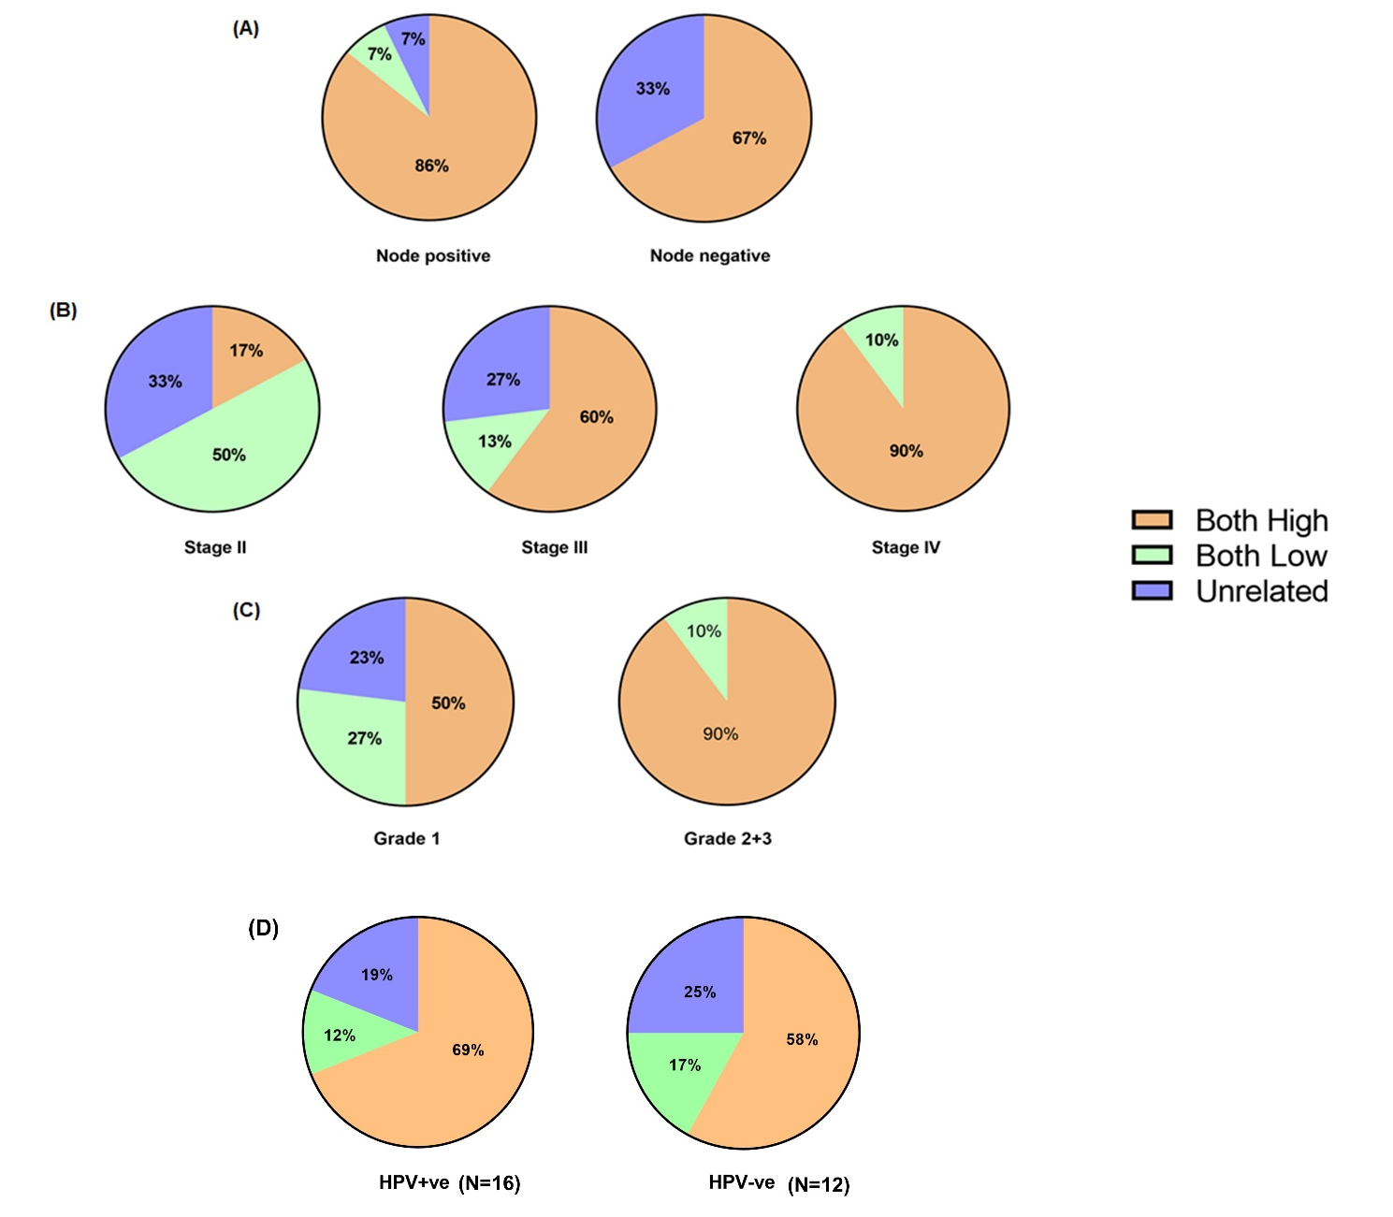
Supplemental Figure 2: Frequency distribution between the CDC20-UBCH10 expression status and the clinico-pathological characteristics of oral squamous cell carcinoma patients from the Eastern-Indian prospective study cohort. The representative pie charts illustrate the percentage of patient groups (CDC20-UBCH10 both high, CDC20-UBCH10 both low, and CDC20-UBCH10 unrelated) with respect to (A) nodal involvement, (B) tumor stage, (C) tumor grade, and (D) Human Papilloma Virus (HPV) infection status in the study cohort.

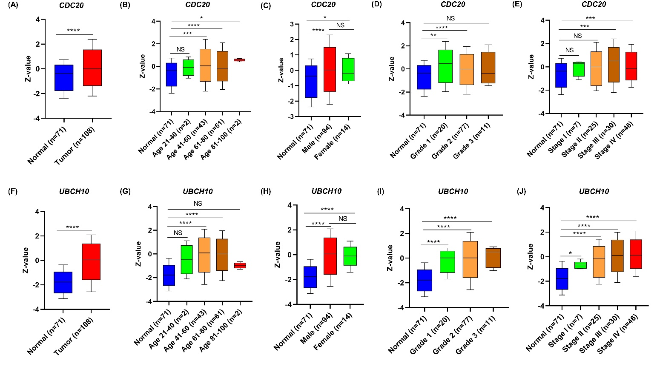
Supplemental Figure 3: The expression of CDC20 and UBCH10 are significantly correlated in primary head and neck (HNSC) malignancies in the CPTAC database. (A & F) The box plots represent Z-values of CDC20 and UBCH10 across primary tumors (n=108) and adjacent normal tissues (n=71) in primary HNSC malignancies. (B-E) The expression of CDC20 are correlated with clinicopathological features in CPTAC HNSC (the cancer genome atlas- head and neck squamous cell carcinoma) cohort. Box plots, derived from UALCAN database, representing Z-values based on (B) Age, (C) Gender, (D) tumor grade status, and (E) tumor stage status. (G-J) Box plots, obtained from UALCAN, representing Z-values of UBCH10 based on (G) Age, (H) Gender, (I) tumor grade, and (J) tumor stage status. The Y axis represents Z values for protein expression. Statistically analysed p values were obtained from UALCAN database. *p<0.05, **p<0.01, ****p<0.0001. (two-tailed unpaired Student’s t-test). All data are represented by mean±SD.

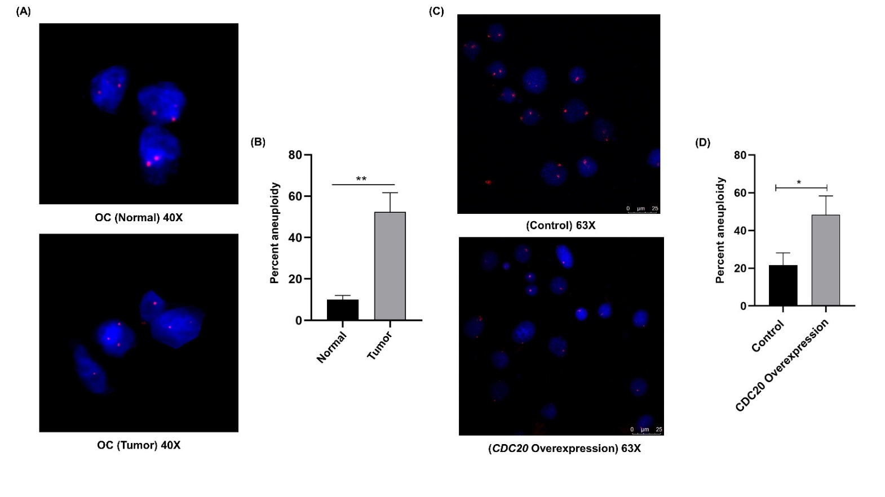
Supplemental Figure 4: Enumerating cellular ploidy status in primary malignant oral tumor tissue samples and oral cancer cell lines. (A) Fluorescent In-situ Hybridization (FISH) assay with the centromeric probe against chromosome 1 was performed to check chromosomal instability in oral tumor and adjacent normal samples. Cells were visualized under fluorescence microscope. In normal tissue sample two red signals of centromeric probes indicated diploid nuclei, while deviation of more or less than two signals indicate aneuploidy. (B) Aneuploidy percentage was determined by dividing the total number of aneuploid nuclei by the total number of cells multiplied by 100 for each experimental set. The experiment was performed in triplicate. (C) CDC20-UBCH10 correlated overexpression is associated with aneuploidy in HNSC cells. SCC084 Cells were transfected with either control or/with Cdc20-expressing plasmid and harvested for FISH assay with chromosome 1 centromeric probe. Cells were visualized under fluorescence microscope. In control cells two red signals indicated diploid nuclei, while deviation of more or less than two signals indicate aneuploidy in Cdc20 overexpressed cells. (B) Aneuploidy percentage was determined by dividing the total number of aneuploid nuclei by the total number of cells multiplied by 100 for each experimental set. Three biological replicates have been performed. For comparisons, Welch’s t-test was applied. *p<0.05, **p<0.01. All data are represented by mean±SD.

Supplemental Figure 5: Correlation of aneuploidy with CDC20-UBCH10 expression. (A-C) The scores of aneuploidy across top quartile and bottom quartile of CDC20 expressing (A), UBCH10 expressing (B), and correlated CDC20-UBCH10 expressing groups from TCGA-BRCA cohort. (D-F) Same as (A-C) in TCGA-HNSC cohort. For comparison between groups, Welch’s t-test was applied. **p<0.01, ***p<0.001, ns (not significant). Data are represented by mean±SD.
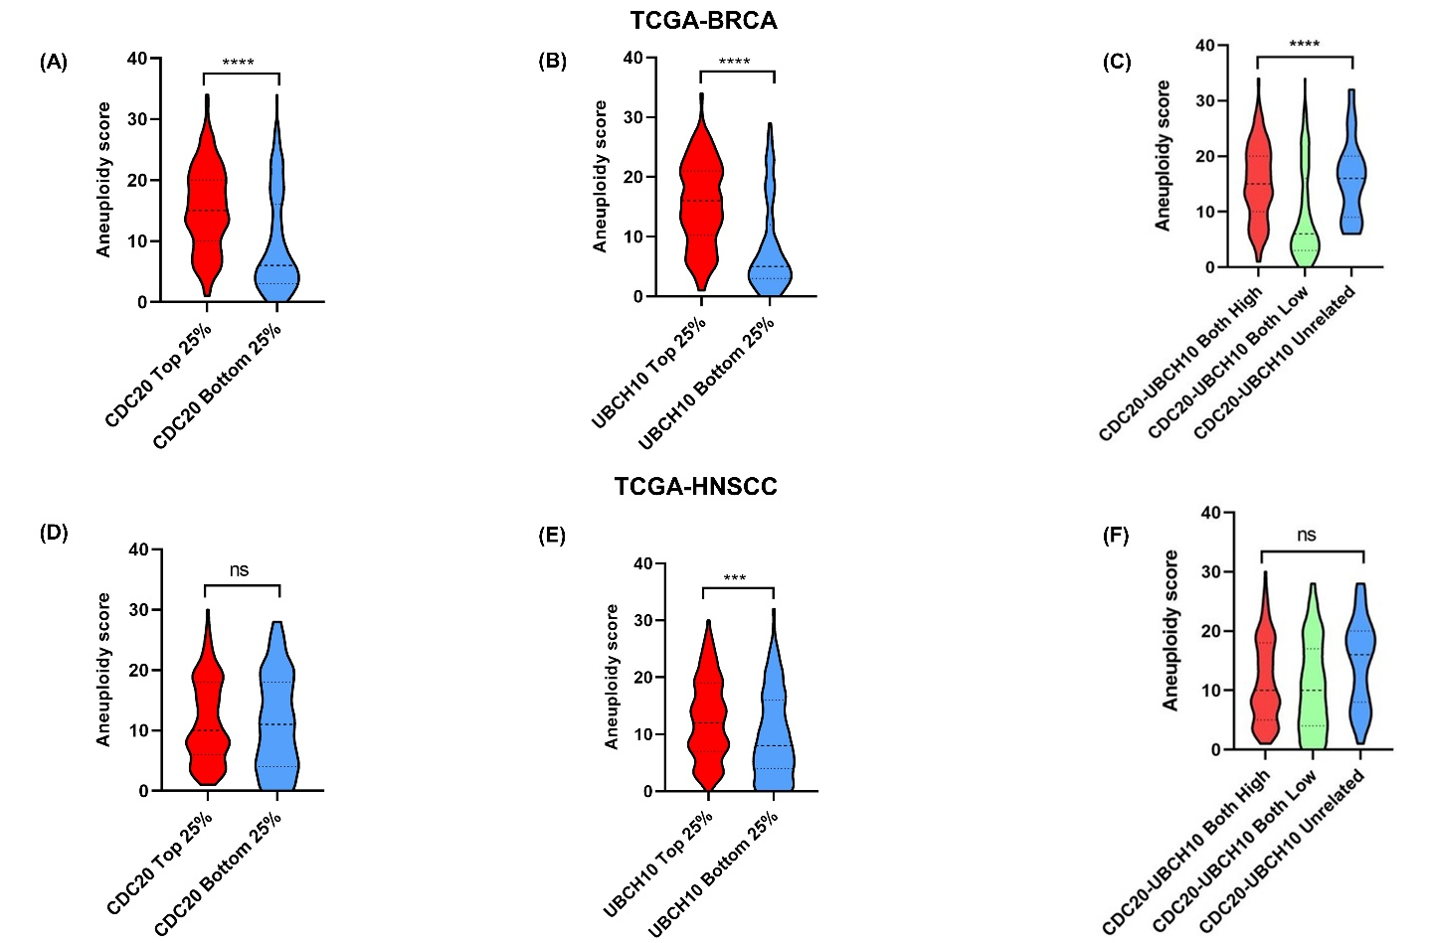

Supplemental Figure 6: The expression of CDC20 and UBCH10 are significantly upregulated in primary solid tumor malignancies in the TCGA (The Cancer Genome Atlas) cohort. The box plots, obtained from the UALCAN database, represents gene expression of primary tumors and adjacent normal tissues of different cancer subtypes. (A-F) Box plots representing the transcript per million (TPM) values of CDC20 across primary tumors and adjacent normal tissues in BRCA, LUAD, LIHC, PRAD, CESC, and COAD respectively. (G-L) Box plots depict the TPM values of UBCH10 across primary tumors and adjacent normal tissues in representative cancer subtypes (BRCA, LUAD, LIHC, PRAD, CESC, and COAD). BRCA, Breast invasive carcinoma; LUAD, Lung adenocarcinoma; LIHC, Liver hepatocellular carcinoma; PRAD, Prostate adenocarcinoma; CESC, Cervical squamous cell carcinoma; COAD, Colon adenocarcinoma. The Y axis represents transcripts per million (TPM) for gene expression. Statistically analysed p values obtained from the UALCAN database. ****p<0.0001 (two-tailed unpaired Student’s t-test). Data are represented by mean±SD.

Supplemental Figure 7: The expression of CDC20 and UBCH10 are significantly upregulated in primary solid tumor malignancies in the CPTAC cohort. (A-D) The box plots, obtained from the CPTAC database, represent Z-values of CDC20 across primary tumors and adjacent normal tissues of different cancer subtypes (BRCA, LUAD, LIHC, and OV). (E-I) Box plots, obtained from the CPTAC database representing the Z-values of UBCH10 expression across primary tumors and adjacent normal tissues in representative cancer subtypes (BRCA, LUAD, LIHC, OV, and COAD). BRCA, Breast invasive carcinoma; LUAD, Lung adenocarcinoma; LIHC, Liver hepatocellular carcinoma; OV, Ovarian carcinoma; COAD, Colon adenocarcinoma. The Y axis represents Z-values for protein expression. Statistically analysed p values obtained from the UALCAN database. N/A (Not available), ****p<0.0001 (two-tailed unpaired Student’s t-test). All data are represented by mean±SD.

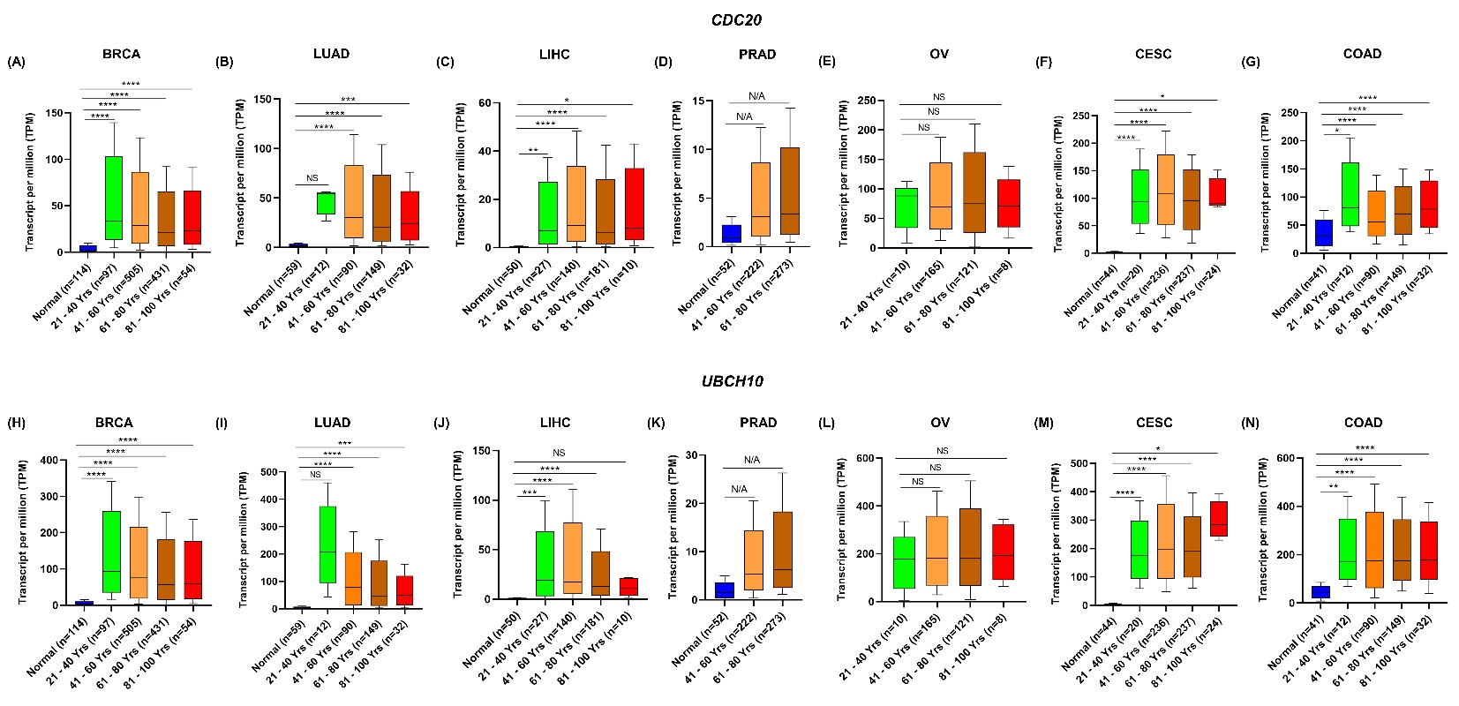
Supplemental Figure 8: The expression of CDC20 and UBCH10 are significantly correlated with patient age status in primary solid tumor malignancies in the TCGA (The Cancer Genome Atlas) cohort. (A-G) The box plots, obtained from the UALCAN database, represent the transcript per million (TPM) values of CDC20 based on age status of different groups (21-40, 41-60, 61-80, and 81-100 years) across primary tumors and adjacent normal tissues of different cancer subtypes (BRCA, LUAD, LIHC, PRAD, OV, CESC, and COAD). (H-N) Box plots, representing the TPM values of UBCH10 expression based on age status of different groups (above mentioned) across primary tumors and adjacent normal tissues in representative cancer subtypes (BRCA, LUAD, LIHC, PRAD, OV, CESC, and COAD). BRCA, Breast invasive carcinoma; LUAD, Lung adenocarcinoma; LIHC, Liver hepatocellular carcinoma; PRAD, Prostate adenocarcinoma; OV, Ovarian carcinoma; CESC, Cervical squamous cell carcinoma; COAD, Colon adenocarcinoma. The Y axis represents transcripts per million (TPM) values for gene expression. Statistically analysed p values obtained from the UALCAN database. N/A (Not available), NS (Not significant), *p<0.05, **p<0.01, ***p<0.001 ****p<0.0001 (two-tailed unpaired Student’s t-test).
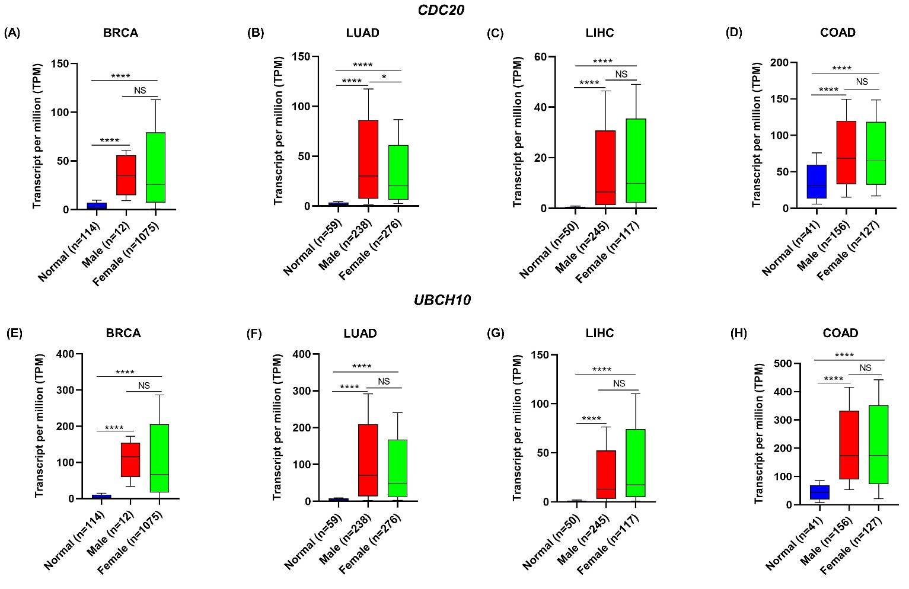
Supplemental Figure 9: The expression of CDC20 and UBCH10 are significantly correlated with patient gender status in primary solid tumor malignancies in the TCGA (The Cancer Genome Atlas) cohort. (A-D) The box plots, obtained from the UALCAN database, represent the transcript per million (TPM) values of CDC20 based on gender status (Male and female) across primary tumors and adjacent normal tissues of different cancer subtypes (BRCA, LUAD, LIHC, and COAD). (E-H) Box plots, representing the TPM values of UBCH10 expression based on gender across primary tumors and adjacent normal tissues in representative cancer subtypes (BRCA, LUAD, LIHC, and COAD). BRCA, Breast invasive carcinoma; LUAD, Lung adenocarcinoma; LIHC, Liver hepatocellular carcinoma; COAD, Colon adenocarcinoma. The Y axis represents transcripts per million (TPM) values for gene expression. Statistically analysed p values obtained from the UALCAN database. N/A (Not available), NS (Non-significant), *p<0.05, **p<0.01, ***p<0.001 ****p<0.0001 (two-tailed unpaired Student’s t-test). All data are represented by mean±SD.
Supplemental Figure 10: The expression of CDC20 and UBCH10 are correlated with nodal metastasis status in primary solid tumor malignancies in the TCGA (The Cancer Genome Atlas) cohort. (A-F) The box plots, obtained from the UALCAN database, representing the transcript per million (TPM) values of CDC20 based on nodal metastasis status (N0, N1, N2, N3) across primary tumors and adjacent normal tissues of representative cancer subtypes (BRCA, LUAD, LIHC, PRAD, CESC, and COAD). (G-L) Box plots derived from the UALCAN database depicting the TPM values of UBCH10 expression across primary tumors and adjacent normal tissues of BRCA, LUAD, LIHC, PRAD, CESC, and COAD respectively. BRCA, Breast invasive carcinoma; LUAD, Lung adenocarcinoma; LIHC, Liver hepatocellular carcinoma; PRAD, Prostate adenocarcinoma; CESC, Cervical squamous cell carcinoma; COAD, Colon adenocarcinoma. The Y axis represents transcripts per million (TPM) for gene expression. NS; non-significant, ***p < 0.001, ****p < 0.0001 (two-tailed unpaired Student’s t-test). All data are represented by mean±SD.

Supplemental Figure 11: The expression of CDC20 and UBCH10 are correlated with tumor grade in primary solid tumor malignancies in the TCGA (The Cancer Genome Atlas) cohort. (A-C) The box plots, obtained from the UALCAN database, representing the transcript per million (TPM) values of CDC20 based on tumor grade status (G1, G2, G3, G4) across primary tumors and adjacent normal tissues of representative cancer subtypes (LIHC, OV, and CESC). (D-F) Box plots derived from the UALCAN database, representing the transcript per million (TPM) values of UBCH10 based on tumor grade status (G1, G2, G3, G4) across primary tumors and adjacent normal tissues of representative cancer subtypes (LIHC, OV, and CESC). LIHC, Liver hepatocellular carcinoma; OV, Ovarian carcinoma; CESC, Cervical squamous cell carcinoma. The Y axis represents transcripts per million (TPM) for gene expression. N/A (Not available), **p < 0.01, ***p < 0.001, ****p < 0.0001 (two-tailed unpaired Student’s t-test). Data are represented by mean±SD.
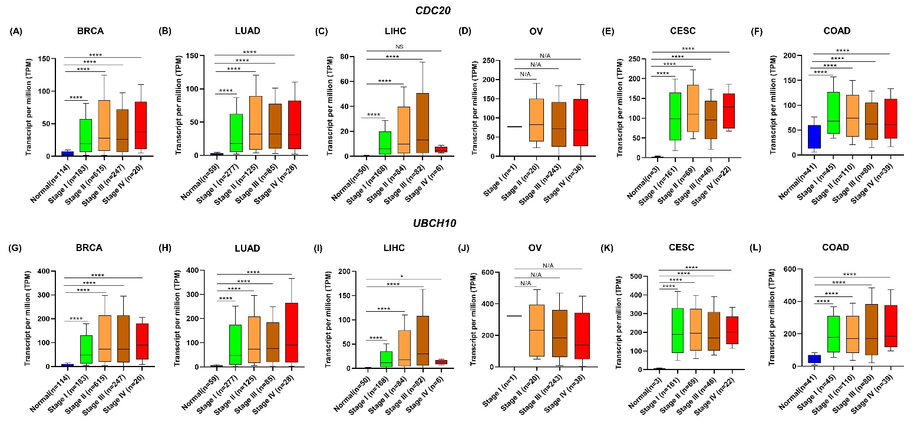
Supplemental Figure 12: The expression of CDC20 and UBCH10 are correlated with pathological tumor stages in primary solid tumor malignancies in the TCGA (The Cancer Genome Atlas) cohort. (A-F) The box plots, obtained from the UALCAN database, representing the transcript per million (TPM) values of CDC20 based on tumor stages (I, II, III, IV) across primary tumors and adjacent normal tissues of representative cancer subtypes (BRCA, LUAD, LIHC, OV, CESC, and COAD). (G-L) Box plot derived from the UALCAN database, representing the transcript per million (TPM) values of UBCH10 based on tumor stages (I, II, III, IV) across primary tumors and adjacent normal tissues of BRCA, LUAD, LIHC, OV, CESC, and COAD respectively. BRCA, Breast invasive carcinoma; LUAD, Lung adenocarcinoma; LIHC, Liver hepatocellular carcinoma; OV, Ovarian carcinoma; CESC, Cervical squamous cell carcinoma; COAD, Colon adenocarcinoma. The Y axis represents transcripts per million (TPM) for gene expression. NS; non-significant, N/A (Not available), *p < 0.05, ***p < 0.001, ****p < 0.0001 (two-tailed unpaired Student’s t-test). All data are represented by mean±SD.

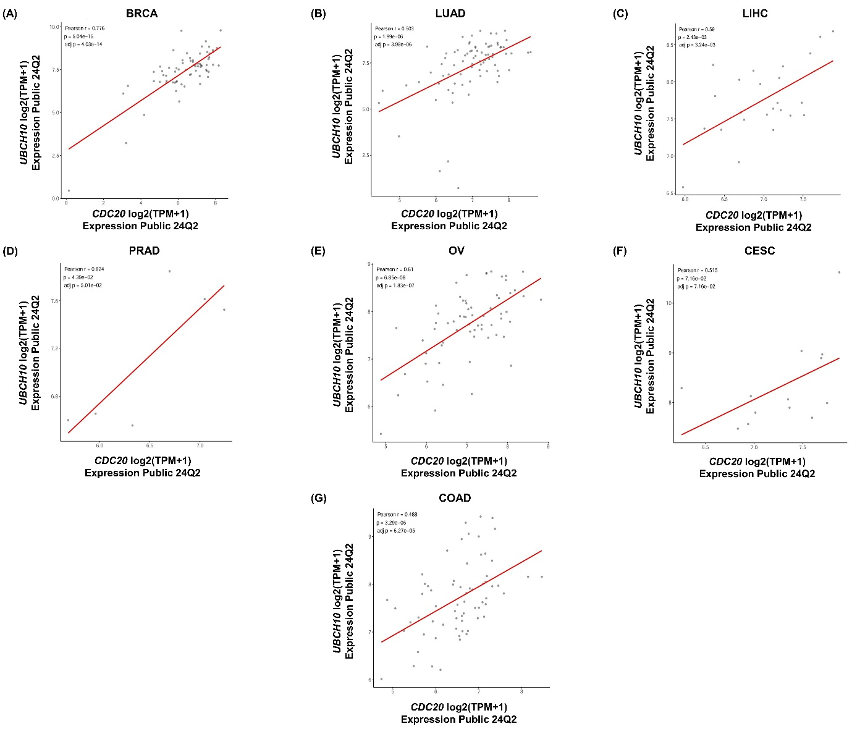
Supplemental Figure 13: The expression of CDC20 and UBCH10 are correlated in cell lines across different solid tumor malignancies in the expression public 24Q2 of Cancer Cell Line Encyclopedia (CCLE) database. (A-G) The representative scatter plots derived from the CCLE database, representing the Pearson’s correlation analysis between the gene expression in log2(TPM+1) values of CDC20 and UBCH10 in cell lines of representative cancer subtypes (BRCA (n=69), LUAD (n=80), LIHC (n=24), PRAD (n=6), OV (n=65), CESC (n=13), and COAD (n=66)). BRCA, Breast invasive carcinoma; LUAD, Lung adenocarcinoma; LIHC, Liver hepatocellular carcinoma; PRAD, Prostate adenocarcinoma; OV, Ovarian carcinoma; CESC, Cervical squamous cell carcinoma; COAD, Colon adenocarcinoma. The Pearson correlation coefficient is reported as ‘R’ value. *p<0.05.
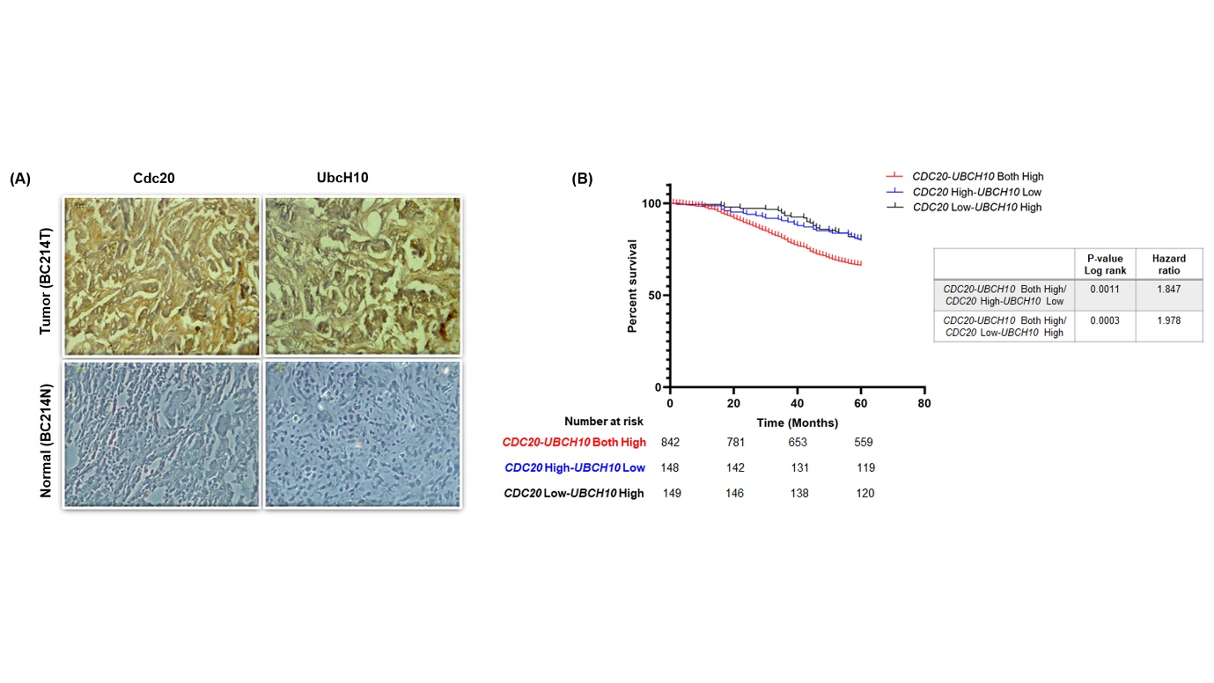

Supplemental Figure 14: Correlation of CDC20-UBCH10 expression and its clinical relevance on survival outcome in primary breast malignancies. (A) Representative images of immunohistochemical (IHC) analysis depicting the correlated expression of Cdc20 and UbcH10 in primary breast malignant (n=3) and adjacent normal tissues (n=3). IHC analysis was carried out by using antibodies against Cdc20 and UbcH10 (BC, Breast cancer; T, tumor; N, normal). (B) Overall survival (OS) data of primary breast cancer patients in the METABRIC, Nature 2012 & Nat Commun 2016 dataset were derived from the cBioPortal database (https://www.cbioportal.org/). OS probabilities of patients with CDC20-UBCH10 both high, CDC20 high-UBCH10 low, and CDC20 low-UBCH10 high expression group were performed. P values were obtained by log rank test. Hazard ratio (HRs) for individual analyses are shown.

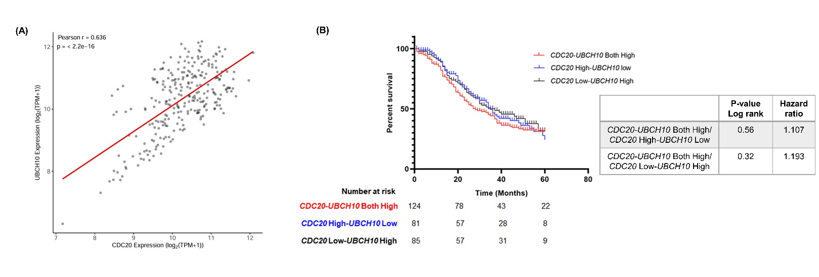
Supplemental Figure 15: Correlated overexpression of CDC20-UBCH10 predicts poor survival in patients with colon adenocarcinoma (TCGA-COAD). (A) The representative scatter plot derived from the GEPIA2 database, depicts the Pearson’s correlation analysis between the gene expression in log2(TPM) values of CDC20 and UBCH10 in primary colon tumor tissues. The Pearson correlation coefficient is reported as ‘R’ value. *p < 0.05. (B) Overall survival probabilities of patients from the TCGA-COAD dataset with ‘CDC20-UBCH10 both high’, ‘CDC20 high-UBCH10 low’, and ‘CDC20 low-UBCH10 high’ groups as estimated by Kaplan-Meier analysis. The p value was calculated using log-rank (Mantel–Cox) test. Hazard ratio (HR) for individual analyses are shown. p value; ns (not significant).

