Supplementary Materials
Supplementary Table S1. Complete Search Strategy and Screening Process
- Search Strategy Details

Item | Details
Database Searched | PubMed
Date Range | January 1, 2015 – Feb 1, 2024
Search Fields | Title, Abstract, MeSH terms
Language Filter | English
Population Filter | Humans
Search Terms and Strategy | ("prostate cancer"[MeSH Terms] OR "prostatic neoplasms"[MeSH Terms] OR "PC"[Title/Abstract] OR "PCM"[Title/Abstract] OR "prostate carcinoma"[Title/Abstract] OR "mPCa"[Title/Abstract]) AND ("metastasis"[Title/Abstract] OR "progression"[Title/Abstract] OR "development"[Title/Abstract] OR "aggressiveness"[Title/Abstract] OR "high-grade"[Title/Abstract] OR "advanced"[Title/Abstract]) AND ("diabetes mellitus"[MeSH Terms] OR "diabetes"[Title/Abstract] OR "diabetes mellitus type 2"[Title/Abstract] OR "obesity"[MeSH Terms] OR "obese"[Title/Abstract] OR "body mass index"[Title/Abstract] OR "overweight"[Title/Abstract] OR "adiposity"[Title/Abstract] OR "dyslipidemias"[MeSH Terms] OR "dyslipidemia"[Title/Abstract] OR "hyperlipidemia"[Title/Abstract] OR "lipid metabolism disorders"[Title/Abstract] OR "hypertension"[MeSH Terms] OR "elevated blood pressure"[Title/Abstract])
Boolean Operators Used | OR within categories; AND across categories
Additional Filters | None beyond language and human studies

B. Screening and Selection Process
Stage | Description
Title and Abstract Screening | Conducted independently by two reviewers based on relevance to prostate cancer outcomes and cardiometabolic exposures.
Full-Text Review | Full texts of eligible articles were reviewed to confirm inclusion criteria were met.
Discrepancy Resolution | Discrepancies were resolved through discussion and consensus. A third reviewer was consulted if needed.
Inclusion Criteria | Cohort studies (prospective or retrospective) reporting associations between diabetes, obesity, hypertension, or dyslipidemia and prostate cancer outcomes (progression, recurrence, metastasis, mortality) with HRs, ORs, or RRs and 95% CI. Human studies, English language.
Exclusion Criteria | Reviews, meta-analyses, case reports, editorials, animal studies, studies without sufficient effect size data.

Supplementary Figure S1. Forest Plot, Association between Sample Size and Aggressive PCa
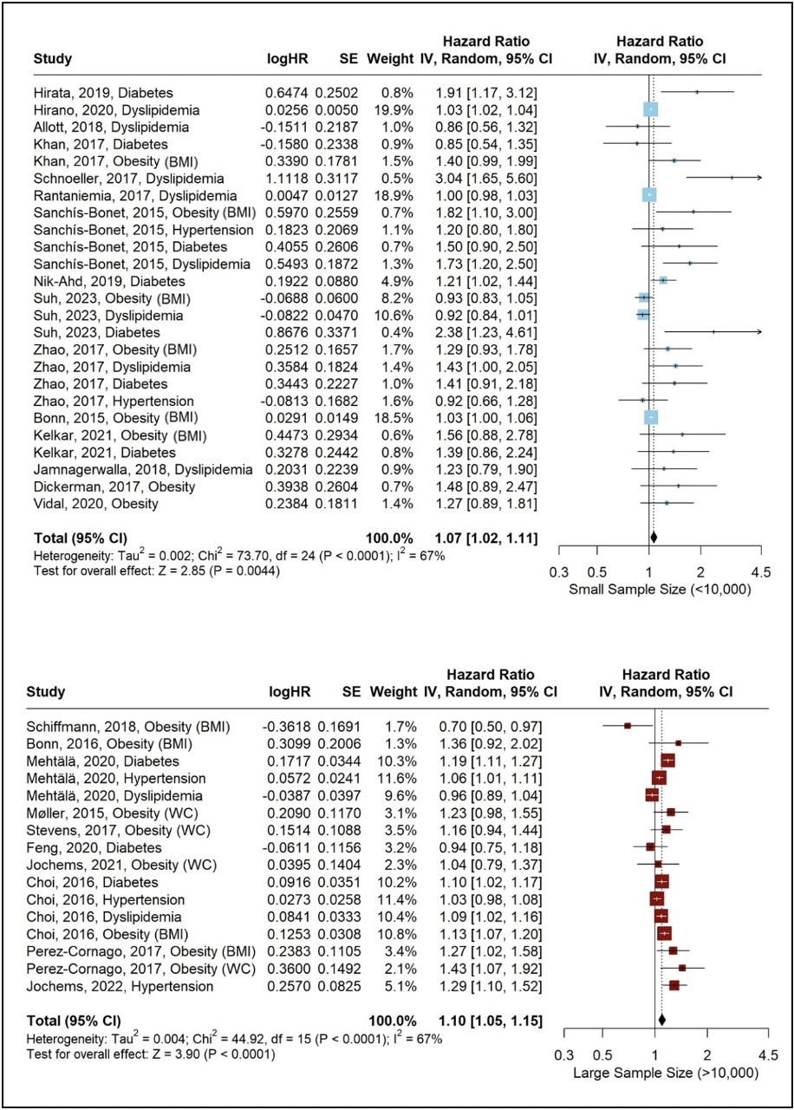
Supplementary Figure S2. Forest Plot, Association in Lengths of Follow-Up and Aggressive PCa
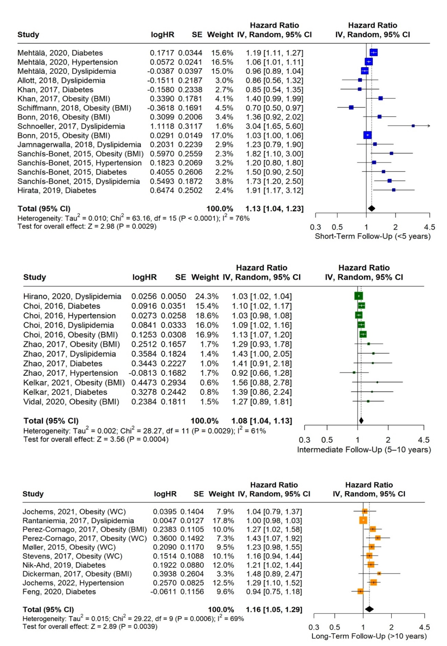

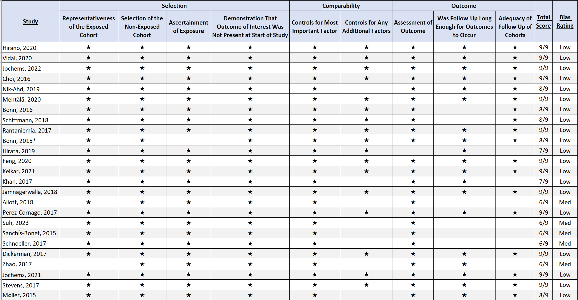
Supplementary Table S2. Risk of Bias Assessment, Newcastle-Ottawa Scale for Cohort Studies

Supplementary Table S3. Descriptive Characteristics of Studies Used in Meta-Analysis

Category | Author | Year | Study Type | Risk Statistic Measurement | Risk Value | Lower 95% CI | Upper 95% CI | Sample Size | Number Of Advanced PCa Cases | Percent of Cardiometabolic Disease Present | Average Age | Country | Risk of Bias Score
Dyslipidemia | Hirano et al. | 2020 | Prospective Cohort | RR | 1.03 | 1.016 | 1.036 | 351 | 108 | 25.07% | 70 | Japan | Low
Obesity (BMI) | Vidal et al. | 2020 | Prospective Cohort | HR | 1.27 | 0.89 | 1.81 | 5,929 | 1,934 | 33.78% | 63 | US | Low
Hypertension | Jochems et al. | 2022 | Prospective Cohort | HR | 1.29 | 1.1 | 1.52 | 430,472 | 1,854 | 37.40% | 38 | Sweden | Low
Diabetes | Choi et al. | 2016 | Prospective Cohort | HR | 1.1 | 1.023 | 1.174 | 139,519 | 7,622 | 11.96% | N/A | South Korea | Low
Hypertension |  |  |  |  | 1.03 | 0.977 | 1.081 | 139,519 | 7,622 | 39.44% | N/A | South Korea | Low
Dyslipidemia |  |  |  |  | 1.09 | 1.019 | 1.161 | 139,519 | 7,622 | 16.03% | N/A | South Korea | Low
Obesity (BMI) |  |  |  |  | 1.13 | 1.067 | 1.204 | 139,519 | 7,622 | 36.16% | N/A | South Korea | Low
Diabetes | Nik-Ahd et al. | 2019 | Prospective Cohort | HR | 1.21 | 1.02 | 1.44 | 1,409 | 59 | 100.00% | 62 | US | Low
Diabetes | Mehtälä et al. | 2020 | Retrospective Cohort | HR | 1.19 | 1.11 | 1.27 | 15,953 | 15,953 | 9.73% | 73.9 | Sweden | Low
Hypertension |  |  |  |  | 1.06 | 1.01 | 1.11 | 15,953 | 15,953 | 24.04% | 73.9 | Sweden | Low
Dyslipidemia |  |  |  |  | 0.96 | 0.89 | 1.04 | 15,953 | 15,953 | 6.43% | 73.9 | Sweden | Low
Obesity (BMI) | Bonn et al. | 2016 | Prospective Cohort | HR | 1.36 | 0.92 | 2.02 | 15,827 | 282 | 13.58% | 65 | Sweden | Low
Obesity (BMI) | Schiffmann et al. | 2018 | Prospective Cohort | HR | 0.7 | 0.5 | 0.97 | 13,667 | 1,047 | 14.60% | 64 | Germany | Low
Dyslipidemia | Rantaniemia et al. | 2017 | Prospective Cohort | HR | 1.01 | 0.98 | 1.03 | 1,314 | ~ 679 | 35.90% | 62 | Finland | Low
Obesity (BMI) | Bonn et al. | 2015* | Prospective Cohort | HR | 1.03 | 1 | 1.06 | 4,376 | ~ 810 | 11.00% | 65 | Sweden | Low
Diabetes | Hirata et al. | 2019 | Prospective Cohort | HR | 1.94 | 1.17 | 3.12 | 121 | 98 | 22.30% | 72 | Japan | Low
Diabetes | Feng et al. | 2020 | Prospective Cohort | HR | 0.94 | 0.75 | 1.18 | 49,392 | 2,513 | 9.80% | 71.3 | US | Low
Obesity (BMI) | Kelkar et al. | 2021 | Prospective Cohort | HR | 1.57 | 0.88 | 2.78 | 4,688 | ~ 770 | 33.30% | 62 | US | Low
Diabetes |  |  |  |  | 1.38 | 0.86 | 2.24 | 4,688 | ~ 770 | 20.40% | 62 | US | Low
Diabetes | Khan et al. | 2017 | Prospective Cohort | HR | 0.86 | 0.54 | 1.35 | 672 | 83 | 17.90% | 62 | US | Low
Obesity (BMI) |  |  |  |  | 1.4 | 0.99 | 1.99 | 672 | 83 | 38.20% | 62 | US | Low
Dyslipidemia | Jamnagerwalla et al. | 2018 | Prospective Cohort | HR | 1.23 | 0.79 | 1.9 | 4,974 | 218 | 5.40% | 63 | US | Low
Dyslipidemia | Allott et al. | 2018 | Prospective Cohort | HR | 0.86 | 0.56 | 1.32 | 669 | 250 | 63.50% | 61 | US | Med
Obesity (BMI) | Perez-Cornago et al. | 2017 | Prospective Cohort | HR | 1.26 | 1.022 | 1.576 | 141,896 | 1,388 | 15.30% | 68 | Europe | Low
Obesity (WC) |  |  |  |  | 1.43 | 1.07 | 1.92 | 141,896 | 1,388 | 20.00% | 68 | Europe | Low
Obesity (BMI) | Suh et al. | 2023 | Retrospective Cohort | OR | 0.93 | 0.83 | 1.05 | 1,740 | 153 | ~ 1.70% | 66 | South Korea | Med
Dyslipidemia |  |  |  |  | 0.92 | 0.84 | 1.01 | 1,740 | 153 | ~ 32.20% | 66 | South Korea | Med
Diabetes |  |  |  |  | 2.38 | 1.23 | 4.61 | 1,740 | 153 | 16.30% | 66 | South Korea | Med
Obesity (BMI) | Sanchís-Bonet et al. | 2015 | Prospective Cohort | OR | 1.9 | 1.1 | 3 | 1,319 | 252 | 15.00% | 66 | Spain | Med
Hypertension |  |  |  |  | 1.2 | 0.8 | 1.8 | 1,319 | 252 | 36.00% | 66 | Spain | Med
Diabetes |  |  |  |  | 1.5 | 0.9 | 2.5 | 1,319 | 252 | 20.00% | 66 | Spain | Med
Dyslipidemia |  |  |  |  | 1.7 | 1.2 | 2.5 | 1,319 | 252 | 34.00% | 66 | Spain | Med
Dyslipidemia | Schnoeller et al. | 2017 | Prospective Cohort | HR | 3.04 | 1.65 | 5.6 | 767 | 358 | 37.40% | 68 | US | Med
Obesity (BMI) | Dickerman et al. | 2017 | Prospective Cohort | HR | 1.48 | 0.89 | 2.47 | 5,158 | 371 | 10.90% | 70 | US | Low
Obesity (BMI) | Zhao et al. | 2017 | Prospective Cohort | OR | 1.29 | 0.929 | 1.779 | 3,102 | 459 | 37.90% | 69 | China | Med
Dyslipidemia |  |  |  |  | 1.43 | 1.001 | 2.046 | 3,102 | 459 | 20.30% | 69 | China | Med
Diabetes |  |  |  |  | 1.41 | 0.912 | 2.183 | 3,102 | 459 | 18.80% | 69 | China | Med
Hypertension |  |  |  |  | 0.92 | 0.663 | 1.282 | 3,102 | 459 | 35.40% | 69 | China | Med
Obesity (WC) | Jochems et al. | 2021 | Prospective Cohort | HR | 1.05 | 0.79 | 1.37 | 58,457 | 483 | 28.40% | 53 | Sweden | Low
Obesity (WC) | Stevens et al. | 2017 | Prospective Cohort | RR | 1.16 | 0.94 | 1.44 | 46,094 | 809 | 40.00% | 68 | US | Low
Obesity (WC) | Møller et al. | 2015 | Prospective Cohort | HR | 1.23 | 0.98 | 1.55 | 1,813 | 626 | 25.60% | 56 | Denmark | Low

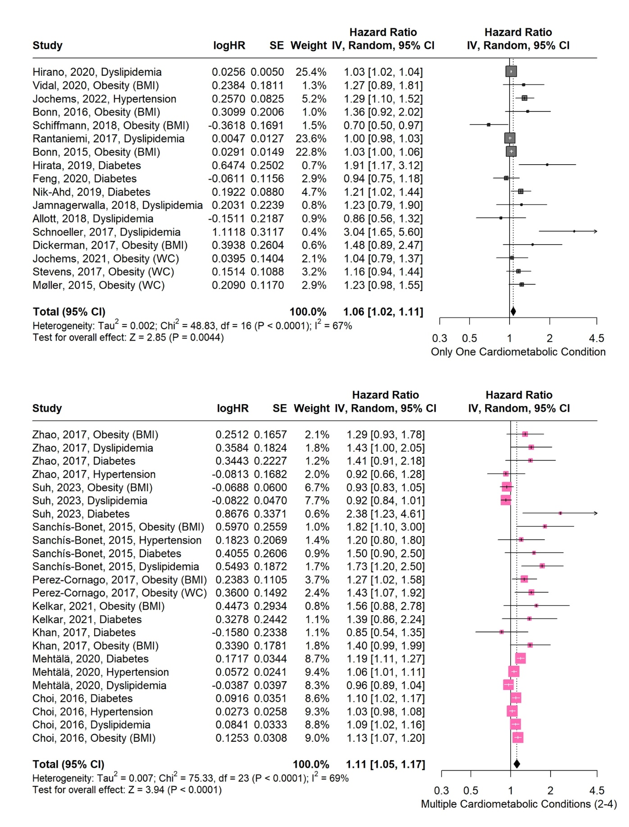
Supplementary Figure S3. Forest Plot, Association of Aggressive PCa with Amount of Cardiometabolic Conditions Present in the Respective Study

Supplementary Table S4. Summary of Previously Published Meta-Analyses Reviewed for Context
Reference | Focus / Exposure | Primary Outcomes | Key Differences from Current Study
YuPeng, 2015 (American Association of Cancer Research) | Blood cholesterol levels | Prostate cancer incidence and mortality | Focused on general PCa risk; did not analyze aggressive or metastatic outcomes or cardiometabolic clustering
Lee, 2016 (SpringerPlus) | Diabetes mellitus | Prostate cancer-specific mortality | Examined diabetes and mortality; did not assess metastasis-specific risk
Perez-Cornago, 2022 (BMC Medicine) | Adiposity (waist circumference, waist-to-hip ratio) | Prostate cancer mortality | Mortality-focused, not metastasis-specific; assessed central adiposity but not hypertension, diabetes, dyslipidemia
Rivera-Izquierdo, 2021 (Cancers MDPI) | Body mass index (BMI) | Prostate cancer mortality | Studied BMI and mortality; did not integrate diabetes, hypertension, or dyslipidemia as exposures
Liang, 2016 (Scientific Reports, naturesearch) | Hypertension | Prostate cancer risk | General PCa risk only; no focus on progression; hypertension assessed independently

