Figure1 Tumour volume and ROC curve analysis of 60-month survival status in 1st groups of patients

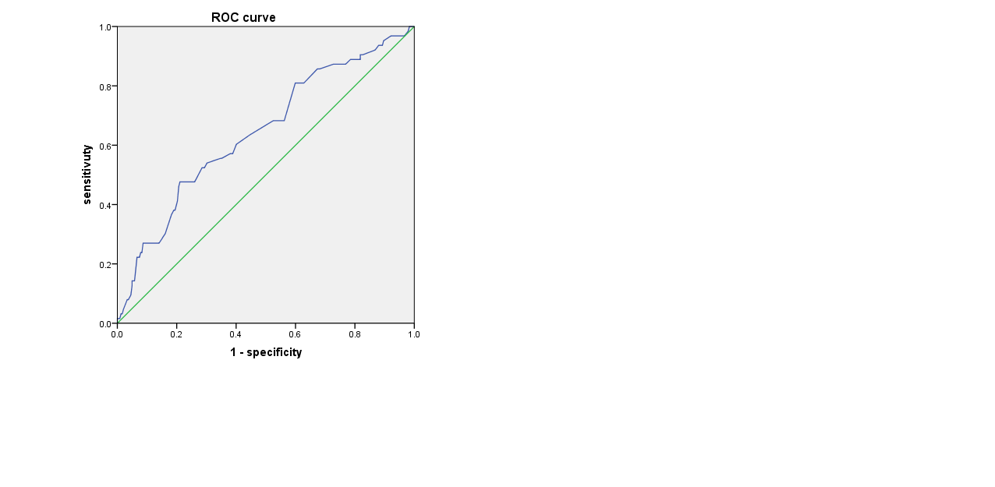

Figure2 Forest plot of survival analysis using multivariate COX regression in Group 1

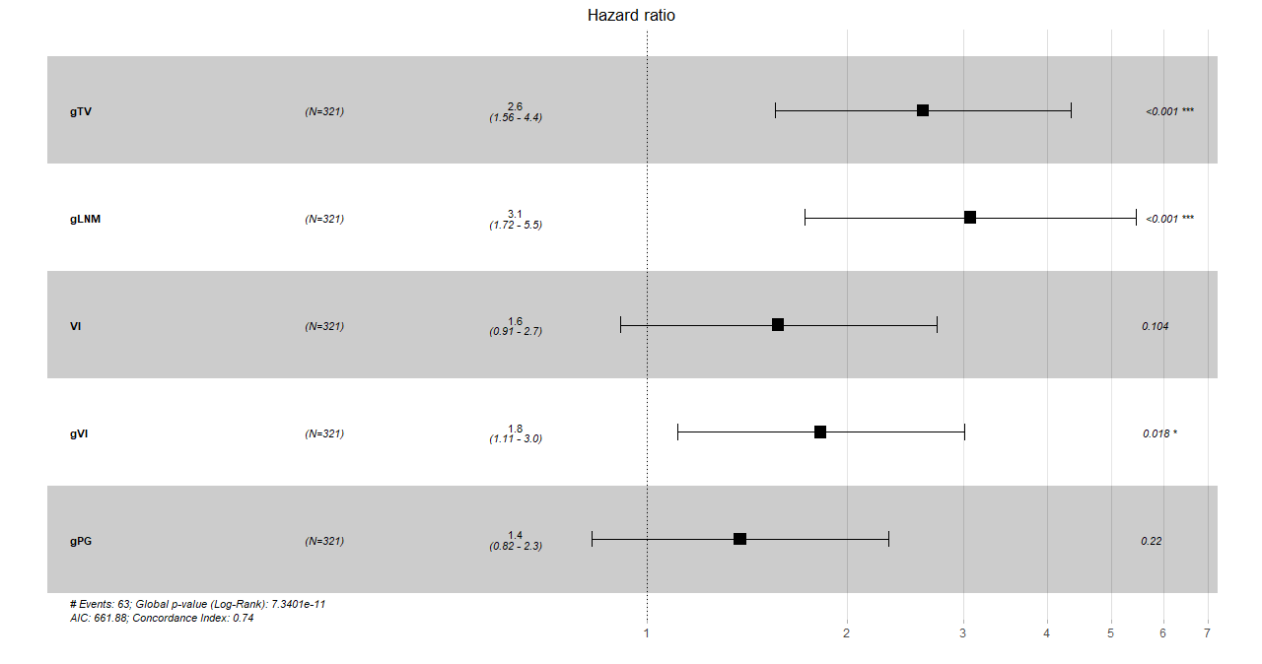

Figure3 Forest plot of survival analysis using multivariate COX regression in Group 2

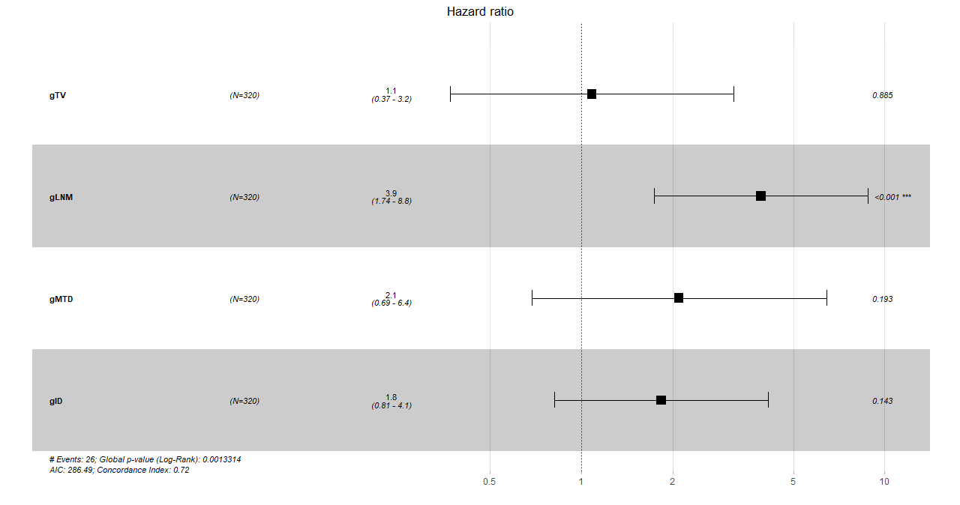

Figure 4 Distribution diagram of residual points in the Schoenfeld residual plot for Group1

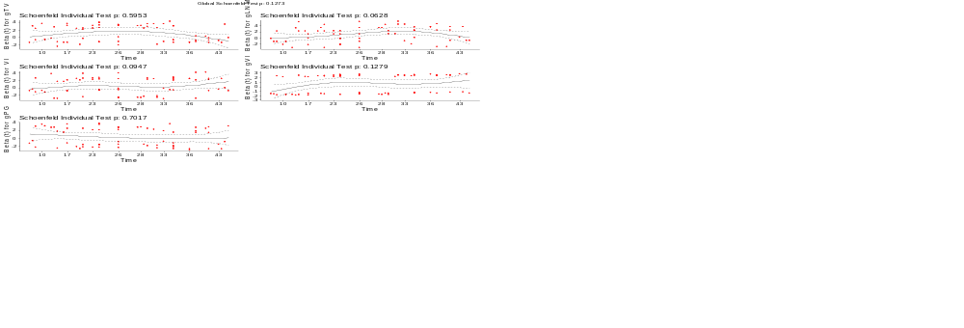

Figure 5 Distribution diagram of residual points in the Schoenfeld residual plot for Group2

