Supplementary: Feasibility Study of Stereoscopic Optical Palpation for Tumour Margin Assessment in Breast-Conserving Surgery

Q. Fang^{a,b,*}, R. W. Sanderson^{a,b}, R. Zilkens^{a,c}, I. Bomanª, K. Y. Foo^{a,b}, D. D. Lakhiani^{a,b}, A. Rijhumal^{d}, M. Hardie^{d,e}, B. F. Dessauvagie^{d,e,f}, C. M. Saunders^{c,g,h}, and B. F. Kennedy^{a,b,i,j}
ªBRITElab, Harry Perkins Institute of Medical Research, QEII Medical Centre, Nedlands and Centre for Medical Research, The University of Western Australia, Crawley, WA 6009, Australia
^{b}Department of Electrical, Electronic & Computer Engineering, School of Engineering, The University of Western Australia, Crawley, WA, 6009, Australia
^{c}Medical School, The University of Western Australia, Crawley, WA 6009, Australia
^{d}PathWest, Fiona Stanley Hospital, 11 Robin Warren Drive, Murdoch, WA 6150, Australia
^{e}School of Pathology and Laboratory Medicine, The University of Western Australia, Crawley, WA 6009, Australia
^{f}Clinipath Pathology, Suite 1, 302 Selby Street North, Osborne Park, WA, 6017, Australia
^{g}Department of Surgery, Melbourne Medical School, The University of Melbourne, Parkville, Victoria 3010, Australia
^{h}The Royal Melbourne Hospital, 300 Grattan Street, Parkville, Victoria, 3050, Australia
^{i}Australian Research Council Centre for Personalised Therapeutics Technologies, Australia
^{j}Institute of Physics, Faculty of Physics, Astronomy and Informatics, Nicolaus Copernicus University in Toruń, ul. Grudziądzka 5, 87-100 Toruń, Poland
*Corresponding author: Qi Fang (qi.fang@uwa.edu.au)

Highlights:

- We developed stereoscopic optical palpation, a new camera-based optical palpation technique.
- Specimens freshly excised from 48 patients were tested using SOP.
- Sensitivity of 82.1% for detecting cancer near the margin.
- Specificity of 83.6% for identifying benign tissue.
- The average stress threshold for identifying positive margins was 10.1 kPa.

S.1 Working principle of stereoscopic optical palpation

Figure S1(a) shows a photograph of the stereoscopic optical palpation (SOP) setup. The stereo cameras are mounted to a post, which is then secured onto a benchtop setting. The imaging window and light-emitting diode (LED) are attached to a custom 3D-printed holder. During the imaging, the sample and the silicone layer are placed on the stage, which can be raised to compress the sample and layer against the imaging window. Figure S1(b) demonstrates the working principle of SOP. The tissue and the compliant layer with embedded phosphorescent microparticles are placed in the overlapped field of view (FOV) of the stereo cameras. The layer is illuminated with ultraviolet (UV) light and stereoscopic imaging of the microparticles is used to map their depth position across the layer surface. When the tissue and layer are uncompressed, the initial depth positions of the microparticles are recorded. When the tissue and layer are compressed, another depth map is recorded to determine the displacement of the microparticles. The layer deformation varies spatially and is dependent on the mechanical properties of the underlying tissue. For example, the layer compresses more in regions above stiff tissue (tumour) than in regions above soft tissue, as illustrated in Fig. S1(b). Figures S1(c) and S1(d) are the photographs, from the left and right camera respectively, of the tissue and layer with UV light illumination. By combining these two photographs, a displacement map (Fig. S1(e)) of the surface containing the phosphorescent microparticles is generated, which is then converted to a strain map using knowledge of the pre-characterised initial layer thickness. In addition, as the stress-strain curve of this layer is pre-characterised using a custom uniaxial compression tester with a load cell, a two-dimensional (2D) stress map of the layer can be derived from the strain measurement, as shown in Fig. S1(f). In the stress map, regions with higher stress indicate stiffer tissue locations. More detailed information of the working principle can be found in our previous work (1).
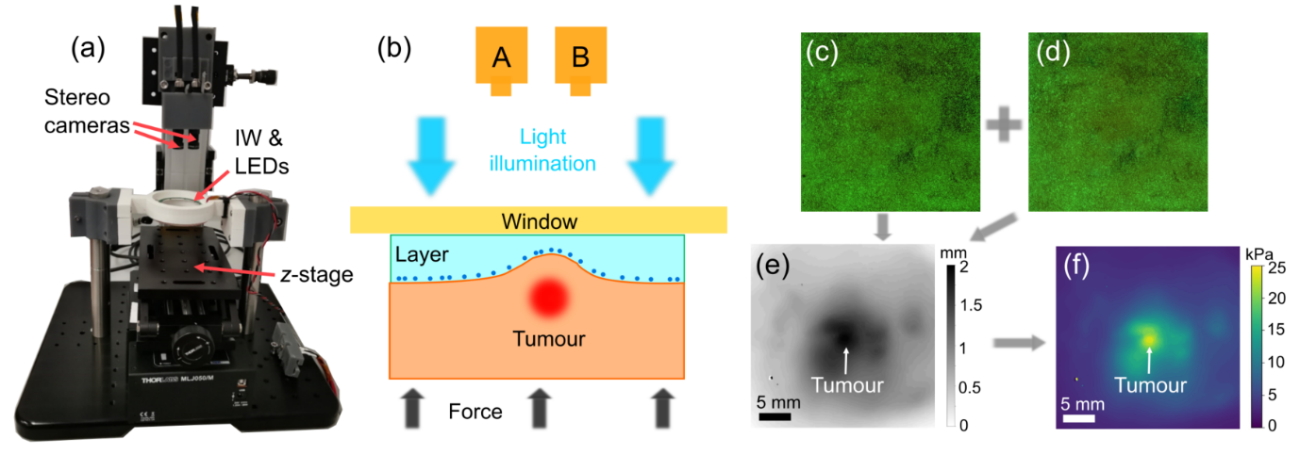
Figure S1 (a) Photograph of the SOP imaging system. (b) Working principle of SOP to measurement displacement of the layer surface through stereoscopic imaging. (c) and (d) Photograph of the tissue and layer with UV illumination taken from the left and right camera, respectively. (e) Displacement map generated by combining (c) and (d) for the tissue containing tumour. (f) Stress map converted from the displacement map (e).

S.2 Calculation of displacement, strain and stress sensitivities

To determine the displacement sensitivity and stress sensitivity, we first study the relationship between the settings of the stereoscopic imaging system and the axial resolution in the depth map. Figure S2 shows a diagram illustrating the relationship between the depth measurement and the pixel location of an object imaged on the camera sensor. In this figure, L1 and L2 are the two lenses that are placed in front of the camera sensors. The distance between the lens plane and the sensor is $t$. An object C is placed at a distance $s$ from the lenses and is imaged at a pixel location on the sensor plane. If the lenses have focal length, f, then the relationship between $s$, $t$ and $f$ is:
$$\frac{1}{s}+\frac{1}{t}=\frac{1}{f} (S1)$$
Assuming the object C moved a distance $d$ along the axial direction and arrived at the position C’, then the same object will have an image at a different pixel location on the sensor plane. On this sensor, the pixel difference between the original and final images is $p$. From trigonometry, and assuming $d « s$, we can express the relationship between $p$ and $d$ as:
$$d=\frac{2p∙s^{2}}{l∙t} (S2)$$
The axial resolution of the depth measurement in SOP is defined as the minimum displacement $d$ that can be calculated from the disparity measurement, i.e., when $p=0.5 pixel.$ The is also the definition of the displacement sensitivity in SOP. For the specific camera sensor used in this initial implementation, the pixel size is 2 µm, so $p=1 µm.$ From Eq. (S2) we know that the axial resolution is higher if $p$ is smaller and $l$ is larger. However, the distance $l$ between the two lenses L1 and L2 cannot be too large as the images acquired from each half of the sensor should have an overlapped field of view.
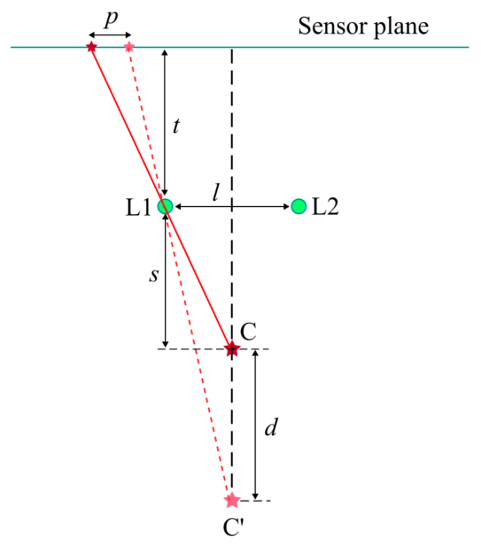
Figure S3 shows a diagram of a perfectly overlapped FOV from the stereoscopic imaging. In this figure, $D_{x}$ is the dimension of the active area of the camera sensor in the horizontal direction. For instance, if we use the selected camera sensor, $D_{x}=7.7 mm$. For the case of perfectly overlapped field of view from the stereoscopic images, according to trigonometry, the relationship between $l$ and $D_{x}$ can be expressed as:
Figure S2. Diagram showing the relationship between the depth of an object and its pixel location on the sensor.
$$\frac{l/2}{\frac{FOV}{2}-l/2}=\frac{\frac{D_{x}}{2}-l/2}{\frac{FOV}{2}+l/2} (S3)$$
Deriving from this equation, $l$ can be expressed as:
$$l=\frac{FOV∙D_{x}}{2FOV+D_{x}} (S4)$$
If $FOV≫D_{x}, l≈D_{x}/2$.
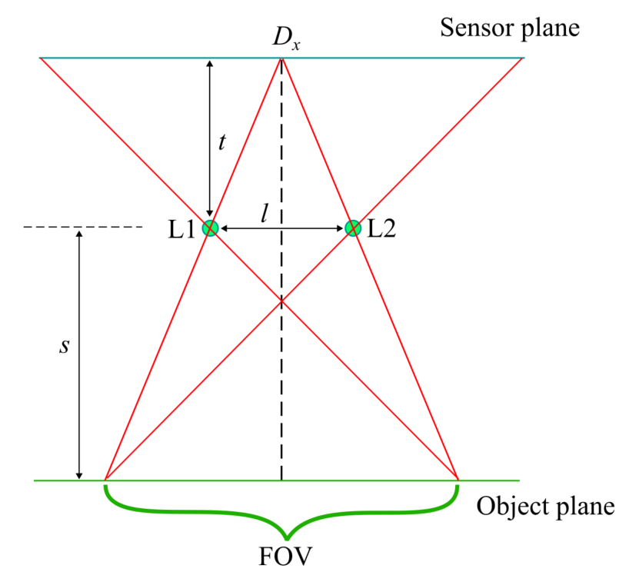
Figure S3. Diagram showing perfectly overlapped FOV with one image at each side of the camera sensor.
We now consider calculation of the parameters of the lenses that are used in this initial setup with the selected camera sensors. If we require the field of view to be 30 mm, according to Eq. (S4), the distance $l$ between the two lenses should be 3.41 mm. Also, $t$ and $s$ have the relationship:
$$\frac{t}{s}=\frac{D_{x}/2}{FOV} (S5)$$
Combining Eqs. (S1) and (S5), we have:
$$s=\frac{D_{x}+2FOV}{D_{x}}f (S6)$$
$$t=\frac{D_{x}+2FOV}{2FOV}f (S7)$$
Substituting Eqs. (S6) and (S7) into Eq. (S2), we have the expression of the displacement:
$$d=\frac{4p∙f∙FOV(D_{x}+2FOV)}{l∙{D_{x}}^{2}} (S8)$$
The displacement sensitivity $δd$ is defined as the displacement when $p=0.5$.
The strain sensitivity can be calculated as:
$$δε=\frac{δd}{T} (S9)$$
where $T=5 mm$ is the thickness of the layer above the embedded phosphorescent particles. The stress sensitivity can be obtained by looking up the stress-strain curve of the layer. As the layer stress-strain curve is non-linear, the stress sensitivity varies as a function of the bulk strain.

S.3 Detailed description and analysis of Figure 2

Figure 2 presents the SOP results for the superficial margin of a BCS specimen containing both invasive ductal carcinoma (IDC) and benign tissue. Figure 2(a) shows the photograph of the tissue acquired with the left camera under white-light illumination. This image allows for clear identification of tissue features, necessary for co-registering tissue locations with histology. The corresponding stress map for the framed region is depicted in Fig. 2(b), revealing an area of elevated stress. Two ROIs are designated by red dashed frames on the stress map. ROI 1 contains a high stress region with an average stress of 13.4 kPa. ROI 2 covers a moderate stress area with an average stress of 7.2 kPa, situated at least 5 mm away from ROI 1. The top right corner of the stress map was masked out, following the post-processing protocol in Sec. 2.3, due to positive strain measured in this region, indicating no direct contact between the tissue and layer. Figure 2(c) displays the overlaid image between the stress map and the photograph within the frame in Fig. 2(a), with the photograph’s transparency set at 65%. The two ROIs are highlighted by the red dashed frames at the same locations as in Fig. 2(b). The masked-out region at the top right corner corresponds clearly to the non-contact region of the layer in the photograph. Figures 2(d) and 2(e) represent histology images of tissue slices perpendicular to the image plane. The locations of these slices, marked by red and green dashed lines, are determined according to the co-registration method outlined in Sec. 2.2. The diamond and circle at the end of the lines denote the orientation of the histology images in Figs. 2(d) and 2(e). In Fig. 2(d), the pathologist identified a 10 mm diameter region of IDC at the tissue surface. This region, labelled with a margin depth of “0” by the pathologist, is considered positive for cancer. ROI 1 was classified as “positive”, consistent with histology. The tumour size matches the dimension of the elevated stress region in ROI 1. Large regions of benign tissue, including stroma (S) and adipose tissue (A), surround the region of IDC, contributing to the lower stress regions outside of ROI 1 in Fig. 2(b). In Fig. 2(e), histology reveals no cancer in this tissue slice, with benign tissue throughout the entire 14 mm tissue depth. ROI 2 in Fig. 2(b) corresponds to a region with adipose tissue at the surface and stroma underneath, correctly identified as “negative” by the automatic classifier.

S.4 Detailed description and analysis of Figure 3

Figure 3 presents the SOP results for the inferior margin of a BCS specimen containing both ductal carcinoma in situ (DCIS) and benign tissue. In Figs. 3(a)-3(c), the photograph, stress map and overlaid image of the tissue are displayed. The photograph, acquired with the left camera under white-light illumination, shows the tissue within the overlapped FOV of the stereoscopic cameras, represented by the red frame. Areas at the top edge and the top-right corner of the tissue, outside the FOV, are not in contact with the layer, corresponding to the masked-out region in Fig. 3(b). In Fig. 3(b), a region with elevated stress is identified at the bottom-left corner. Two ROIs are designated on this stress map, represented by the red dashed frames. ROI 1 contains a high stress region with an average stress of 20.8 kPa. ROI 2 covers a low-stress area with an average stress of 4.6 kPa, situated approximately 8 mm from ROI 1. In Fig. 3(c), the transparency of the photograph is set at 65%. The high-stress region in Fig. 3(c) corresponds to a tissue location with a clear boundary to the surrounding tissue. Figures 3(d) and 3(e) show histology images of tissue slices, with their locations marked by red and green dashed lines, respectively. According to the histology report, the plane of the tissue slices is perpendicular to the image plane. The diamond and circle at the end of the lines represent the orientation of the histology images in Figs. 3(d) and 3(e). In Fig. 3(d), regions of DCIS are identified at the top and right side of the image, while adipose tissue is found at the left side. The inset of Fig. 3(d) shows a magnified histology image, revealing DCIS regions with sizes between 1 mm – 3 mm at the top edge. As the distance from the closest DCIS to the margin surface is 0 mm, this tissue slice is labelled with a margin depth of “0” and is considered a positive case. In post-processing, the automatic classifier identifies ROI 1 as “positive”. In the stress map Fig. 3(b), the size of the elevated stress region is approximately 10 mm, and individual DCIS regions cannot be found. This is likely due to the high density of DCIS in this tissue, resulting in elevated surface stress for the entire tissue region within the ROI. In Fig. 3(e), the tissue imaged within ROI 2 is mainly stroma. A region of DCIS is about 12 mm from the inferior margin, measured ~5 mm long and ~1 mm from the right edge of the tissue slice, representing the deep margin of the BCS specimen. The inset shows the magnified image of this DCIS region. As the cancer is distant from the inferior margin, the stress in ROI 2 is relatively low compared to ROI 1 in Fig. 3(b). ROI 2 was classified as “negative”, consistent with histology.

S.5 Sensitivity and specificity of tumour detection at various depths from the tissue surface

We have used SOP in a recent pilot study using excised breast tissue to show that high stress corresponds to regions of either invasive (i.e. invasive ductal carcinoma or invasive lobular carcinoma) or non-invasive cancer (i.e. ductal carcinoma in situ) (1). High stress areas in the SOP images corresponded to regions of DCIS up to 3 mm below the tissue surface while normal dense tissue appears to correspond to lower stress. In the present feasibility study, we aim to determine the accuracy (sensitivity and specificity) of SOP for detecting tumour on or close (≤ 1 mm) to the boundary of fresh specimens from patients undergoing wide local excision. SOP relies on generating a 2D stress map. By lacking 3D capacity, it cannot be used to visualise stress at different depths. Despite this, our feasibility study also determines the accuracy of SOP at identifying cancer at varying depths from the tissue surface, specifically 2, 3, 4 and 5 mm. Cross-validation of the automatic classifier was conducted to determine the sensitivity and specificity of SOP in detecting breast cancer at these varying depths in wide local excisions, as shown in Tables S1-S4. According to these results, the general trend is that the accuracy at larger depths is degraded compared to smaller depths.

Table S1 Cross-validation results for cancer depth ≤ 2 mm. TP, true positive. TN, true negative. FP, false positive. FN, false negative. Sens, sensitivity. Spec, specificity. PPV, positive predictive value. NPV, negative predictive value. Acc, accuracy. StdDev, standard deviation.
Cross-validation  group | Circle diameter  (mm) | Stress threshold  (kPa) | TP | TN | FP | FN | Sens | Spec | PPV | NPV | Acc
1 | 0.2 | 10.87 | 2 | 11 | 7 | 1 | 0.67 | 0.61 | 0.22 | 0.92 | 0.61
2 | 0.2 | 11.51 | 4 | 22 | 2 | 2 | 0.67 | 0.92 | 0.67 | 0.92 | 0.87
3 | 0.2 | 10.87 | 3 | 22 | 0 | 2 | 0.6 | 1 | 1 | 0.92 | 0.93
4 | 0.2 | 10.87 | 4 | 17 | 4 | 1 | 0.8 | 0.81 | 0.5 | 0.94 | 0.81
5 | 0.2 | 10.87 | 3 | 9 | 8 | 1 | 0.75 | 0.53 | 0.27 | 0.9 | 0.57
6 | 0.2 | 10.87 | 1 | 16 | 5 | 2 | 0.33 | 0.76 | 0.17 | 0.89 | 0.71
7 | 1.3 | 10.71 | 1 | 19 | 2 | 2 | 0.33 | 0.90 | 0.33 | 0.9 | 0.83
8 | 0.2 | 10.87 | 1 | 20 | 3 | 1 | 0.5 | 0.87 | 0.25 | 0.95 | 0.84
9 | 0.3 | 6.61 | 2 | 10 | 10 | 1 | 0.67 | 0.5 | 0.17 | 0.91 | 0.52
10 | 0.2 | 10.87 | 5 | 12 | 9 | 0 | 1 | 0.57 | 0.36 | 1 | 0.65
Total |  |  | 26 | 158 | 50 | 13 | 0.667 | 0.76 | 0.342 | 0.924 | 0.745
Mean | 0.32 | 10.49 |  |  |  |  | 0.632 | 0.747 | 0.394 | 0.925 | 0.735
StdDev | 0.33 | 1.31 |  |  |  |  | 0.194 | 0.172 | 0.25 | 0.031 | 0.131

Table S2 Cross-validation results for cancer depth ≤ 3 mm.
Cross-validation  group | Circle diameter  (mm) | Stress threshold  (kPa) | TP | TN | FP | FN | Sens | Spec | PPV | NPV | Acc
1 | 1.1 | 6.34 | 7 | 12 | 6 | 0 | 1 | 0.67 | 0.54 | 1 | 0.76
2 | 1 | 10.78 | 4 | 17 | 3 | 1 | 0.8 | 0.85 | 0.57 | 0.94 | 0.84
3 | 1.3 | 6.34 | 6 | 8 | 10 | 1 | 0.86 | 0.44 | 0.38 | 0.89 | 0.56
4 | 1 | 10.78 | 3 | 16 | 2 | 1 | 0.75 | 0.89 | 0.6 | 0.94 | 0.86
5 | 0.3 | 11.51 | 4 | 18 | 3 | 3 | 0.57 | 0.86 | 0.57 | 0.86 | 0.79
6 | 0.7 | 10.87 | 2 | 24 | 2 | 2 | 0.5 | 0.92 | 0.5 | 0.92 | 0.87
7 | 1.3 | 6.34 | 3 | 14 | 6 | 3 | 0.5 | 0.7 | 0.33 | 0.82 | 0.65
8 | 1 | 10.78 | 4 | 16 | 1 | 1 | 0.8 | 0.94 | 0.8 | 0.94 | 0.91
9 | 1.3 | 10.71 | 1 | 16 | 3 | 2 | 0.33 | 0.84 | 0.25 | 0.89 | 0.77
10 | 1.3 | 10.71 | 2 | 17 | 2 | 1 | 0.67 | 0.9 | 0.5 | 0.94 | 0.86
Total |  |  | 36 | 158 | 38 | 15 | 0.706 | 0.806 | 0.486 | 0.913 | 0.785
Mean | 1.03 | 9.52 |  |  |  |  | 0.678 | 0.801 | 0.504 | 0.915 | 0.788
StdDev | 0.31 | 2.09 |  |  |  |  | 0.191 | 0.146 | 0.147 | 0.048 | 0.103

Table S3 Cross-validation results for cancer depth ≤ 4 mm.
Cross-validation  group | Circle diameter  (mm) | Stress threshold  (kPa) | TP | TN | FP | FN | Sens | Spec | PPV | NPV | Acc
1 | 0.2 | 10.29 | 6 | 14 | 8 | 2 | 0.75 | 0.64 | 0.43 | 0.88 | 0.67
2 | 4.3 | 7.37 | 3 | 17 | 3 | 4 | 0.43 | 0.85 | 0.5 | 0.81 | 0.74
3 | 4.3 | 4.96 | 3 | 10 | 6 | 1 | 0.75 | 0.63 | 0.33 | 0.91 | 0.65
4 | 4.3 | 4.96 | 5 | 11 | 3 | 0 | 1 | 0.79 | 0.63 | 1 | 0.84
5 | 1.3 | 6.34 | 5 | 13 | 5 | 3 | 0.625 | 0.722222 | 0.5 | 0.8125 | 0.69
6 | 1.3 | 5.93 | 7 | 15 | 4 | 1 | 0.88 | 0.79 | 0.64 | 0.94 | 0.81
7 | 0.2 | 10.29 | 5 | 11 | 6 | 3 | 0.63 | 0.65 | 0.45 | 0.79 | 0.64
8 | 4.3 | 4.96 | 3 | 13 | 10 | 2 | 0.6 | 0.57 | 0.23 | 0.87 | 0.57
9 | 4.3 | 4.96 | 2 | 10 | 8 | 2 | 0.5 | 0.56 | 0.2 | 0.83 | 0.55
10 | 0.2 | 10.57 | 2 | 12 | 4 | 3 | 0.4 | 0.75 | 0.33 | 0.8 | 0.67
Total |  |  | 41 | 126 | 57 | 21 | 0.661 | 0.689 | 0.418 | 0.857 | 0.682
Mean | 2.47 | 7.06 |  |  |  |  | 0.655 | 0.693 | 0.424 | 0.863 | 0.683
StdDev | 1.87 | 2.3 |  |  |  |  | 0.182 | 0.096 | 0.142 | 0.065 | 0.09

Table S4 Cross-validation results for cancer depth ≤ 5 mm.
Cross-validation  group | Circle diameter  (mm) | Stress threshold  (kPa) | TP | TN | FP | FN | Sens | Spec | PPV | NPV | Acc
1 | 1.1 | 5.93 | 6 | 12 | 3 | 3 | 0.67 | 0.8 | 0.67 | 0.8 | 0.75
2 | 1.1 | 5.74 | 8 | 8 | 8 | 2 | 0.8 | 0.5 | 0.5 | 0.8 | 0.62
3 | 4.3 | 4.96 | 4 | 14 | 3 | 2 | 0.67 | 0.82 | 0.57 | 0.88 | 0.78
4 | 4.3 | 4.96 | 5 | 8 | 6 | 3 | 0.63 | 0.57 | 0.45 | 0.73 | 0.59
5 | 1.1 | 5.85 | 3 | 9 | 5 | 2 | 0.6 | 0.64 | 0.38 | 0.82 | 0.63
6 | 1.1 | 5.85 | 7 | 14 | 8 | 1 | 0.88 | 0.64 | 0.47 | 0.93 | 0.7
7 | 1.1 | 5.85 | 5 | 11 | 5 | 4 | 0.56 | 0.69 | 0.5 | 0.73 | 0.64
8 | 4.3 | 4.96 | 3 | 14 | 9 | 2 | 0.6 | 0.61 | 0.25 | 0.88 | 0.61
9 | 1.1 | 5.85 | 5 | 10 | 3 | 4 | 0.56 | 0.77 | 0.63 | 0.71 | 0.68
10 | 1.3 | 5.93 | 5 | 10 | 4 | 2 | 0.71 | 0.71 | 0.56 | 0.83 | 0.71
Total |  |  | 51 | 110 | 54 | 25 | 0.671 | 0.671 | 0.486 | 0.815 | 0.671
Mean | 2.08 | 5.59 |  |  |  |  | 0.666 | 0.675 | 0.496 | 0.811 | 0.671
StdDev | 1.45 | 0.41 |  |  |  |  | 0.099 | 0.098 | 0.115 | 0.068 | 0.061

References
1. Fang Q, Choi S, Taba A, Lakhiani DD, Newman K, Zilkens R, et al. Stereoscopic optical palpation for tumour margin assessment in breast-conserving surgery. Optics and Lasers in Engineering. 2023;166:107582.

