Supplementary Material

Table of Contents
Figure S1. Mapping of staging information to the Toronto Stage Tier 1 classification. 2
Figure S2. Results of record linkage results between the Spanish Registry of Childhood Tumours (RETI-SEHOP) and the Spanish Neuroblastoma Clinical Database. Neuroblastoma cases, 0-14 years, 2000-2021. 3
Figure S3. Number of registered and expected incident cases, 0-14 years, 2000-2021, Spain. 4
Figure S4. Neuroblastoma cases by age at diagnosis in Spain, 0-14 years, 2000-2021. 5
Figure S5. Summary of pairwise association analyses between available demographic and clinical variables. 6
Figure S6. Neuroblastoma cases by age at diagnosis, sex and tumour morphology, 0-14 years, 2000-2021, Spain. 7
Figure S7. Kaplan-Meier 5-year survival estimates of neuroblastoma in Spain by sex and cohort of diagnosis, 0-14 years, 2000-2017. 8
Figure S8. Kaplan-Meier 5-year survival estimates of LR stage neuroblastoma cases by sex and cohort of diagnosis for stage LR cases, 0-14 years, 2000-2017, Spain. 8
Table S1. Grouping of ICD-O-3.1 topography codes into clinical categories of tumour sites for neuroblastoma. 9
Table S2. Completeness of neuroblastoma registration within the study, 0-14 years, 2000-2021, Spain. 9
Table S3. Association of tumour morphology with sex, age group, primary tumour site, stage at diagnosis and cohort of diagnosis, 0-14 years, 2000-2021, Spain. 10
Table S4. Association of stage at diagnosis with sex, age group, primary tumour site and cohort of diagnosis, 0-14 years, 2000-2021, Spain. 11
Table S5. Association of age groups with sex, primary tumour site and cohort of diagnosis, 0-14 years, 2000-2021, Spain. 12
Table S6. Association of sex with primary tumour site and cohort of diagnosis, 0-14 years, 2000-2021, Spain. 13
Table S7. 5-year overall survival trends for neuroblastoma in Spain by age group, sex, morphology, primary site and stage at diagnosis, 0-.14 years, 2000-2017. 14
Table S8. Neuroblastoma cases by primary site in Spain and other countries or international databases. 15

Figure S1. Mapping of staging information to the Toronto Stage Tier 1 classification.
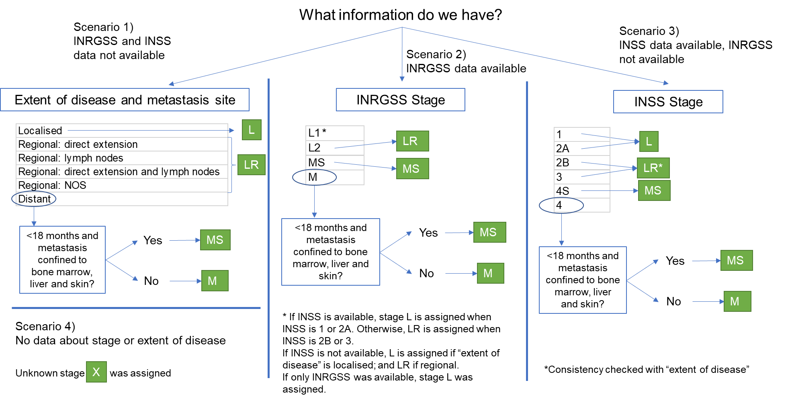

Note: In cases of inconsistency between information sources, INRGSS stage was prioritized, followed hierarchically by INSS stage and, lastly, extent of disease.

Stage L: localised; stage LR: locoregional; stage MS: metastatic special; stage M: metastatic; X: stage unknown.

Figure S2. Results of record linkage results between the Spanish Registry of Childhood Tumours (RETI-SEHOP) and the Spanish Neuroblastoma Clinical Database. Neuroblastoma cases, 0-14 years, 2000-2021.

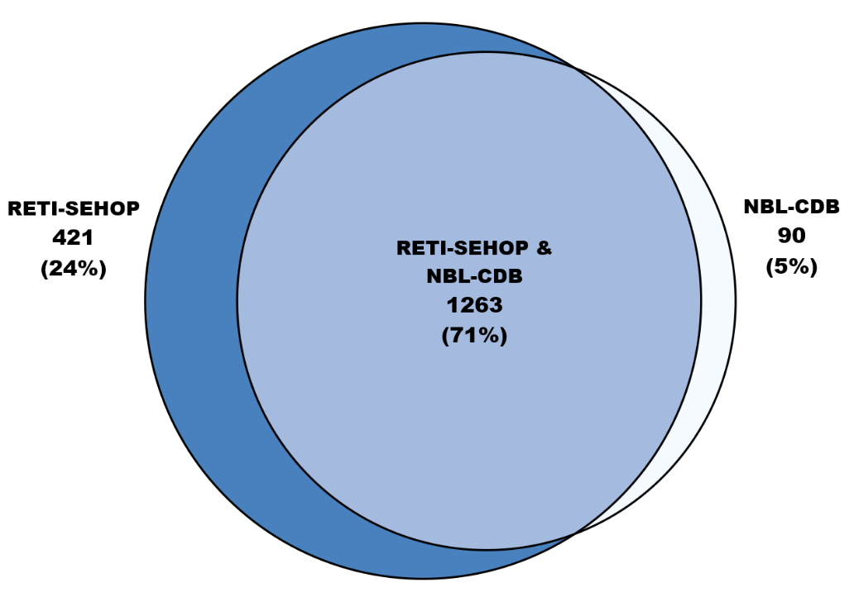

Figure S3. Number of registered and expected incident cases, 0-14 years, 2000-2021, Spain.
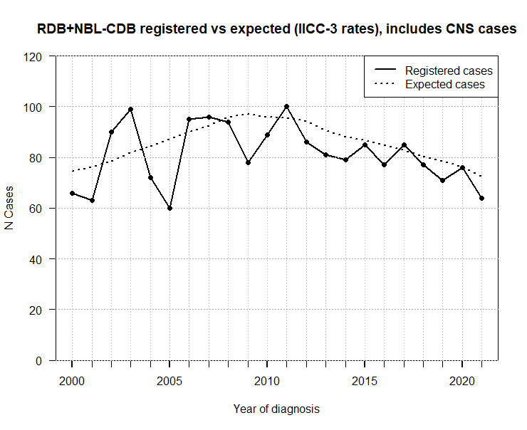

Expected cases are calculated from the reference age-specific incidence rates for neuroblastoma in Spain [1] and the annual paediatric populations by age group. CNS neuroblastoma cases were included to enhance comparability between sources. Solid line: registered cases. Dotted line: expected cases.

Figure S4. Neuroblastoma cases by age at diagnosis in Spain, 0-14 years, 2000-2021.
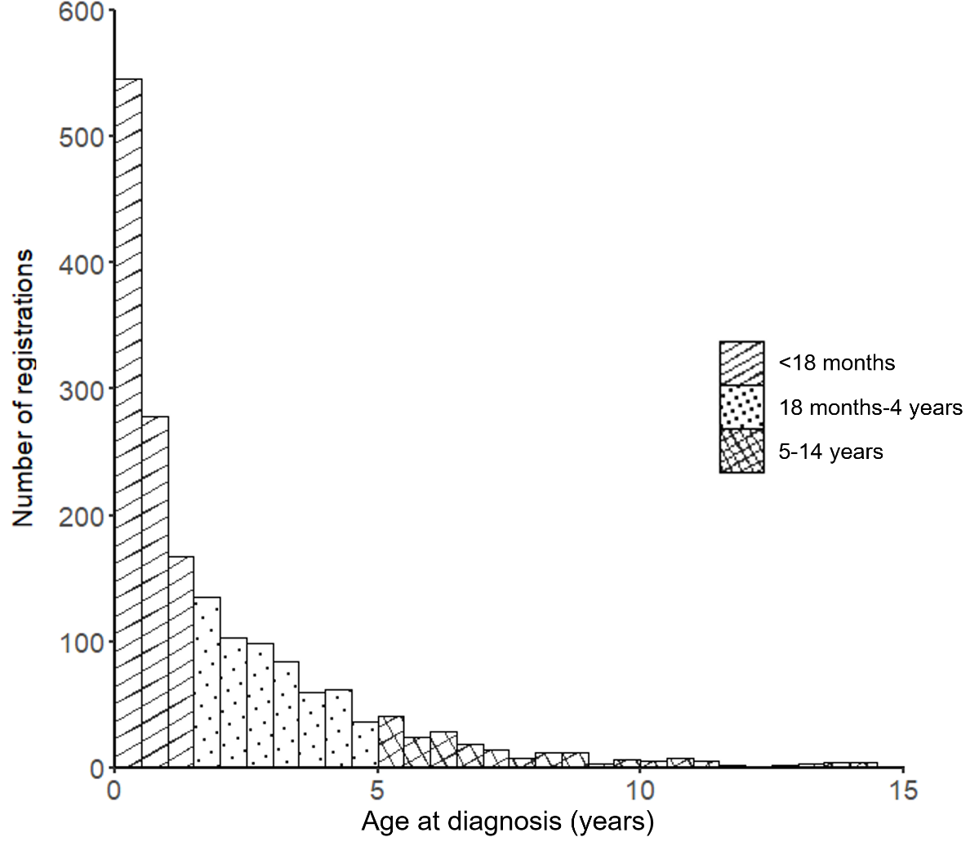

Figure S5. Summary of pairwise association analyses between available demographic and clinical variables.
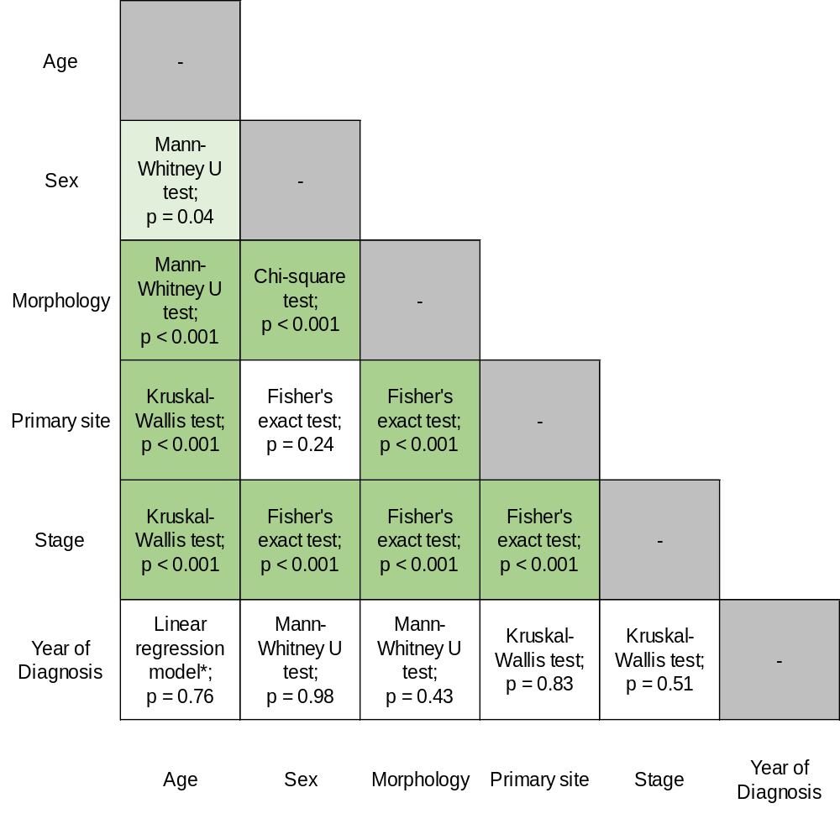

Note: All tests were two-sided.
* Age was introduced as the response variable.

Figure S6. Neuroblastoma cases by age at diagnosis, sex and tumour morphology, 0-14 years, 2000-2021, Spain.
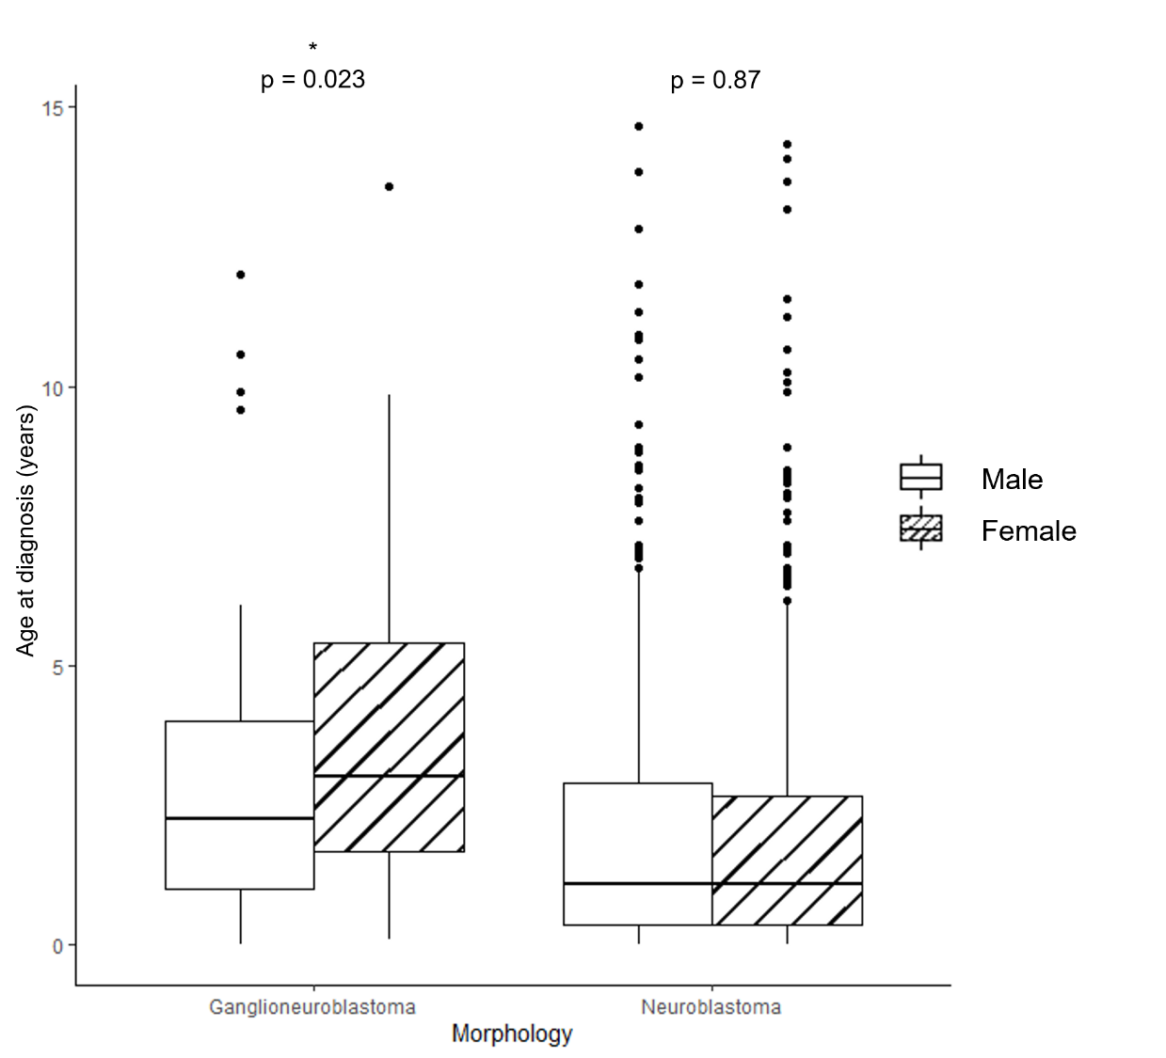

Note: p-values from two-sided Mann-Whitney U tests are displayed.

Figure S7. Kaplan-Meier 5-year survival estimates of neuroblastoma in Spain by sex and cohort of diagnosis, 0-14 years, 2000-2017.

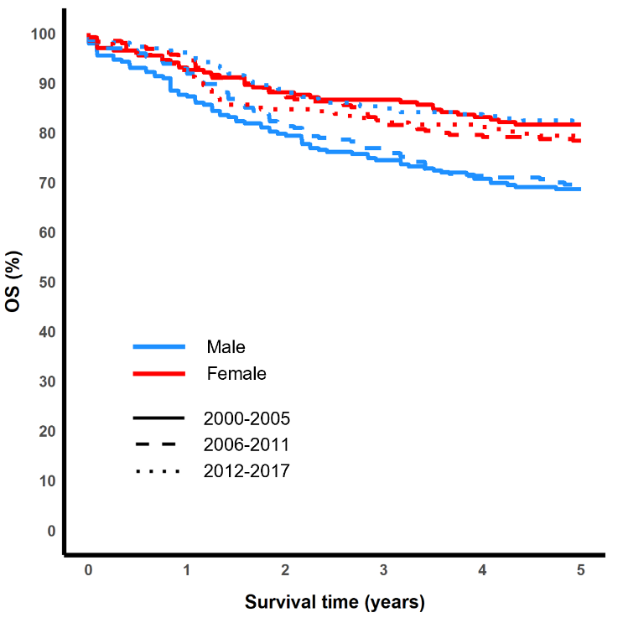

OS (%): Overall survival rate.

Figure S8. Kaplan-Meier 5-year survival estimates by sex and cohort of diagnosis for stage LR (locoregional) cases, 0-14 years, 2000-2017, Spain.
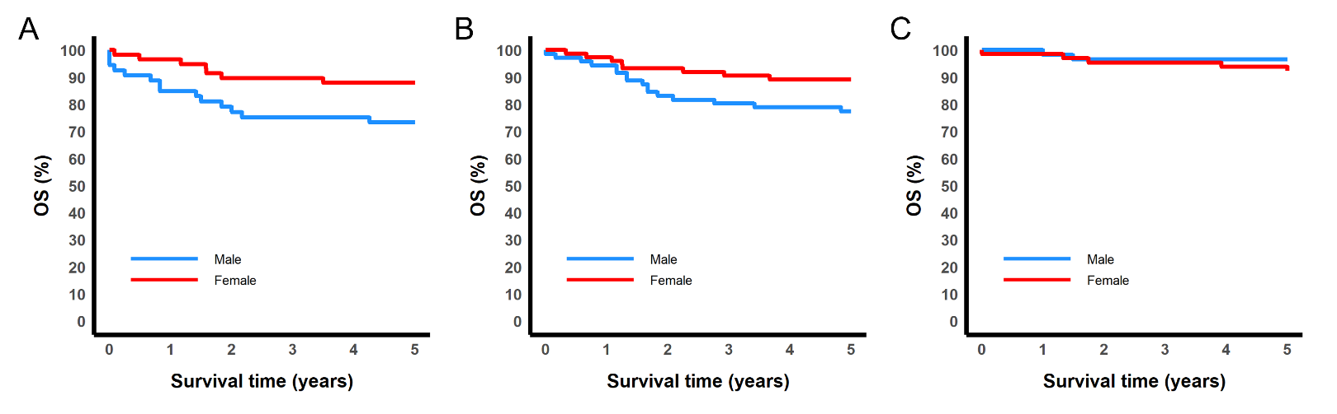

OS (%): Overall survival rate. A: 2000-2005. B: 2006-2011. C: 2012-2017.

Table S1. Grouping of ICD-O-3.1 topography codes into clinical categories of tumour sites for neuroblastoma.

Primary site groups | ICD-O-3.1 topography codes
Adrenal | C74.1
Abdominal (non-adrenal) | C47.4, C48.0
Cervical | C47.0
Pelvic | C47.5
Thoracic | C38.1-38.3, C47.3
Multiple compartments | C47.8
Other and unspecified | Topographies not included above and excluding C71.0-72.9 (CNS)

Table S2. Completeness of neuroblastoma registration within the study, 0-14 years, 2000-2021, Spain. CNS neuroblastoma included.
 | Period of diagnosis
 | 2000-2010 | 2011-2021 | 2000-2021
Observed | 902 | 881 | 1,783
Expected | 954.4 | 930.3 | 1,884.7
% Completeness (95% CI) | 94.5 (88,101) | 94.7 (89,101) | 94.6 (90,99)

Table S3. Association of tumour morphology with sex, age group, primary tumour site, stage at diagnosis and cohort of diagnosis, 0-14 years, 2000-2021, Spain.

 | Tumour morphology |  |  | Total
 | Neuroblastoma | Ganglioneuroblastoma |  | Total
 | No. (%) | No. (%) | OR (95% CI) | No. (%)
Sex***
Male | 897 (92.1) | 75 (7.9) | 1.00 (Reference) | 954 (100.0)
Female | 701 (85.5) | 119 (14.5) | 1.99 (1.5,2.7) | 820 (100.0)
Age group***
<18 months | 939 (95.5) | 44 (4.5) | 1.00 (Reference) | 983 (100.0)
18 months-4 years | 494 (84.2) | 93 (15.8) | 4.02 (2.8,5.9) | 587 (100.0)
5-14 years | 147 (72.1) | 57 (27.9) | 8.28 (5.4,12.8) | 204 (100.0)
Primary tumour site***
Adrenal | 864 (94.7) | 48 (5.3) | 1.00 (Reference) | 912 (100.0)
Abdominal (non-adrenal) | 355 (86.4) | 56 (13.6) | 2.84 (1.9,4.3) | 411 (100.0)
Cervical | 55 (79.7) | 14 (20.3) | 4.58 (2.3,8.6) | 69 (100.0)
Pelvic | 42 (77.8) | 12 (22.2) | 5.14 (2.5,10.2) | 54 (100.0)
Thoracic | 196 (79.4) | 51 (20.6) | 4.68 (3.1,7.2) | 247 (100.0)
Multiple compartments | 32 (91.4) | 3 (8.6) | 1.69 (0.4,4.9) | 35 (100.0)
Other and unspecified | 36 (78.3) | 10 (21.7) | 5.00 (2.2,10.4) | 46 (100.0)
Toronto stage Tier 1***
L | 459 (80.4) | 112 (19.6) | 1.00 (Reference) | 571 (100.0)
LR | 390 (86.3) | 62 (13.7) | 0.65 (0.5,0.9) | 452 (100.0)
MS | 171 (98.3) | 3 (1.7) | 0.07(0.0,0.2) | 174 (100.0)
M | 557 (97.4) | 15 (2.6) | 0.1 (0.1,0.2) | 572 (100.0)
X | 3 (60.0) | 2 (40.0) | - | 5 (100.0)
Cohort of diagnosis
2000-2010 | 796 (88.5) | 103 (11.5) | 1.00 (Reference) | 899 (100.0)
2011-2021 | 784 (89.6) | 91 (10.4) | 0.90 (0.7,1.2) | 875 (100.0)
Total | 1,580 (89.1) | 194 (10.9) |  | 1,774 (100.0)

The number of asterisks (*) indicate if the association with tumour morphology is statistically significant for one of the following significance levels: * p < 0.05, ** p < 0.01, *** p < 0.001.
Stage L: localised; stage LR: locoregional; stage MS: metastatic special; stage M: metastatic; X: stage unknown. CI: Confidence interval. OR: Odds ratios represent the odds of being diagnosed with ganglioneuroblastoma (9490/3) among individuals in each category compared to those in the reference ("ref") category. Values are derived from logistic regression models with tumour morphology as the response (ganglioneuroblastoma (9490/3) = 1, neuroblastoma (9500/3) = 0). Models are univariable and include only the feature listed in the corresponding block of rows.

Table S4. Association of stage at diagnosis with sex, age group, primary tumour site and cohort of diagnosis, 0-14 years, 2000-2021, Spain.
 | Toronto stage Tier 1 |  |  |  |  |  |  |  | Total
 | L |  | LR |  | MS |  | M |  | Total
 | No. (%) | OR (95% CI) | No. (%) | OR (95% CI) | No. (%) | OR (95% CI) | No. (%) | OR (95% CI) | No. (%)
Sex***
Male | 317 (33.3) | 1.00 (Reference) | 217 (22.8) | 1.00 (Reference) | 79 (8.3) | 1.00 (Reference) | 338 (35.5) | 1.00 (Reference) | 951 (100.0)
Female | 254 (31.1) | 0.90 (0.7,1.1) | 235 (28.7) | 1.36 (1.1,1.7) | 95 (11.6) | 1.45 (1.1,2.0) | 234 (28.6) | 0.73 (0.6,0.9) | 818 (100.0)
Age group***
<18 months | 409 (41.7) | 1.00 (Reference) | 259 (26.4) | 1.00 (Reference) | 174 (17.7) | - | 139 (14.2) | 1.00 (Reference) | 981 (100.0)
18 months-4 years | 109 (18.6) | 0.32 (0.2,0.4) | 150 (25.6) | 0.96 (0.8,1.2) | - | - | 327 (55.8) | 7.65 (6.0,9.8) | 586 (100.0)
5-14 years | 53 (26.2) | 0.50 (0.4,0.7) | 43 (21.3) | 0.75 (0.5,1.1) | - | - | 106 (52.5) | 6.69 (4.8,9.3) | 202 (100.0)
Primary tumour site***
Adrenal | 299 (32.9) | 1.00 (Reference) | 126 (13.8) | 1.00 (Reference) | 122 (13.4) | 1.00 (Reference) | 363 (39.9) | 1.00 (Reference) | 910 (100.0)
Abdominal (non-adrenal) | 90 (22.0) | 0.57 (0.4,0.8) | 152 (37.1) | 3.67 (2.8,4.8) | 33 (8.0) | 0.57 (0.4,0.8) | 135 (32.9) | 0.74 (0.6,0.9) | 410 (100.0)
Cervical | 29 (42.0) | 1.48 (0.9,2.4) | 32 (46.4) | 5.38 (3.2,9.0) | 1 (1.4) | 0.09 (0.0,0.4) | 7 (10.1) | 0.17 (0.1,0.4) | 69 (100.0)
Pelvic | 18 (33.7) | 1.02 (0.6,1.8) | 24 (44.4) | 4.98 (2.8,8.8) | 2 (3.7) | 0.25 (0.0,0.8) | 10 (18.5) | 0.34 (0.2,0.7) | 54 (100.0)
Thoracic | 115 (46.7) | 1.79 (1.3,2.4) | 83 (33.7) | 3.17 (2.3,4.4) | 10 (4.1) | 0.27 (0.1,0.5) | 38 (15.4) | 0.28 (0.2,0.4) | 246 (100.0)
Multiple compartments | 4 (11.4) | 0.26 (0.1,0.7) | 18 (51.4) | 6.59 (3.3,13.2) | 4 (11.4) | 0.83 (0.2,2.2) | 9 (25.7) | 0.52 (0.2,1.1) | 35 (100.0)
Other and unspecified | 16 (35.6) | 1.12 (0.6,2.1) | 17 (37.8) | 3.8 (2.0,7.0) | 2 (4.4) | 0.30 (0.0,1.0)ª | 10 (22.2) | 0.43 (0.2,0.8) | 45 (100.0)
Cohort of diagnosis
2000-2010 | 291 (32.5) | 1.00 (Reference) | 229 (25.6) | 1.00 (Reference) | 82 (9.2) | 1.00 (Reference) | 294 (32.8) | 1.00 (Reference) | 896 (100.0)
2011-2021 | 280 (32.1) | 0.98 (0.8,1.2) | 223 (25.5) | 1.00 (0.8,1.2) | 92 (10.5) | 1.17 (0.9,1.6) | 278 (31.8) | 0.96 (0.8,1.2) | 873 (100.0)
Total | 571 (32.3) |  | 452 (25.6) |  | 174 (9.8) |  | 572 (32.3) |  | 1,769 (100.0)

The number of asterisks (*) indicate if the association with stage is statistically significant for one of the following significance levels: * p < 0.05, ** p < 0.01, *** p < 0.001. ª: 95% confidence interval doesn’t include 1.
Stage L: localised; stage LR: locoregional; stage MS: metastatic special; stage M: metastatic; X: stage unknown. CI: Confidence interval. OR: Odds ratios represent the odds of being diagnosed with the specified stage among individuals in each category compared to those in the reference ("ref") category. Values are derived from logistic regression models in which stage is decomposed into binary (“dummy”) variables (specified stage = 1, all other stages = 0). Models are univariable and include only the feature listed in the corresponding block of rows.

Table S5. Association of age groups with sex, primary tumour site and cohort of diagnosis, 0-14 years, 2000-2021, Spain.
 | Age group |  |  |  |  |  | Total
 | <18 months |  | 18 months-4 years |  | 5-14 years |  | Total
 | No. (%) | OR (95% CI) | No. (%) | OR (95% CI) | No. (%) | OR (95% CI) | No. (%)
Sex*
Male | 544 (57.0) | 1.00 (Reference) | 315 (33.0) | 1.00 (Reference) | 95 (10.0) | 1.00 (Reference) | 954 (100.0)
Female | 439 (53.5) | 0.87 (0.7,1.0)^{b} | 272 (33.2) | 1.01 (0.8,1.2) | 109 (13.3) | 1.38 (1.0,1.9)ª | 820 (100.0)
Primary tumour site***
Adrenal | 522 (57.2) | 1.00 (Reference) | 291 (31.9) | 1.00 (Reference) | 99 (10.9) | 1.00 (Reference) | 912 (100.0)
Abdominal (non-adrenal) | 205 (49.9) | 0.74 (0.6,0.9) | 159 (38.7) | 1.35 (1.1,1.7) | 47 (11.4) | 1.06 (0.7,1.5) | 411 (100.0)
Cervical | 45 (65.2) | 1.40 (0.8,2.4) | 19 (27.5) | 0.81 (0.5,1.4) | 5 (7.2) | 0.64 (0.2,1.5) | 69 (100.0)
Pelvic | 33 (61.1) | 1.17 (0.7,2.1) | 17 (31.5) | 0.98 (0.5,1.7) | 4 (7.4) | 0.66 (0.2,1.7) | 54 (100.0)
Thoracic | 135 (54.7) | 0.90 (0.7,1.2) | 77 (31.2) | 0.97 (0.7,1.3) | 35 (14.2) | 1.36 (0.9,2.0) | 247 (100.0)
Multiple compartments | 22 (62.9) | 1.26 (0.6,2.6) | 10 (28.6) | 0.85 (0.4,1.7) | 3 (8.6) | 0.77 (0.2,2.2) | 35 (100.0)
Other | 21 (45.7) | 0.63 (0.3,1.1) | 14 (30.4) | 0.93 (0.5,1.7) | 11 (23.9) | 2.58 (1.2,5.1) | 46 (100.0)
Cohort of diagnosis
2000-2010 | 495 (55.1) | 1.00 (Reference) | 296 (32.9) | 1.00 (Reference) | 108 (12.0) | 1.00 (Reference) | 899 (100.0)
2011-2021 | 488 (55.8) | 1.03 (0.9,1.2) | 291 (33.3) | 1.02 (0.8,1.2) | 96 (11.0) | 0.90 (0.7,1.2) | 875 (100.0)

The number of asterisks (*) indicate if the association with age is statistically significant for one of the following significance levels: * p < 0.05, ** p < 0.01, *** p < 0.001. ª: 95% confidence interval doesn’t include 1. ^{b}: 95% confidence interval includes 1.
CI: Confidence interval. OR: Odds ratios represent the odds of belonging to the specified age group among individuals in each category compared to those in the reference ("ref") category. Values are derived from logistic regression models in which age is decomposed into binary (“dummy”) variables (specified age group = 1, all other age groups = 0). Models are univariable and include only the feature listed in the corresponding block of rows.

Table S6. Association of sex with primary tumour site and cohort of diagnosis, 0-14 years, 2000-2021, Spain.

 | Sex |  |  | Total
 | Male | Female |  | Total
 | No. (%) | No. (%) | OR (95%CI) | No. (%)
Primary tumour site
Adrenal | 517 (56.7) | 395 (43.3) | 1.00 (Reference) | 912 (100.0)
Abdominal (non-adrenal) | 212 (51.6) | 199 (48.4) | 1.23 (1.0,1.6)^{b} | 411 (100.0)
Cervical | 36 (52.2) | 33 (47.8) | 1.20 (0.7,2.0) | 69 (100.0)
Pelvic | 29 (53.7) | 25 (46.3) | 1.13 (0.6,2.0) | 54 (100.0)
Thoracic | 118 (47.8) | 129 (52.2) | 1.43 (1.1,1.9) | 247 (100.0)
Multiple compartments | 17 (48.6) | 18 (51.4) | 1.39 (0.7,2.7) | 35 (100.0)
Other and unspecified | 25 (54.3) | 21 (45.7) | 1.10 (0.6,2.0) | 46 (100.0)
Cohort of diagnosis
2000-2010 | 483 (53.7) | 416 (46.3) | 1.00 (Reference) | 899 (100.0)
2011-2021 | 471 (53.8) | 404 (46.2) | 0.99 (0.8,1.2) | 875 (100.0)
Total | 954 (53.8) | 820 (46.2) |  | 1,774 (100.0)

The number of asterisks (*) indicate if the association with sex is statistically significant for one of the following significance levels: * p < 0.05, ** p < 0.01, *** p < 0.001. ^{b}: 95% confidence interval includes 1.
CI: Confidence interval. OR: Odds ratios represent the odds of being female among individuals in each category compared to those in the reference ("ref") category. Values are derived from univariable logistic regression models in which sex is the response variable (coded as: female = 1, male = 0). Models are univariable and include only the feature listed in the corresponding block of rows.
Table S7. 5-year overall survival trends for neuroblastoma in Spain by age group, sex, morphology, primary site and stage at diagnosis, 0-.14 years, 2000-2017.

 | Cohort of diagnosis
 | 2000-2005 |  |  | 2006-2011 |  |  | 2012-2017
 | No. (%) | 5-y OS  (%, 95% CI) | No. (%) |  | 5-y OS  (%, 95% CI) | No. (%) |  | 5-y OS  (%, 95% CI)
Age group
<18 months | 251 (56.0) | 89.2 (85.3,92.0) | 287 (52.1) |  | 89.9 (86.4,93.4) | 284 (58.1) |  | 90.0 (86.4,93.5)
18 months-4 years | 151 (33.7) | 59.7 (51.9,67.6) | 192 (34.8) |  | 56.3 (49.2,63.3) | 153 (31.3) |  | 68.0 (60.6,75.4)
5-14 years * | 46 (10.3) | 43.5 (29.2,57.8) | 72 (13.1) |  | 55.9 (44.2,67.5) | 52 (10.6) |  | 67.3 (54.6,80.1)
Sex
Male ** | 245 (54.7) | 68.6 (62.8,74.5) | 294 (53.4) |  | 69.6 (64.3,74.9) | 260 (53.2) |  | 82.1 (77.4,86.8)
Female | 203 (45.3) | 81.6 (76.3,87.0) | 257 (46.6) |  | 78.3 (73.3,83.4) | 229 (46.8) |  | 78.9 (73.5,84.2)
Tumour morphology
Ganglioneuroblastoma | 54 (12.1) | 84.9 (75.2,94.5) | 62 (11.3) |  | 93.5 (87.3,99.7) | 41 (8.4) |  | 95.1 (88.5,100)
Neuroblastoma * | 394 (87.9) | 73.1 (68.7,77.5) | 489 (88.7) |  | 71.1 (67.1,75.2) | 448 (91.6) |  | 79.2 (75.4,83.0)
Primary site
Abdominal (non-adrenal) | 106 (23.7) | 73.3 (64.8,81.8) | 140 (25.4) |  | 67.1 (59.3,74.9) | 101 (20.7) |  | 83.2 (75.9,90.5)
Adrenal | 225 (50.2) | 68.5 (62.4,74.7) | 276 (50.1) |  | 72.8 (67.5,78.1) | 261 (53.4) |  | 75.1 (69.8,80.4)
Thoracic | 66 (14.7) | 90.9 (84.0,97.8) | 77 (14.0) |  | 83.1 (74.8,91.5) | 67 (13.7) |  | 88.0 (80.1,95.8)
Cervical | 19 (4.2) | 89.5 (75.7,100) | 15 (2.7) |  | 80.0 (59.8,100) | 20 (4.1) |  | 95.0 (85.5,100)
Pelvic | 16 (3.6) | 86.7 (69.5,100) | 10 (1.8) |  | - | 18 (3.7) |  | 94.4 (83.9,100)
Multiple compartments | 8 (1.8) | - | 13 (2.4) |  | - | 8 (1.6) |  | -
Other and unspecified | 8 (1.8) | - | 20 (3.6) |  | 84.2 (67.8,100) | 14 (2.9) |  | -
Toronto stage Tier 1
L | 154 (34.4) | 98.0 (95.8,100) | 162 (29.4) |  | 98.1 (96.1,100) | 162 (33.1) |  | 96.8 (94.0,99.6)
LR ** | 113 (25.2) | 81.0 (73.7,88.3) | 145 (26.3) |  | 83.5 (77.4,89.5) | 125 (25.6) |  | 94.4 (90.4,98.4)
MS | 42 (9.4) | 83.3 (72.1,94.6) | 49 (8.9) |  | 79.3 (67.8,90.7) | 43 (8.8) |  | 83.5 (72.4,94.7)
M | 138 (30.8) | 40.4 (32.2,48.6) | 193 (35.0) |  | 44.3 (37.3,51.4) | 157 (32.1) |  | 52.2 (44.4,60.0)
X | 1 (0.2) | - | 2 (0.4) |  | - | 2 (0.4) |  | -

The number of asterisks (*) indicate if the differences between survival curves are statistically significant (log-rank test) for one of the following significance levels: * p < 0.05, ** p < 0.01, *** p < 0.001.
Stage L: localised; stage LR: locoregional; stage MS: metastatic special; stage M: metastatic; X: stage unknown. CI: Confidence interval. OS: Overall survival.

Table S8. Neuroblastoma cases by primary site in Spain and other countries or international databases. 0-14 years populations if not stated otherwise.

 | No. | Adrenal | Abdominal  (non-adrenal) | Pelvic | Cervical | Thoracic | Multiple  compartments | Other
Spain, 2000-2021 | 1,774 | 51.4 | 23.2 | 3.0 | 3.9 | 13.9 | 2.0 | 2.6
SEER data, 2000-2021 [39] | 5,937 | 52.6 | 19.4 | 2.6 | 2.9 | 15.4 | 0.5 | 6.7
INRG database, 1990-2002 [38]* | 8,369 | 47.4 | 23.8 | 3.0 | 2.7 | 15.1 | 1.9 | 6.1
Germany, 1979-2015 [28] | 4,459 | 49.9 | 28.9 |  | 3.8 | 16.0 | 1.4
Southern & Eastern Europe, 1990-2016 [36] | 4,901 | 68.9 |  | 3.0 | 3.8 | 16.1 | 8.2

*Age 0-21 years.

