Supplementary Table 1. Bivariate of response and clinical factors.

 | ICR (N=226) | CR (N=92) | Total (N=318) | p value
Cohort |  |  |  | 0.45 (1)
MSK, Timing | 210 (92.9%) | 88 (95.7%) | 314 (93.7%)
UM | 16 (7.1%) | 4 (4.3%) | 20 (6.3%)
Sex |  |  |  | 0.53 (1)
Female | 90 (40.5%) | 41 (45.1%) | 131(41.9%)
Male | 132 (59.5%) | 50 (54.9%) | 182 (58.1%)
Age |  |  |  | 0.08 (2)
Mean (SD) | 53.9 (13.1) | 56.7 (12.7) | 54.7 (13.0)
Tumor size (cm) |  |  |  | 0.09 (3)
Median (Q1, Q3) | 4.6 (3.8, 6.0) | 4.2 (3.3, 5.3) | 4.5 (3.6, 5.8)
Distance from av (cm) |  |  |  | 0.91 (2)
Mean (SD) | 6.6 (3.1) | 6.7 (3.1) | 6.6 (3.1)
Rectal location |  |  |  | 0.57 (1)
Lower | 47 (22.4%) | 20 (23.5%) | 67 (22.7%)
Middle | 95 (45.2%) | 33 (38.8%) | 134 (43.4%)
Upper | 68 (32.4%) | 32 (37.6%) | 100 (33.9%)
AJCC classification |  |  |  | 0.12 (1)
2 | 38 (16.8%) | 23 (25.0%) | 61 (19.2%)
3 | 188 (83.2%) | 69 (75.0%) | 257 (80.8%)
T stage |  |  |  | 0.25 (1)
2 | 5 (2.9%) | 6 (9.2%) | 11 (4.7%)
3 | 144 (84.2%) | 51 (78.5%) | 195 (82.6%)
4 | 22 (12.9%) | 8 (12.3%) | 30 (12.7%)
Ln positive |  |  |  | 0.18 (1)
No | 25 (14.1%) | 14 (21.2%) | 39 (16.0%)
Yes | 152 (85.9%) | 52 (78.8%) | 204 (84.%)
Race |  |  |  | 0.23 (1)
Asian | 15 (7.1%) | 7 (8.0%) | 22 (7.4%)
Black | 8 (3.8%) | 4 (4.5%) | 12 (4.0%)
Others | 37 (17.6%) | 24 (27.3%) | 61 (20.5%)
White | 150 (71.4%) | 53 (60.2%) | 203 (68.1%)
p values calculated by 1. Fisher’s exact test, 2. Student’s t-test, 3. Wilcoxon rank sum test

Supplementary Table 2. Significantly mutated genes (SMGs) detected by MutSig2CV in CR and ICR groups. Ranked by q-value
SMGs | q-value | Group
APC | 3.77E-13 | ICR
TP53 | 3.77E-13 | ICR
KRAS | 3.77E-13 | ICR
FBXW7 | 3.77E-13 | ICR
NRAS | 3.77E-13 | ICR
TP53 | 4.72E-13 | CR
APC | 4.72E-13 | CR
KRAS | 4.72E-13 | CR
FBXW7 | 4.72E-13 | CR
TCF7L2 | 5.24E-12 | ICR
SMAD4 | 6.58E-12 | ICR
SOX9 | 8.90E-12 | ICR
ARID1A | 3.72E-11 | ICR
BRAF | 1.85E-09 | ICR
PTEN | 3.46E-08 | ICR
SOX9 | 4.28E-08 | CR
FAM123B | 6.93E-07 | ICR
RNF43 | 1.89E-06 | ICR
B2M | 5.53E-06 | ICR
TCF7L2 | 6.45E-06 | CR
NRAS | 4.16E-05 | CR
EPHA3 | 7.09E-05 | ICR
SOX17 | 7.09E-05 | ICR
ATM | 1.95E-04 | ICR
TRAF7 | 2.19E-04 | ICR
RAF1 | 3.21E-04 | ICR
EPHA3 | 8.29E-04 | CR
SMAD3 | 1.09E-03 | ICR
IKZF1 | 1.34E-03 | ICR
DNMT3B | 2.67E-03 | ICR
NCOR1 | 2.96E-03 | ICR
ELF3 | 4.76E-03 | ICR
PIK3CA | 8.64E-03 | ICR
KDM6A | 1.57E-02 | ICR
ARID2 | 1.72E-02 | ICR
AXIN2 | 1.79E-02 | ICR
HGF | 1.96E-02 | ICR
ERBB3 | 2.08E-02 | ICR
NTRK1 | 2.10E-02 | ICR
MAPK1 | 2.16E-02 | ICR
ARID1A | 2.21E-02 | CR
CTCF | 2.47E-02 | ICR
ASXL2 | 2.96E-02 | ICR
PIK3CA | 3.09E-02 | CR
INPP4B | 4.44E-02 | ICR

q-value is FDR-corrected (Benjamini-Hochberg) overall p-value

Supplementary Table 3. Significant mutated genes associated with response.
 | ICR (N=226) | CR (N=92) | Total (N=318) | p value
AMER1 |  |  |  | 0.294 (1)
mutation not present | 211 (93.4%) | 89 (96.7%) | 300 (94.3%)
mutation present | 15 (6.6%) | 3 (3.3%) | 18 (5.7%)
ATM |  |  |  | 0.206 (1)
mutation not present | 209 (92.5%) | 89 (96.7%) | 298 (93.7%)
mutation present | 17 (7.5%) | 3 (3.3%) | 20 (6.3%)
CTCF |  |  |  | 0.187 (1)
mutation not present | 220 (97.3%) | 92 (100.0%) | 312 (98.1%)
mutation present | 6 (2.7%) | 0 (0.0%) | 6 (1.9%)
NCOR1 |  |  |  | 0.199 (1)
mutation not present | 219 (96.9%) | 92 (100.0%) | 311 (97.8%)
mutation present | 7 (3.1%) | 0 (0.0%) | 7 (2.2%)
SMAD4 |  |  |  | 0.120 (1)
mutation not present | 203 (89.8%) | 88 (95.7%) | 291 (91.5%)
mutation present | 23 (10.2%) | 4 (4.3%) | 27 (8.5%)
SOX17 |  |  |  | 0.291 (1)
mutation not present | 217 (96.0%) | 91 (98.9%) | 308 (96.9%)
mutation present | 9 (4.0%) | 1 (1.1%) | 10 (3.1%)
ARID1B |  |  |  | 0.210 (1)
mutation not present | 219 (96.9%) | 86 (93.5%) | 305 (95.9%)
mutation present | 7 (3.1%) | 6 (6.5%) | 13 (4.1%)
EPHA3 |  |  |  | 0.276 (1)
mutation not present | 216 (95.6%) | 85 (92.4%) | 301 (94.7%)
mutation present | 10 (4.4%) | 7 (7.6%) | 17 (5.3%)
TCF7L2 |  |  |  | 0.120 (1)
mutation not present | 211 (93.4%) | 81 (88.0%) | 292 (91.8%)
mutation present | 15 (6.6%) | 11 (12.0%) | 26 (8.2%)
p value was calculated using Fisher’s Exact Test

Supplementary Figure 1. Cohort overview and Comparison of clinical factors between complete responders and incomplete responders. A: Overview of the analysis and datasets. B: Statistical comparison of clinical variables (left) and clinical outcomes (right) between CR (n=92) and ICR tumors (n=226).The continuous factors: age, BMI, tumor size, distance from AV, overall survival (OS), disease-free survival (DFS) from neoadjuvant therapy (NEO), DFS from surgery, were compared using Mann Whitney U test. The discrete factors: sex, race, clinical T stage, N stage, M stage, AJCC classification, OS status, DFS from NEO status, and recurrence, were compared using Chi-squared test. Factors with p < 0.05 are highlighted in red, indicating a statistically significant difference between CR and ICR groups, while those with p > 0.05 are in gray, indicating no significant difference.

Supplementary Figure 2. Propensity Score Weighting (PSW) analysis for mutation burden and the mutation frequencies in CR and ICR tumors. A: The forest plot displays standardized mean differences of confounding factors between the groups before (Unadjusted) and after applying PSW. B: Box plot comparing mutation burden (weighted by propensity score) between CR and ICR (Weighted t-test, p=0.46, n=318, with CR:92, ICR:226). C: Bar plot showing all mutated genes have higher mutation frequencies in CR (n=92) than ICR tumors (n=226). D: Bar plot showing mutated genes which have higher mutation frequencies in ICR (n=226) than CR tumors (n=92).

Supplementary Figure 3. Differences in transcriptomic profile between CR and ICR to nCRT and Network analysis of predictive mutated genes for treatment response. Box plots comparing the infiltration levels of immune cells within tumor microenvironments between CR (n=26) and ICR (n=80) groups.
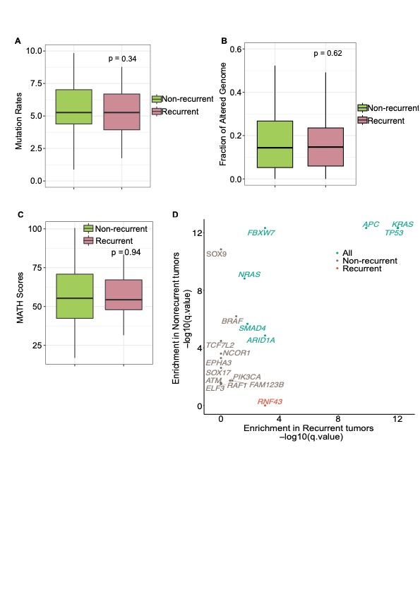

Supplementary Figure 4. Genomic differences and significant mutated genes associated with recurrence in incomplete responders to nCRT. A-C: Box plots showing the comparison of genomic metrics between recurrent (n=62) and nonrecurrent ICR tumors (n153), including mutation rate (A), fraction of altered genome (B), and MATH scores (C). No statistically significant differences were observed (Mann Whitney U test, p > 0.05). D: Dot plots showing Significantly Mutated Genes (SMGs) enriched in recurrent ICR tumors (red, n=62), non-recurrent ICR tumors (wheat, n=153), and both groups (light green), q-value < 0.05 after correction for multiple hypothesis testing.
Supplementary Figure 5. Additional gene expression profiles in ICR tumor subsets. A: Distribution of patient samples across four identified subgroups. B-D, F: Pathway enrichment analysis for DEGs between specific subgroups (cluster1: C, cluster2: D, cluster3: E, and cluster4: F) and all other subgroups. E: Fraction of recurrent cases in each ICR patient subgroup. G-J: Kaplan-Meier Curve showing the survival difference between tumors with high (> median) and low (< median) expression of DUOXA2 (G, n=107, High:48, Low:59), DUOX2 (H, n=107, High:50, Low:57), SSH1 (I, n=107, High:48, Low:59), and FRMD6 (J, n=107, High:61, Low:46) genes (The Log-rank test, p < 0.05). K-P: Box plots illustrating the distribution of immune cells (neutrophils (K), monocytes (L), macrophages (M), naïve T CD4 T cell (N), dendritic cells (O), and regulatory T cells (P)) across the four ICR patient subgroups (ANOVA, p < 0.05, n=76, Cluster 1:36, Cluster 2:25, Cluster 3:5, Cluster 4:10). Q: Heatmap of the top 50 DEGs between tumors in Cluster 4 (n=10) and other clusters (n=66). R: Heatmap of the top 50 DEGs between tumors in Cluster 4-like (n=10) and other clusters (n=31) from the TCGA READ dataset. S: Composition of consensus molecular subtypes (CMS) in Cluster4-like and other clusters.

