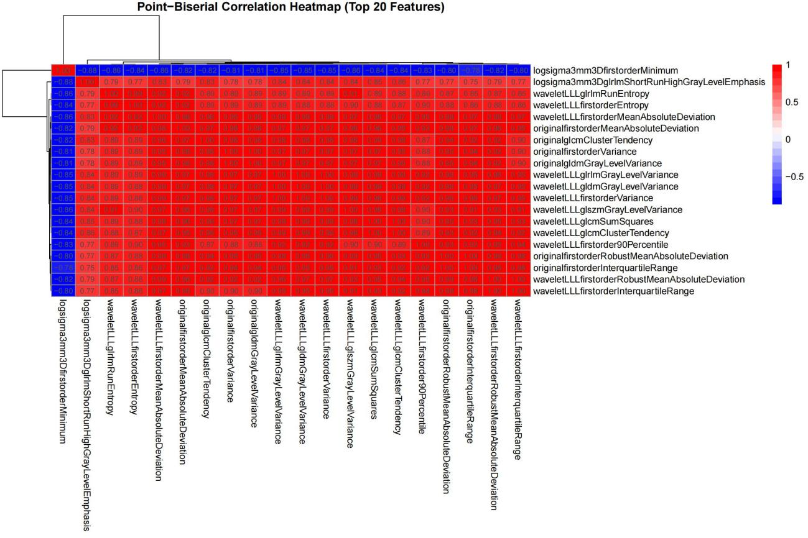
Figure S1. Heatmap of the top 20 most strongly correlated variables in primary cohort

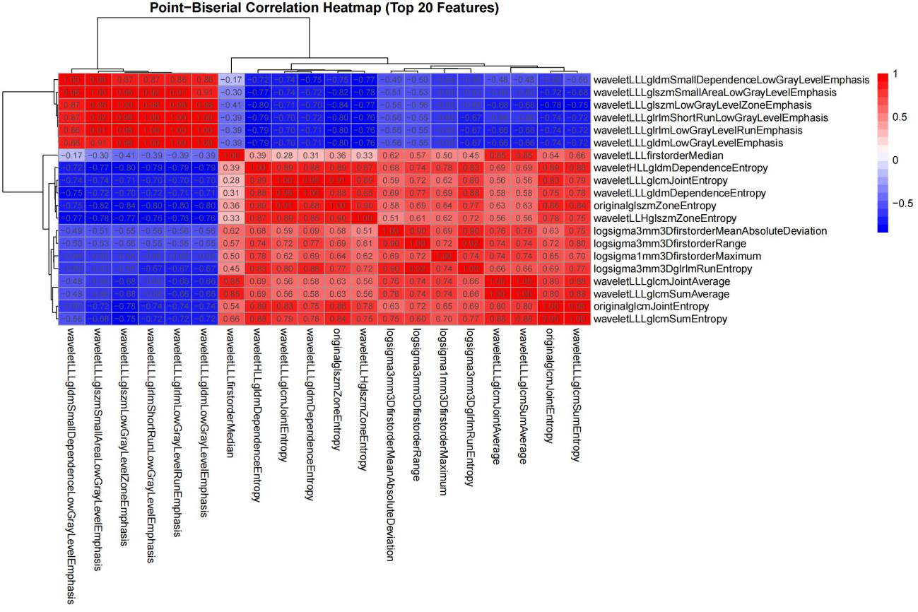
Figure S2. Heatmap of the top 20 most strongly correlated variables in validation cohort

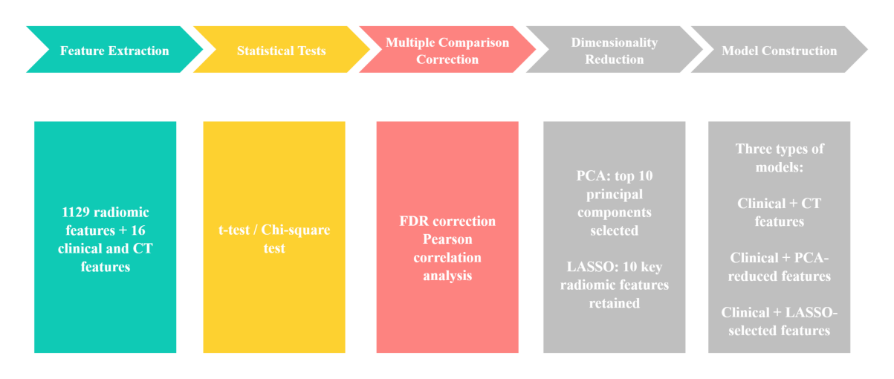
Figure S3. Feature selection flowchart

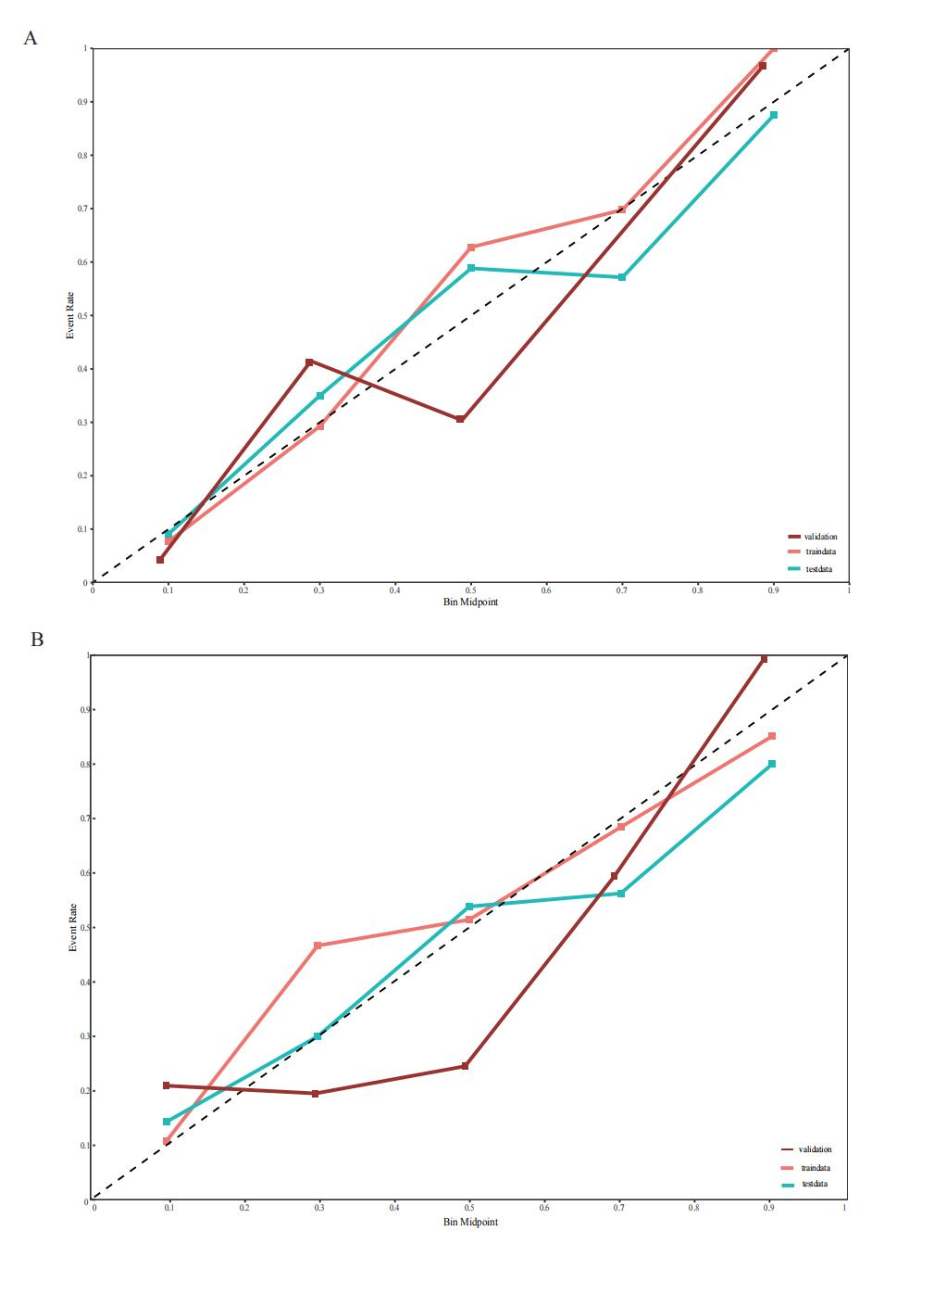
Figure S4. Calibration curve of the RF model
A:Clinical CT Features-LASSO Radiomics Model,B:Clinical CT Features-PCA Radiomics Model,Light red (training cohort), blue (test cohort), dark red (external validation cohort)

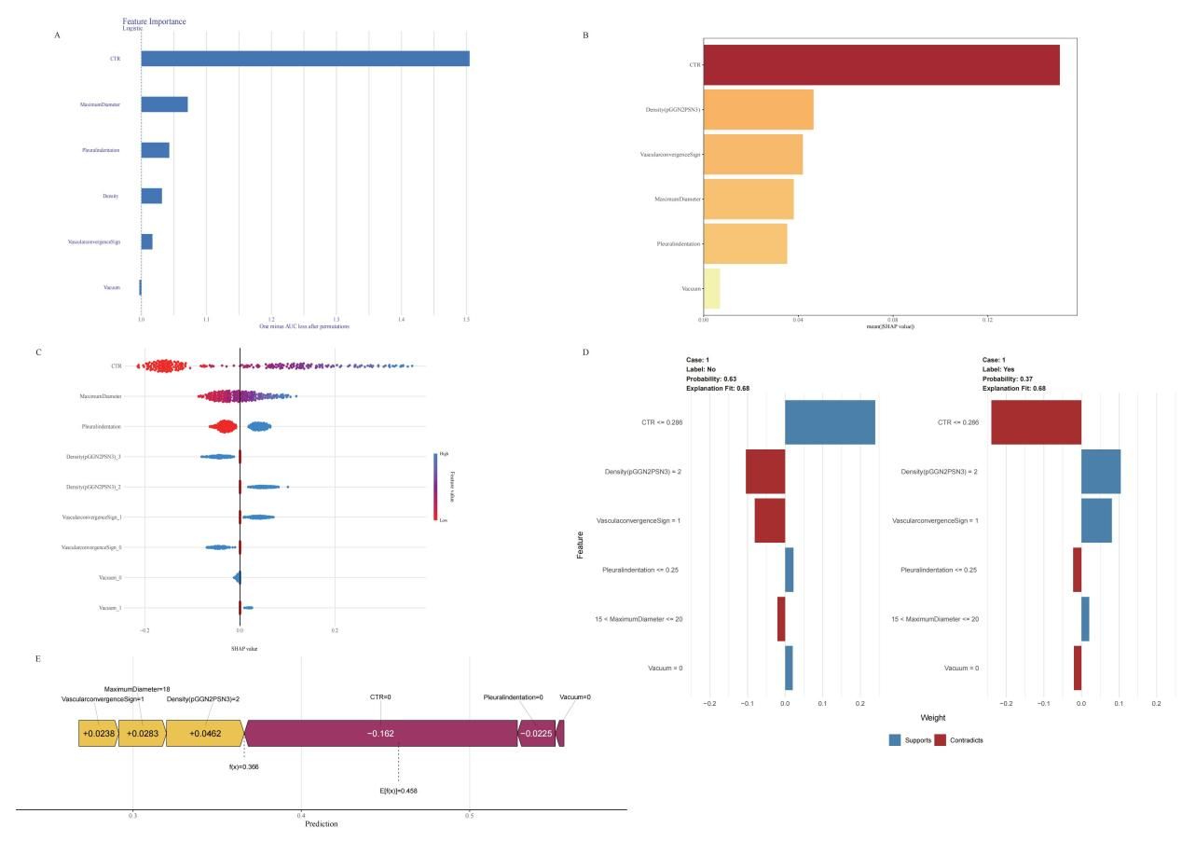

Figure S5 SHapley Additive exPlanations of Clinical CT Features
Panel （LR）A: SHAP Feature Importance Plot.Panel B: SHAP Summary Plot.Panel C: SHAP Value Distribution Plot.Panel D: SHAP Decision Explanation Plot.Panel E: Local Interpretable Model-agnostic Explanations (LIME).0: Absence of Feature, 1: Presence of Feature.

