Supplementary Fig. S1. The PFS curves of SII-low group and SII-high group
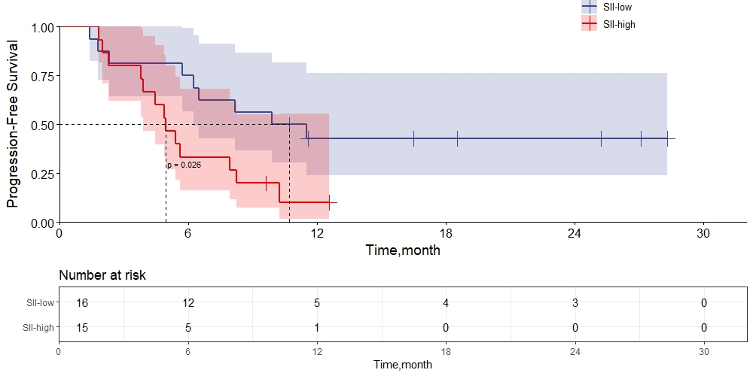
PFS, progression free survival; SII, systemic inflammation index

Supplementary Fig. S2. The OS curves of SII-low group and SII-high group
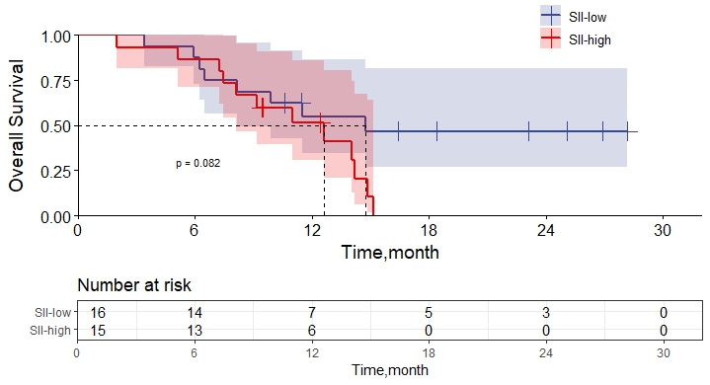
OS, overall survival; SII, systemic inflammation index

