The multi-stage optimisation protocol for Fit4Transplant: Utilising sequential single-arm bayesian optimal phase II adaptive trials and co-design to iteratively improve and evaluate an exercise prehabilitation service for haematological cancer patients .

Supplementary File 2 – Co-design intervention packages

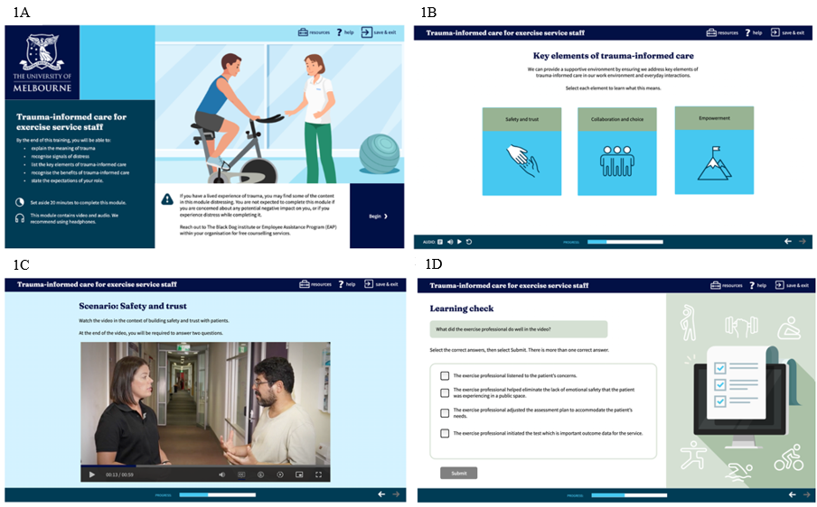
Figure S2.1. Top left: Introduction page, describing content, and a warning for those with a lived trauma experience; Top right: Core facets of trauma-informed care, each box directs to further educational content; Bottom left: Filmed scenario showcasing how to ensure safety and trust when conducting exercise assessments with patients; Bottom right: Quiz questions following a video scenario.
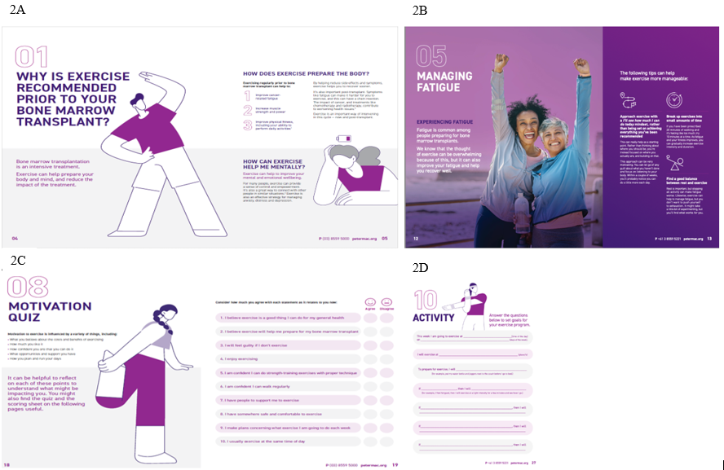
Figure S2.2 Top left: Benefits of exercise to physical and mental health; Top Right: Strategies to overcome fatigue, one of the most reported barriers to exercise engagment; Bottom left: Quiz evaluating key determinants of exercise engagement, incuding motivation type, self-efficacy, social support, planning, and routine. Subsequent pages provide advice based on quiz responses; Bottom right: This page allows participants to create their own exercise plan to promote engagement in physical activity.


Figure S2.3. Final wireframe developed and approved through an iterative co-design process.

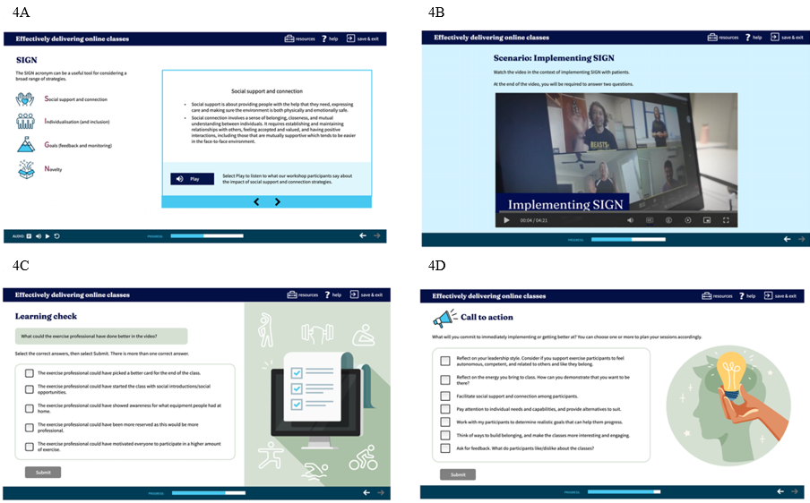
Figure S4. 4A: Core strategies recommended by consumers for improving online exercise classes; 4B: Filmed scenario showcasing how to implement suggested strategies; 4C: Quiz questions following the video scenario depicted in 4B; 4D: Call to action at the end of the training module.

