Supplementary

Details of Deep Learning Training Process
Data Augmentation: To improve model robustness and generalization, we applied real-time augmentation techniques such as random cropping, and horizontal and vertical flipping to the training images. These transformations increased the variance within our dataset while preserving the structural integrity of the images. Z-score normalization was employed to standardize the intensity distribution across RGB channels, preparing the images for model input. For the validation and test sets, preprocessing was restricted to normalization to ensure a consistent evaluation framework.
Data Normalization: We standardized the grayscale values of image slices using min-max normalization, scaling pixel values to the range of [-1, 1], which facilitated uniform data handling and enhanced the learning efficiency. Each cropped subregion image was resized to a consistent 224 × 224 pixels using nearest neighbor interpolation, aligning with the input requirements of our neural networks.
Training Parameters: We adopted a transfer learning approach, initializing our models with parameters pre-trained on the ImageNet Large Scale Visual Recognition Challenge 2012 (ILSVRC-2012). To optimize training dynamics and avert premature convergence, we employed a cosine decay (early stop=8) strategy for the learning rate adjustment, expressed mathematically as:
$$η_{t}=η_{min}^{i}+\frac{1}{2}\left(η_{max}^{i}−η_{min}^{i}\right)\left(1+cos\left(\frac{T_{cur}}{T_{i}}π\right)\right)$$
where $η_{min}^{i}$ is set to 0, $η_{max}^{i}$ is set to 0.01, and $T_{i}$ represents the total number of training epochs, set at 96.
- Optimizer: Stochastic Gradient Descent (SGD) was chosen for its effectiveness in managing noisy gradients, which enhances stability and maintains compatibility across various network architectures.
- Loss Function: We used softmax cross-entropy as the loss metric to support multi-class classification by providing a probabilistic interpretation of model outputs.
- Batch Size and Epochs: Training was conducted with a batch size of 32 over 48 epochs to balance computational efficiency with learning performance, enhancing the model's ability to generalize to new, unseen data.

Imaging Protocols for Different Datasets
1. Training Cohort (Dade Road Headquarters) - Italy IMS Giotto System
Mammography Imaging Protocol (IMS Giotto)
Equipment & Environment
- Model: IMS Giotto Class (Italy)
- Detector: Amorphous selenium direct digital flat panel, 70 µm pixel size, 3328 × 4096 matrix
- Target-filter: Tungsten (W)/Rhodium (Rh); optional Mo/Mo or Mo/Rh for specific cases
- Tube voltage: 28 kVp (AEC automatic, manual range 26–32 kVp)
- AEC mode: Semi-automatic; Mean Glandular Dose (MGD) 1.0–1.3 mGy at 53 mm standard breast thickness (below NHSBSP limit of 2.5 mGy)
Projection Views
- Standard views: Bilateral Craniocaudal (CC) + Bilateral Mediolateral Oblique (MLO)
- Supplementary views: Magnification, Exaggerated Mediolateral Oblique (XCCL), or Cleopatra view (tangential) as needed
Compression & Dose
- Force: 120–180 N (auto-pressure control, maximized to patient tolerance)
- Thickness: Recorded actual value (mm)
- Dose output: MGD automatically calculated and stored in DICOM header
Post-processing & Storage
- Software: Raffaello (built-in IMS)
- Algorithm: Spectral Contrast Enhancement (SCE) + noise reduction
- Storage: Lossless JPEG-LS compression, 16-bit grayscale
- Quality control: Daily ACR phantom test; weekly repeatability, linearity, and Contrast-to-Noise Ratio (CNR) checks
2. Ersha Branch - Hologic Selenia Dimensions System
Equipment & System
- Model: Hologic Selenia Dimensions
- Detector: Amorphous selenium (a-Se) direct digital flat panel, 70 µm pixel size, 2560 × 3328 or 3328 × 4096 matrix
- Target-filter: Tungsten (W) + 50 µm Rh (2D standard); W + 50 µm Ag + 700 µm Al (3D Tomosynthesis)
- Focus-detector distance: 700 mm; Focus-table distance: 675 mm
Projection Views
- Standard views: Bilateral CC + Bilateral MLO
- Compression paddle: Standard flat or optional curved paddle
Exposure Parameters (AEC Automatic)
- kVp: 28 kVp (AEC automatic; manual range 26–32 kVp)
- Pre-exposure mAs: 5 mAs for ≤50 mm thickness; 10 mAs for >50 mm thickness
- Compression force: 120–180 N (SmartCurve auto-compression, patient-tolerance maximized)
- Thickness: Real-time recording (mm)
Dose & Image Quality
- Mean Glandular Dose (MGD): ≤0.78 mGy for 60 mm equivalent breast (3Dimensions)
- HVL & Output: Validated per NHSBSP/EUREF QC protocols every 3 kV interval
Post-processing & Display
- Software: C-View (synthetic 2D) or Standard 2D
- Processing: Contrast enhancement (SCE), noise reduction, gradient equalization
- Viewing: SecurView® DX workstation, 5 MP grayscale dual monitors, one-click hanging protocol
3. External Validation (Guangzhou First People’s Hospital) - Finland Planmed Oy System
Equipment & Detector
- Model: Planmed Nuance™ Excel (Finland)
- Detector: 24 × 31 cm amorphous selenium (a-Se) direct digital flat panel, 70 µm pixel size, 3328 × 4096 matrix
- Gantry: Side-Access design, auto-rotation ±180°, focus-detector distance 66 cm
Target-filter & Exposure Parameters
- Target: Tungsten (W)
- Filter: Rhodium (Rh) default; switchable to W/Ag for dense breasts
- Tube voltage: 28 kVp (Flex-AEC automatic); manual range 26–32 kVp
- AEC: Flex-AEC auto-selects mAs based on thickness/density; manual 20–120 mAs adjustable
- Focus: Dual 0.1/0.3 mm; small focus (0.1 mm) for magnification
- Compression: 120–180 N; auto-stop at force-image quality balance (smart mode)
Projection Views
- Standard views: Bilateral CC + MLO
- Supplementary views:
  - Magnification (×1.5 or ×1.8, 0.1 mm small focus)
  - Exaggerated Mediolateral (XCML), Exaggerated Mediolateral Oblique (XCCL)
  - ATAN tangential view (skin calcification localization)
Post-processing & Storage
- Software: Planmed ClearView™ with SCE and noise reduction
- Default window: Width 1.8, Level 1.2 (adjustable at workstation)
- Archive: 16-bit lossless + 12-bit compressed DICOM, IHE-Mammo compliant
Dose & QC
- Mean Glandular Dose (MGD): ≤1.2 mGy for 4 cm PMMA phantom; complies with EUREF/NHSBSP limits
- QC procedures: Daily ACR phantom; weekly repeatability, linearity, CNR checks; semi-annual HVL testing

Rad Signature
Handcrafted Features Statistics: In this study, with each modal a comprehensive set of 1834 handcrafted radiomic features was extracted, classified into three primary categories: shape, first-order, and texture. This encompassed 360 first-order features, 14 shape features, and a diverse array of texture features. The extraction of these features was conducted using an in-house program developed with Pyradiomics, which is documented at http://pyradiomics.readthedocs.io.
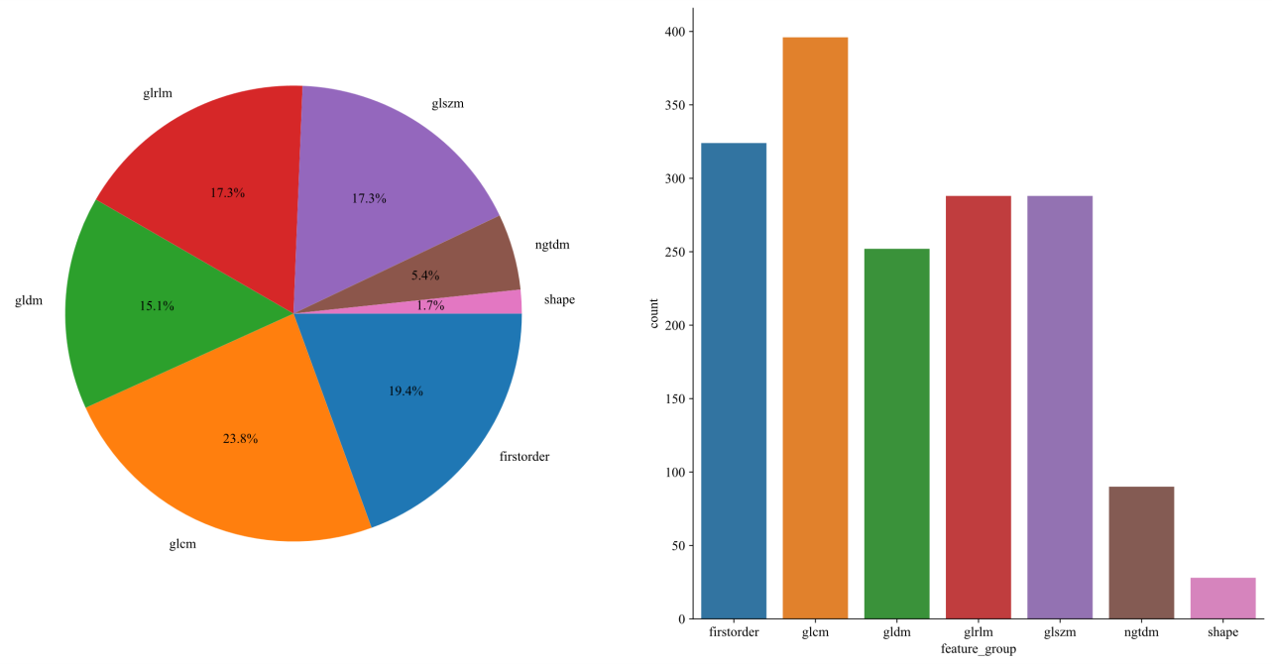
Fig. 1Number and ratio of handcrafted features
Lasso-based Radiomics Feature Selection: We implemented LassoCV. This approach, coupled with 10-fold cross-validation, was used for the selection of radiomics features. The details of this process are visually represented in Figures2 and table1.
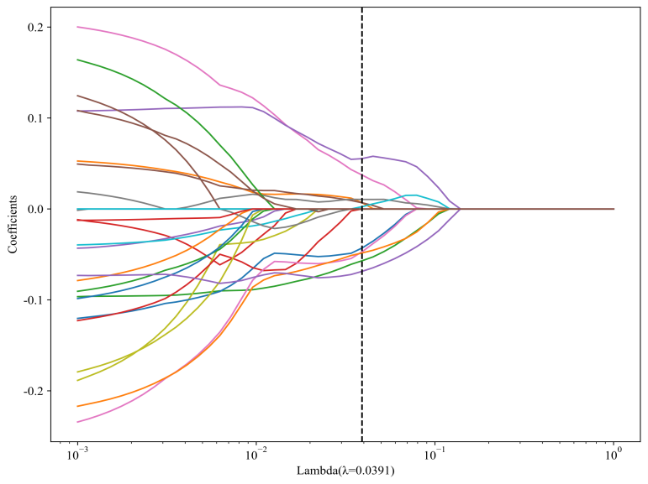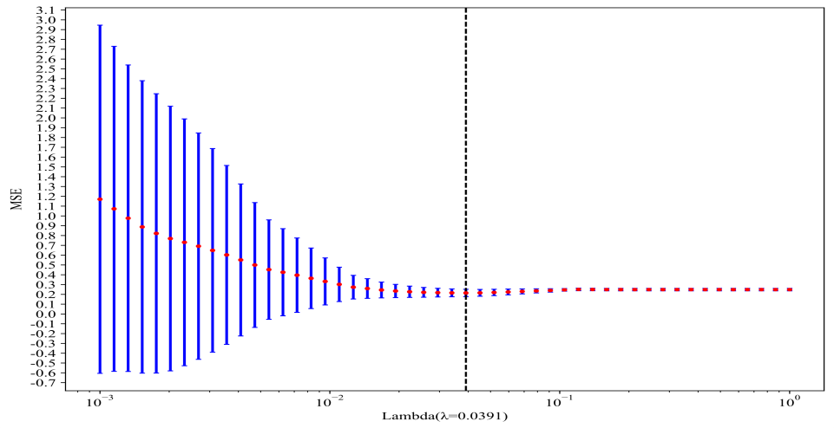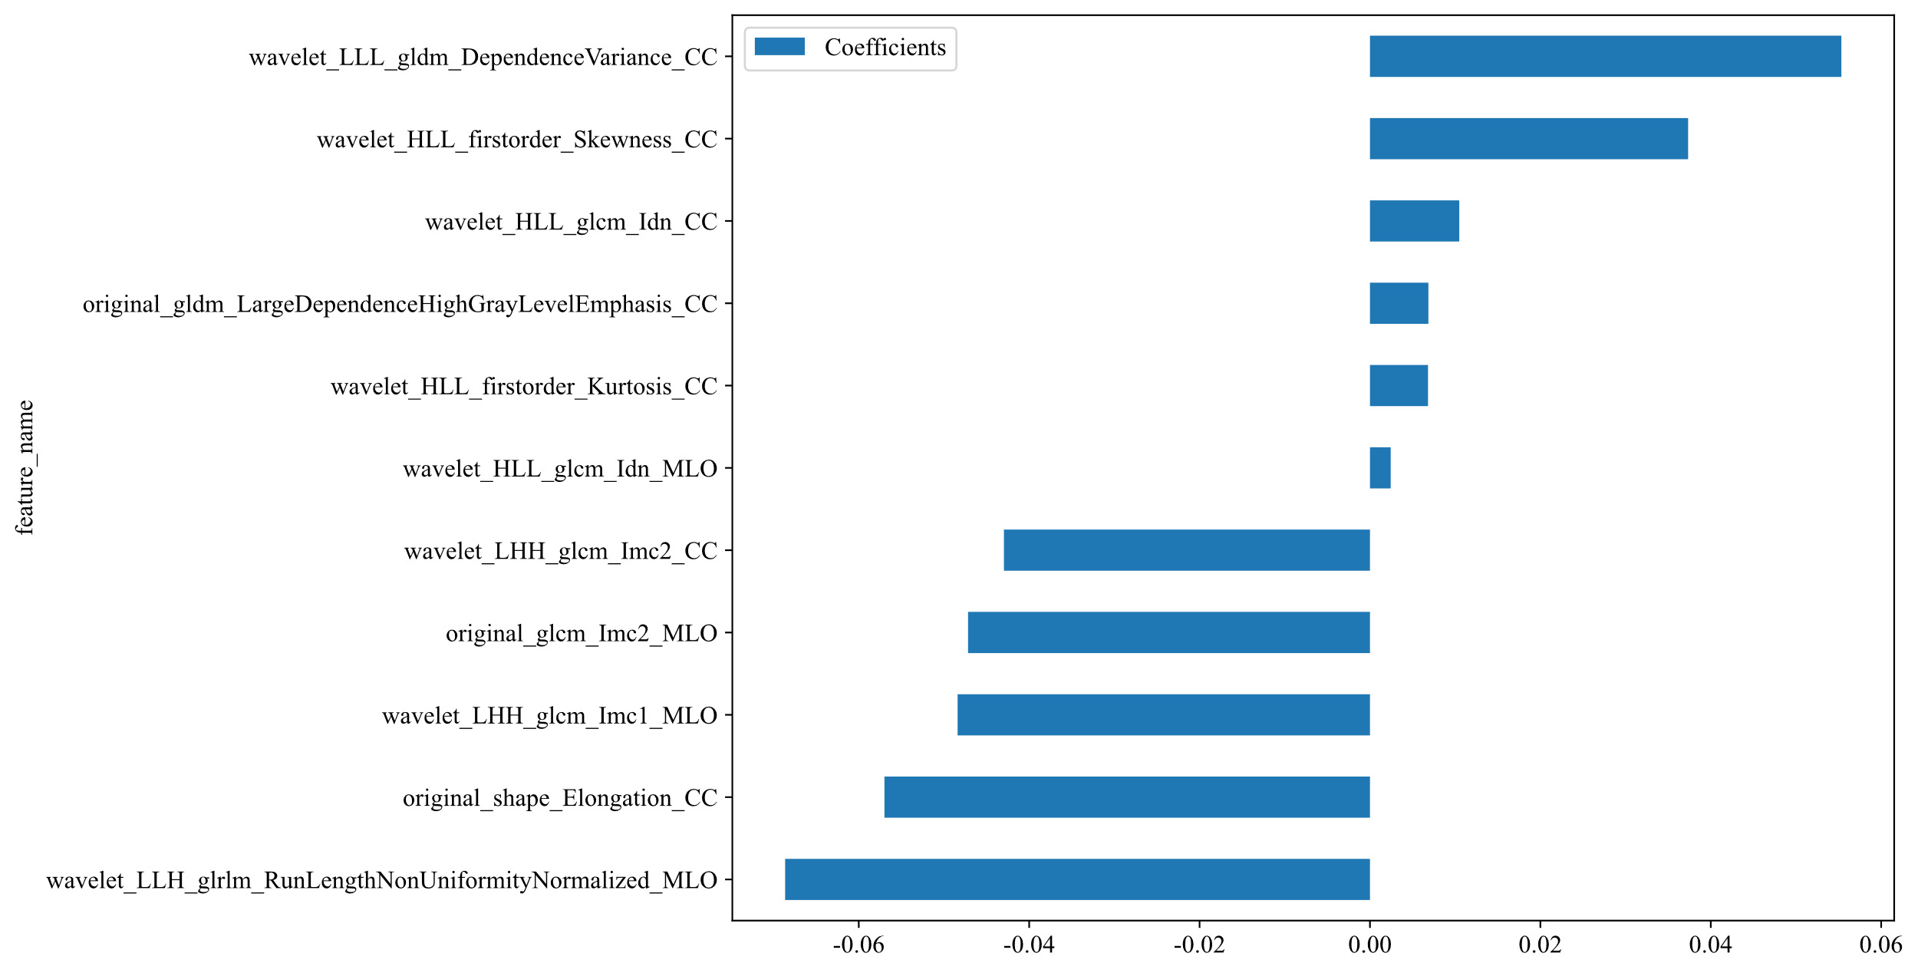
Figure 2 displays the coefficients derived from the Least Absolute Shrinkage and Selection Operator (LASSO) during 10-fold cross-validation, as applied in both Radiomics Signature and INTRA Signature analyses. The left and right sections of these sub-figures correspond to the Lasso path, Mean Squared Error (MSE), and weights of the selected radiomic features.
model_name | Accuracy | AUC | 95% CI | Sensitivity | Specificity | PPV | NPV | Cohort
LR | 0.696 | 0.789 | 0.699 - 0.880 | 0.622 | 0.754 | 0.667 | 0.717 | train
LR | 0.651 | 0.731 | 0.578 - 0.884 | 0.600 | 0.722 | 0.750 | 0.565 | val
LR | 0.604 | 0.682 | 0.529 - 0.836 | 0.211 | 0.862 | 0.500 | 0.625 | test1
LR | 0.649 | 0.634 | 0.448 - 0.820 | 0.437 | 0.810 | 0.636 | 0.654 | test2
SVM | 0.451 | 0.770 | 0.680 - 0.861 | 1.000 | 0.018 | 0.446 | 1.000 | train
SVM | 0.581 | 0.696 | 0.536 - 0.855 | 1.000 | 0.000 | 0.581 | 0.000 | val
SVM | 0.396 | 0.595 | 0.420 - 0.770 | 0.947 | 0.034 | 0.391 | 0.500 | test1
SVM | 0.432 | 0.625 | 0.438 - 0.812 | 1.000 | 0.000 | 0.432 | 0.000 | test2
ExtraTrees | 0.696 | 0.795 | 0.710 - 0.879 | 0.600 | 0.772 | 0.675 | 0.710 | train
ExtraTrees | 0.698 | 0.700 | 0.538 - 0.862 | 0.560 | 0.889 | 0.875 | 0.593 | val
ExtraTrees | 0.583 | 0.639 | 0.496 - 0.782 | 0.211 | 0.828 | 0.444 | 0.615 | test1
ExtraTrees | 0.595 | 0.631 | 0.445 - 0.817 | 0.625 | 0.571 | 0.526 | 0.667 | test2
Table1 Rad Signature results

Clinical Signature
We numerically mapped all clinical features and then modeled these features using machine learning algorithms similar to those employed in the Radiomics Signature.
model_name | Accuracy | AUC | 95% CI | Sensitivity | Specificity | PPV | NPV | Cohort
LR | 0.583 | 0.611 | 0.500 - 0.722 | 0.652 | 0.526 | 0.526 | 0.652 | train
LR | 0.605 | 0.596 | 0.417 - 0.774 | 0.600 | 0.611 | 0.682 | 0.524 | val
LR | 0.408 | 0.405 | 0.236 - 0.575 | 0.368 | 0.433 | 0.292 | 0.520 | test1
LR | 0.730 | 0.744 | 0.577 - 0.911 | 0.812 | 0.667 | 0.650 | 0.824 | test2
SVM | 0.757 | 0.813 | 0.726 - 0.899 | 0.739 | 0.772 | 0.723 | 0.786 | train
SVM | 0.581 | 0.627 | 0.456 - 0.798 | 0.440 | 0.778 | 0.733 | 0.500 | val
SVM | 0.531 | 0.607 | 0.446 - 0.768 | 0.368 | 0.633 | 0.389 | 0.613 | test1
SVM | 0.568 | 0.628 | 0.446 - 0.810 | 0.500 | 0.619 | 0.500 | 0.619 | test2
ExtraTrees | 0.680 | 0.743 | 0.647 - 0.838 | 0.739 | 0.632 | 0.618 | 0.750 | train
ExtraTrees | 0.628 | 0.611 | 0.432 - 0.791 | 0.640 | 0.611 | 0.696 | 0.550 | val
ExtraTrees | 0.592 | 0.541 | 0.368 - 0.714 | 0.579 | 0.600 | 0.478 | 0.692 | test1
ExtraTrees | 0.622 | 0.676 | 0.500 - 0.851 | 0.687 | 0.571 | 0.550 | 0.706 | test2
Table1. Metrics of clinical model

Peri3mm
Lasso-based Radiomics Feature Selection: We implemented LassoCV. This approach, coupled with 10-fold cross-validation, was used for the selection of radiomics features. The details of this process are visually represented in Figures2.
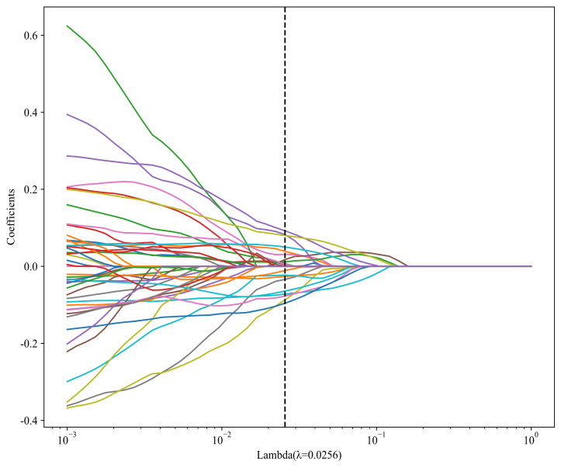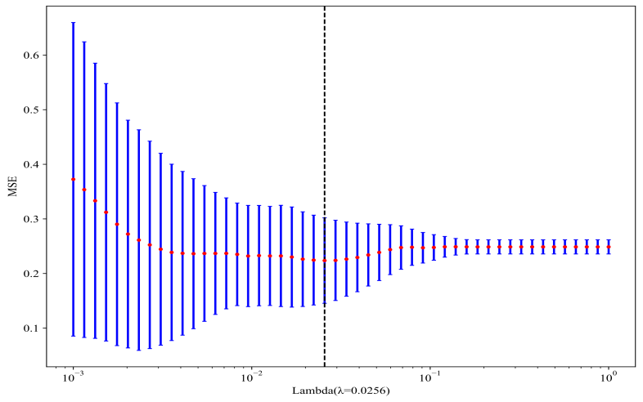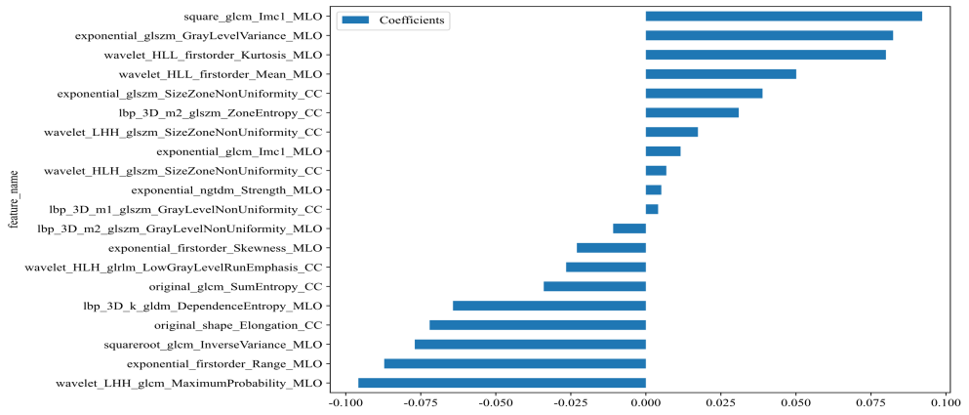
Figure 2 displays the coefficients derived from the Least Absolute Shrinkage and Selection Operator (LASSO) during 10-fold cross-validation, as applied in both Radiomics Signature and INTRA Signature analyses. The left and right sections of these sub-figures correspond to the Lasso path, Mean Squared Error (MSE), and weights of the selected radiomic features.
model_name | Accuracy | AUC | 95% CI | Sensitivity | Specificity | PPV | NPV | Cohort
LR | 0.745 | 0.799 | 0.711 - 0.887 | 0.689 | 0.789 | 0.721 | 0.763 | train
LR | 0.581 | 0.673 | 0.509 - 0.838 | 0.560 | 0.611 | 0.667 | 0.500 | val
LR | 0.667 | 0.722 | 0.570 - 0.875 | 0.684 | 0.655 | 0.565 | 0.760 | test1
LR | 0.595 | 0.702 | 0.525 - 0.880 | 0.875 | 0.381 | 0.519 | 0.800 | test2
SVM | 0.520 | 0.867 | 0.796 - 0.937 | 1.000 | 0.140 | 0.479 | 1.000 | train
SVM | 0.581 | 0.553 | 0.375 - 0.731 | 0.960 | 0.056 | 0.585 | 0.500 | val
SVM | 0.604 | 0.739 | 0.587 - 0.890 | 0.895 | 0.414 | 0.500 | 0.857 | test1
SVM | 0.432 | 0.562 | 0.369 - 0.756 | 1.000 | 0.000 | 0.432 | 0.000 | test2
ExtraTrees | 0.775 | 0.848 | 0.775 - 0.921 | 0.622 | 0.895 | 0.824 | 0.750 | train
ExtraTrees | 0.628 | 0.728 | 0.573 - 0.883 | 0.520 | 0.778 | 0.765 | 0.538 | val
ExtraTrees | 0.646 | 0.644 | 0.466 - 0.823 | 0.632 | 0.655 | 0.545 | 0.731 | test1
ExtraTrees | 0.595 | 0.674 | 0.485 - 0.863 | 0.750 | 0.476 | 0.522 | 0.714 | test2
Table1 Rad Signature results

Peri5mm
Lasso-based Radiomics Feature Selection: We implemented LassoCV. This approach, coupled with 10-fold cross-validation, was used for the selection of radiomics features. The details of this process are visually represented in Figures2.
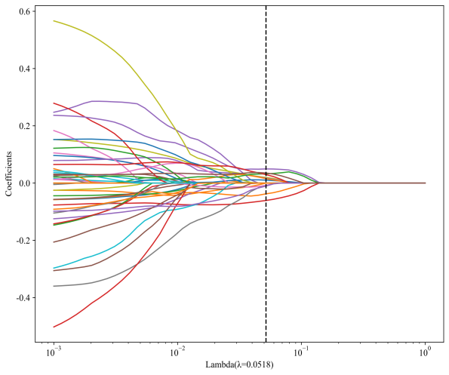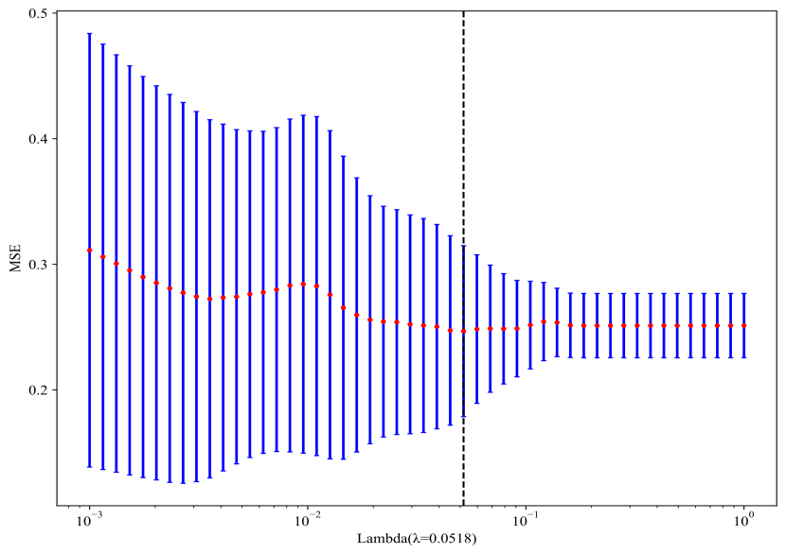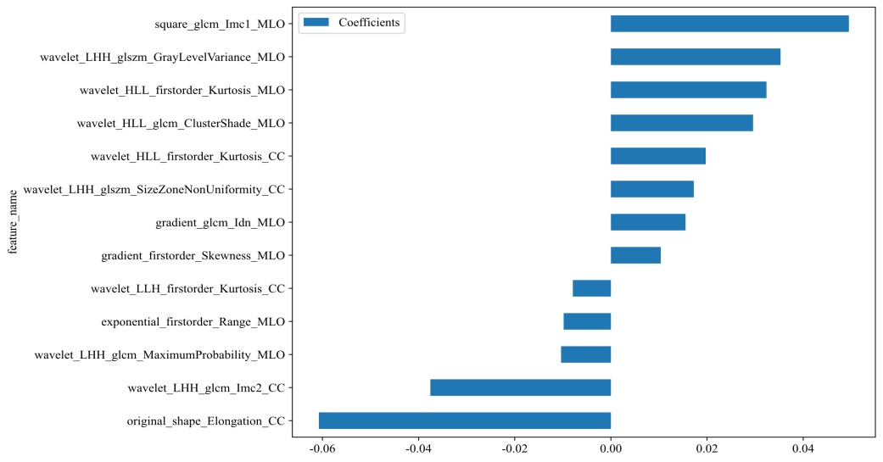
Figure 2 displays the coefficients derived from the Least Absolute Shrinkage and Selection Operator (LASSO) during 10-fold cross-validation, as applied in both Radiomics Signature and INTRA Signature analyses. The left and right sections of these sub-figures correspond to the Lasso path, Mean Squared Error (MSE), and weights of the selected radiomic features.

model_name | Accuracy | AUC | 95% CI | Sensitivity | Specificity | PPV | NPV | Cohort
LR | 0.745 | 0.815 | 0.732 - 0.899 | 0.733 | 0.754 | 0.702 | 0.782 | train
LR | 0.558 | 0.613 | 0.441 - 0.786 | 0.560 | 0.556 | 0.636 | 0.476 | val
LR | 0.604 | 0.708 | 0.547 - 0.868 | 0.842 | 0.448 | 0.500 | 0.812 | test1
LR | 0.568 | 0.589 | 0.399 - 0.779 | 0.562 | 0.571 | 0.500 | 0.632 | test2
SVM | 0.794 | 0.911 | 0.859 - 0.963 | 0.800 | 0.789 | 0.750 | 0.833 | train
SVM | 0.605 | 0.667 | 0.502 - 0.831 | 0.640 | 0.556 | 0.667 | 0.526 | val
SVM | 0.646 | 0.655 | 0.494 - 0.816 | 0.684 | 0.621 | 0.542 | 0.750 | test1
SVM | 0.514 | 0.585 | 0.389 - 0.781 | 0.562 | 0.476 | 0.450 | 0.588 | test2
ExtraTrees | 0.775 | 0.870 | 0.803 - 0.937 | 0.711 | 0.825 | 0.762 | 0.783 | train
ExtraTrees | 0.605 | 0.608 | 0.437 - 0.779 | 0.560 | 0.667 | 0.700 | 0.522 | val
ExtraTrees | 0.542 | 0.473 | 0.303 - 0.643 | 0.526 | 0.552 | 0.435 | 0.640 | test1
ExtraTrees | 0.622 | 0.583 | 0.390 - 0.776 | 0.437 | 0.762 | 0.583 | 0.640 | test2
Table1 Rad Signature results

Comparison of Different Models for DCIS
Tabel 1 Different Models for DCIS
 | Country | Design evaluation study | Sample size evaluation study | Main finding evaluation study | AUC | IPDAS score for CONTENT (% criteria met) | IPDAS score for DEVELOPMENT (% criteria met) | IPDAS score for EFFECTIVENESS (% criteria met)
Decision Aid Berger-Hoger et al^{[1]}. | Germany | RCT | 64 | More patient involvement | N.A. | 87% | 71% | 100%
Communication Aid De Morgan et al^{[2]}. | Australia | Interview | 25 | Communication tool assists SDM | N.A. | 57% | 59% | 50%
Online DeCISion.org Ozanne et al^{[3]}. | USA | N.A. | N.A. | N.A. | N.A. | 65% | 67% | 75%
DCISoptions.org COMET Trial Decision Aid^{[4]}. | USA | N.A. | N.A. | N.A. | N.A. | 78% | 42% | 75%
This study | China | Retrospective diagnostic model validation | 232 | A multimodal fusion model integrating deep learning, radiomics, and clinical features | Training set: 0.925, External test set 2: 0.801 | N.A. | N.A. | N.A.

Reference：
[1] Berger-Höger B., Liethmann K., Mühlhauser I., Haastert B., Steckelberg A. Nurse-led coaching of shared decision-making for women with ductal carcinoma in situ in breast care centers: A cluster randomized controlled trial. Int J. Nurs Stud. 2019;93:141–152. doi: 10.1016/j.ijnurstu.2019.01.013.
[2] De Morgan S.E., Butow P.N., Lobb E.A., Price M.A., Nehill C. Development and pilot testing of a communication aid to assist clinicians to communicate with women diagnosed with ductal carcinoma in situ (DCIS) Support. Care Cancer. 2011;19:717–723. doi: 10.1007/s00520-010-1040-5.
[3] Ozanne E.M., Soeteman D.I., Frank E.S., Clarke J., Hassett M.J., Stout N.K., Punglia R.S. Commentary: Creating a patient-centered decision aid for ductal carcinoma in situ. Breast J. 2020;26:1498–1499. doi: 10.1111/tbj.13779.
[4] Dcisoptions.Org. [(accessed on 26 June 2020)]. Available online: https://dcisoptions.org/

