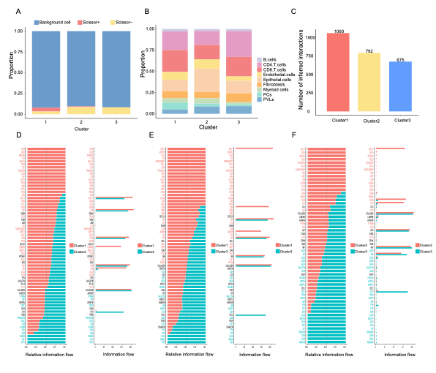
Figure S1: Cell type composition and intercellular communication patterns across CAF-derived clusters
A: Proportion of prognosis-related cells within each cluster.
B: Bar plot showing the distribution of cell types within each cluster.
C: Bar plot of total cell-cell interactions (count) in each cluster as determined by CellChat.
D: Bar plot showing total signal inputs and outputs of cell interactions in cluster1 vs. cluster2.
E: Bar plot showing total signal inputs and outputs of cell interactions in cluster1 vs. cluster3.
E: Bar plot showing total signal inputs and outputs of cell interactions in cluster2 vs. cluster3.
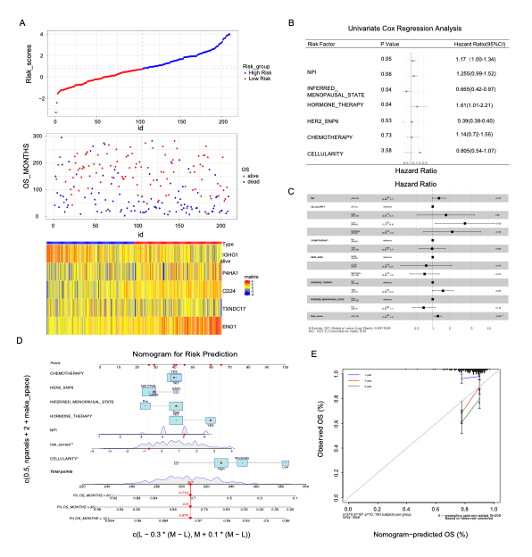
Figure S2: Clinical relevance of the CAF-derived risk model in the METABRIC cohort
A: Riskscore linkage plots:
Top: Scatter plot of riskscore values, with patients divided into high-risk and low-risk groups based on the median riskscore.
Middle: Scatter plot of patient survival times.
Bottom: Heatmap showing the expression levels of CAF-related genes.
B: Univariate Cox regression analysis of OS-related clinical factors.
C: Multivariate Cox regression analysis of OS-related parameters.
D and E: Nomogram and calibration curve for predicting 1-, 3-, and 5-year OS in BC patients.
METABRIC, Molecular Taxonomy of Breast Cancer International Consortium

