Supplementary Figure S1

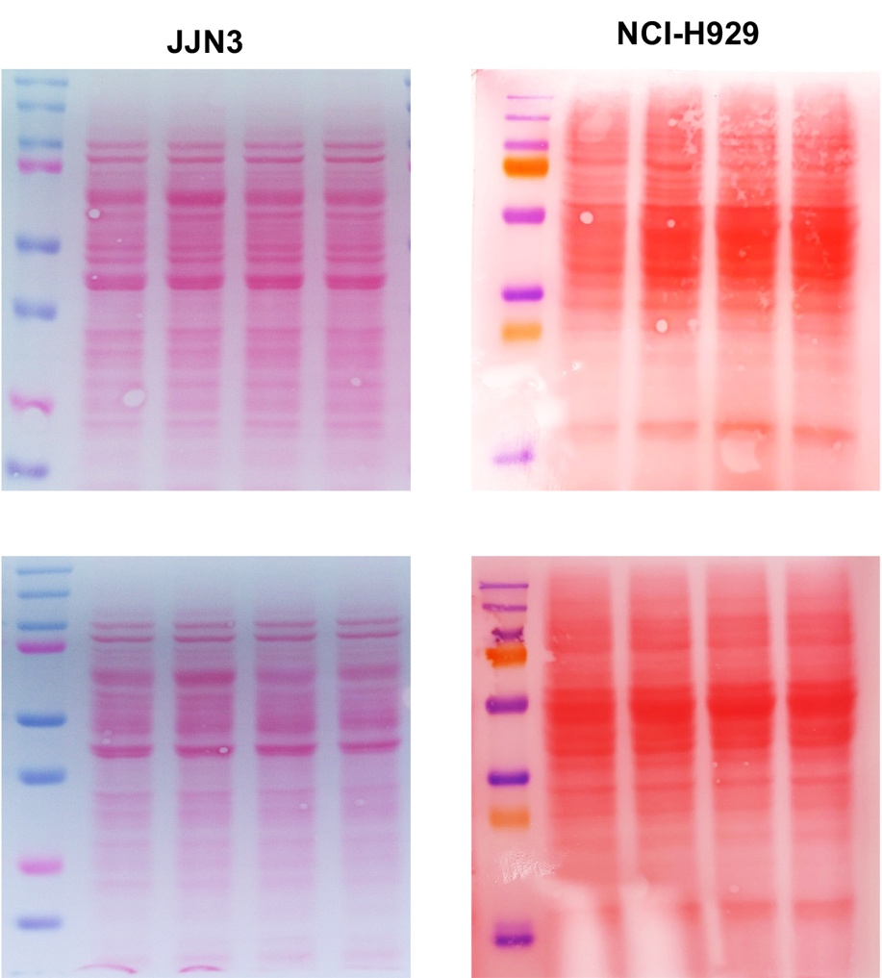

Supplementary Figure S1 | Ponceau staining confirms equal protein loading. Ponceau staining of membranes from ADMA and MMA western blots in JJN3 and NCI-H929 cells, confirming equal protein loading.

Supplementary Figure S2

Supplementary Figure S3 | PRMT1 inhibition triggers cell cycle progression defects. Representative histograms showing DNA content profiles of JJN3 and NCI-H929 cells under the indicated PRMTi concentrations. The percentage of cells in G0/G1, S, and G2/M phases are shown within each panel.

Supplementary Figure S3

Supplementary Figure S3 | PRMT1 inhibition does not increase apoptotic cell death. Bar graph showing the percentage of apoptosis and cell death measured by Annexin V-PI staining of JJN3 and NCI-H929 MM cells 72 hours post-PRMTi treatment. Data are presented as the mean ± SEM from three replicates.

Supplementary Figure S4

Supplementary Figure S4 | Distribution of 102 DEPs across key molecular functions. Bar graph showing the distribution of 102 DEPs categorized by their involvement in key molecular functions.

