Supplementary Table S1 CTU protocol and contrast injection parameters
Parameters
CT scanner | Revolution CT
Tube voltage | Fast tube voltage switching (80/140kVp)
Tube current | GSI-Assist
Noise index（NI） | 10
Pitch | 0.992:1
Section thickness | 5 mm
Section thickness | 5 mm
Detector width | 80 mm
Rotation speed | 0.6 s/r
Image matrix | 512×512
Pre-ASIR-V | 40%
Post-ASIR-V | 60%
Reconstruction kernel | STND
Reconstruction section thickness | 1.25 mm
Reconstruction section interval | 1.25 mm
Contrast agent type | Ioversol
Contrast agent concentration | 350mgI/mL
Iodine intake | 500mgI/kg(≤100ml)
Flow rate | 3.0-4.0 ml/s

Supplementary: Statistical analysis
R software (version 4.2.1), MedCalc (version 20.2; MedCalc, Ltd, Ostend, Belgium), and SPSS (version 26.0; SPSS Inc., Chicago, IL, USA) were employed for the analysis. A p-value of less than 0.05 was deemed to indicate statistical significance. Quantitative parameters were initially assessed for normality using the Shapiro-Wilk test. Normally distributed parameters are presented as the mean ± standard deviation (SD), while non-normally distributed variables are expressed as the median and interquartile range (IQR). Comparisons among variables were made using the independent samples t-test, Mann-Whitney U test, chi-square tests, or Fisher’s exact test, as appropriate. Variables with a p-value of < 0.05 in the univariate analysis were identified as candidates for multivariable binary logistic regression analysis. Subsequently, these candidate variables were included as independent variables in a forward stepwise binary logistic regression to determine the independent predictors. The area under the curve (AUC) was calculated based on the R programming language to evaluate the diagnostic efficacy of the different models, and statistical differences between AUCs were compared using the DeLong test.

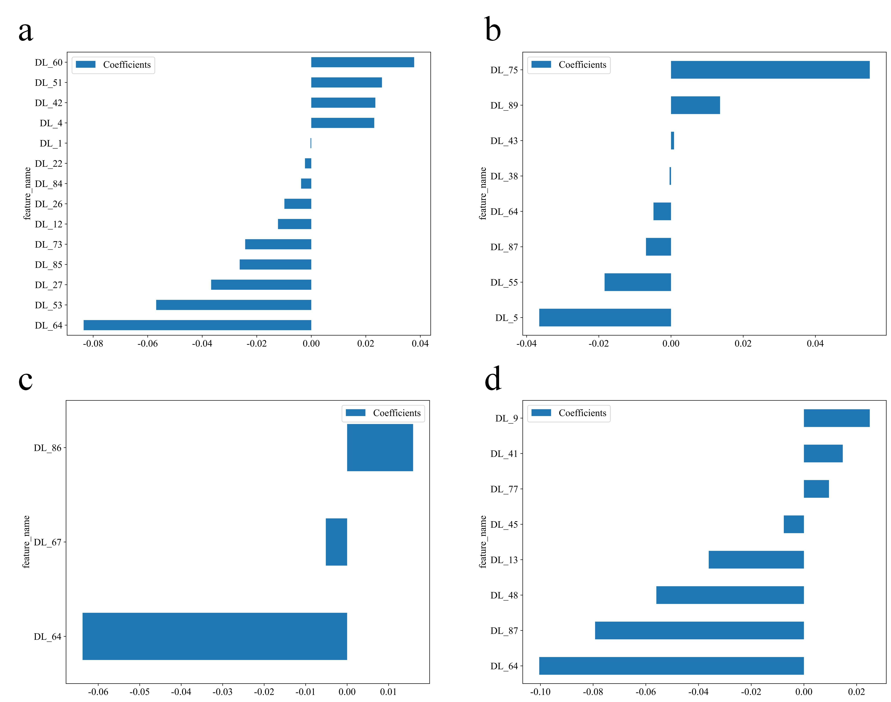
Supplementary Figure S1 Image Features and Correlation Coefficients of Different DL Models. a. ResNet 18; b. ResNet 50; c. ResNet 101; d. DenseNet 121.

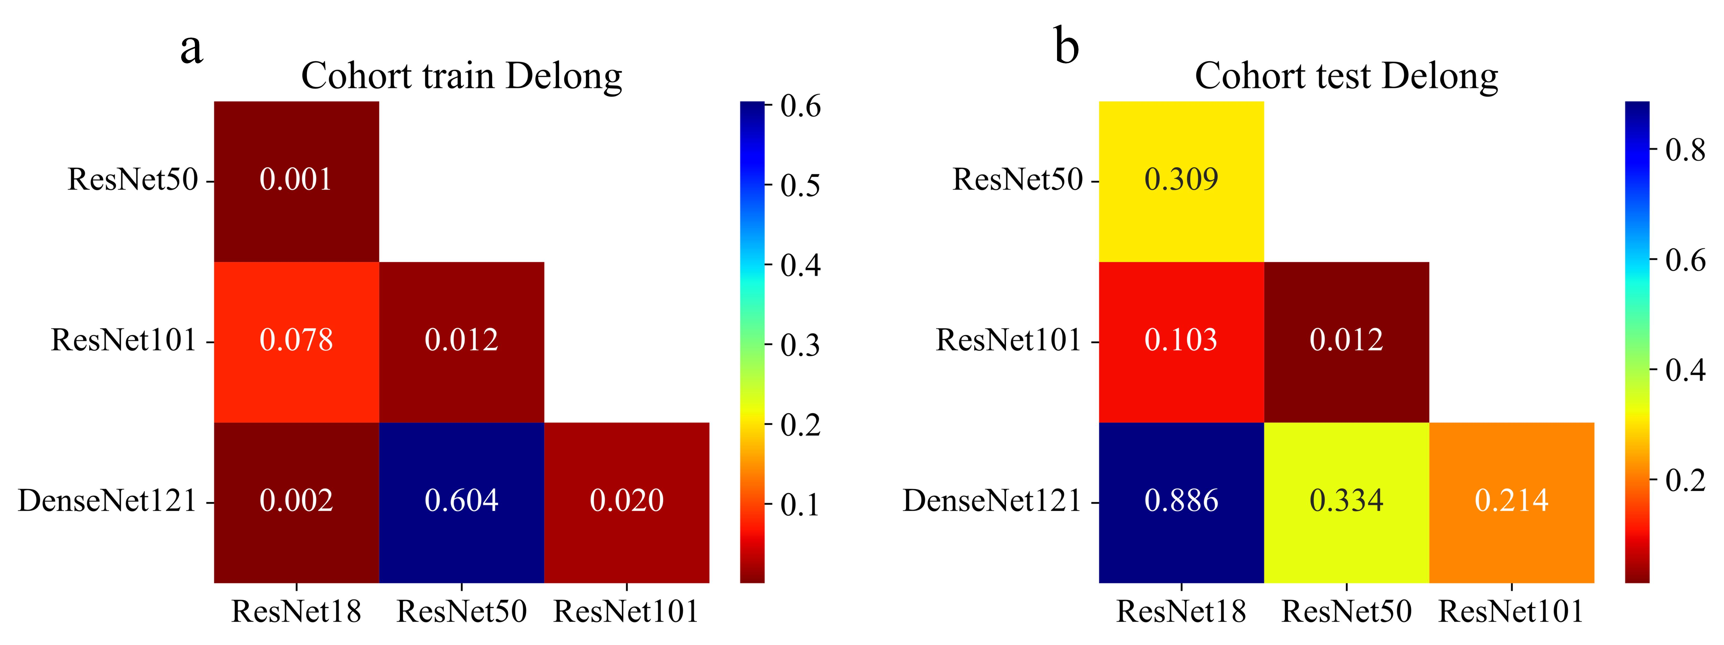
Supplementary Figure S2 Delong test of different DL models in the training and test cohorts

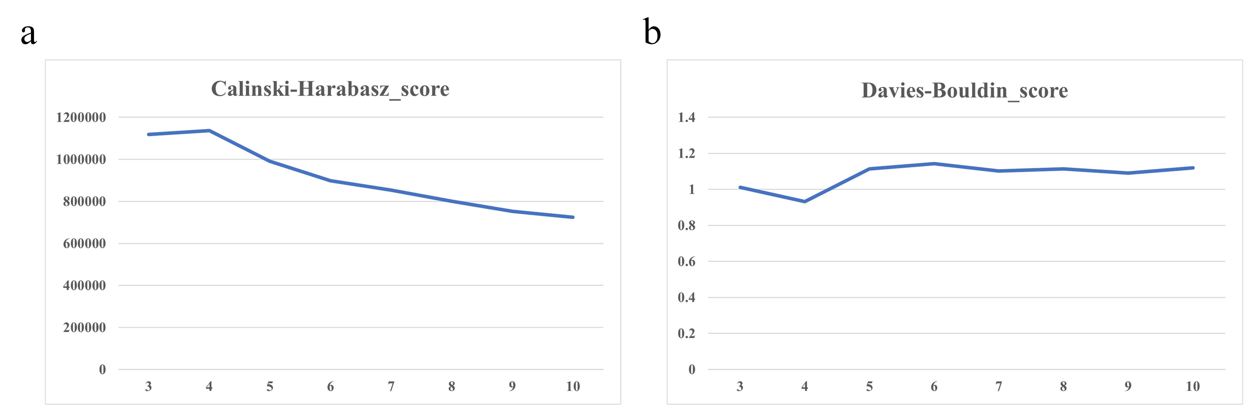
Supplementary Figure S3 Calinski-Harabasz score (a) and Davis-Bouldin score (b) of different clusters

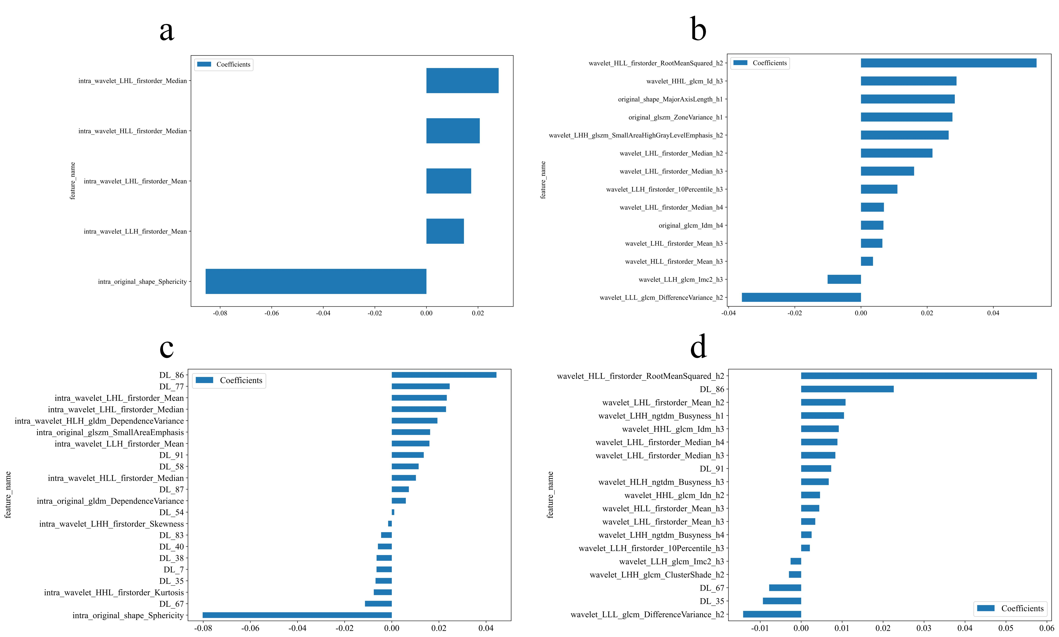
Supplementary Figure S4 Image Features and Correlation Coefficients of Different Models. a. Radiomics model; b. Habitat model; c. DLR model; d. DLH model.

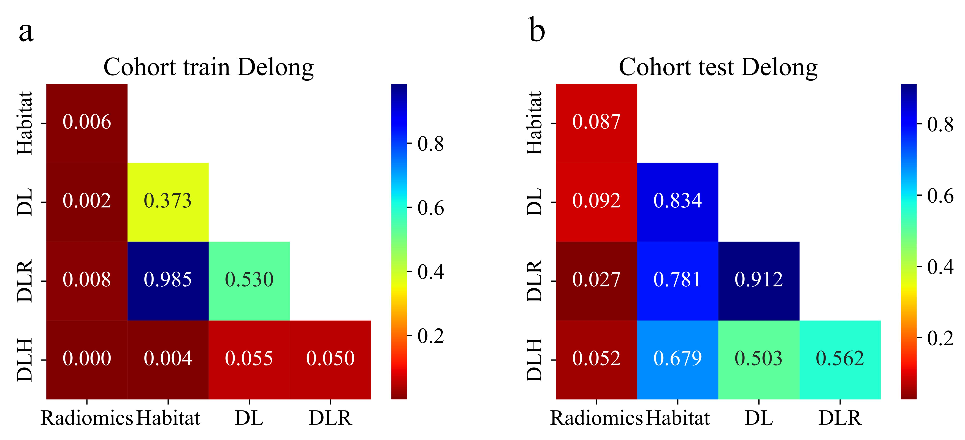
Supplementary Figure S5 Delong test of different models in the training and test cohorts

