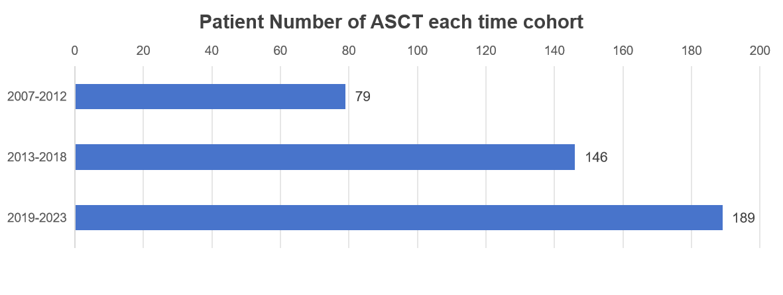
Supplemental Figure 1. Increase in the number of patients with MM who underwent ASCT in each time cohort

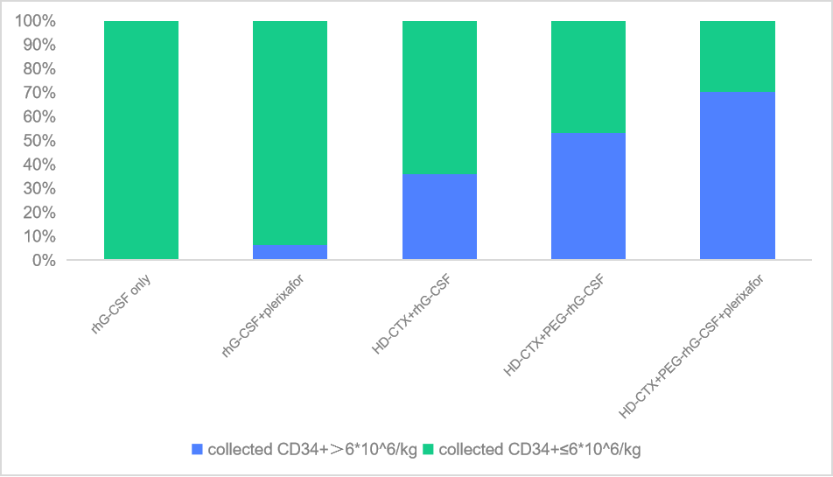
Supplemental Figure 2. Stem cell doses stratified by mobilization regimen

Supplemental Table 1. Discovery of three M-protein decline patterns
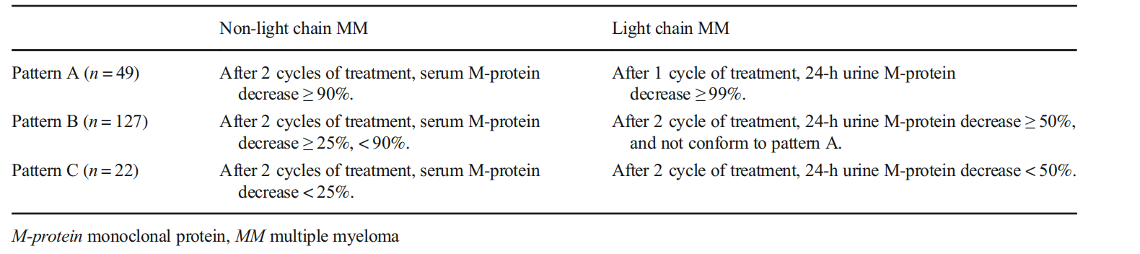

Supplemental Table 2. Univariate and multivariate analyses of factors associated with PFS
PFS | Univariate analysis |  |  | Multivariate analysis
 | HR | 95% CI | p value | HR | 95% CI | p value
Age, >65 years vs. ≤65 years | 0.99 | 0.54–1.83 | 0.973
Sex, male vs. female | 1.04 | 0.76–1.41 | 0.806
R-ISS stage, I vs. II/III | 1.77 | 1.21–2.58 | 0.003 | 1.65 | 0.89–3.07 | 0.110
LDH >240 U/L | 1.52 | 1.02–2.27 | 0.038 | 1.21 | 0.74–1.96 | 0.447
Hypercalcaemia | 1.33 | 0.82–2.17 | 0.251
Renal insufficiency | 1.43 | 1.04–1.97 | 0.029 | 1.13 | 0.74–1.71 | 0.577
Anaemia | 1.40 | 1.03–1.91 | 0.031 | 0.90 | 0.59–1.37 | 0.622
Platelets <100*10⁹/L | 3.32 | 1.93–5.72 | <0.001 | 3.07 | 1.43–6.59 | 0.004
Extramedullary extraosseous (EME) | 4.78 | 2.10–10.91 | <0.001 | 3.53 | 1.19–10.48 | 0.022
Secondary amyloidosis | 2.08 | 1.25–3.47 | 0.005 | 1.74 | 0.96–3.16 | 0.070
HBsAb positive | 1.34 | 0.91–1.96 | 0.142
High-risk FISH | 2.32 | 1.64–3.28 | <0.001 | 1.78 | 1.20–2.62 | 0.004
Tandem ASCT | 0.61 | 0.19–1.91 | 0.393
Pattern B of M-protein decline | 0.61 | 0.45–0.83 | 0.002 | 0.65 | 0.45–0.95 | 0.027
Initial treatment regimen, two-drug regimen vs. three-/four-drug regimen | 0.76 | 0.54–1.08 | 0.128
Mobilization regimen | 0.64 | 0.20–2.00 | 0.438
Conditioning regimen | 0.89 | 0.65–1.22 | 0.476
Best response, MRD- vs. MRD+ | 0.35 | 0.25–0.49 | <0.001 | 0.48 | 0.31–0.74 | <0.001

Supplemental Table 3. Univariate and multivariate analyses of factors associated with OS
OS | Univariate analysis |  |  | Multivariate analysis
 | HR | 95% CI | p value | HR | 95% CI | p value
Age, >65 years vs. ≤65 years | 1.31 | 0.69–2.50 | 0.413
Sex, male vs. female | 0.91 | 0.64–1.28 | 0.572
R-ISS stage, I vs. II/III | 2.05 | 1.30–3.23 | 0.002 | 1.88 | 0.09–3.92 | 0.091
LDH >240 U/L | 1.54 | 0.99–2.41 | 0.056
Hypercalcaemia | 1.53 | 0.92–2.56 | 0.103
Renal insufficiency | 1.49 | 1.05–2.13 | 0.027 | 1.06 | 0.66–1.71 | 0.798
Anaemia | 1.47 | 1.03–2.08 | 0.033 | 0.79 | 0.48–1.31 | 0.368
Platelets <100*10^⁹/L | 2.52 | 1.45–4.40 | 0.001 | 2.44 | 1.11–5.34 | 0.026
Extramedullary extraosseous | 6.95 | 2.99–16.16 | <0.001 | 4.66 | 1.74–12.49 | 0.002
Secondary amyloidosis | 2.73 | 1.62–4.61 | <0.001 | 2.48 | 1.36–4.53 | 0.003
HBsAb positive | 1.30 | 0.83–2.02 | 0.247
High-risk chromosomal abnormalities | 2.21 | 1.50–3.26 | <0.001 | 1.70 | 1.10–2.61 | 0.016
Tandem ASCT | 1.16 | 0.36–3.69 | 0.807
Pattern B of M-protein decline | 0.65 | 0.46–0.92 | 0.016 | 0.77 | 0.49–1.20 | 0.243
Initial treatment regimen, two-drug regimen vs. three-/four-drug regimen | 0.65 | 0.45–0.94 | 0.024 | 0.39 | 0.22–0.72 | 0.003
Mobilization regimen, chemotherapy vs. G-CSF | 0.69 | 0.17–2.83 | 0.611
Conditioning regimen, Mel vs. CVB | 0.86 | 0.60–1.23 | 0.405
Best response, MRD- vs. MRD+ | 0.37 | 0.25–0.53 | <0.001 | 0.56 | 0.35–0.89 | 0.015
Abbreviations: ASCT, autologous stem cell transplantation; CI, confidence interval; HR, hazard ratio; RISS, Revised International Staging System; MM, multiple myeloma; OS, overall survival; PFS, progression-free survival; MRD minimal residual disease; VB=busulfan/etoposide/cyclophosphamide; Mel=melphalan. High-risk chromosomal abnormalities were defined as the presence of del(17p) and/or t(4;14) and/or t(14;16) and/or amp1q21; standard risk was defined as the absence of high-risk chromosomal abnormalities.

