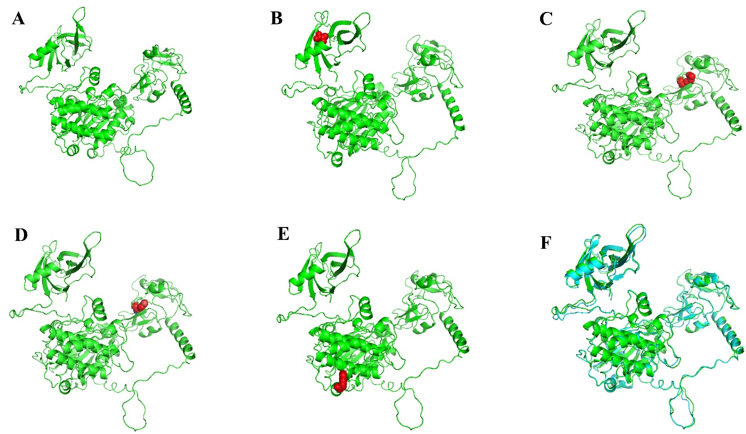
Supplementary Figure 2: 3D structures of native and variants PKCδ. The variant residues is depicted as red spheres. Refined model of the Native (a) and variant Protein V114G (b), C189R(c), C189Y (d), W608R (e), Superimposing of predicted PKCδ protein structure (green color) and refined structure (Cyan color) (f).

