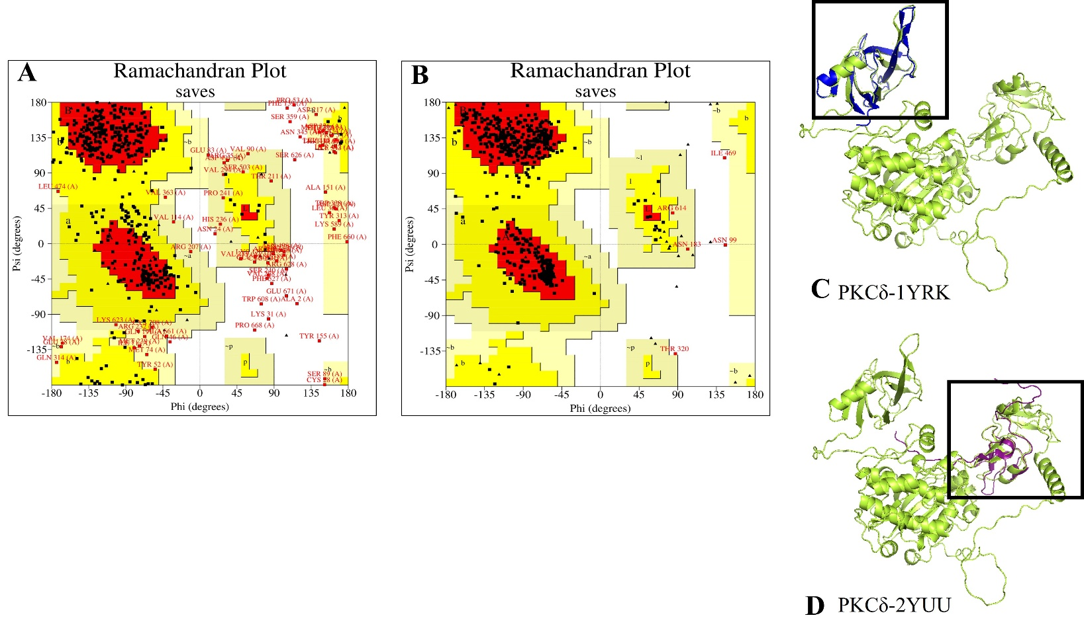
Supplementary Figure 2: Comparison of PKCδ predicted models from I-TASSER and AlphaFold. Only 69.9% residues were present in allowed region in the Ramachandran plot of I-TASSER predicted model (a) AlphaFold predicted model has 90% of the residues in allowed region in Ramachandran plot (b) AlphaFold predicted PKCδ model aligned with 1YRK (C2-domain) structure with RMSD of 0.261Å (c) predicted PKCδ model aligned with 2YUU (C1-domain) structure with RMSD of 0.76Å.

