Details on Joinpoint regression model selection criteria
The maximum number of joinpoints was set to 4, and the Bayesian Information Criterion (BIC) was used for model selection, with the final number determined by minimizing the WBIC.

AMSR in China: The optimal number of joinpoints selected by the software was 2, corresponding to a WBIC of 2.39 and an MSE of 4.61. Accordingly, we also selected 2 joinpoints.
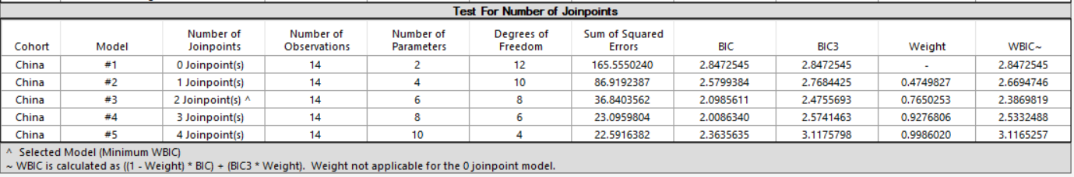
AMSR of Male: The software automatically identified 3 joinpoints as the optimal number, with a WBIC of 2.07 and an MSE of 2.45. However, more complex models (i.e., those with more joinpoints) led to increased estimation uncertainty, as reflected by wider confidence intervals for the AAPC and larger p-values. Therefore, to prioritize the model's ability to summarize the overall trend across the entire period, we selected the second-best model—with 1 joinpoint, a WBIC of 2.17, and an MSE of 5.28. Although this model has a slightly higher BIC, it provides a stable and interpretable estimate of the overall trend. Moreover, the difference in BIC between the selected model and the optimal model was small (ΔBIC < 2), indicating comparable strength of evidence.
AMSR of Female: The software-determined optimal model contained 2 joinpoints, yielding a WBIC of 1.95 and an MSE of 2.94. For the reasons stated above, we ultimately selected a model with one joinpoint, which had a WBIC of 2.17 and an MSE of 5.28 (ΔBIC < 2).
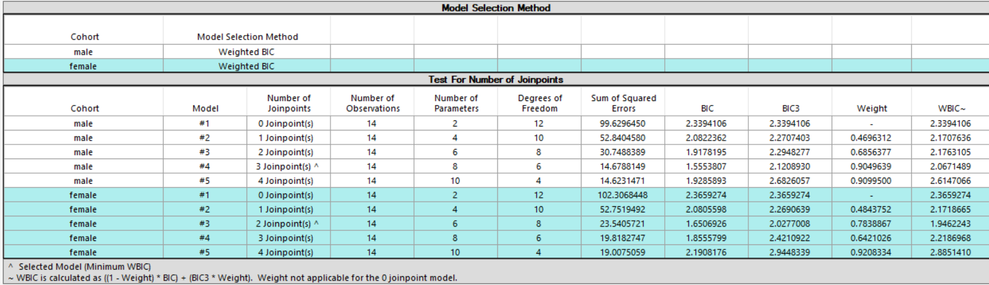
AMSR of Urban area: The software identified 1 joinpoint as the optimal model, with a WBIC of 2.41 and an MSE of 6.81. This result was adopted as the final model.
AMSR of Rural area: The software identified 2 joinpoint as the optimal model, with a WBIC of 1.83 and an MSE of 2.60. This result was adopted as the final model.
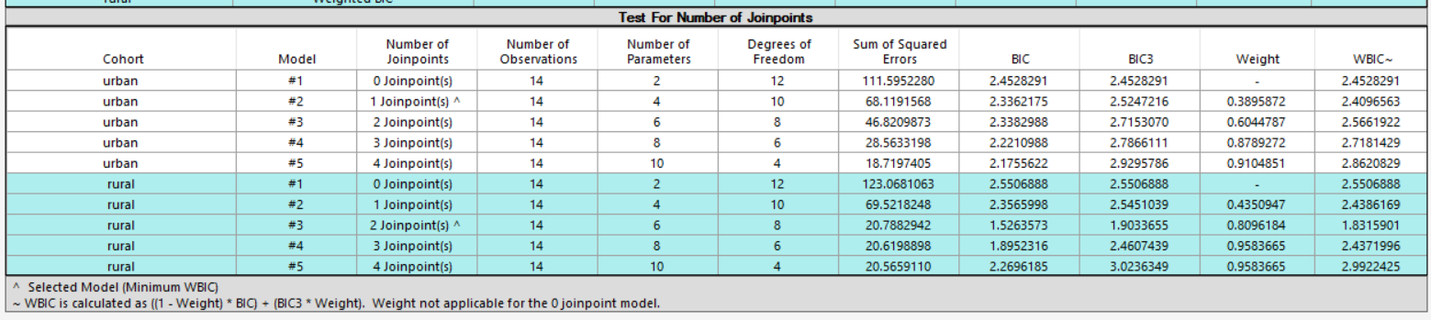
AMSR of Eastern China: The software identified 0 joinpoint as the optimal model, with a WBIC of 1.43 and an MSE of 3.34. This result was adopted as the final model.
AMSR of Central China: The software identified 1 joinpoint as the optimal model, with a WBIC of 2.09 and an MSE of 4.72. This result was adopted as the final model.
AMSR of Western China: The software identified 0 joinpoint as the optimal model, with a WBIC of 1.56 and an MSE of 3.80. This result was adopted as the final model.
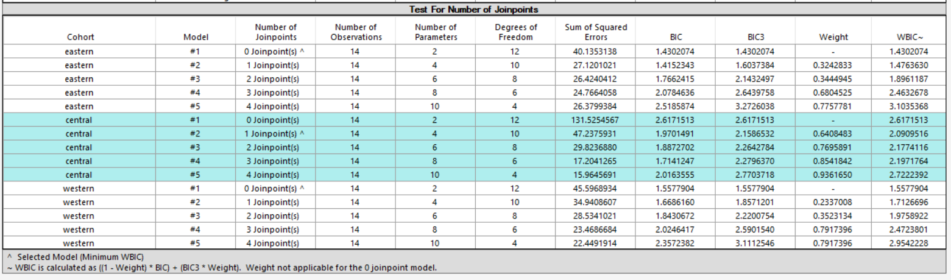

PYLLR of China: The software identified 0 joinpoint as the optimal model, with a WBIC of -0.95 and an MSE of 0.31. This result was adopted as the final model.
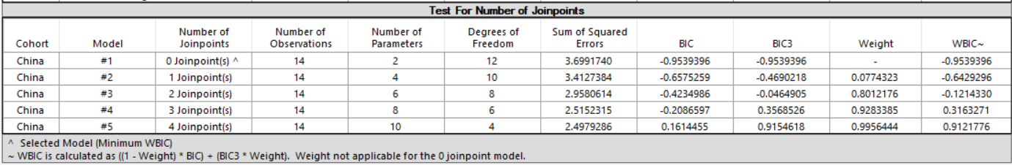
PYLLR of Male: The software identified 0 joinpoint as the optimal model, with a WBIC of -0.97 and an MSE of 0.30. This result was adopted as the final model.
PYLLR of Female: The software identified 0 joinpoint as the optimal model, with a WBIC of -1.35 and an MSE of 0.21. This result was adopted as the final model.
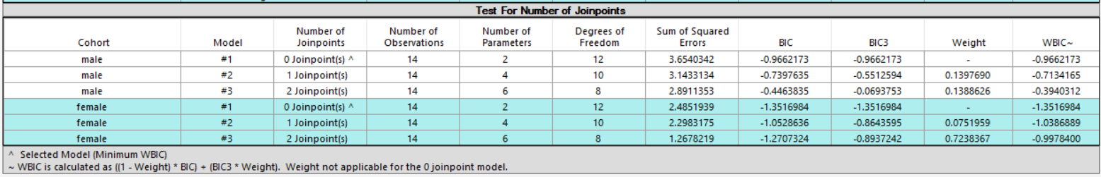
PYLLR of Urban area: The software identified 0 joinpoint as the optimal model, with a WBIC of -0.73 and an MSE of 0.39. This result was adopted as the final model.
PYLLR of Rural area: The software identified 0 joinpoint as the optimal model, with a WBIC of -1.05 and an MSE of 0.28. This result was adopted as the final model.
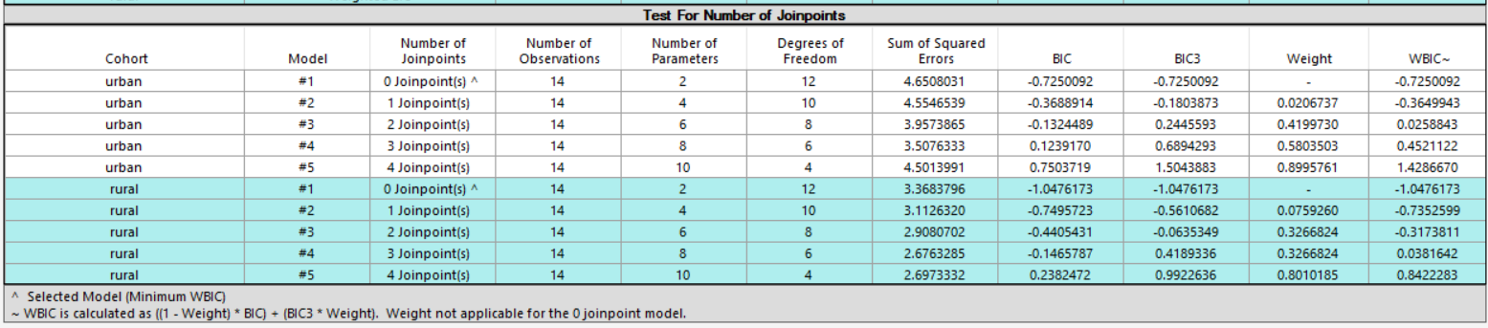
PYLLR of Eastern China: The software identified 1 joinpoint as the optimal model, with a WBIC of -1.35 and an MSE of 0.15. This result was adopted as the final model.

PYLLR of Central China: The software identified 1 joinpoint as the optimal model, with a WBIC of -0.78 and an MSE of 0.26. This result was adopted as the final model.
PYLLR of Western China: The software identified 0 joinpoint as the optimal model, with a WBIC of -1.49 and an MSE of 0.18. This result was adopted as the final model.
