Pairwise comparisons (Bonferroni-corrected) across the eastern, central, and western regions。
2008
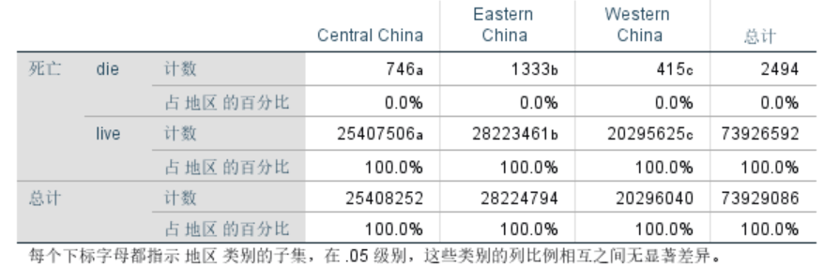
2009
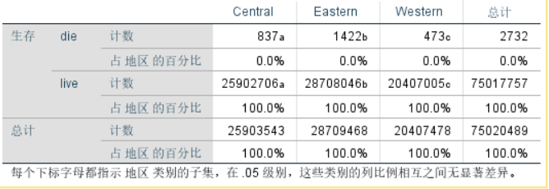
2010
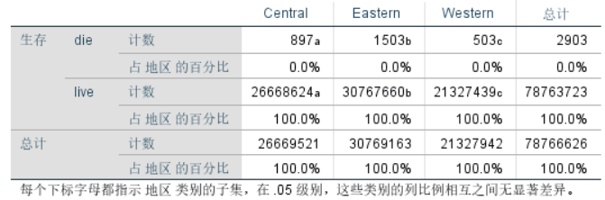
2011
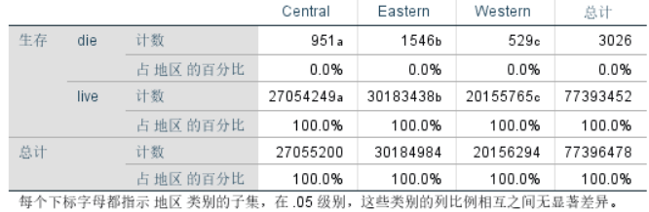
2012
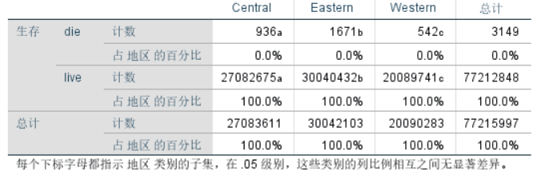
2013
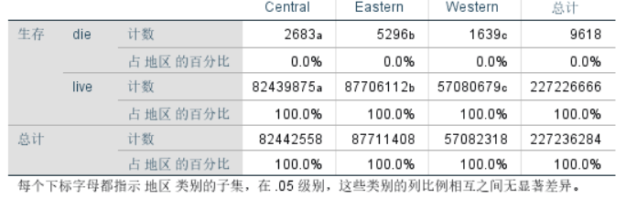
2014
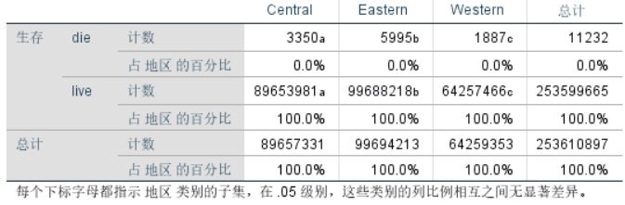
2015
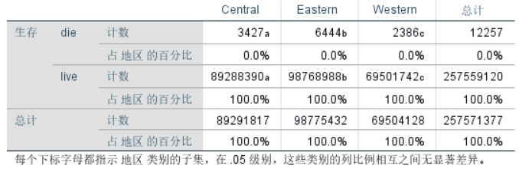
2016
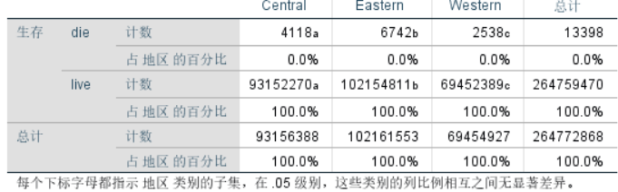
2017
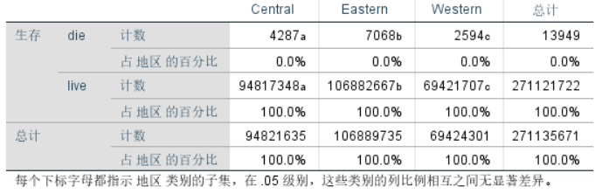
2018
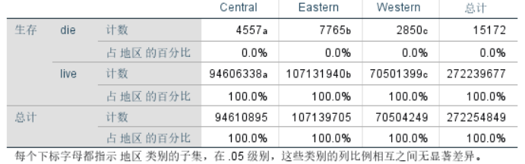
2019
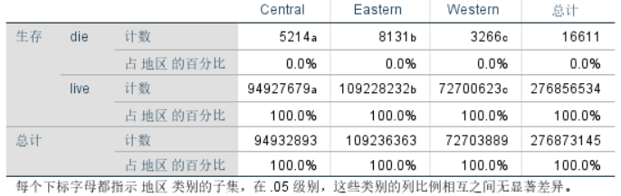
2020
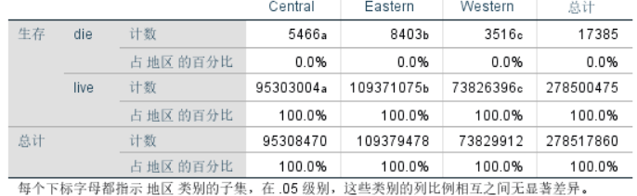
2021
