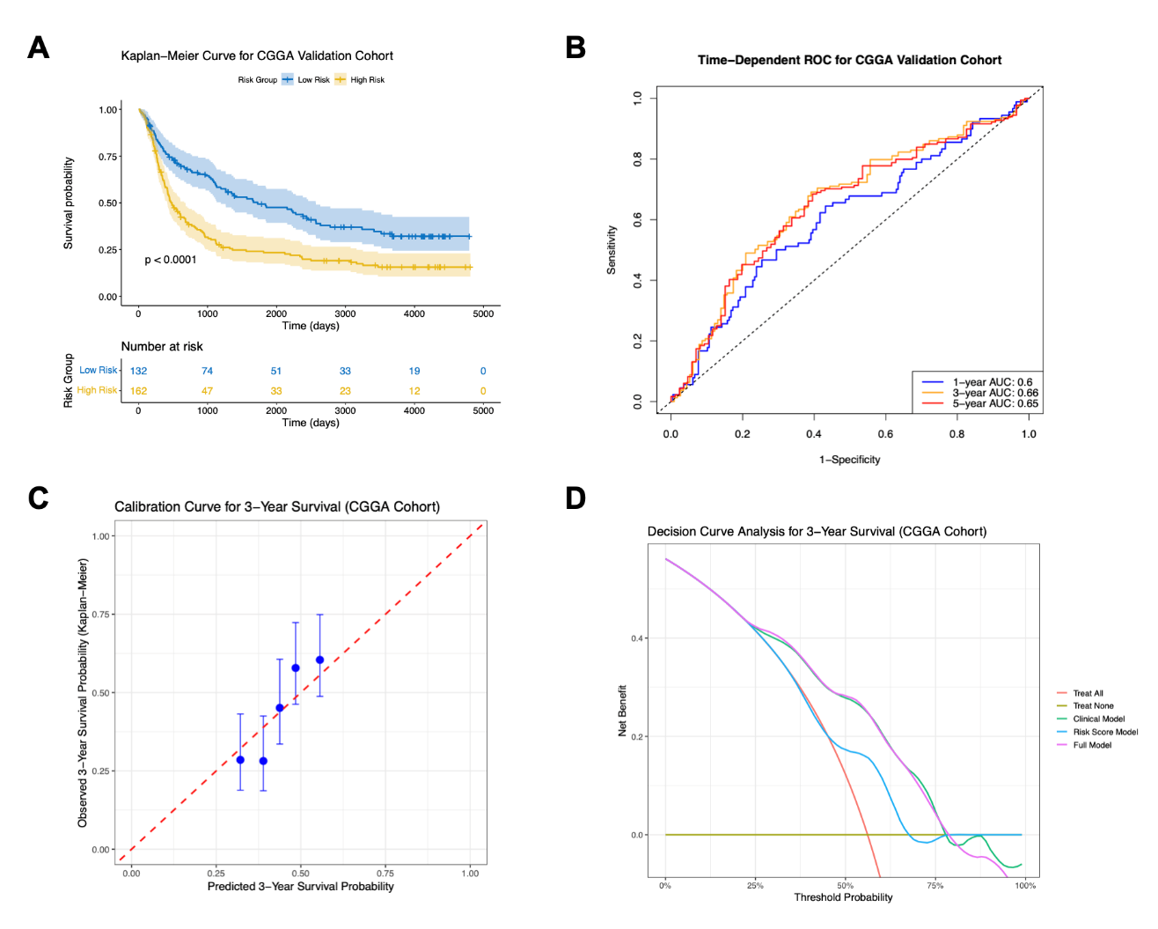
Supplementary Figure 1. External validation of the 9-gene prognostic signature in the CGGA cohort. (A) Kaplan-Meier survival analysis for patients in the CGGA cohort (n=294), stratified into high- and low-risk groups by the optimal cut-off of the risk score. The log-rank test p-value is shown. The table below indicates the number of patients at risk at different time points. (B) Time-dependent ROC curve analysis for the prognostic signature. The Area Under the Curve (AUC) for predicting overall survival at 1, 3, and 5 years is displayed. The dashed line represents the reference line. (C) Calibration curve for the 3-year overall survival prediction. The x-axis represents the model-predicted survival probability, and the y-axis represents the actual survival probability (Kaplan-Meier estimate). The dashed red line indicates a perfect calibration. Error bars represent 95% confidence intervals. (D) Decision-curve analysis (DCA) for 3-year overall survival. The net benefit of the "Full Model" (risk score + clinical variables), the "Risk Score Model" alone, and the "Clinical Model" alone are compared against the default strategies of "Treat All" or "Treat None".

