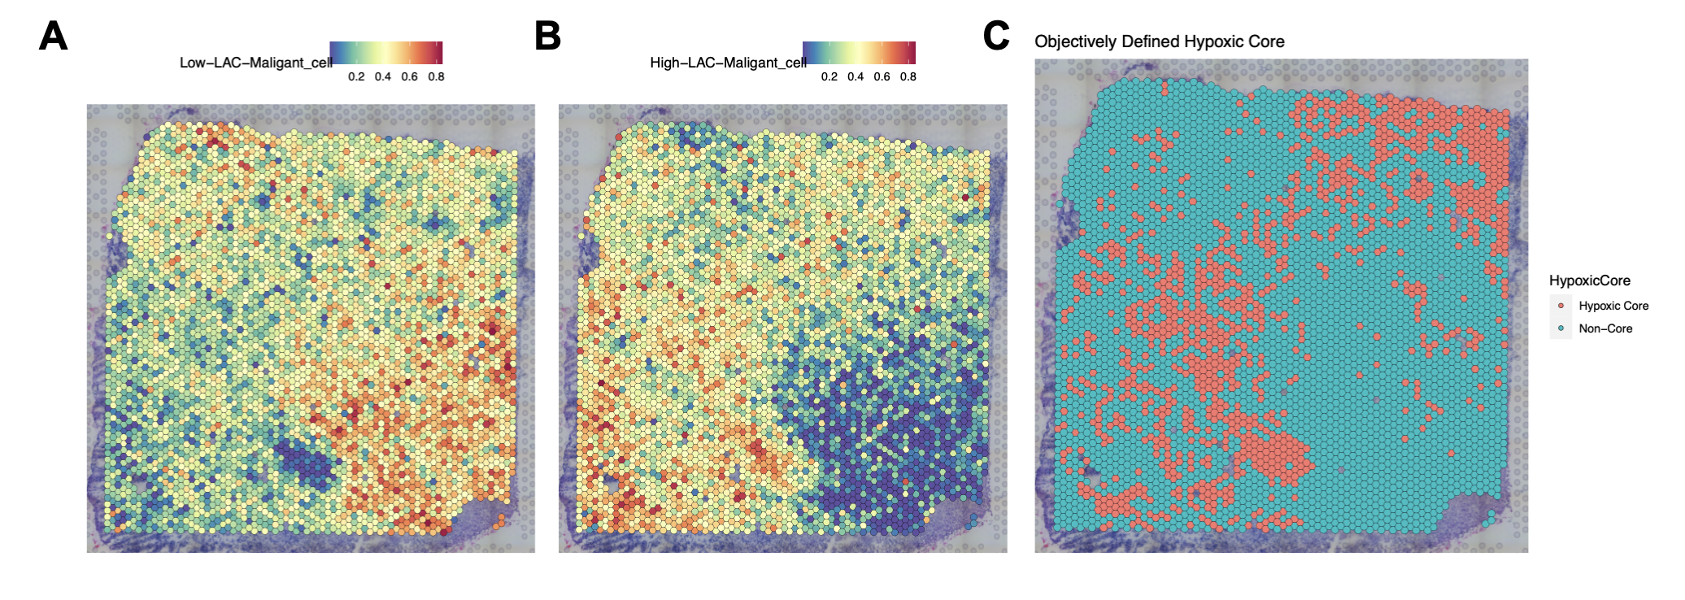
Supplementary Figure 2. Spatial localization of lactylation signatures and objective definition of the hypoxic core. (A) Spatial feature plot from a representative GBM tissue section showing the RCTD-estimated proportion of "Low-LAC-Maligant_cell". (B) Spatial feature plot showing the RCTD-estimated proportion of "High-LAC-Maligant_cell". Note the enrichment in the lower-left and central regions. (C) Spatial dim plot illustrating the objectively defined "Hypoxic Core" (red), which was defined as the top quartile of spots based on a hypoxia signature score. The spatial pattern of the hypoxic core strongly co-localizes with the enrichment of the "High-LAC-Maligant_cell" signature shown in (B).

